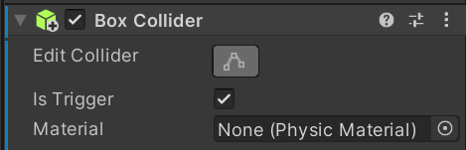**Item pickup package.**

Item that is to be picked up needs a collider and Is Trigger to be ticked.

Also needs a layer that will be set 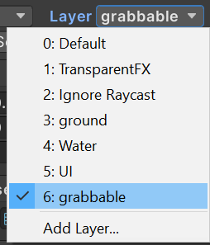on all objects that are to be picked up, I have chosen “grabbable” in this instance.

An empty gameObject will need to be placed in front of the camera, this is used to tell the script where to hold the objects that the player picks up.

On the player camera, add the Grab Listener and Grab Script.

Under the final position on the Grab Listener script, put the empty gameObject that was just made and adjust speeds if needed.

Under the Grab Script, place the player camera as the main origin, set the Grab Object to whichever button you desire and set the Object Layer to the one you made previously.

Under Movement, place your player with their script that handles their movement. Finally, under On Object Grabbed and Dropped, drag in your player camera and set them to their corresponding 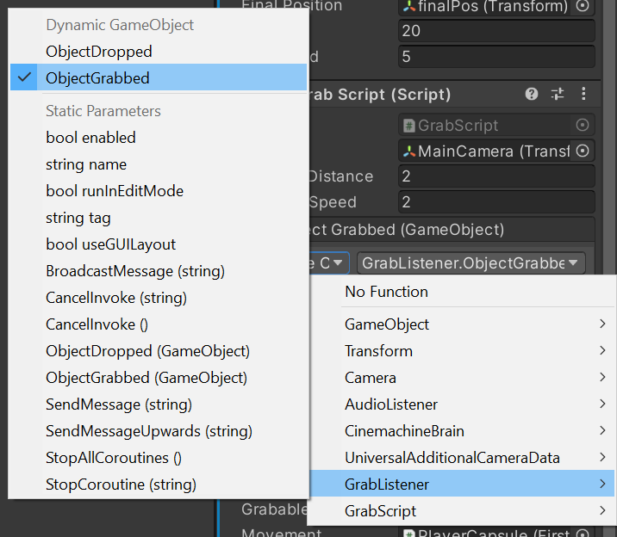settings.