Dash

Step 1

belt column, click “character player." Right column, create name / title, 'Trail Renderer’

Step 2 Right click width to 1.0, then edit key 0.5.to end. Right click add edit key 0.0.

Step 3

In the same column, click Time 0.5

Step 4

Click colour to create a white square, sea red- circles below in the image. Click numbero, this. is the start of dash speed. The background will appear white, then slow down, showing its “speed. trail."

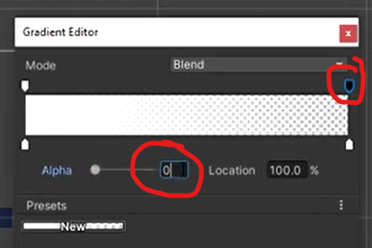

Step 5

Tick in Emitting to be taken off, see image.

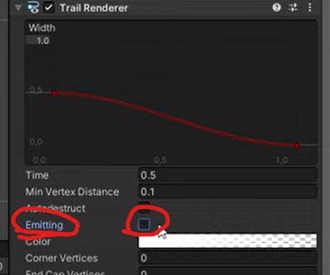

Step 6

Go to materials. Open up Sprites to select material and colour for the "speed trail" (see step 4).

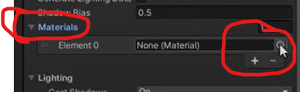

Step 7

In movement (Script) double click to Open the Coding.

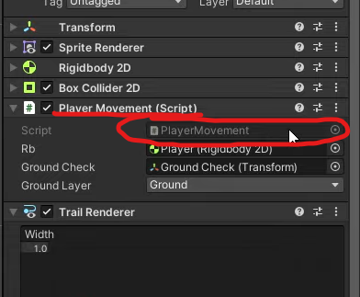

Step 8

Create the coding for Dash, as this image below shaws.

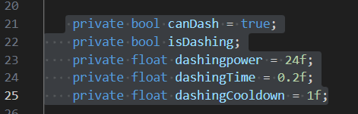

Step 9

Add this to the code: [serializefield]

Ignore the red areas below.

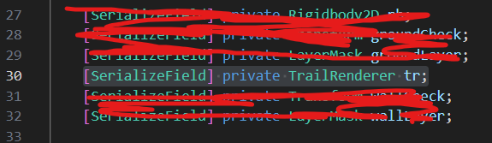

Step 10

See image: below, add the private IEnumerator

Dash() This enables speed and pause in this process.

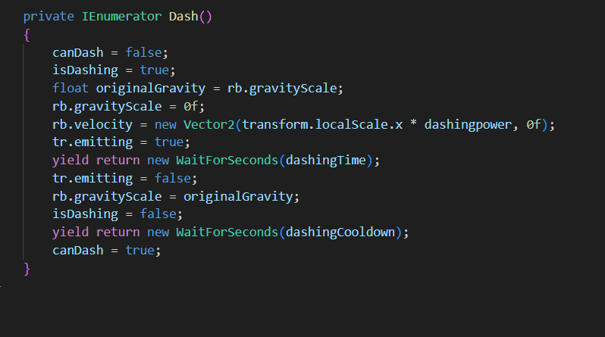

Step11

See yellow circled areas, add 'void update' in Dash.

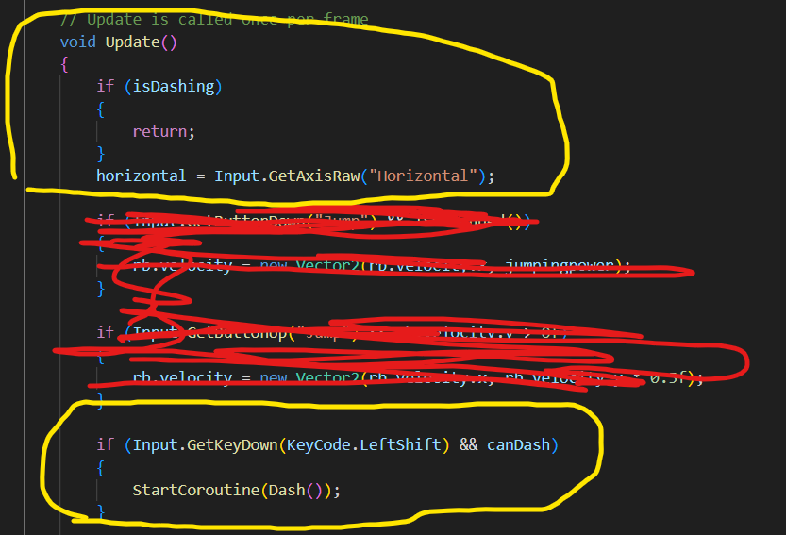

Step 12

In Void update, add within the yellow circle below.

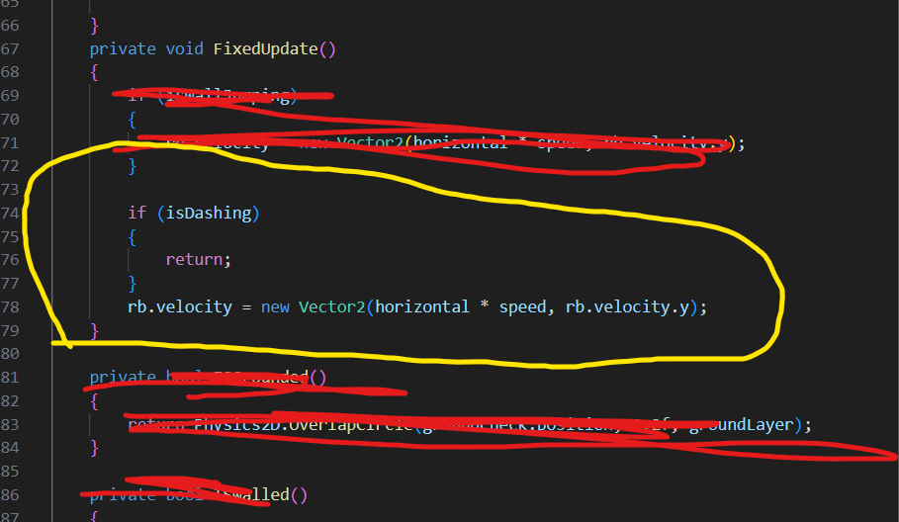

Step 13

Return to UNITY, pick and drag "Trail Renderer" into "Tr" (right column under movement).

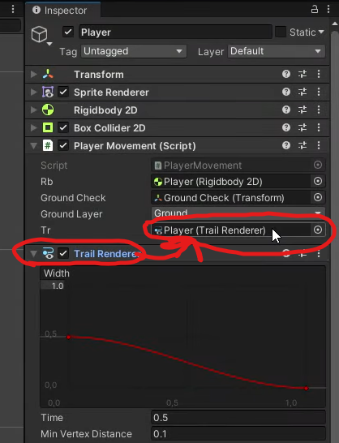

Step 14

Check shift DASH with player, using keyboard.