Step 1:

Creating the assets:

You need to create 3 2D objects. The player, the shooter, the bullet.

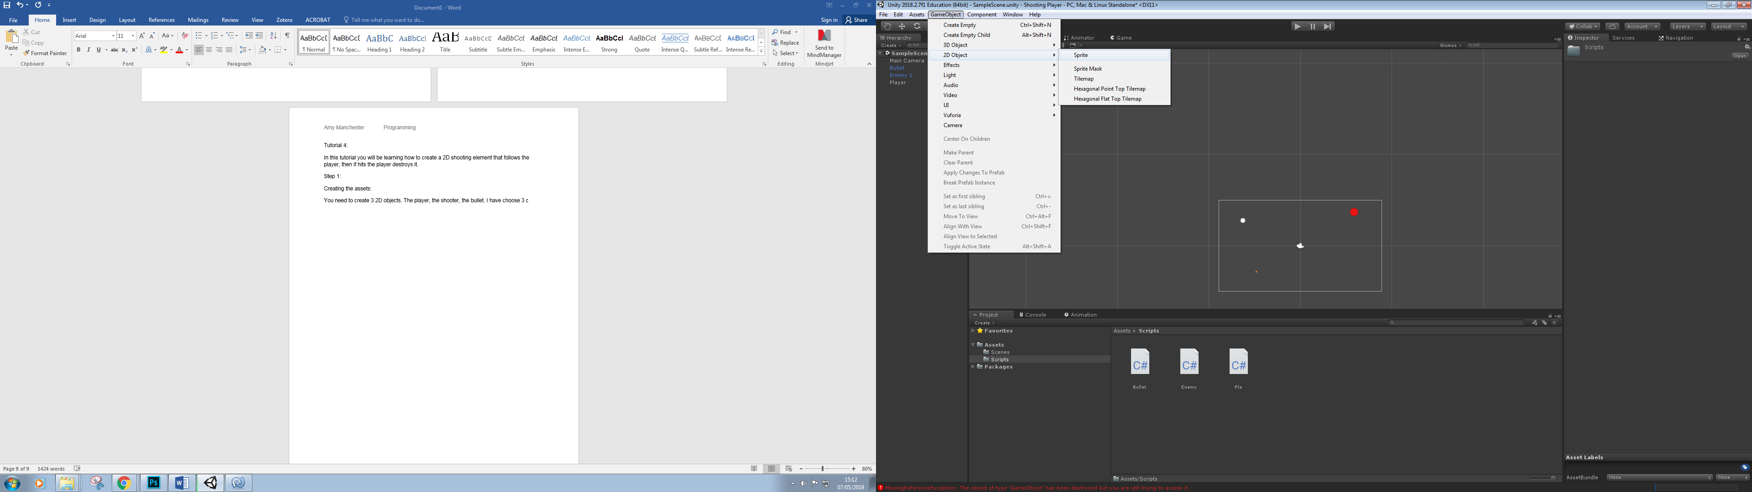

As you can see, they do not appear with the shapes as the option of 3D gameObjects do. In the inspector, select which shape you’d like to have. Ensure you name them correctly.

Step 2:

Adding materials:

In order to have a clear view of what object is what, add 3 different colours to them. To do this, select Assets, Material, select which colour you prefer and drag this onto the object.

Step 3:

Creating the scripts. We have to create 3 scripts, so let’s go through them one at a time, starting with the player:

using System.Collections;  
using System.Collections.Generic;  
using UnityEngine;  
  
public class Pla : MonoBehaviour {  
      
        [SerializeField]  
        float moveSpeed = 5f; *//what speed to move at*  
  
        float dirX , dirY; *//which direction*  
        Rigidbody2D rb; *//refering to the rigidbody attached to the object*  
  
        *// Use this for initialization*  
        void Start () {  
            rb = GetComponent<Rigidbody2D> ();   
        }  
  
        *// Update is called once per frame*  
        void Update () {  
            dirX = Input.GetAxis ("Horizontal") * moveSpeed; *//as unitys go to controls are the key arrows, we do not have to set these, but this part of code shows which direction to travel in and when.*  
            dirY = Input.GetAxis ("Vertical") * moveSpeed;  
        }  
  
        void FixedUpdate()  
        {  
            rb.velocity = new Vector2 (dirX, dirY);  
        }  
}

We also need to add a tag to the player, add a tag named “Pla”, you can name the tag whatever you prefer but ensure you change this in the next script.

Bullet:

using System.Collections;  
using System.Collections.Generic;  
using UnityEngine;  
  
public class Bullet : MonoBehaviour {  
  
    float moveSpeed = 7f; *//what speed the bullet moves at*  
  
    Rigidbody2D rb; *//refering to the rigidbody attatched to the player*  
  
    Pla target;  
    Vector2 moveDirection; *//what direction the bullet will travel in*  
  
    *// Use this for initialization*  
    void Start () {  
        rb = GetComponent<Rigidbody2D> ();  
        target = GameObject.FindObjectOfType<Pla>(); *//what object are you aiming the bullets towards*  
        moveDirection = (target.transform.position - transform.position).normalized * moveSpeed; *// move towards the targets location at the given speed*  
        rb.velocity = new Vector2 (moveDirection.x, moveDirection.y); *//the new direction in which the bullet will move*  
  
    }  
  
    void OnTriggerEnter2D (Collider2D other){  
  
  
        if(other.gameObject.tag.Equals ("Pla"))  
            {  
                  
                Destroy(other.gameObject); *//destroy player*  
            }  
        }  
    }

Enemy:

using System.Collections;  
using System.Collections.Generic;  
using UnityEngine;  
  
public class Enemy : MonoBehaviour {  
  
    [SerializeField]  
    GameObject Bullet; *// what object will be the bullet, this iwll be se tin the inspector.*  
  
    float fireRate; *//how often it fires*  
    float nextFire; *// how much time between the fires*  
  
    *// Use this for initialization*  
    void Start () {  
        fireRate = 1f;  
        nextFire = Time.time;  
    }  
  
    *// Update is called once per frame*  
    void Update () {  
        CheckIfTimeToFire ();   
    }  
  
    void CheckIfTimeToFire()  
    {  
        if (Time.time > nextFire) {  
            Instantiate (Bullet, transform.position, Quaternion.identity);  
            nextFire = Time.time + fireRate; *//check if its enough time to fire*  
        }  
           
    }  
  
}

Step 4:

We now need to set up the inspectors to ensure our code will work. In the player’s inspector, change the Move speed to your desired speed.

We need to make the bullet a Prefab, as it will not start on screen, but appear once the game is running. In order to do this, simply go onto assets, create prefab and drag the Bullet object we have been previously using onto the prefab. It is now a prefab. Ensure it is renamed Bullet.

For the enemy inspector, ensure you have dragged the bullet prefab into the Bullet option.

|  |  |  |  |  |
| --- | --- | --- | --- | --- |
| Date | Estimate Start | End | Interruptions | Task |
| 21/03/2019 | 2.17pm | 2.30pm | 2 minutes | Creaitng assets |
| 21/03/2019 | 2.32pm | 2.38pm | 0 | Adding Materials |
| 21/03/2019 | 3.00pm | 4.32pm | 5 minutes | Writing the code |
| 21/03/2019 | 4.44pm | 4.50pm | 0 | Setting up inspector |