**Shuffle**

The shuffle script allows for a list of any data type to be rearranged randomly.

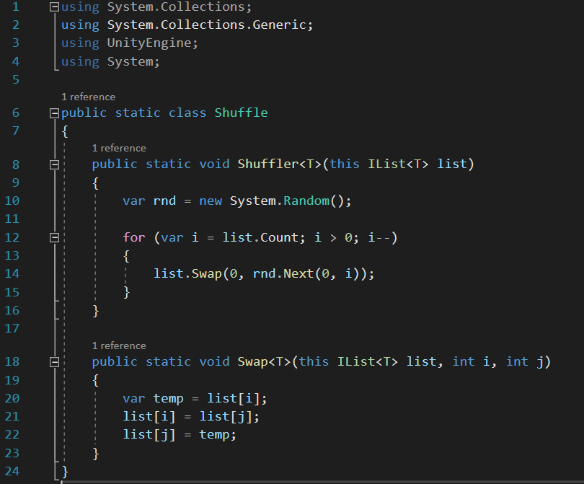

The Shuffler method takes in a list of any data type, for each entry in the list it calls the Swap Method. This method takes in two indexes of the list and swaps them.

By doing this each entry is swapped with another random entry in the list. The result of this is a list that has been shuffled.

Within the swap method, it takes an entry and stores it as another variable called temp so it is not overwritten. It then overwrites the original with another entry from the list and replaces that entry with the stored entry, temp.