**Speedometer**

The speedometer script can be placed onto any game object within the scene.

The speedometer script allows the user to select any game object and measure how fast it is moving when the game is running. It converts Unity’s movement scale to MPH.

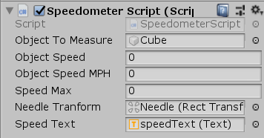

To convert Unity’s movement scale to MPH this formula is used. 1 unity unit being 1m you can take velocity/1000 to find KPS multiply by 60 for minutes then 60 again for hours and then multiply by 0.621371 to get MPH.

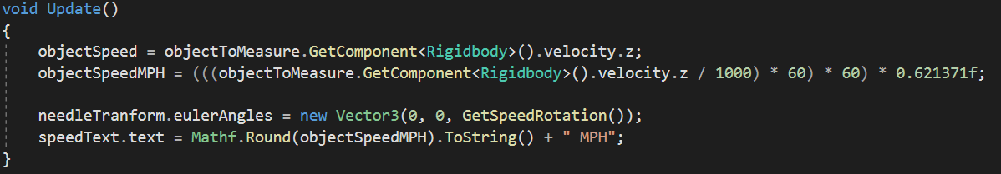

The transform of the needle on the UI is then set based on the speed of the object.

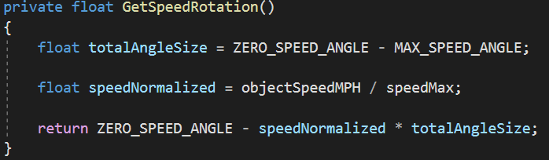

This method returns a float for the rotation of the needle UI element. It takes the pre-set angle of the max speed of the object and subtracts it from the angle at 0 MPH. Then the max speed of the object is divided by the current speed of the object.

The method then returns the normalised speed multiplied by the total angle size variable and subtracts it from the angle when the object is at 0 MPH. this is then applied to the needle UI element.