**SPEEDOMETER BRIEF**

**BY SAMUEL PARSONS**

For the speedometer brief I began by creating a character controller. I first needed three variables which consisted of two floats speed which was the speed of the player which I set to 25f and rotationSpeed which is the speed the player rotated which I set to 50f as well as a reference to the rigidbody of the player.

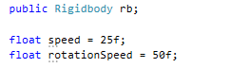

To find the rigidbody of the player I made a function inside the start void which used *.GetComponent* to find the rigidbody from the gameobject the script was attached to.

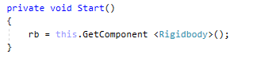

Next I needed to take the players input and convert that to movement. To do this I made two separate floats one for movement and one for rotation. For the movement float I took the players vertical input and multiplied it by the speed float. Similarly for the rotation float I took the horizontal input of the player and multiplied it by the rotationSpeed float. I then multiplied them both by *Time.deltaTime* to give it a gentle increase over time. I then applied that movement float to a *addForce* function to give forward momentum to the player by multiplying it with the forward direction of the player and an integer of 40 which I had to fiddle around with before having a decent feeling speed for the player. Next I used the *addTorque* function to give the player rotation using the rotation float multiplied by the characters upward direction and another integer I messed around with to get a working turn for the player.

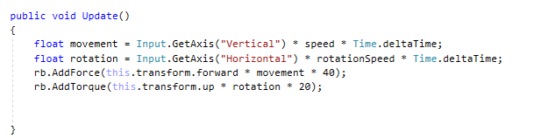

Next I made a cube gameobject in the scene and applied both a rigidbody to it as well as the playerMovement script. I then froze the x and y rotation of the rigidbody so that the drag wont tip the player over when moving. I also then attached the main camera to the player object as a child so that it would follow the player around. I also made a plane which I applied a simple ground texture I found from the internet to.

I then added an image ui element and applied a blank speedometer sprite to it that I found from google. I also made another image ui element that I applied an arrow sprite to that I made in photoshop. These would together make the speedometer visual. I set the arrow as a child of the speedometer and then set the arrow's pivot point to be in the center of the image so that it could rotate around, I also recorded the rotations at which the arrow pointed to 0 and 120 on the image which was 219 and -25.

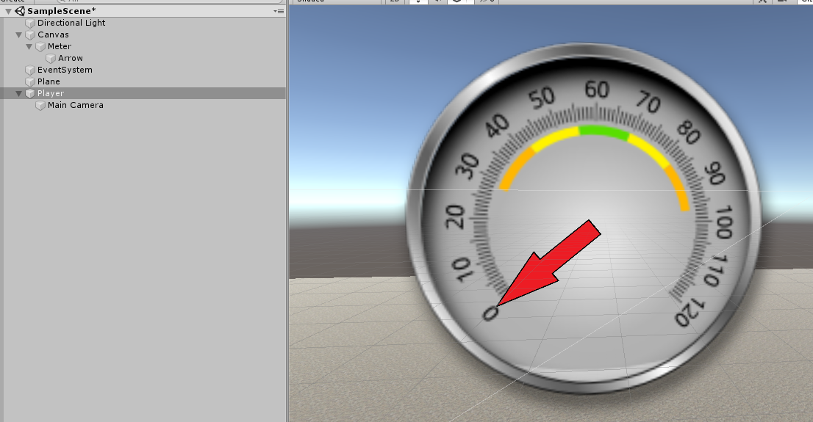

Now with the visual side out of the way I created a script named speedometer which I attached to the ui arrow. Inside the script I created two static floats that recorded the minimum angle of the speedometer and the maximum which I applied their respective values. I also made a reference to the Speedometer code, which I set to be equal to *this* in the start function

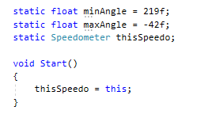

Next I made a static void called ShowSpeed that took 3 arguments( current speed, minimum speed and maximum speed). I then made a float that's value was equal to a linear interpretation of the minimum and maximum angles as well as an inverse linear interpretation of the minimum,maximum and current speeds which all together gives an angle that we can use for our visual arrow to point towards to show how fast the player is moving.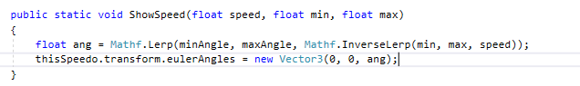

Finally I went back to the PlayerController script and added one final line initiating the ShowSpeed void from the speedometer. This initiation fed the ShowSpeed function the players current velocity as the current movespeed as well as 0 and 100 for the min and max speed.

