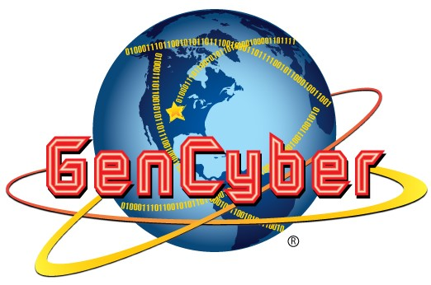

RASPBERRY PI: PYTHON PROGRAMMING

# LESSON

**Lesson Details:**

**Level 1 Coding in Scratch:** Scratch is a great resource for students just starting out coding, as many are unfamiliar with “what” you can do or how “code” fits together. Scratch is web based and available in many different languages.

Using the below flow chart and use the provided blocks together to make the Hen count up after pecking the ground.

*Challenge*: Students who are experienced in Scratch and understand this coding, can alter the code to make the chicken count up by 2’s, or start counting at a different number, or have the sprite in the program move and peck while counting up.

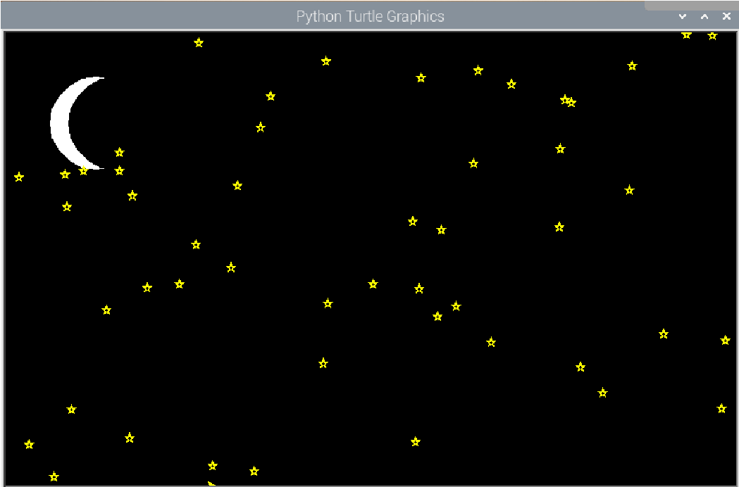**Level 2 Coding in Python Turtle:** Using the StarryNight.py program found in the Thursday github folder, tinker and debug the code until you get a starry night that resembles the picture.

*Challenge*: Try to create stars of different sizes, create a cloud, and to have the moon move across the screen from left to right.

**Level 3 Coding in Python with Minecraft:**

Using the [PythonMinecraft.pdf](https://tinyurl.com/21GenCyberPythonMinecraft)[,](https://drive.google.com/file/d/1nQ4RXcAnFGN6H0Bd2mv9g1NlTWc0xw6T/view?usp=sharing) found in the Github, open Minecraft and build a house in a world. Running programs in Minecraft requires Minecraft to be running for them to be successful.

Following the PDF, try creating a Python script to start building blocks in a world.

*Challenge*: Modify the stackingBlocks.py program to make a city skyline from your favorite city.