OXFORD BULLETIN OF ECONOMICS AND STATISTICS, 72, 1 (2010) 0305-9049

doi:10.1111/j.1468-0084.2009.00567.x

**A Coincident Index, Common Factors, and Monthly Real GDP**Å

Roberto S. Mariano† and Yasutomo Murasawa‡

†*School of Economics, Singapore Management University, Singapore 178903*

*(e-mail: rsmariano@smu.edu.sg)*

‡*School of Economics, Osaka Prefecture University, Sakai, Osaka 599-8531, Japan*

*(e-mail: murasawa@eco.osakafu-u.ac.jp)*

# Abstract

The Stock–Watson coincident index and its subsequent extensions assume a static linear one-factor model for the component indicators. This restrictive assumption is unnecessary if one defines a coincident index as an estimate of monthly real gross domestic products (GDP). This paper estimates Gaussian vector autoregression (VAR) and factor models for latent monthly real GDPand other coincident indicators using the observable mixed-frequency series. For maximum likelihood estimation of a VAR model, the expectation-maximization (EM) algorithm helps in finding a good starting value for a quasi-Newton method. The smoothed estimate of latent monthly real GDP is a natural extension of the Stock–Watson coincident index.

# I. Introduction

Since the seminal work by Stock and Watson (1989, 1991), it has been common in the literature on business cycle indices to assume a static linear one-factor model for coincident indicators, and use the estimated ‘common factor’ as a coincident index;

ÅA former title is ‘Constructing a Coincident Index of Business Cycles Without Assuming a One-Factor

Model’. The authors thank Jonathan Temple (associate editor), an anonymous referee, Hisashi Tanizaki, and

Atsuko Ueda for useful comments; in particular, the comments by the referee were extremely helpful in clarifying the focus of the paper. Murasawa acknowledges partial funding for this research from the research collaboration programme of the School of Economics and Social Sciences (SESS) at Singapore Management University (SMU) and from KAKENHI (16730113, 19530185). This work was also partially done while Murasawa attended the Econometrics Programme in Singapore in 2004, jointly organized and supported by SESS-SMU and the Institute for Mathematical Sciences at the National University of Singapore.

JEL Classification numbers: C32, C43, C82, E32.

27

© Blackwell Publishing Ltd and the Department of Economics, University of Oxford, 2009. Published by Blackwell Publishing Ltd, 9600 Garsington Road, Oxford OX4 2DQ, UK and 350 Main Street, Malden, MA 02148, USA.

for example, Kim and Yoo (1995), Diebold and Rudebusch (1996), Chauvet (1998), KimandNelson(1998),andMarianoandMurasawa(2003).Thisone-factorstructure assumption is often restrictive in practice, however. For instance, Murasawa (2009) tests the autocovariance structure of the four US coincident indicators used in these works, and finds strong evidence against a one-factor structure.

This paper thus proposes a method for constructing a coincident index without assuming a one-factor model. The idea is simple. Many, if not all, will agree that if we observe real gross domestic product (GDP) promptly on a monthly basis, then we do not need a coincident index; that is, a coincident index is a proxy for monthly real GDP. For instance, the NBER Business Cycle Dating Committee writes on its home page (http://www.nber.org/cycles/recessions.html),

The committee views real GDP as the single best measure of aggregate economic activity. *...* The traditional role of the committee is to maintain a monthly chronology, however,andtheBEA’srealGDPestimatesareonlyavailablequarterly.Forthisreason, thecommitteereferstoavarietyofmonthlyindicatorstodeterminethemonthsofpeaks and troughs.

If so, then it is natural to estimate monthly real GDP directly, which does not require a one-factor model. This paper thus unites two separate issues, namely index construction and estimation of monthly real GDP.

Mariano and Murasawa (2003) stress that a business cycle index must have an economic interpretation, because the ‘amplitude’of a cycle depends on the choice of an index. Figure 1 compares the composite index of coincident indicators released by the Conference Board, the Stock–Watson Experimental Coincident Index (XCI) released by themselves on their home page (although they retired their indices in June 2004, the historical values are still available), and seasonally adjusted quarterly real GDPfrom 1979 to 1983, during which there are two peaks and two troughs. The XCI indicates that the trough in November 1982 is deeper than that in July 1980, whereas the CI indicates that the depth of the two are almost equal. In fact, real GDP is *higher* in the fourth quarter of 1982 than in the third quarter of 1980. Such inconsistency can arise because the levels of the two indices have no direct economic interpretation. MarianoandMurasawa(2003)thusincluderealGDPintheone-factormodeltorelate the common factor to monthly real GDP, whereas this paper estimates monthly real GDP directly.

Specifically,weestimateGaussianvectorautoregression(VAR)andfactormodels for latent monthly real GDP and other coincident indicators using the observable mixed-frequency series. Following Mariano and Murasawa (2003), we derive a state-space model for the observable mixed-frequency series, and treat the mixedfrequency series as monthly series with missing observations. Maximum likelihood (ML) estimation of a linear Gaussian state-space model with missing observations is straightforward if we use SsfPack 2.2 by Koopman, Shephard and Doornik (1999) on Ox 3.40 by Doornik (2001). For our US data, Akaike’s information criterion (AIC) selects aVAR model, whereas Schwarz’s Bayesian information criterion (BIC)

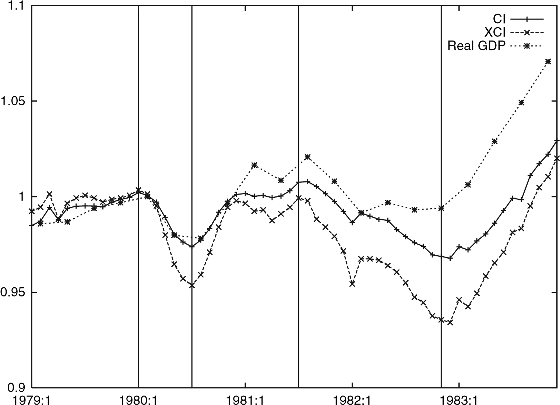

Figure 1. The composite index, the Stock–Watson Experimental Coincident Index, and seasonally adjusted quarterly real gross domestic product, 1979–83 (1980:Q1=1). The vertical lines are the NBER Business Cycle reference dates.The sources are the NBER, James Stock and MarkWatson’s home page, and the Bureau of Economic Analysis

selects a two-factor model. The smoothed estimate of latent monthly real GDP is a natural extension of the Stock–Watson XCI.

In practice, quasi-Newton methods may fail to converge if the model has too many parameters to estimate.The EM algorithm is often useful in such cases. Shumway and Stoffer (1982) derive the EM algorithm for ML estimation of a linear Gaussian statespace model, allowing for missing observations. As the EM algorithm slows down significantly near the maximum, the common wisdom is to switch to a quasi-Newton method at some point, that is, use the EM algorithm to find a good starting value for a quasi-Newton method; see Watson and Engle (1983) and Demos and Sentana (1998). Unfortunately, the EM algorithm does not apply directly to our factor models with mixed-frequency series; hence, we apply it only to VAR models in this paper.

In the literature on estimation of monthly GDP from quarterly GDP, the best linear unbiased interpolation by Chow and Lin (1971) is still most popular, but some authors use state-space models; for example, Bernanke, Gertler and Watson (1997), Cuche and Hess (1999, 2000), and Liu and Hall (2001). They assume univariate linear regression models for monthly GDP without taking the log transformation. This paper considers multivariate models and takes the log transformation, following the convention in the literature on index construction.

We do not (cannot) claim, however, that our estimate of monthly real GDP is better than others. It depends on the true data generation process, and it is unclear how to find the best estimate without observing the true monthly real GDP *ex post*. Such considerations are interesting and important, but beyond the scope of this paper.

This paper proceeds as follows. Section II introduces what we call a mixedfrequency VAR model; that is, we set up a VAR model for partially latent monthly series, and derive a state-space model for the observable mixed-frequency series. We also derive the EM algorithm for MLestimation of such a model. Section III develops a mixed-frequency factor model, and explains why the EM algorithm does not apply in this case. Section IVapplies the method to US data to obtain an estimate of monthly real GDP, which extends the Stock–Watson XCI. Section V discusses the remaining issues.

# II. Mixed-frequency VAR model

## VAR model

Let {***x****t*,1} be an *N*1-variate quarterly series observable every third period, and {***x****t*,2} be an *N*2-variate monthly series observable every period. Let for all *t*, ***x****t* : *t*,1 *t*,2 . Let *N* :=*N*1 +*N*2. Assume that {ln***x****t*}∼*I*(1).

Let be a latent monthly series underlying {***x****t*,1} such that for all *t*,

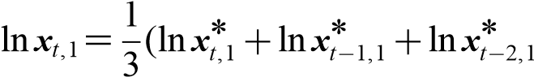), (1)

that is, ***x****t*,1 is the geometric mean of ***x***Å*t*,1, ***x***Å*t*−1,1 and ***x***Å*t*−2,1. Although it would be the arithmetic mean (sum) under the usual accounting identity, Mitchell *et al.* (2005, pp. F115–F116) note that this is a good first-order approximation in this particular case. Alternatively, one can think of as a series defined in such a way. Let for all *t*, ***y****t*,1 :***x****t*,1, ***y***Å*t*,1 :***x***Å*t*,1 and ***y****t*,2 :***x****t*,2. Then for all *t*,

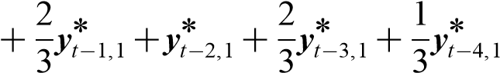***y****t*,1 = 1 Å*.* (2) ***y****t*,1

3

We observe {***y****t*,1} every third period, and never observe. Let for all *t*,

***y****t* :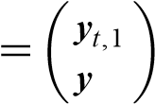, ***y***Å*t 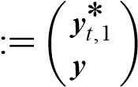. t*,2 *t*,2

Let

***H***(*L*):=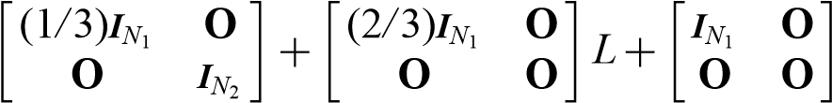 *L*2

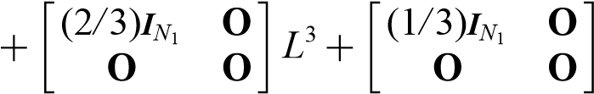 *L*4,

where *L* is the lag operator. Let :=*E*(***y****t*) and Å :=*E*(***y***Å*t* ). Then for all *t*,

 ***y****t* Å Å)*.* (3)

Assume a Gaussian VAR(*p*) model forsuch that for all *t*,

 ***y***Å Å ***w****t*, (4)

*.* (5)

## State-space representation

If *p*≤5, then we define the state vector as:

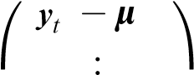Å Å ***s****t* :=*. .*

⎝

***y****t*Å−4 −Å⎠

A state-space representation of the VAR model is:

***s****t* +1 =***As****t* +***Bz****t*, (6)

***y****t* =+***Cs****t*, (7)

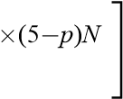 {***z****t*}∼IN(**0**,***I****N* ), (8)

where

*p* **O***N*

***A***:=,

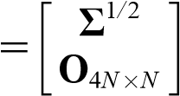 ***I***4*N* **O**4*N*×*N*

***B***:,

***C***:=[***H***0 *...* ***H***4 ]*.*

As {***y****t*} is a mixed-frequency series, it has missing observations.

If *p*≥5, then we define the state vector as:

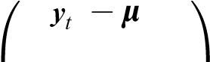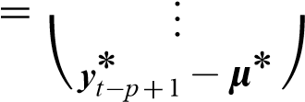 Å Å

***s****t* :*.*

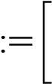A state-space representation of the VAR model is the same except that

*p*−1 *p*

***A***,

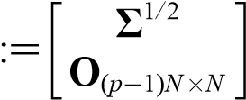 ***I***(*p*−1)*N* **O**(*p*−1)*N*×*N*

***B***,

***C***:=[***H***0 *...* ***H***4 **O***N*×(*p*−5)*N* ]*.*

## ML estimation

*Quasi-Newton methods*

Using SsfPack 2.2 by Koopman *et al.* (1999) on Ox 3.40 by Doornik (2001), ML estimation of a linear Gaussian state-space model by a quasi-Newton method is straightforward, even with missing observations. It may fail to converge with a poor starting value, however, if the model has too many parameters to estimate. The EM algorithm explained next is useful in such cases.

*Missing observations*

Following Mariano and Murasawa (2003), we put zeros for missing observations, and rewrite the measurement equation as if they are random draws from *N*(0,1) independent of the model parameters, so that the Kalman filter ‘skips’missing observations; see also Brockwell and Davis (1991, section 12.3) and Brockwell, Davis and Salehi (1991, section 3.1). Let for all *t*,

|  |  |
| --- | --- |
| ***y***+*t*,1:= ***y****t*,1  *t* | if ***y****t*,1 is observable , otherwise |

where) whose realizations are all zeros. The measurement equation is:

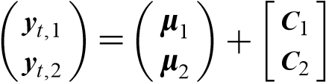 ***s****t.*

We can write for all *t*,

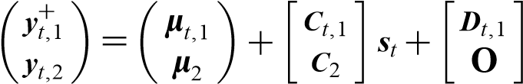 ***v****t*,

where

if

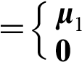*t*,1:***y****t*,1 is observable ,

otherwise

|  |  |
| --- | --- |
| ***C****t*,1:=***C***1  **O** | if ***y****t*,1 is observable , otherwise |
| **O**  ***D****t*,1:=  ***I****N*1 | if ***y****t*,1 is observable  *.*  otherwise |

Let for all *t*,

***y***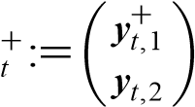, *t* :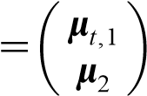, ***C****t*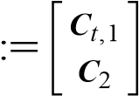, ***D****t* :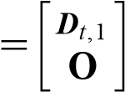*.*

Then we have a time-varying state-space model for {***y***+*t* } such that for all *t*,

***s****t* +1 =***As****t* +***Bz****t*, (9)

|  |  |
| --- | --- |
| ***y***+*t* =*t* +***C****t****s****t* +***D****t****v****t*, | (10) |

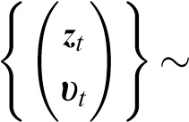IN(**0**,***I****N* +*N*1)*.* (11)

Ashas no missing observations, the Kalman filter and smoother apply directly.

*EM algorithm*

Assume for simplicity that we know Å to be **0**. Let  vec(), and :,vech(). Consider the conditional ML estimator of given ***s***0.

Let ***Y***Å0 :=∅ and for *t* ≥1, ***Y***Å*t* :=[***y***Å1 , *...*,***y****t*Å]. Let for *t* ≥0, ***S****t* :=[***s***0, *...*,***s****t*]. By the prediction error decomposition, the joint probability density function (pdf) of (***Y***Å*T* ,***S****T*) is:

*f* (***Y***Å*T* ,***S****T*;)=*f* (***S****T*;)

*T*

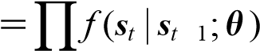−

*t* =1

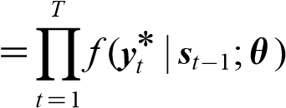*.*

Let

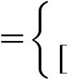 ***F***:[***I****N* **O***N*×4*N* ] if *p*≤5 ,

***I****N* **O***N*×(*p*−1)*N* ] if *p*≥5

***G***:=[***I****pN* **O***pN*×(5−*p*)*N* ] if *p*≥≤5 *.*

***I****pN* if *p* 5

Then for all *t*,

***Fs****t* =***y***Å*t*

***w****t*

***w****t*

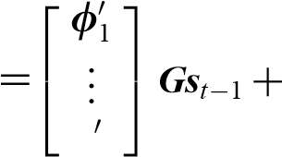***w****t*

*N*

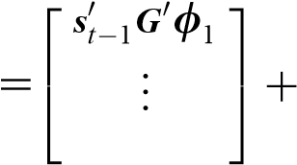***w****t*

***s****t*−1***G*** *N*

*.*

The complete-data log-likelihood function of given (***Y***Å*T* ,***S****T*) is:

`(;***Y***Å*T* ,***S****T*)

*T*

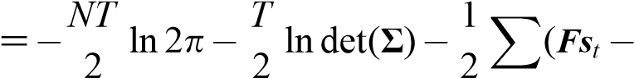 ***Gs****t****Gs****t*−1)

*t* =1

*.*

The score function of given (***Y***Å*T* ,***S****T*) consists of

`(;***Y***Å*T* ,***S****T*)

*T*

− − −

*t* =1

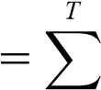*t*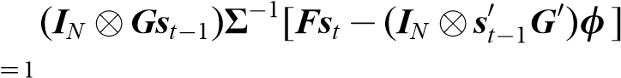

*T*

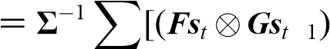*t* 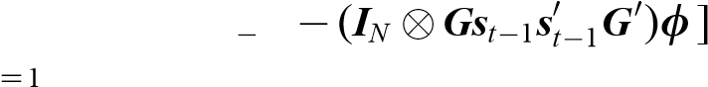

=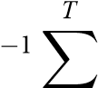vec(***Gs****t*),

*t* =1

`−1(;***Y***Å*T* ,***S****T*)

*T*

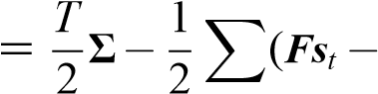***Gs****t*−1)(***Fs****t* −***Gs****t*

*t* =1 *T*

*T* 

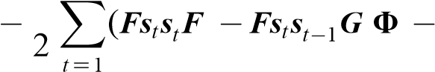= 2 ***Gs****t****Gs****t.*

Let ***Y***+0 :=∅ and for *t*]. Let for all *r*,*s*, for *t* ≥0,

***s****r*),

***P****r*),

***P****r*,*s*|*t* :=cov(***s****r*,*.*

Let for all *r*,*s*,

*T*

***M****r*,*s*: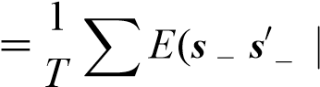  *t r t s* ***Y***+*T* )

*t* =1

*T*

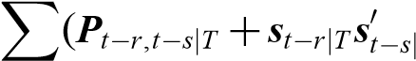  *T*)*.*

*T*

*t* =1

Taking the conditional expectation of the likelihood equation given ***Y***+*T* ,

***GM***1,0***F*****O**,

ÅÅ***GM***1,0***F*** +Å***GM*****O**,

or

 Å = (***GM***1,1***G*** )− ***GM***1,0***F***, (12)

Å=***FM******GM****.* (13)

The EM algorithm proceeds as follows:

1. Choose a starting value (0).
2. (E-step) Compute {***s****t*|*T*Å},,{Å***P***)*t*|, and use it as*T* }, and {***P****t*,*t*−1|*T*(1)}..
3. (M-step) Compute (
4. Iterate until convergence.

See theAppendix for the smoothing algorithm.As the EM algorithm slows down significantly near the maximum, it is better to switch to a quasi-Newton method at some point; that is, use the EM algorithm to find a good starting value for a quasi-Newton method. The smoothing algorithm gives {*E*(***y***Å*t*,1 |***Y***, the smoothed estimate of the latent monthly series underlying the quarterly series.

# III. Mixed-frequency factor model

## Factor model

Assume a *K*-factor model for, where *K<N*, such that for all *t*,

***y***Å*t* =Å***u****t*, (14)

|  |  |
| --- | --- |
| *f* (*L*)***f****t* =*t*, | (15) |
| *u*(*L*)***u****t* = ***w****t*, | (16) |

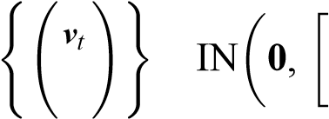 ∼ *vv* **O** , (17)

***w****t* **O** *ww*

where *f* (·) is the *p*th-order polynomial on R*K*×*K* and *u*(·) is the *q*th-order polynomial on R*N*×*N* . For identification, assume that (i) :=[***I****K*, ] , and (ii) *u*(·) and *ww* are diagonal.

## State-space representation

Assume that *p*,*q*≤5. Let for all *t*,

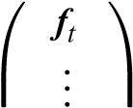

***f***

***s****t* :=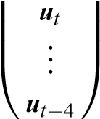⎜⎜⎜ *t*−4 ⎟⎟⎟*.*

A state-space representation of the factor model is for all *t*,

***s****t* +1 =***As****t* +***Bz****t*, (18) ***y****t* =+***Cs****t*, (19)

{***z****t*}∼IN(**0**,***I****K* +*N* ), (20)

|  |  |  |  |  |  |
| --- | --- | --- | --- | --- | --- |
| where |  |  |  |  |  |
| *f* ,1  ***A***:=⎡  ⎢⎣ | *... f* ,*p*  ***I***4*K*  **O**5*N*×5*K* | **O***K*×(5−*p*)*K*  **O**4*K*×*K* | *u*,1 | *...*  ***I***4*N* | **O**5*K*×5*N* ⎤  *u*,*q* **O***N*×(5−*q*)*N* ⎥⎦  **O**4*N*×*N* |

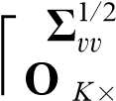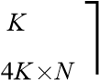**O** ×*N*

⎢

4 *K* **O**

***B***:=1*/*2 ,

**O***N*×*K* 4*Nww* ⎥⎦

⎣**O**4*N*×*K* **O** ×*N*

***C*** ***H***0 *...* ***H***4 ]*.*

As {***y****t*} is a mixed-frequency series, it has missing observations.

## ML estimation

If the measurement equation has unknown parameters but has no error term, then these parameters do not appear in the complete-data likelihood function, and the EM algorithm does not apply. Ruud (1991, p. 310) writes,

the transformation from latent to observable data cannot depend on parameters to be estimated in such a way that the support of *y*Å conditional on *y* depends on .

Watson and Engle (1983, p. 397) give an alternative state-space representation of a factor model to apply the EM algorithm, but their representation does not hold with mixed-frequency series. Hence, we use an *ad hoc* starting value for a quasi-Newton method.

Given the parameters, we have for *t* = 1, *...*,*T*,

*E**.* (21)

The smoothing algorithm gives. Thus one can obtain

{*E*(***y***Å*t*,1 |***Y***, the smoothed estimate of the latent monthly series underlying the quarterly series.

# IV. Application

## Data

We apply the aforedescribed method to US coincident indicators to construct a new coincident index, or an estimate of monthly real GDP. The component indicators are quarterly real GDP and the four monthly coincident indicators that make up the CI currently released by the Conference Board; see Table 1 for their descriptions. The sample period is from January 1959 to December 2002.

To make the series *I*(0), we take the first difference of the natural log of each series and multiply it by 100, which is approximately equal to the quarterly or monthly percentage growth rate series. Table 2 gives summary statistics of the ‘growth rate’ series.

## VAR coincident index

We take two shortcuts in the estimation of our state-space models, both of which are common and useful in practice. First, we ‘demean’the series, and delete the constant term from the model. This reduces the number of the parameters by *N*. Second, we use an approximate ML estimator instead of the exact one regarding the initial state for the Kalman filter, that is, we assume that ***s***0 :=**0**. This avoids inversion of a large matrix, saving the computational cost further. Recall that without missing observations, one usually estimates a VAR model by applying ordinary least squares to the ‘demeaned’ series. We take similar shortcuts here.

One must select *p*, the order of the VAR model. The two common model selection criteria areAIC and BIC, but the correctedAIC (AICc) is preferable toAIC whenever available. Hurvich and Tsai (1993) derive AICc for Gaussian VAR models. For our model,

### TABLE 1

*US coincident indicators*

|  |  |
| --- | --- |
| *Indicator* | *Description* |
| Quarterly  GDP | Real GDP (billions of chained 2,000 dollars, SA, AR) |
| Monthly  EMP | Employees on non-agricultural payrolls (thousands, SA) |
| INC | Personal income less transfer payments (billions of chained 1996 dollars, SA, AR) |
| IIP  SLS | Index of industrial production (1997=100, SA)  Manufacturing and trade sales (millions of chained 1996 dollars, SA) |

*Notes*:SAmeans‘seasonallyadjusted’,ARmeans‘annualrate’andGDPindicates‘grossdomesticproduct’.

### TABLE 2

*Summary statistics*

|  |  |  |  |  |
| --- | --- | --- | --- | --- |
| *Indicator* | *Mean* | *SD* | *Minimum* | *Maximum* |
| Quarterly  GDP | 0.82 | 0.88 | −2.04 | 3.86 |
| Monthly  EMP | 0.17 | 0.23 |  |  |
| INC | 0.27 | 0.56 |  |  |
| IIP | 0.26 | 0.83 |  |  |
| SLS | 0.27 | 1.05 |  |  |

*Notes*: Statistics are for the first difference of the natural log times 100.

GDP, gross domestic product; EMP, employees; INC, income; IIP, index of industrial production; SLS, sales.

AIC:=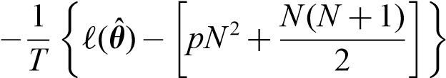,

AICc:= ,

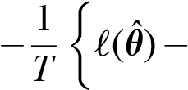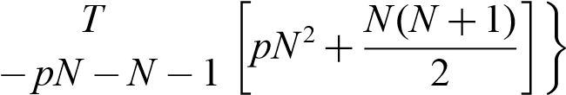*T*

BIC:=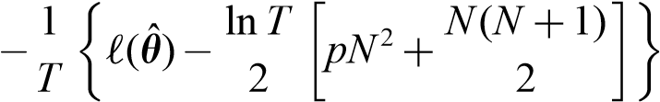 ,

where ˆ is the (approximate) ML estimator of .

We estimate the mixed-frequency VAR model and compute AIC, AICc, and BIC for *p*=1, *...*,12. As a quasi-Newton method from an *ad hoc* starting value may fail to converge when *p* is large, we estimate the model in two steps:

1. Apply the EM algorithm to obtain a preliminary ML estimate.
2. Using this as the starting value, apply a quasi-Newton method (Broyden– Fletcher–Goldfarb–Shanno algorithm) to obtain the final ML estimate.

We use Ox 3.40 with SsfPack 2.2 for computation.

Table 3 summarizes the results of model selection. We see that AIC selects

VAR(10),AICc selects VAR(8), and BIC selects VAR(1). Typically, one usesAIC(c) for optimal one-step ahead prediction and BIC for consistent model selection, but it is unclear which is better for optimal interpolation. A consistent model selection criterion may be preferable, but the level 0.05 likelihood ratio (LR) test rejects VAR(1) against VAR(2), whereas it does not reject VAR(8) against VAR(9). Hence, we try both VAR(1) and VAR(8).

The smoothing algorithm gives the smoothed estimate of the ‘demeaned’growth rate series of monthly real GDP. We transform it to the level series as follows:

1. Add the mean growth rate of monthly real GDP (the mean growth rate of quarterly real GDP divided by 3), and divide the series by 100.
2. Take the cumulative sum; then take the exponential transformation.

### TABLE 3

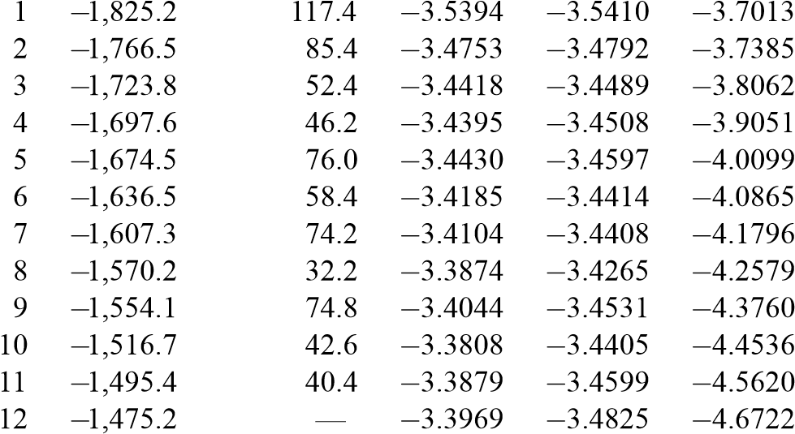*Model selection (VAR model)*

*p*

*Log-likelihood*

*LR*

*AIC*

*AICc*

*BIC*

*Notes*:ThenulldistributionoftheLRteststatisticfortestingVAR(*p*) against VAR(*p*+1) is *χ*2(25); the 5% critical value is 37.6525.

VAR,Vectorautoregression;LR,likelihoodratio;AIC,Akaikeinformation criterion; AICc, Corrected AIC; BIC, Bayesian information criterion.

We call the resulting series the *VAR*(*p*) *coincident index*.

Figure 2 plots the VAR(1) and VAR(8) coincident indices. The former captures the NBER Business Cycle reference dates fairly well; the latter is occasionally too volatile, perhaps because it involves too many parameters. Hence, the former is preferable.

## *K*-factor coincident index

A factor model may predict monthly real GDP better than VAR models with fewer parameters. AIC and BIC for a *K*-factor model are:

AIC:=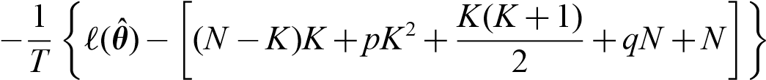,

BIC:=*.*

AICc for factor models does not seem available in the literature.

As the EM algorithm does not apply directly to mixed-frequency factor models, we use an *ad hoc* starting value for a quasi-Newton method. We find that numerical singularity tends to occur as *K* increases, which may be an identification problem as well as a numerical problem; hence, we consider only up to *K* =2.

We find that AIC selects (*K*,*p*,*q*)=(2,1,3) and BIC selects (*K*,*p*,*q*)=(2,1,1); hencetheone-factormodelinMarianoandMurasawa(2003)isinadequate.Wefollow BIC here, preferring the simpler model. Among all the VAR and factor models considered, AIC selects VAR(10), whereas BIC selects this two-factor model.

VAR(1)

1

1.5

2

2.5

3

3.5

4

4.5

2000:1

1990:1

1980:1

1970:1

1960:1

1

1.5

2

2.5

3

3.5

4

4.5

2000:1

1990:1

1980:1

1970:1

1960:1

VAR(8)

Figure 2. Historical plots of theVAR coincident indices (1959:M1Business Cycle reference dates =1).The vertical lines are the NBER

The factor model gives two types of coincident indices: the smoothed estimate of monthlyrealGDP,whichwecallthe*K-factorcoincidentindex*,anditscommonfactor

component (or simply the first common factor, as 1,1 =1 and

Mariano and Murasawa (2003) assume a one-factor model, and propose the latter as an extension of the Stock–Watson XCI.

Figure 3 plots the two-factor coincident index and its common factor component.

Although both capture the NBER Business Cycle reference dates, sometimes the levelsofthetwoindicesdiffersubstantially.Thisreflectsthespecificfactorinmonthly real GDP.

## Comparison

We have three candidate coincident indices:

1. smoothed estimate of monthly real GDP based on the VAR model (VAR coincident index)
2. smoothed estimate of monthly real GDP based on the two-factor model

(two-factor coincident index)

1. smoothed estimate of the common factor component of monthly real GDP in the two-factor model.

1

1.5

2

2.5

3

3.5

4

4.5

2000:1

1990:1

1980:1

1970:1

1960:1

factor

2-

Common factor

Figure 3. Historical plots of the two-factor coincident index and its common factor component (1959:M1=1). The vertical lines are the NBER Business Cycle reference dates

Figure 4 plots these indices from 1979 to 1983, together with the monthly real GDP index based on the Chow–Lin method (CHOWLIN procedure in RATS 6.2, which assumes random walk errors). We observe the following:

1. The three estimates of monthly real GDP are close to each other and to quarterly real GDP in Figure 1.
2. The VAR and two-factor coincident indices are sometimes volatile.
3. The common factor component is smooth, but differs from the other indices substantially.

Turning points in monthly real GDPand its common factor component may differ, because the latter excludes the specific factor in real GDP. For instance, monthly real GDP indicates that the ‘dip’ in January 1982 is deeper than the trough in November 1982, whereas the common factor component indicates the opposite. This occurs because although quarterly real GDP increased, all the four monthly coincident indicators decreased between the two months. Hence, if real GDP is the single best measure of aggregate economic activity, then one should not exclude its specific factor.

The ‘zig-zagging’behaviour of the two-factor coincident index indicates that the specific factor in monthly real GDPhas a negative serial correlation. This is common

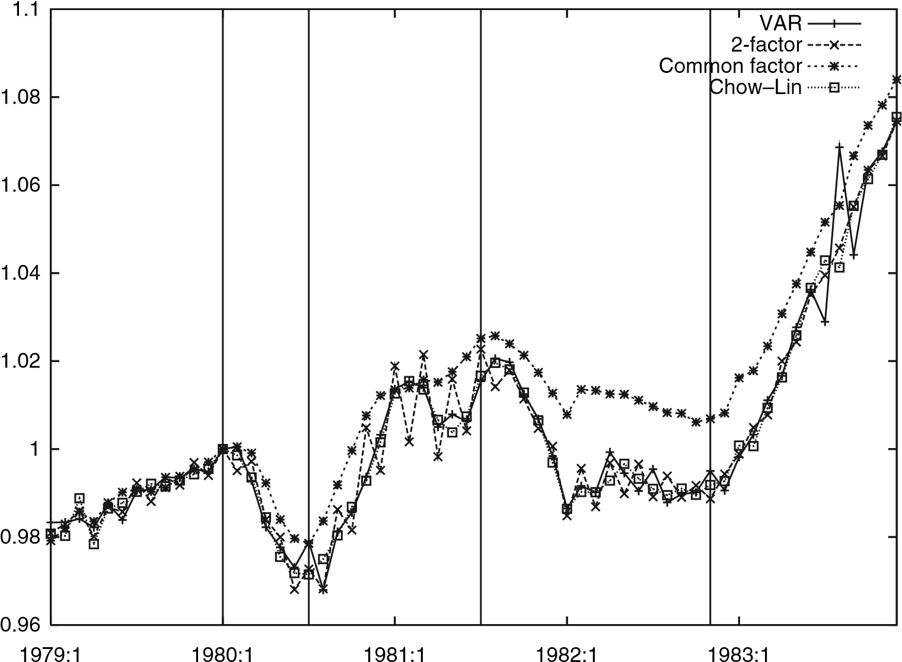

Figure 4. Comparison of alternative coincident indices, 1979–83 (1980:M1the NBER Business Cycle reference dates =1). The vertical lines are

not only for real GDP but also for some other indicators as well; cf. Stock and Watson (1989, 1991), Kim andYoo (1995), Chauvet (1998), Kim and Nelson (1998), and Mariano and Murasawa (2003). Following Litterman (1983, p.172), the default CHOWLIN procedure in RATS assumes away negative serial correlations in the error terms. This explains why the Chow–Lin method gives a ‘smooth’ estimate.

The best method for estimating monthly real GDP depends on the true data generation process, which may differ across countries. Moreover, one cannot find the best method without observing the true monthly real GDP *ex post*. Hence we do not (cannot) claim that our method is better than the Chow–Lin method, or vice versa. We simply suggest to look at monthly real GDP instead of the common factor when measuring business cycles.

# V. Discussion

The NBER Business Cycle Dating Committee views real GDP as the single best measure of aggregate economic activity. If so, then index construction is simply estimation or prediction of monthly real GDP, and various models are available for that purpose. This paper tries VAR and factor models. For factor models, one should not exclude the specific factor in real GDP.

In practice, ML estimation of a mixed-frequency factor model is difficult when therearetoomanyparameterstoestimate,astheEMalgorithmdoesnotapplydirectly. One solution is to extract major principal components from quarterly and monthly indicatorsrespectively,andestimateamixed-frequencyVARmodelforquarterlyreal GDPand these principal components.Another solution is to apply Bayesian methods, perhaps using simulation.

The means for dating the turning points in the estimated monthly real GDP is controversial. The dating algorithm by Bry and Boschan (1971) is most popular. An alternative is to fit a Markov-switching model to the estimated monthly real GDP; see Hamilton (1989). Harding and Pagan (2003) compare the two dating methods, and criticize the latter.

One can extend this paper in several ways. First, to construct leading and lagging indices, define them as, say, six-month ahead and behind forecasts of monthly real GDP respectively, and apply the same method using appropriate indicators. Second, other models may predict monthly real GDP better with fewer parameters, and hence are worth trying; for example, univariate regression models (extensions of the Chow– Lin method), vector autoregressive moving average (VARMA) models, dynamic factor models, more general latent variable models, Markov switching models, cointegration, etc. Third, to exploit information in the various indicators available, one can extract major principal components from the indicators, and consider a VAR model for latent monthly real GDPand the principal components; see Stock and Watson (2002a,b). Fourth, it seems useful to predict monthly real GDP from the three sides (production, distribution and expenditure) separately, and combine the three forecasts. Fifth, our framework has other applications; for example, estimation of monthly impulse response functions using mixed-frequency series seems interesting.

*Final Manuscript Received: June 2009*

# References

Bernanke, B. S., Gertler, M. and Watson, M. W. (1997). ‘Systematic monetary policy and the effects of oil price shocks’, *Brookings Papers on Economic Activity*, Vol. 1997, pp. 91–157.

Brockwell, P. J. and Davis, R. A. (1991). *Time Series: Theory and Methods*, 2nd edn, Springer-Verlag, New York.

Brockwell, P. J., Davis, R. A. and Salehi, H. (1991). ‘A state-space approach to transfer-function modeling’, in Prabhu N. U. and Basawa I. V. (eds), *Statistical Inference in Stochastic Processes*, Marcel Dekker, New York, pp. 233–247.

Bry, G. and Boschan, C. (1971). *Cyclical Analysis of Time Series: Selected Procedures and Computer Programs*, Technical Paper 20, National Bureau of Economic Research.

Chauvet, M. (1998). ‘An econometric characterization of business cycle dynamics with factor structure and regime switching’, *International Economic Review*, Vol. 39, pp. 969–996.

Chow, G. C. and Lin, A. (1971). ‘Best linear unbiased interpolation, distribution, and extrapolation of time series by related series’, *Review of Economics and Statistics*, Vol. 53, pp. 372–375.

Cuche, N. A. and Hess, M. K. (1999). ‘A monthly time series of Swiss GDP: business cycle indicator and research tool’, Unpublished.

Cuche, N. A. and Hess, M. K. (2000). ‘Estimating monthly GDP in a general Kalman filter framework: evidence from Switzerland’, *Economic & Financial Modelling*, Vol. 7, pp. 153–194.

Demos, A. and Sentana, E. (1998). ‘An EM algorithm for conditionally heteroskedastic factor models’, *Journal of Business & Economic Statistics*, Vol. 16, pp. 357–361.

Diebold, F. X. and Rudebusch, G. D. (1996). ‘Measuring business cycles: a modern perspective’, *Review of Economics and Statistics*, Vol. 78, pp. 67–77.

Doornik, J. A. (2001). *Ox: An Object-Oriented Matrix Language*, 4th edn, Timberlake Consultants, London.

Durbin, J. and Koopman, S. J. (2001). *Time Series Analysis by State Space Methods*, Oxford University Press, Oxford.

Hamilton, J. D. (1989). ‘A new approach to the economic analysis of nonstationary time series and the business cycle’, *Econometrica*, Vol. 57, pp. 357–384.

Hamilton, J. D. (1994). *Time Series Analysis*, Princeton University Press, Princeton.

Harding, D. and Pagan, A. (2003). ‘A comparison of two business cycle dating methods’, *Journal of Economic Dynamics and Control*, Vol. 27, pp. 1681–1690.

Hurvich, C. M. and Tsai, C.-L. (1993). ‘AcorrectedAkaike information criterion for vector autoregressive model selection’, *Journal of Time Series Analysis*, Vol. 14, pp. 271–279.

de Jong, P. (1989). ‘Smoothing and interpolation with the state-space model’, *Journal of the American Statistical Association*, Vol. 84, pp. 1085–1088.

de Jong, P. and MacKinnon, M. J. (1988). ‘Covariances for smoothed estimates in state space models’, *Biometrika*, Vol. 75, pp. 601–602.

Kim, C.-J. and Nelson, C. R. (1998). ‘Business cycle turning points, a new coincident index, and tests of duration dependence based on a dynamic factor model with regime switching’, *Review of Economics and Statistics*, Vol. 80, pp. 188–201.

Kim, M.-J. andYoo, J.-S. (1995). ‘New index of coincident indicators: a multivariate Markov switching factor model approach’, *Journal of Monetary Economics*, Vol. 36, pp. 607–630.

Koopman, S. J., Shephard, N. and Doornik, J.A. (1999). ‘Statistical algorithms for models in state space using SsfPack 2.2’, *Econometrics Journal*, Vol. 2, pp. 107–160.

Litterman, R. B. (1983). ‘A random walk, Markov model for the distribution of time series’, *Journal of Business & Economic Statistics*, Vol. 1, pp. 169–173.

Liu, H. and Hall, S. G. (2001). ‘Creating high-frequency national accounts with state-space modelling: a Monte Carlo experiment’, *Journal of Forecasting*, Vol. 20, pp. 441–449.

Mariano, R. S. and Murasawa, Y. (2003). ‘Anew coincident index of business cycles based on monthly and quarterly series’, *Journal of Applied Econometrics*, Vol. 18, pp. 427–443.

Mitchell, J., Smith, R. J., Weale, M. R., Wright, S. and Salazar, E. L. (2005). ‘An indicator of monthly GDP and an early estimate of quarterly GDP growth’, *Economic Journal*, Vol. 115, pp. F108–F129.

Murasawa, Y. (2009). ‘Do coincident indicators have one-factor structure?’ *Empirical Economics*, Vol. 36, pp. 339–365.

Ruud, P. A. (1991). ‘Extensions of estimation methods using the EM algorithm’, *Journal of Econometrics*, Vol. 49, pp. 305–341.

Shumway, R. H. and Stoffer, D. S. (1982). ‘An approach to time series smoothing and forecasting using the EM algorithm’, *Journal of Time Series Analysis*, Vol. 3, pp. 253–265.

Stock, J. H. and Watson, M. W. (1989). ‘New indexes of coincident and leading economic indicators’, *NBER Macroeconomics Annual*, Vol. 4, pp. 351–409.

Stock, J. H. and Watson, M. W. (1991). ‘A probability model of the coincident economic indicators’, in Lahiri K. and Moore G. H. (eds), *Leading Economic Indicators*, Cambridge University Press, Cambridge, pp. 63–89.

Stock, J. H. and Watson, M. W. (2002a). ‘Forecasting using principal components from a large number of predictors’, *Journal of the American Statistical Association*, Vol. 97, pp. 1167–1179.

Stock, J. H. and Watson, M. W. (2002b). ‘Macroeconomic forecasting using diffusion indexes’, *Journal of Business & Economic Statistics*, Vol. 20, pp. 147–162.

Watson, M. W. and Engle, R. F. (1983). ‘Alternative algorithms for the estimation of dynamic factor, MIMIC and varying coefficient regression models’, *JournalofEconometrics*,Vol. 23, pp. 385– 400.

# Appendix: Kalman filtering and smoothing

## Initial state

To start the Kalman filter, one must specify ***s***1|0 and ***P***1|0. Given the stationarity, we have

***s***1|0 =**0**, vec(***P***1|0)=(***I****M*2 −***A***⊗***A***)−1vec(***BB***),

where *M* is the dimension of the state vector; see Hamilton (1994, p. 378). The second equation involves inversion of a potentially large matrix, which can cause a computational problem. Hence we instead assume that ***s***0 :=**0**, which implies that

***s***1|0 =**0**,

***P****.*

The resulting estimator is asymptotically equivalent to the exact ML estimator.

## Updating

We have for *t* ≥1,

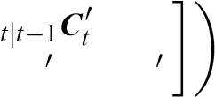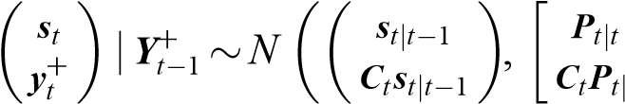−1 ***P****. t*−1 ***C****t****P****t*|*t*−1***C****t* +***D****t****D****t*

The updating equations are for *t* ≥1,

***s***

= ***s****t*|*t*−1 +***K****t****e****t*, (A1)

***P***

=(***I****M* −***K****t****C****t*)***P****t*|*t*−1, (A2)

where

***K****t* :, ***e****t* :*.*

## Prediction

The prediction equations are for *t* ≥1,

***s****t* +1|*t* = ***As****t*|*t*, (A3)

***P****.* (A4)

## Fixed-interval smoothing

The following algorithm by de Jong (1989) avoids inversion of large matrices, and hence is more efficient than the standard smoothing equations; see also Durbin and Koopman (2001, section 4.3). Let ***r****T* +1:=**0**, ***R****T* +1:=**O**, and for *t* =*T*, *...*,1,

***r****t* ,

***R****t* ***L****t*,

where

***L****t* :=***A***(***I****M* −***K****t****C****t*)*.*

The smoothing equations are for *t* = 1, *...*,*T*,

***s****t*|*T* = ***s****t*|*t*−1 +***P****t*|*t*−1***r****t*, (A5)

***P****t*|*T* = ***P****t*|*t*−1 −***P****t*|*t*−1***R****t****P****t*|*t*−1*.* (A6)

The EM algorithm for ML estimation of a linear Gaussian state-space model also requires {***P****t*,*t*−1|*T* }. de Jong and MacKinnon (1988) show that for *s*=1, *...*,*T* −1, for *t* =1, *...*,*T* −*s*,

***P****t* +*s*,*t*|*T* = (***I****M* −***P****t* +*s*|*t* +*s*−1***R****t* +*s*)***L****t* +*s*−1 *...****L****t****P****t*|*t*−1*.* (A7)

In particular, for *t* = 1, *...*,*T* −1,

***P****t* +1,*t*|*T* =(***I****M* −***P****t* +1|*t****R****t* +1)***L****t****P****t*|*t*−1*.* (A8)