服装设计文本完整评分报告
本文档汇总两份 Look 文本评估结果，各报告独立成节。

逆解析样例完整评分报告
被评文本
A layered runway look centered on a long, open-front statement coat with a bulky, tactile surface of repeated horizontal chevron-like waves in golden beige, cream, and dark flecks, creating a shaggy fringed texture from shoulder to below the visible frame. The coat has a wide, turned collar and front edges outlined with small red and dark trim, and it hangs straight and generously around the body, framing the outfit underneath. Beneath it is a black, tailored-looking layer with broad lapel-like panels falling open at the chest, creating a deep V neckline and exposing an asymmetric striped garment below. The inner striped piece uses bold vertical and diagonal bands in red, white, black, green, and orange, with a sharp, graphic composition that runs down the torso and continues into the lower visible area; a small dark belt or tab detail crosses near the waist. The silhouette is elongated and layered, with the voluminous textured outer coat contrasting against the flatter, graphic, close-to-body striped underlayer. Styling includes large decorative drop earrings with dark and red accents, hair pulled back, and a polished runway mood with maximal texture and color blocking.

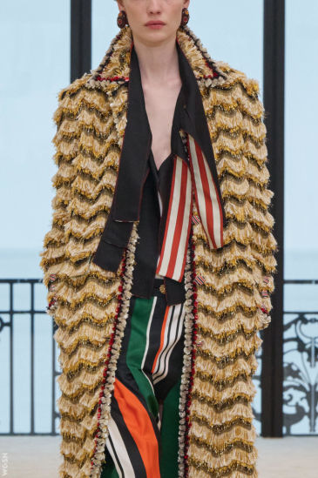

- Judge model：gpt-5.4-mini

总览
- 覆盖轴 C：0.9412
- 质量轴（加权 Q_w）：0.8125
- 内容主分 s_fp_base：0.8382
- 最终 S_fp：0.8387 (Strong)
- 惩罚综合 P̄：0.1

门限
- Score gate：0.8387 / 0.7 → PASS
- Penalty gate：0.1 / 0.5 → PASS
- 双门限：True

S_fp 计算
- s_fp_base：0.8382
- S_fp：0.8387

覆盖轴
轴权重 0.2；问题：有没有。衡量文本是否覆盖服装主体、材质颜色、结构细节和造型关系等核心信息。每项命中 1 分、未命中 0 分，只对适用指标取平均。

模块分
维度｜适用｜命中｜模块分 — 维度：评估模块；适用：该模块下参与计分的指标数；命中：判定为「是」的指标数；模块分：该模块得分。
- 服装主体：适用 4，命中 4，模块分 1.0
- 材质颜色：适用 6，命中 5，模块分 0.8333
- 结构细节：适用 1，命中 1，模块分 1.0
- 造型配件：适用 3，命中 3，模块分 1.0
- 造型关系：适用 3，命中 3，模块分 1.0

覆盖项
指标｜得分｜命中｜说明 — 指标：具体评估项；得分：1 分命中 / 0 分未命中；命中：文本是否覆盖该指标；说明：判定理由。

服装主体
- 服装品类：1.0，是 — The text clearly names the main garment categories and layered pieces.
- 廓形：1.0，是 — Overall shape and structural contour are explicitly described.
- 长度/下摆：1.0，是 — The description gives clear length/extent information for the coat and inner layer.
- 裸露/包裹：1.0，是 — The text clearly describes body reveal and coverage through the deep V opening.

材质颜色
- 材质类别：0.0，否 — The text describes texture and surface character, but not a clear material family such as wool, leather, silk, denim, etc.
- 表面性质：1.0，是 — Surface qualities are clearly described, including tactile/shaggy texture and a straight, generous drape.
- 主色：1.0，是 — The dominant outer coat reads as golden beige/cream, with black also strongly present in the layered look.
- 副色：1.0，是 — Secondary colors are clearly present through trim and the striped underlayer, with visible contrast against the outer coat.
- 配色逻辑：1.0，是 — The text explains the color logic as a contrast between a muted textured outer coat and a vivid multicolor striped underlayer.
- 图案：1.0，是 — Pattern types are explicitly identified as chevron-like waves and striped bands.

结构细节
- 功能细节：1.0，是 — A functional waist detail is explicitly mentioned and is visually salient.

造型配件
- 首饰：1.0，是 — Salient earrings/body ornament are explicitly described.
- 腰带/腰胯附件：1.0，是 — A visible waist-crossing belt/tab detail is explicitly mentioned.
- 叠搭层次：1.0，是 — The text clearly reconstructs the layered order from outer coat to inner layers and waist detail.

造型关系
- 上下比例：1.0，是 — The text clearly describes overall vertical proportion and silhouette balance, with a long outer coat and elongated layered look.
- 不对称：1.0，是 — Asymmetry is explicitly stated.
- 跨单品区分：1.0，是 — The description clearly distinguishes attributes across multiple garments and layers, keeping coat, black layer, and striped inner piece separate.

质量轴
轴权重 0.8；问题：好不好。衡量文本是否具体、准确、清晰、具备设计价值，并适合直接用于图像生成。各指标五档计分（0 / 0.25 / 0.5 / 0.75 / 1.0），模块分 = 适用指标算术平均。

模块分
维度｜适用｜命中｜模块分 — 维度：评估模块；适用：该模块下参与计分的指标数；命中：判定为「是」的指标数；模块分：该模块得分。
- 设计价值：适用 5，命中 5，模块分 0.85
- 可见性优先级：适用 1，命中 1，模块分 0.75
- 生成适配：适用 2，命中 2，模块分 0.75
- 属性绑定：适用 2，命中 2，模块分 0.75
- 语言清晰：适用 1，命中 1，模块分 1.0
- 结构清晰：适用 2，命中 2，模块分 0.75

质量项
指标｜得分｜命中｜说明 — 指标：具体评估项；得分：五档分（0 / 0.25 / 0.5 / 0.75 / 1.0）；命中：是否达到该指标要求；说明：判定理由。

设计价值
- 设计独特性：0.75，是 — The look has a clear non-formula memory point in the shaggy chevron-textured coat plus the graphic multicolor striped underlayer.
- 视觉观察锚定：1.0，是 — The description is strongly anchored in visible garment parts, layering, and placement, with precise body-zone observations.
- 工艺装饰显著度：0.75，是 — Craft and surface treatment are clearly described with type and location, though the functional visual role is implied more than explicitly analyzed.
- 组合原创性：0.75，是 — The layered silhouette is distinctive and less formulaic than a standard resort template, though it still uses familiar coat-over-tailored-layer structure.
- 设计信号纯度：1.0，是 — The text is dominated by concrete design facts, materials, structure, color, and placement, with only minimal mood framing.

可见性优先级
- 可见性优先级：0.75，是 — The description keeps the visible outfit structure, layers, colors, and accessories in focus. There is some interpretive framing like “runway mood,” but it is brief and does not overpower the garment

生成适配
- 生图提示词适配：0.75，是 — The description is highly visual, garment-centered, and mostly prompt-ready, with clear silhouette, layering, materials, and color logic. It is still somewhat explanatory and stylistically interpretiv
- 空间关系：0.75，是 — The layering and inside-outside relationships are clearly described and visually reconstructable. Minor ambiguity remains in the exact attachment/termination of some lower details, but overall the spa

属性绑定
- 属性实体绑定：0.75，是 — Most attributes are bound to the correct garment layers, and the waist detail is explicitly framed as a small belt/tab. Minor ambiguity remains around the black tailored layer versus the striped inner
- 多单品绑定：0.75，是 — The text keeps most attributes attached to the correct item across multiple layers: coat, black layer, striped underlayer, and accessories. There is slight cross-layer complexity in the chest/waist ar

语言清晰
- 指代清晰度：1.0，是 — References are consistently anchored to clear garment subjects, and pronouns like "it" and "the inner striped piece" are easy to resolve without ambiguity.

结构清晰
- 信息顺序：0.75，是 — Overall follows a clear trunk-to-details progression: outer coat, then inner layers, then accessories. Minor compression and some material/color detail are embedded within the garment descriptions, bu
- 层级单品聚合：0.75，是 — The outer coat, middle black layer, and inner striped piece are mostly grouped by layer, so garment identity is usually clear. There is slight cross-layer interleaving in the waist detail and contrast

惩罚项
惩罚项｜得分｜说明 — 惩罚项：惩罚维度；得分：惩罚分（0 最好，1 最差）；说明：判定理由。
- 一致性：0.0 — The layers are distinct but not mutually contradictory; no trunk-level left-right or material identity conflict is stated.
- 协调性：0.0 — The outfit reads as intentionally layered and visually coordinated; accessory styling does not create trunk-level mismatch.
- 公式模板：0.25 — The description is somewhat formulaic and mood-led, but still anchored by specific craft and silhouette details rather than being fully interchangeable.
- 非生成导向内容：0.25 — Mostly grounded garment description, but ends with some runway-styling framing that slightly dilutes imaging efficiency.
- 合理性：0.0 — No physically implausible materials or construction are asserted; the described garment logic is wearable and coherent.

未覆盖
- 材质类别 — The text describes texture and surface character, but not a clear material family such as wool, leather, silk, denim, etc.

不适用
- 肩部结构（覆盖轴）— Shoulder design is not a salient structural focus; the text mentions a "wide, turned collar" but not a distinct shoulder treatment.
- 开合方式（覆盖轴）— No explicit closure detail such as buttons, zipper, ties, or buckle is described.
- 结构工艺（覆盖轴）— The text describes texture and layering, but not a specific construction technique with a named craft and body placement.
- 解构（覆盖轴）— No deconstruction, splicing, displacement, or reconstruction is explicitly stated.
- 五金装饰（覆盖轴）— No salient hardware or decorative metal/crystal embellishment is described.
- 包袋（覆盖轴）— No bag is described or implied as a salient look element.
- 鞋履（覆盖轴）— Footwear is not mentioned.
- 数量准确性（质量轴）— No explicit counts, numbers, or quantity relations are used in the text.
- 左右一致性（质量轴）— No explicit left-right or other bilateral garment differences are described.

Look 01 · The Shoreline Opening Suit
低分生成样例完整评分报告
被评文本
Please generate female models and the matching clothing for them.
Look 1: The Shoreline Opening Suit
1. The Outerwear: Cropped Marina Jacket
A sharply cut cropped jacket in chalk-white cotton canvas with a faintly structured hand, tailored close through the bust and finished with crisp, slightly squared shoulders that give the look its opening authority. The front closes with a hidden placket for a clean salon line, while a narrow notched lapel and a discreet black enamel button at the collar keep the Chanel finish precise rather than decorative. The hem lands just above the waist, allowing the layer beneath to show immediately, so the jacket feels lifted for movement and air, as if prepared for a promenade in sea light rather than an enclosed room. Fine sand-beige topstitching traces the seams and pocket edges, quietly echoing the shoreline tone and softening the graphic white with warmth.
* Key Structure: cropped length; structured shoulder; concealed closure; narrow notch lapel
* Material & Finish: cotton canvas with a matte surface; black enamel button; sand-beige topstitching
2. The Foundation: Banker-Stripe Shirt and Tailored Short
Beneath the jacket, a slim banker-stripe shirt in white cotton poplin with pale navy pinstripes brings a subtle masculine code into the look, cut with a neat collar and a smooth front that sits flat under the jacket without bulk. The shirt is tucked into straight-cut tailored shorts in deep navy lightweight gabardine, with a pressed crease and a clean waistband that sharpens the body into a disciplined vertical line. The shorts are high enough on the waist to meet the jacket hem precisely, creating a controlled break at midriff level and keeping the silhouette long through the leg despite the abbreviated proportion. Together, the shirt and short translate workwear precision into seaside ease, balancing crispness and mobility.
* Top: white cotton poplin shirt with pale navy banker stripes, slim collar, and smooth concealed placket
* Bottom: deep navy tailored shorts in lightweight gabardine with pressed front crease
* Fit & Line: fitted at the waist, straight through the torso, and released into a clean short leg for ease of movement
3. The Details: Materiality & Hardware
A narrow black leather belt with a small brushed-silver Double C buckle cinches the waist where the jacket and shorts meet, giving the look a precise center point and restoring Chanel’s graphic sharpness against the lighter canvas. The shirt cuffs peek just past the jacket sleeve in a crisp white edge, while the jacket’s bound interior reveals only a suggestion of pale sand lining when the model moves, a quiet reference to sun-warmed shore stones. One front pocket on the jacket is edged with tonal piping, and the shorts are finished with discreet side entry, keeping the construction technically clean and wearable. The overall detailing is restrained but exact, allowing the materials themselves—matte canvas, polished hardware, and crisp cotton—to carry the sense of modern luxury.
* Hardware Focus: brushed-silver Double C buckle and a single black enamel collar button
* Waist Treatment: narrow black leather belt defining the high waist and linking jacket to shorts
4. The Finish: Footwear & Stance
Flat black leather sandals with a slim sole and a delicate toe strap complete the silhouette, keeping the line grounded and ready for walking along the promenade. Their minimal profile allows the cropped jacket and tailored short to remain the focus, while the polished finish of the leather adds a controlled glint that connects back to the jacket’s button and belt hardware. The model’s stance should feel poised but mobile, with a slight forward step that lets the shorts swing cleanly and the jacket sit away from the body, suggesting wind, daylight, and public confidence. The footwear finishes the look with stability and elegance, making the entire ensemble feel seaworthy without losing couture discipline.
* Shoe: flat black leather sandals with slim sole and delicate toe strap

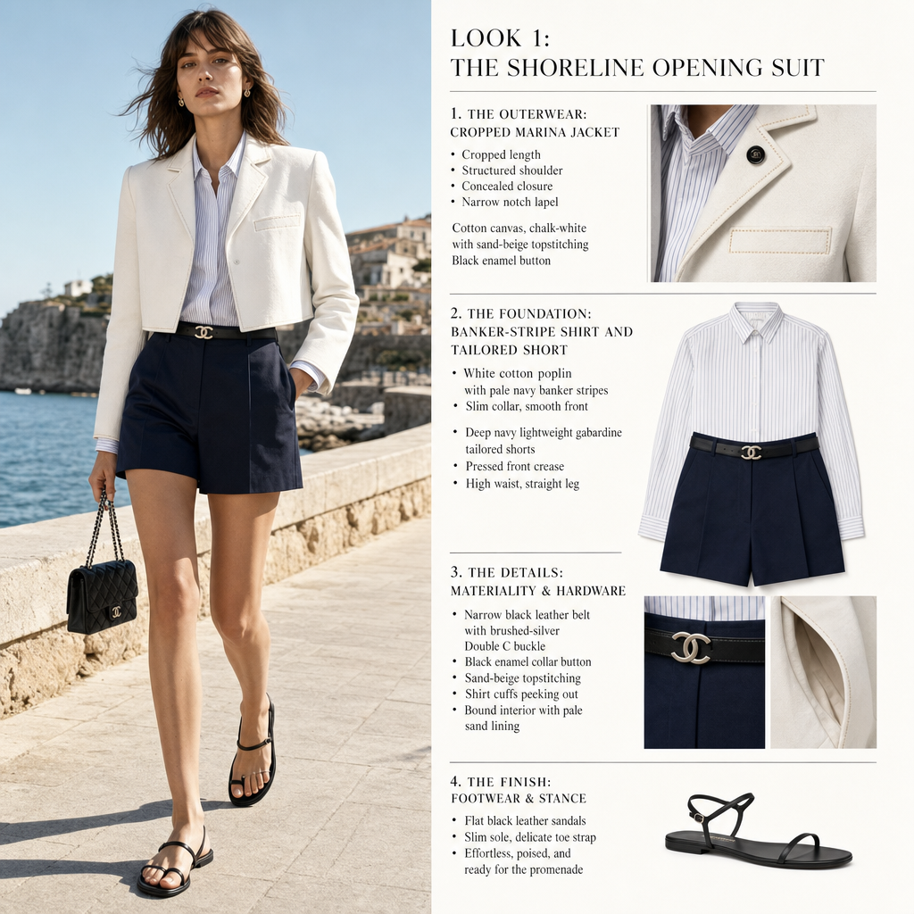

- Judge model：gpt-5.4-mini

总览
- 覆盖轴 C：1.0
- 质量轴（加权 Q_w）：0.5208
- 内容主分 s_fp_base：0.6166
- 最终 S_fp：0.6147 (Usable)
- 惩罚综合 P̄：0.3

门限
- Score gate：0.6147 / 0.7 → FAIL
- Penalty gate：0.3 / 0.5 → PASS
- 双门限：False

S_fp 计算
- s_fp_base：0.6166
- S_fp：0.6147

覆盖轴
轴权重 0.2；问题：有没有。衡量文本是否覆盖服装主体、材质颜色、结构细节和造型关系等核心信息。每项命中 1 分、未命中 0 分，只对适用指标取平均。

模块分
维度｜适用｜命中｜模块分 — 维度：评估模块；适用：该模块下参与计分的指标数；命中：判定为「是」的指标数；模块分：该模块得分。
- 服装主体：适用 5，命中 5，模块分 1.0
- 材质颜色：适用 6，命中 6，模块分 1.0
- 结构细节：适用 3，命中 3，模块分 1.0
- 造型配件：适用 3，命中 3，模块分 1.0
- 造型关系：适用 2，命中 2，模块分 1.0

覆盖项
指标｜得分｜命中｜说明 — 指标：具体评估项；得分：1 分命中 / 0 分未命中；命中：文本是否覆盖该指标；说明：判定理由。

服装主体
- 服装品类：1.0，是 — The text clearly names the main garment categories.
- 廓形：1.0，是 — It gives a clear overall structural and silhouette description.
- 长度/下摆：1.0，是 — The text explicitly states garment length and hem placement.
- 肩部结构：1.0，是 — The shoulder structure is explicitly described.
- 裸露/包裹：1.0，是 — The text clearly describes exposed/revealed body and layer coverage.

材质颜色
- 材质类别：1.0，是 — The text clearly names the main fabric families for the garments.
- 表面性质：1.0，是 — It specifies surface qualities including structure, matte finish, and polished sheen.
- 主色：1.0，是 — The main color palette is explicitly stated, with clear dominant garment colors.
- 副色：1.0，是 — Secondary accent colors are clearly described and tied to visible garment details.
- 配色逻辑：1.0，是 — The text explains the color logic through contrast and tonal accents, with white, navy, and sand-beige working in a controlled palette.
- 图案：1.0，是 — A specific pattern type is named and visually anchored.

结构细节
- 开合方式：1.0，是 — The text clearly describes closure mechanisms for the jacket and belt.
- 功能细节：1.0，是 — Pocket and functional entry details are explicitly mentioned.
- 五金装饰：1.0，是 — The description includes visible hardware elements that function as embellishment.

造型配件
- 鞋履：1.0，是 — Footwear is clearly specified by type and key features, with color/material and construction details.
- 腰带/腰胯附件：1.0，是 — A visible belt is explicitly described, including its placement and fastening relation at the waist.
- 叠搭层次：1.0，是 — The text clearly describes layered garments and their visible overlap/order in a way that is imageable.

造型关系
- 上下比例：1.0，是 — The text clearly describes the relationship between cropped top and high-waisted shorts, including waist position and overall vertical balance.
- 跨单品区分：1.0，是 — The description consistently assigns attributes and spatial relations to specific garments, making the multi-item layering and binding clear.

质量轴
轴权重 0.8；问题：好不好。衡量文本是否具体、准确、清晰、具备设计价值，并适合直接用于图像生成。各指标五档计分（0 / 0.25 / 0.5 / 0.75 / 1.0），模块分 = 适用指标算术平均。

模块分
维度｜适用｜命中｜模块分 — 维度：评估模块；适用：该模块下参与计分的指标数；命中：判定为「是」的指标数；模块分：该模块得分。
- 设计价值：适用 5，命中 0，模块分 0.35
- 可见性优先级：适用 1，命中 0，模块分 0.5
- 生成适配：适用 2，命中 2，模块分 0.75
- 属性绑定：适用 2，命中 2，模块分 0.75
- 语言清晰：适用 2，命中 2，模块分 0.75
- 结构清晰：适用 2，命中 2，模块分 0.75

质量项
指标｜得分｜命中｜说明 — 指标：具体评估项；得分：五档分（0 / 0.25 / 0.5 / 0.75 / 1.0）；命中：是否达到该指标要求；说明：判定理由。

设计价值
- 设计独特性：0.25，否 — There are some specific details, but the overall look still reads as a highly formulaic cropped jacket + shirt + tailored short + belt + flat sandal combination, with brand-coded finishing rather than
- 视觉观察锚定：0.5，否 — The description is anchored to visible garment parts and layering, but it is mixed with mood-led phrasing like promenade, sea light, and seaworthy, so the observation remains only moderately grounded.
- 工艺装饰显著度：0.5，否 — Craft details are present and somewhat located, but they are described in a restrained, generic luxury way rather than as a dominant, highly legible craft hook.
- 组合原创性：0.25，否 — This matches a classic formula template of cropped jacket, striped shirt, tailored shorts, belt, and flat sandals, so the combination is not especially original.
- 设计信号纯度：0.25，否 — Design facts are repeatedly diluted by mood and narrative framing, with several promenade/seaside/seaworthy style phrases reducing the purity of the design signal.

可见性优先级
- 可见性优先级：0.5，否 — The visible garments, colors, and construction are clearly described, but the text repeatedly shifts into mood/stance/transition framing and brand-coded commentary. Hidden/interior details are also pr

生成适配
- 生图提示词适配：0.75，是 — The text is highly imageable and already organized around visible garments, silhouette, materials, and styling, so it is close to a usable prompt. It is still somewhat essay-like and descriptive rathe
- 空间关系：0.75，是 — Layering and attachment relations are clear and visually coherent, with readable tuck, hem, and waist interactions. The spatial logic is strong enough for generation, though the prose includes some in

属性绑定
- 属性实体绑定：0.75，是 — Most attributes are correctly tied to the jacket, shirt, shorts, belt, and sandals. There is only minor complexity from the waist-level interaction and the jacket/shorts meeting point, but the binding
- 多单品绑定：0.75，是 — The text cleanly separates attributes across multiple garments and accessories, with only slight cross-layer dependence at the waist and hem. No major misbinding or garment confusion is present.

语言清晰
- 数量准确性：0.75，是 — The text uses explicit quantity and side-related references clearly overall, and the counts do not conflict. There is only minor local complexity in tracking garment references across layers, but it r
- 指代清晰度：0.75，是 — Pronouns and omitted subjects are generally easy to resolve, with references staying anchored to the jacket, shirt, shorts, and sandals. The prose is layered, but the antecedents remain stable and und

结构清晰
- 信息顺序：0.75，是 — Overall progression is clear from main garment to layering, then belt and footwear. Minor compression and a few detail insertions within garment descriptions keep it from being fully ideal.
- 层级单品聚合：0.75，是 — Each major garment is mostly described in its own block, and the layer relation is explicit before detailing the inner shirt and shorts. There is some cross-item linking through shared effects and fin

惩罚项
惩罚项｜得分｜说明 — 惩罚项：惩罚维度；得分：惩罚分（0 最好，1 最差）；说明：判定理由。
- 一致性：0.0 — The trunk garments read coherently with no left-right or structural contradictions.
- 协调性：0.0 — The outfit is stylistically aligned: crisp nautical/seaside tailoring with matching restrained accessories and footwear.
- 公式模板：0.75 — The look follows a highly reusable cruise/resort formula and is strongly driven by mood language, making it broadly transferable across outfits.
- 非生成导向内容：0.75 — The description is heavily essay-like and mood-driven, with repeated promenade/seaside/confidence framing that dilutes the concrete garment prompt.
- 合理性：0.0 — Materials and construction are physically plausible and described as ordinary wearable garments.

质量短板
- 可见性优先级（得分 0.5）— The visible garments, colors, and construction are clearly described, but the text repeatedly shifts into mood/stance/transition framing and brand-coded commentary. Hidden/interior details are also present, though they do not fully overwhelm the clothing description.
- 设计独特性（得分 0.25）— There are some specific details, but the overall look still reads as a highly formulaic cropped jacket + shirt + tailored short + belt + flat sandal combination, with brand-coded finishing rather than a strongly original design memory point.
- 视觉观察锚定（得分 0.5）— The description is anchored to visible garment parts and layering, but it is mixed with mood-led phrasing like promenade, sea light, and seaworthy, so the observation remains only moderately grounded.
- 工艺装饰显著度（得分 0.5）— Craft details are present and somewhat located, but they are described in a restrained, generic luxury way rather than as a dominant, highly legible craft hook.
- 组合原创性（得分 0.25）— This matches a classic formula template of cropped jacket, striped shirt, tailored shorts, belt, and flat sandals, so the combination is not especially original.
- 设计信号纯度（得分 0.25）— Design facts are repeatedly diluted by mood and narrative framing, with several promenade/seaside/seaworthy style phrases reducing the purity of the design signal.

不适用
- 结构工艺（覆盖轴）— No salient named construction technique like quilting, pleating, embroidery, or cut-out architecture is described.
- 解构（覆盖轴）— The text does not mention deconstruction, splicing, displacement, or reconstruction as a design method.
- 包袋（覆盖轴）— No bag is described in the look.
- 首饰（覆盖轴）— No jewelry or body ornament is explicitly present.
- 不对称（覆盖轴）— No clear asymmetrical design or uneven structural feature is described.
- 左右一致性（质量轴）— No explicit left-right or other bilateral garment differences are described.

