Daniel Louback S. Lubanco

Exercises 5

import numpy as np
import pandas as pd
import matplotlib.pyplot as plt

#First part of the exercise
def first_and_second(x,y,df):
plt.plot(x,y)
plt.xlabel('Months')
plt.ylabel('Sunspots')
plt.axis('tight')
plt.title('Months x Sunspots')
plt.show()

#Second - using insets and only first thousand datapoints
x_short = df['Months'][0:1000]

y_short = df['Sunspots'][0:1000]

fig = plt.figure()
axes1 = fig.add_axes([0.1,0.1,0.8,0.8])
axes2 = fig.add_axes([0.6,0.6,0.3,0.2])
axes1.plot(x_short,y_short,'r')
axes1.set_xlabel('Months')
axes1.set_ylabel('Sunspots')
axes1.set_title('Months x Sunspots [First 1000 Samples]')
axes2.plot(x,y)
axes2.set_xlabel('Months')
axes2.set_ylabel('Sunspots')
axes2.set_title('Months x Sunspots')
plt.show()

# Third part -- Move average filter

def move_avg(data,radius):
row,=data.shape
new_y_size = row-radius*2
new_y = np.zeros(new_y_size)
k = 0
for idx,element in enumerate(data):
#debugging print(idx)
if (idx > (radius-1)) and (idx < (row-radius)):
#debugging print("Here")
new_y[k]=np.average(data[idx-radius:idx+radius])
k +=1
return new_y,new_y_size
def plot_handler(data0,t0,data1,t1,data2,t2,data3,t3):
fig,axes = plt.subplots(4,1,figsize=(20,6))
fig.tight_layout()
axes[0].plot(np.arange(0,t0),data0)
axes[0].set_title("Original Plot",loc='left')
axes[0].set_xlabel('Months')
axes[0].set_ylabel('Sunspots')
axes[1].plot(np.arange(0,t1),data1,'k')
axes[1].set_title("Radius = 5",loc='left')
axes[1].set_xlabel('Months')
axes[1].set_ylabel('Sunspots')
axes[2].plot(np.arange(0,t2),data2,'r')
axes[2].set_xlabel('Months')
axes[2].set_ylabel('Sunspots')
axes[2].set_title("Radius = 50",loc='left')
axes[3].plot(np.arange(0,t3),data3,'m')
axes[3].set_title("Radius = 100",loc='left')
axes[3].set_xlabel('Months')
axes[3].set_ylabel('Sunspots')
plt.show()

def main():
headers = ['Months','Sunspots']
df = pd.read_csv("sunspots.csv", header=None, names=headers)

x = df['Months']
y = df['Sunspots']
first_and_second(x,y,df)
rows,=y.shape
d1,t1 = move_avg(y,5)
d2,t2 = move_avg(y,50)
d3,t3 = move_avg(y,100)
plot_handler(y,rows,d1,t1,d2,t2,d3,t3)
print(d1.shape)
print(t1)
if __name__ == "__main__":
main()

---Output of exercise 5

- Original
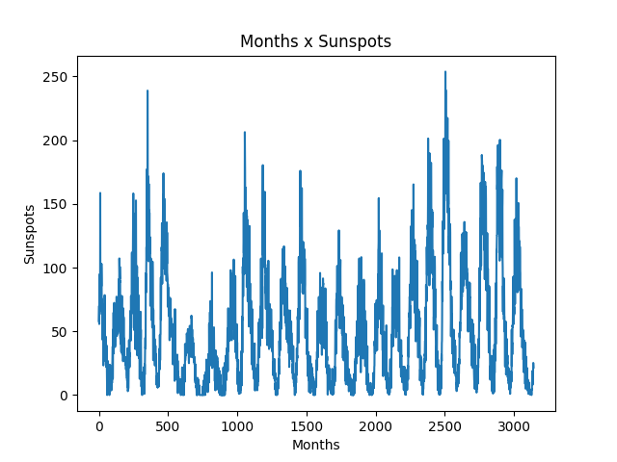

- First 1000 samples and original as inset

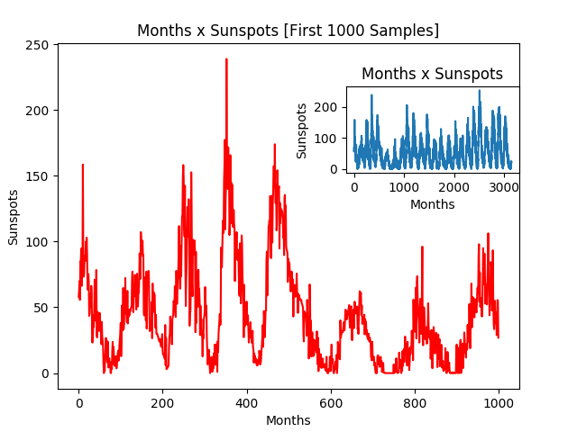

- Comparing different filters

