Daniel Louback S. Lubanco

Exercises 7

'''
Pendulun

d_d_theta = -g/l*sin(theta)+C*cos(theta)*sin(Omega*t)
'''
import numpy as np
from scipy.integrate import odeint
from math import *
import matplotlib.pyplot as plt

#from IPython.display import display, clear_output
#import time
def sys(theta, t, l, C, omega, g):
theta1 = theta[0]
theta2 = theta[1]
dtheta1_dt = theta2
dtheta2_dt = -g/l*sin(theta1)+ C*cos(theta2)*sin(omega*t)

dtheta_dt = [dtheta1_dt,dtheta2_dt]
return dtheta_dt

def main():
C = 2
l = 10/100 #m
t = np.linspace(0,100,2500)
g = 9.81
theta_0=np.array([0,0]).T
omega = np.sqrt(g/l)#5

theta = odeint(sys,theta_0,t,args = (l,C,omega,g))
plt.plot(t,theta)
print(theta)
plt.legend(['theta','thetadot'])
plt.title("Pendulum change through time with force in natural pendulum's frequency")
plt.xlabel("time")
plt.show()

fig, ax = plt.subplots(figsize=(4,4))
x=theta

if __name__ == "__main__":
main()

---- Output figures

(a)
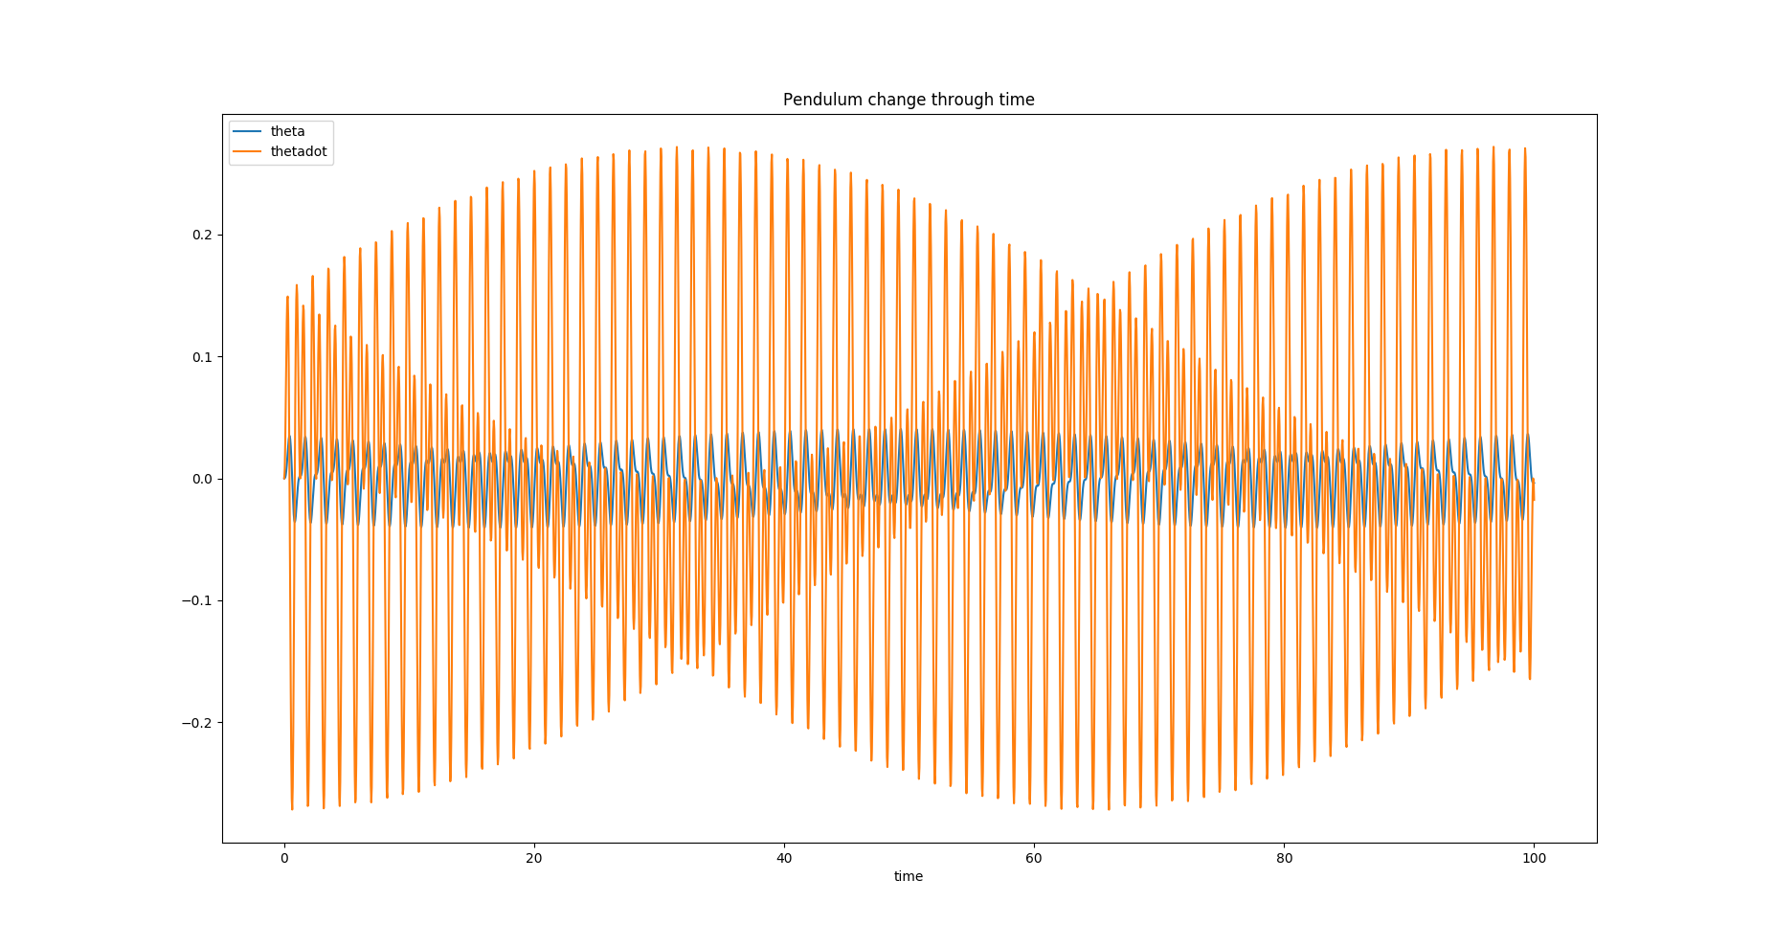

(b)

