

**ASSIGNMENT # 02**

Instructor: Dr. Faheem Akhtar Rajput

CMS ID: 053-18-0005

Submitted by: Madan Lal

**Department of Computer Science**

Semester VI

**SIBAU**

Sukkur IBA University, Nisar Ahmed Siddique Road, Sukkur

**String All Common Methods**

class StringMethods

{

    public static void main(String args[])

    {

        String FirstName = "Madan";

        String LastName = "Lal";

        //charAt return character at particular index

        System.out.println(FirstName.charAt(1));

        //codePointAt return AASCII

        System.out.println(FirstName.codePointAt(1));

        //codePointerBefore return AASCII of character before index

        System.out.println(FirstName.codePointBefore(1));

        //return AASCII of specified string

        System.out.println(FirstName.codePointCount(0,2));

        //compareTo compares two strings (if match return 0 else 1)

        System.out.println(FirstName.compareTo(LastName));

        //compare two string ignore case(capital/small)

        System.out.println(FirstName.compareToIgnoreCase(LastName));

        //Append two strings

        System.out.println(FirstName.concat(LastName));

        //string contains given string or not

        System.out.println(FirstName.contains("a"));

        //endsWith return is it end with particular string or not?

        System.out.println(FirstName.endsWith("n"));

        //equals return true if both string are equals else false.

        System.out.println(FirstName.equals("madan"));

        //return index of character if not return -1

        System.out.println(FirstName.indexOf("d"));

        //check string if empty return true else false

        System.out.println(FirstName.isEmpty());

        //return last index of string

        System.out.println(FirstName.lastIndexOf("a"));

        //return length of the string

        System.out.println(FirstName.length());

        //replace character

        System.out.println(FirstName.replace("a","b"));

        //replace first occurance

        System.out.println(FirstName.replaceFirst("a","b"));

        //replace All occurances

        System.out.println(FirstName.replaceAll("a","b"));

        //split string

        String[] str = FirstName.split("d",0);

        for(String a : str)

        {

            System.out.println(a);

        }

        //start with particular character

        System.out.println(FirstName.startsWith("M"));

        //return sub sequence from 0 to 2-1 index

        System.out.println(FirstName.subSequence(0, 2));

        ///return subString after particular index

        System.out.println(FirstName.substring(2));

        //convert string into lower case

        System.out.println(FirstName.toLowerCase());

        //convert string into upper case

        System.out.println(FirstName.toUpperCase());

        //trim removes whitespace from both ends of string

        System.out.println(FirstName.trim());

        //String.valueOf(anyValue) converts value into string

        int a = 12;

        System.out.println(String.valueOf(a));

    }

}

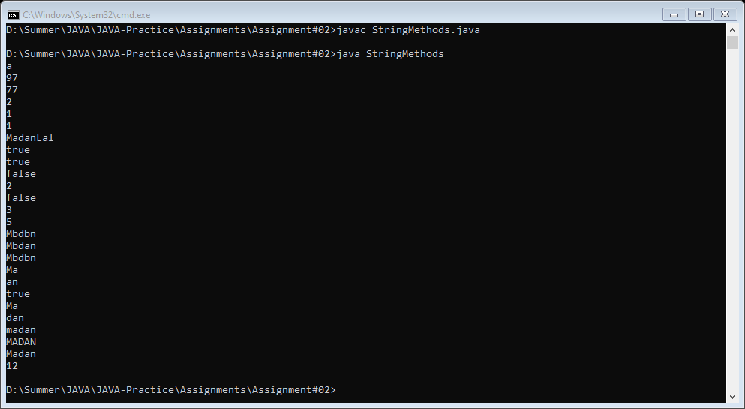

**End of Assignment 2**