|  |  |  |  |  |
| --- | --- | --- | --- | --- |
| t | 3 | 5 | 7 | 9 |
| s | 1.33333 | 1.53333 | 1.67619 | 1.7873 |

# 3.10:

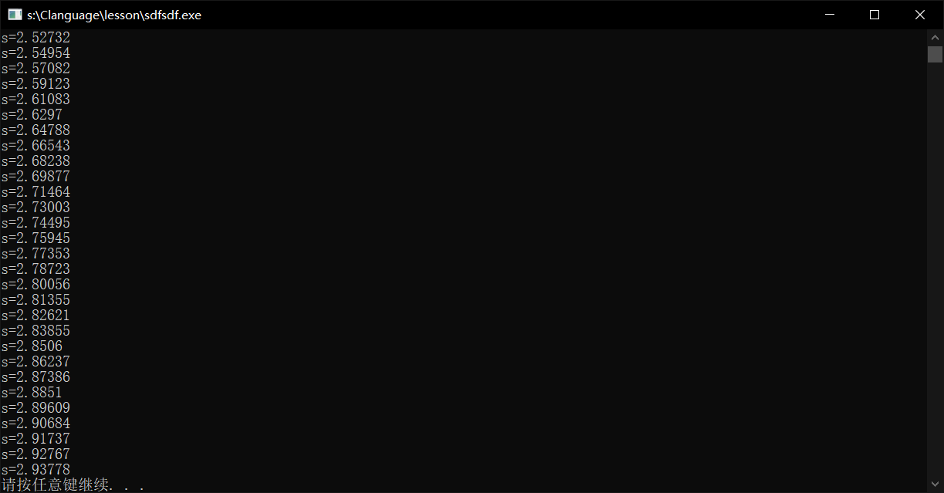

# 3.11:

|  |  |  |  |  |
| --- | --- | --- | --- | --- |
| t | 3 | 5 | 7 | 9 |
| s | 1.33333 | 1.53333 | 1.67619 | 1.7873 |

|  |  |  |  |  |
| --- | --- | --- | --- | --- |
| t | 3 | 5 | 7 | 9 |
| S | 2.66667 | 3.4666 | 2.89524 | 3.33968 |

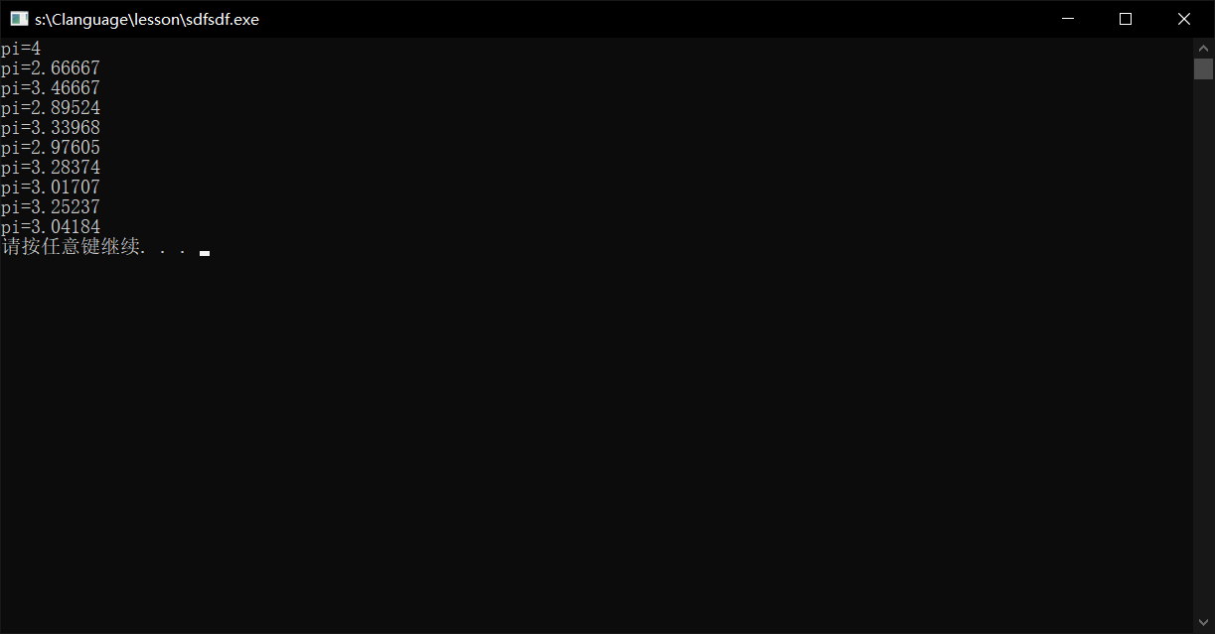

# 读书笔记：

1. 返回什么类型就用什么类型定义

2.唉。。。真没什么要说的，毕竟比较基础（你可理解为暂时不需要笔记🤣）