# 一

**DCADCABBBD**

1. **关键词 变量与常量 识符 运算符 表达式 主函数 输入与输出**
2. **命名规范 缩进格式 代码多余**
3. **编写 编译 运行**

# 二

**CBCBDCBBDD**

**冒泡排序变量变化表：**

|  |  |  |  |  |  |  |  |  |  |
| --- | --- | --- | --- | --- | --- | --- | --- | --- | --- |
| 初始 | 中间过程 | | | | | | | | |
| 7 | 6 | 6 | 6 | 6 | 6 | 6 | 6 | 6 |  |
| 6 | 7 | 5 | 5 | 5 | 5 | 5 | 5 | 5 |  |
| 5 | 5 | 7 | 3 | 3 | 3 | 3 | 3 | 3 |  |
| 3 | 3 | 3 | 7 | 4 | 4 | 4 | 4 | 4 |  |
| 4 | 4 | 4 | 4 | 7 | 0 | 0 | 0 | 0 |  |
| 0 | 0 | 0 | 0 | 0 | 7 | 1 | 1 | 1 |  |
| 1 | 1 | 1 | 1 | 1 | 1 | 7 | 2 | 2 |  |
| 2 | 2 | 2 | 2 | 2 | 2 | 2 | 7 | 7 |  |
| 9 | 9 | 9 | 9 | 9 | 9 | 9 | 9 | 8 |  |
| 8 | 8 | 8 | 8 | 8 | 8 | 8 | 8 | 9 |  |

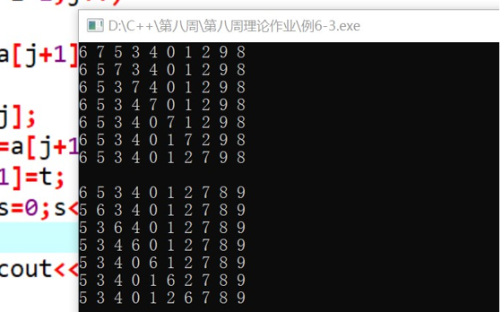

|  |  |  |  |  |  |  |
| --- | --- | --- | --- | --- | --- | --- |
| 初始 | a[0] | a[1] | a[2] | a[3] | a[4] | a[5] |
|  | 1 | 3 | 5 | 7 | 9 | 11 |
|  | a[0] | a[1] | a[2] | a[3] | a[4] | a[5] |
|  | 1 | 3 | 7 | 9 | 11 |  |

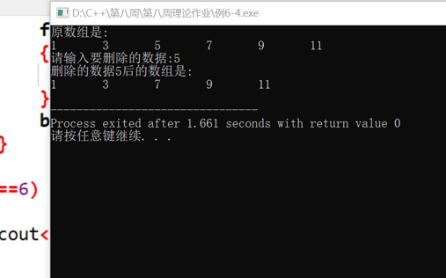

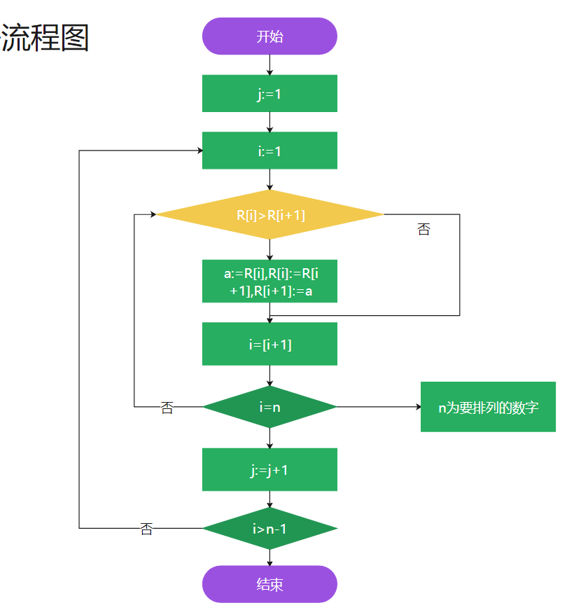

# 亮

**学会了如何实现冒泡排序**

# 帮

如何实现快速排序？