计算机科学与工程学院
《算法与数据结构》作业5
专业班级 |  | 2023级 |  | 学生学号 |  | 2307120312
学生姓名 |  | 余尚正 |  | 指导教师 |  | 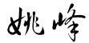
作业内容 |  | 树
考核目标 |  | 1．树的基本概念；树的性质；树的基本运算；树的存储结构；  2．二叉树的基本概念；二叉树树的性质；  3．二叉树与树、森林之间的转换  4．二叉树存储结构；二叉树的基本运算及其实现；  5．二叉树的遍历；二叉树遍历应用；  6．二叉树的构造；  7．线索二叉树；  8．哈夫曼树。
作业考核评价标准
观察点 |  |  | 考核参考标准 |  |  |  | 得分
二叉树的逻辑结构、存储结构、遍历、构造、线索化；霍夫曼树； |  |  | 掌握二叉树的逻辑结构、存储结构、遍历、构造、线索化的情况，霍夫曼树的构造和应用，能否熟练求解二叉树相关问题。
指导老师 |  |  | 日期

具体作业内容
- 设计求一棵二叉树中结点总数的算法并实现。（要求程序可执行并附执行结果）
输出：
代码：
#include <iostream>

using namespace std;

struct TreeNode {
int val;
TreeNode* left;
TreeNode* right;
TreeNode(int x) : val(x), left(nullptr), right(nullptr) {}
};

int countNodes(TreeNode* root) {
if (root == nullptr) {
return 0;
}
return 1 + countNodes(root->left) + countNodes(root->right);
}

TreeNode* createExampleTree() {
TreeNode* root = new TreeNode(1);
root->left = new TreeNode(2);
root->right = new TreeNode(3);
root->left->left = new TreeNode(4);
root->left->right = new TreeNode(5);
root->right->left = new TreeNode(6);
root->right->right = new TreeNode(7);
return root;
}

int main() {

TreeNode* root = createExampleTree();

int totalNodes = countNodes(root);

cout << "二叉树的结点总数为: " << totalNodes << endl;

delete root->left->left;
delete root->left->right;
delete root->right->left;
delete root->right->right;
delete root->left;
delete root->right;
delete root;

return 0;
}

- 给出二叉树的自下而上，从右到左的层次遍历算法。
输出：
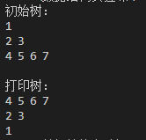
代码：
#include <iostream>
#include <queue>
#include <stack>
#include <vector>

using namespace std;

struct TreeNode {
int val;
TreeNode* left;
TreeNode* right;
TreeNode(int x) : val(x), left(nullptr), right(nullptr) {}
};

void printTree(TreeNode* root) {
if (root == nullptr) {
return;
}

queue<TreeNode*> q;
q.push(root);

while (!q.empty()) {
int levelSize = q.size();
for (int i = 0; i < levelSize; ++i) {
TreeNode* node = q.front();
q.pop();
cout << node->val << " ";

if (node->left) {
q.push(node->left);
}
if (node->right) {
q.push(node->right);
}
}
cout << endl;
}
}

vector<vector<int>> levelOrderBottom(TreeNode* root) {
vector<vector<int>> result;
if (root == nullptr) {
return result;
}

queue<TreeNode*> q;
q.push(root);

while (!q.empty()) {
int levelSize = q.size();
stack<int> levelStack;

for (int i = 0; i < levelSize; ++i) {
TreeNode* node = q.front();
q.pop();
levelStack.push(node->val);

if (node->right) {
q.push(node->right);
}
if (node->left) {
q.push(node->left);
}
}
vector<int> level;
while (!levelStack.empty()) {
level.push_back(levelStack.top());
levelStack.pop();
}
result.insert(result.begin(), level);
}

return result;
}

TreeNode* createExampleTree() {
TreeNode* root = new TreeNode(1);
root->left = new TreeNode(2);
root->right = new TreeNode(3);
root->left->left = new TreeNode(4);
root->left->right = new TreeNode(5);
root->right->left = new TreeNode(6);
root->right->right = new TreeNode(7);
return root;
}

int main() {
TreeNode* root = createExampleTree();
cout << "初始树： ";
cout<< endl;
printTree(root);
cout<< endl;
cout << "打印树：" << endl;

vector<vector<int>> result = levelOrderBottom(root);

for (const auto& level : result) {
for (int val : level) {
cout << val << " ";
}
cout << endl;
}
delete root->left->left;
delete root->left->right;
delete root->right->left;
delete root->right->right;
delete root->left;
delete root->right;
delete root;

return 0;
}
3、 一份电文中有6种字符：A,B,C,D,E,F，它们的出现频率依次为16，5，9，3，30，1，完成问题：
（1）设计一棵哈夫曼树；（画出其树结构）
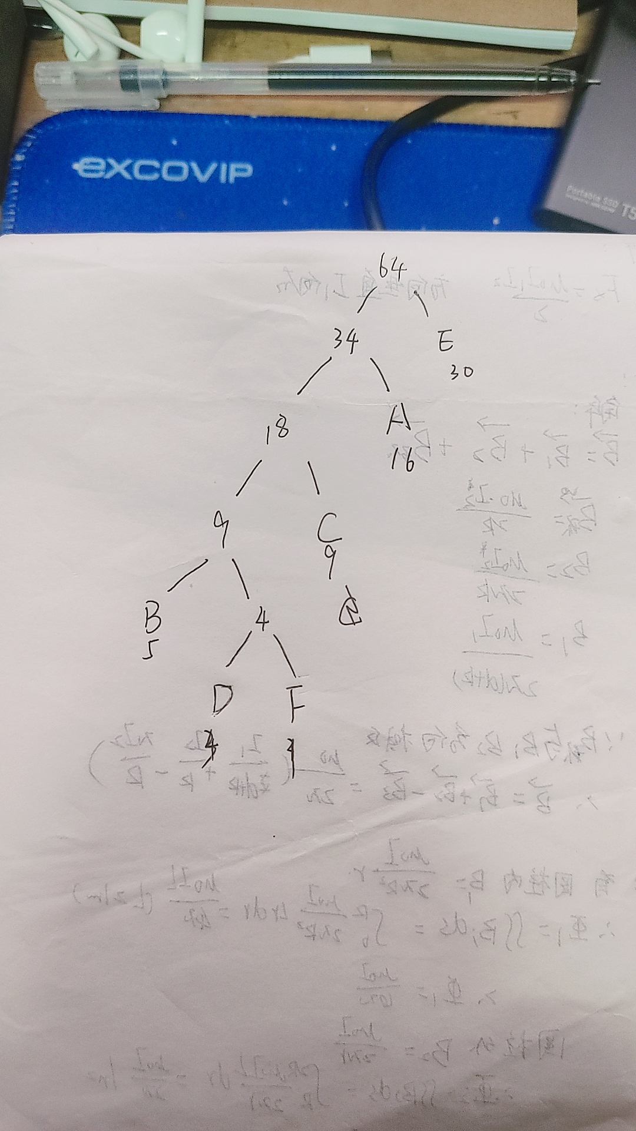
- 计算其带权路径长度WPL；
WPL = 32 + 15 + 27 + 12 + 30 + 4 = 120

