Installing Visual Studio Code
Visual Studio Code is a code editor which we will use to work on our project.
Download Visual Studio Code - Mac, Linux, Windows
After VSCode is downloaded and installed, you need to get a few extensions within the application.
Within the application, press Ctrl + Shift + X to open the extensions menu.
Search up and install the following extensions:
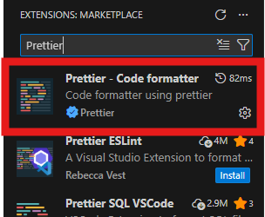
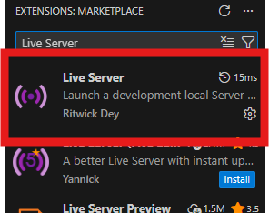
Once the extensions are finished installing, select File -> Open Folder and open the downloaded project folder website-workshop-26.
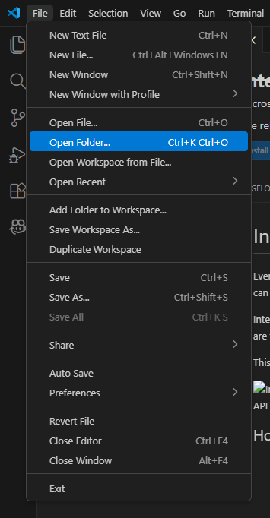

Using Visual Studio Code
Somewhere in your open window there should be a listing of the contents of the project folder.
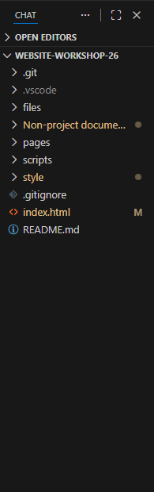
Select the index.html file to open it in the code editor, then right-click where the code is, then select the Open with Live Server option in the context menu.
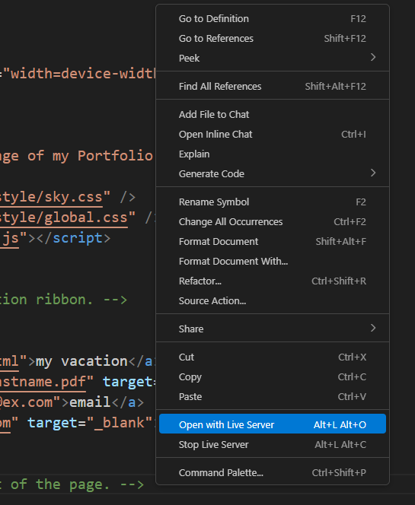
This will open the webpage on localhost, essentially simulating the webpage being online when it is not. When using Live Server the webpage is only on your machine and is not accessible over the internet. We’ll set up hosting later so that your webpage can be accessed by others.
When you save your changes the localhost server will update instantly unlike an actual host (server)

Coding Basics
In the simplest form, we can think of websites as a series of documents connected by links. We use HTML and CSS to write on the documents, or pages of our website.
Hyper-Text Markup Language (HTML) defines the structure of our site in sequential blocks. We program in HTML using tags.
So, HTML code looks a little like this:
<body> this tag defines the start of the body block.
Here, we define our title, or ‘Heading One’, the largest text on the page.
<h1>This is the title of our page!</h1>
This is how we create a paragraph block.
<p>Here is a paragraph below our title.</p>
</body> this tag defines the end of the body block.

More formally, each tag is called an ‘Element’ some elements have specific functionality (ex: img for images) and some are only semantic, or used to convey something to humans but doesn’t do anything (ex: header, footer, main)
To write good HTML, you know how to use the semantic tags: HTML Semantic Elements
Here is what a complete HTML document looks like in the browser:
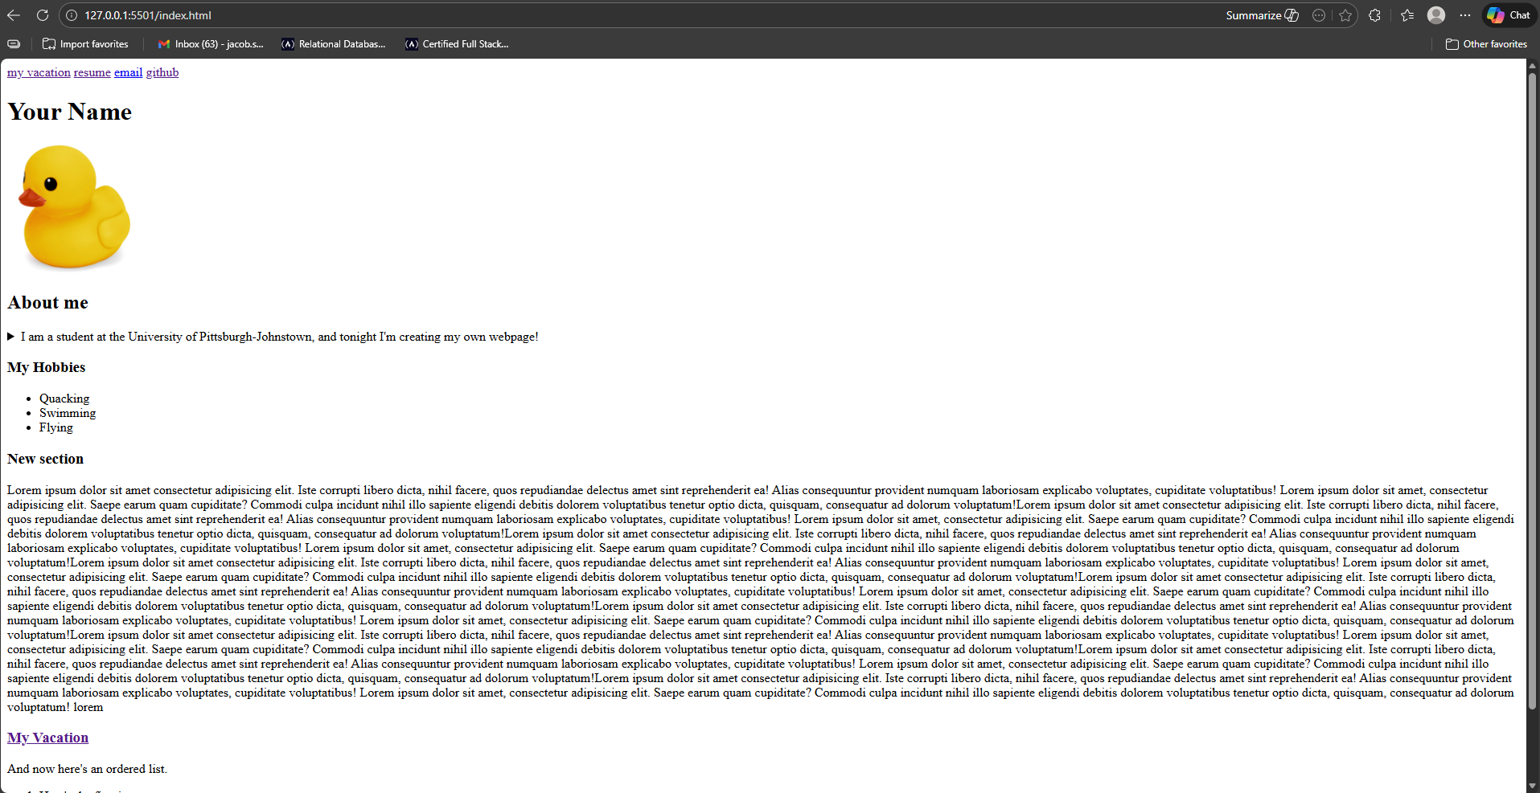
The top block is our navigation ribbon. Although, right now it barely looks like a ribbon! Below that is our title, followed by an image, etc. The obvious issue with this is that it is hideously ugly.
Before you continue, take a moment to read the comments within the index.html file in the project folder.

We use Cascading Style Sheets (CSS) to style our document, or make it look pretty.
CSS allows us to have full control over the HTML blocks of our document. We can change colors, set sizes, and even change positioning and layout using CSS.
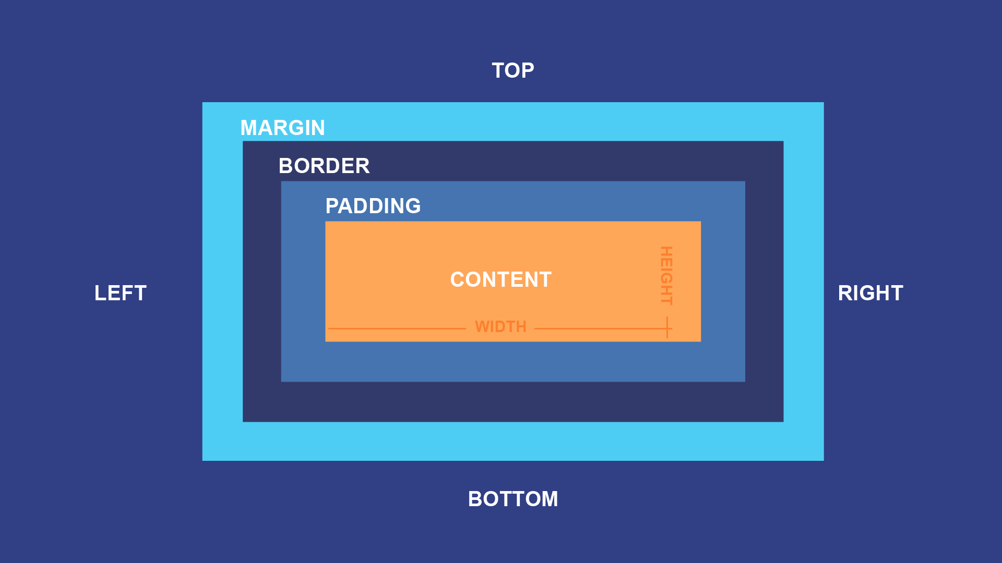
Where HTML allows us to create simple boxes, CSS gives us more properties to edit these boxes. See above, the CSS box model
We must provide the links to our style sheets within the head of our HTML document.
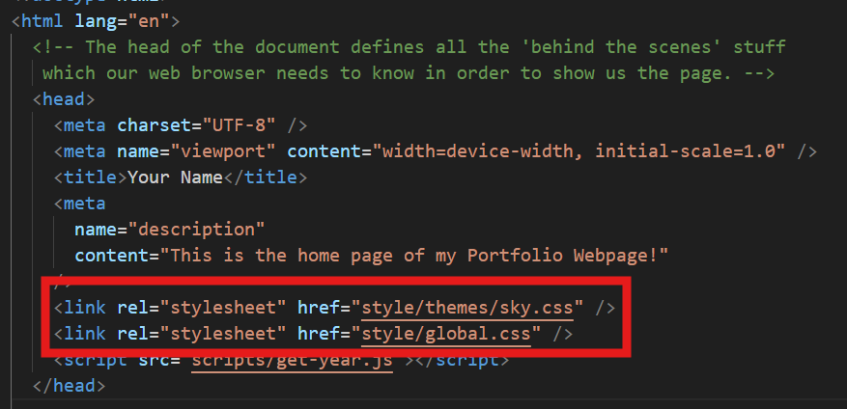
You can see I have linked two style sheets: global.css and sky.css
In this project, I’ve broken styling up into two parts: themes and standards. global.css contains standard styling which we want to stay the same across all themes. sky.css is a theme.
If you haven’t modified the two lines in the above screenshot, your styling should already be applied to the HTML document. For demonstrations purposes I have purposely removed these lines and will now add them back in to my project.
Here’s what it looks like if I add global.css to my current ugly HTML document:
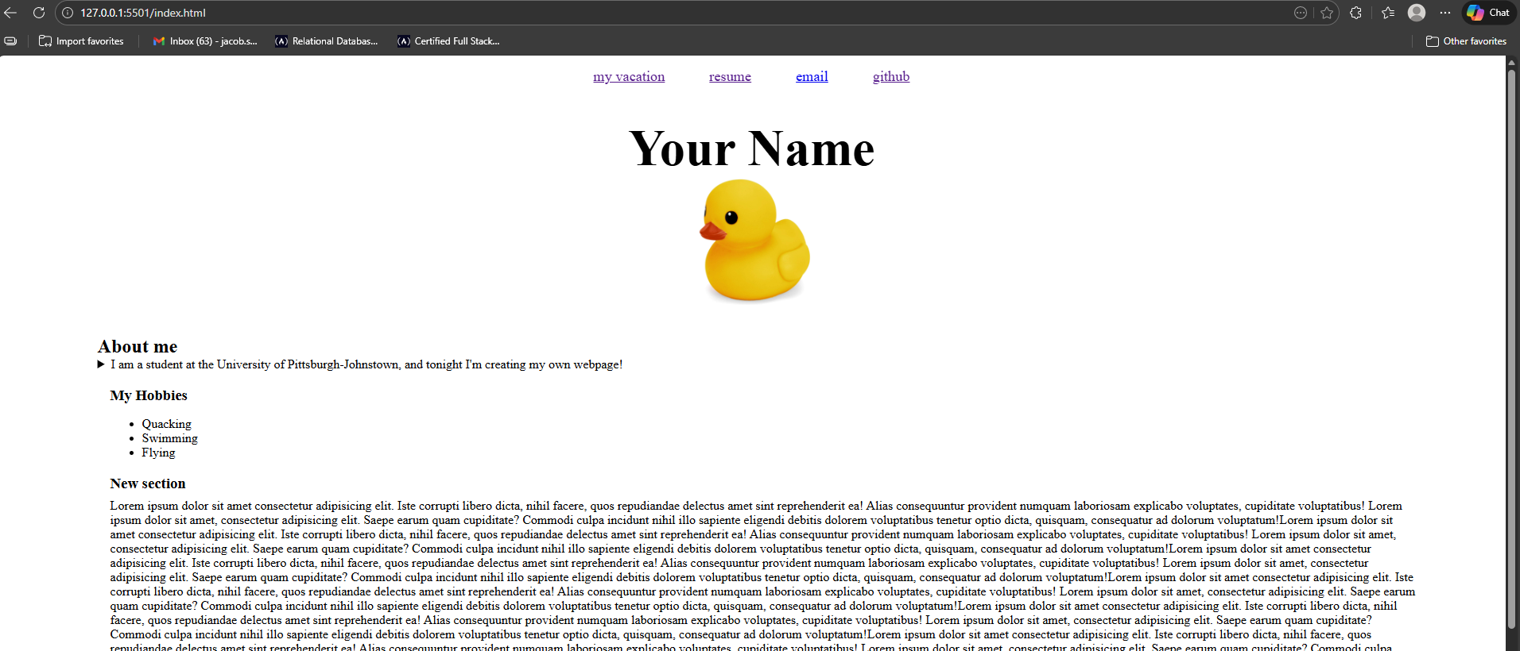
Already this is a big improvement. While still boring, the site is much more readable.
To take it to the next level, I’ll apply the sky theme.
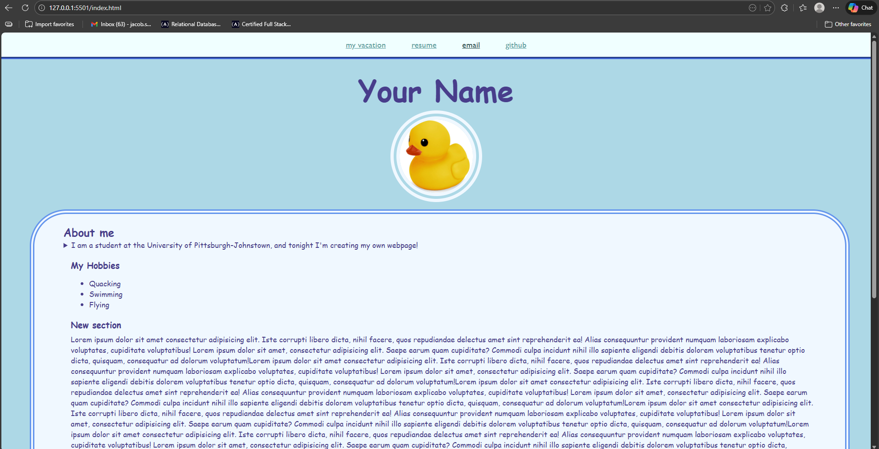
I’ve created a few other themes in the themes folder for you to test out. Just change the link in the HTML head to point to the theme you want and save your document. Live sever should update automatically.
Here’s what the CSS behind this looks like. For example, here’s the styling for our h1 in global.css
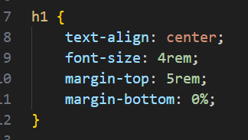
This code is essentially just a list of settings. At the top, we denote that we want to change the settings for the h1 element. Then we list the settings we want to change. Any HTML document that is linked to this style sheet will have those settings applied to the h1 element.
When working with CSS we have a few options for measurements. You can see, in the above example, that I am using rem (root-em) and %. You can also use vh (viewheight) and px (pixels) (and more). In general try to avoid using px, as using the other measurements will allow your webpage to adapt depending on the size of the screen in which it is being viewed. If you don’t want to memorize all the different units just use %.
We can also define ‘blueprint settings’ which we can apply to any HTML element. More formally, these are called classes. Here’s what one of those looks like:
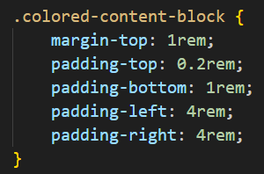 in global.css
And to apply these settings in HTML:
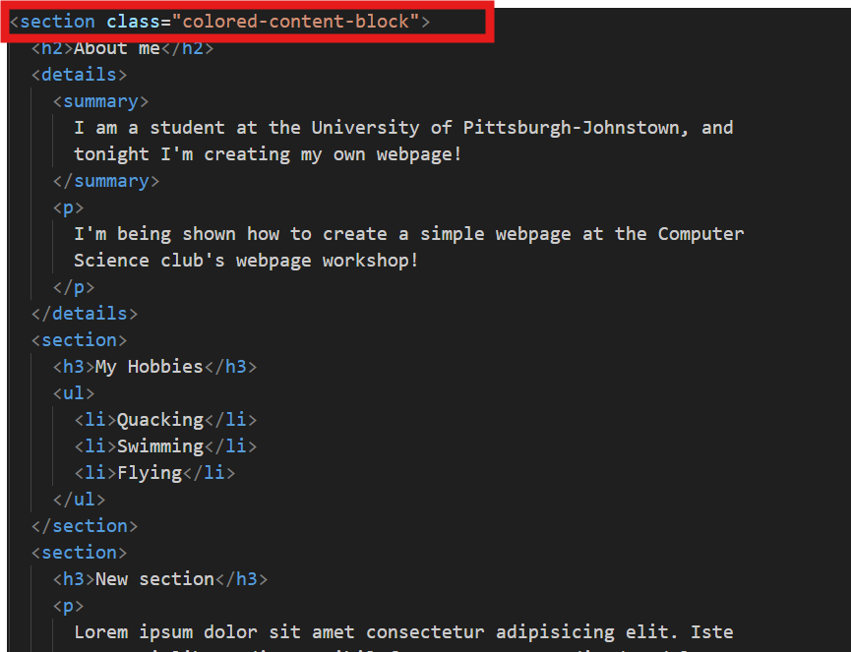
After both the styling from global.css and the sky theme is applied, here is that the colored content block looks like in the document:
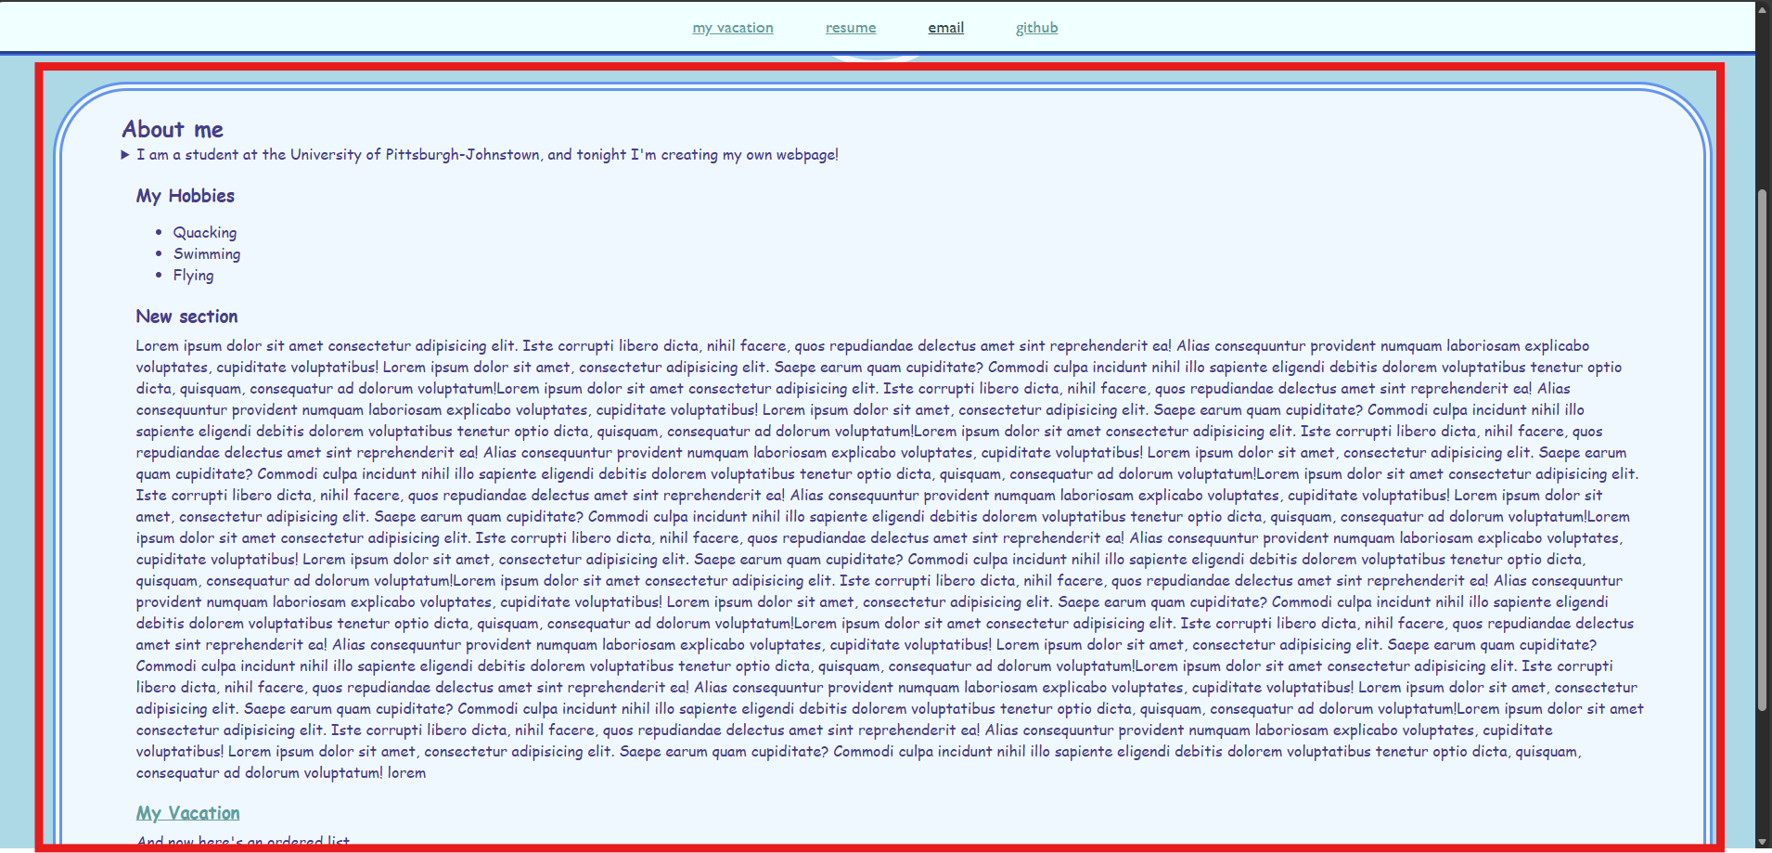
the colored-content-block class can be applied to most HTML elements.

Coding References
If we covered everything there is to know about HTML and CSS, this event would be horrifically boring. Here are some references to read if you want to learn these technologies.
HTML Tutorial
CSS Tutorial
HTML: HyperText Markup Language | MDN
CSS: Cascading Style Sheets | MDN
JavaScript is beyond the scope of this workshop, but resources for the language are easily found on Mozilla Dev Network as well as W3 schools, and lots of other places. I did include one very simple JavaScript script in the project to display how to link it in HTML.

The good news is that every possible issue you can run into while programming HTML and CSS has already been asked and answered on the internet. If you run into an issue, try looking it up. Chances are the first result will be a stack overflow question from 13 years ago answering your exact question. Therefore, the most important thing to learn when learning these technologies are terminologies.

Deploying as a GitHub Page
GitHub provides a free service for hosting static webpages. There are some other limitations, which are worth reading about here. But, in general, the average sensible person is never going to run into an issue using this service.
WARNING: THIS WILL MAKE YOUR WEBPAGE ACCESSABLE OVER THE INTERNET. IS IT CRITICAL THAT YOUR PROJECT DOES NOT CONTAIN INFORMATION WHICH YOU DO NOT WANT OTHERS TO KNOW. EVEN IN THE CODE OR WITHIN FILES, WHICH WILL ALL STILL BE ABLE TO BE SEEN AND ACCESSED AFTER YOUR PAGE IS DEPLOYED.
If you’re familiar with GitHub, use the official documentation guide.
Create a GitHub account.
Create a new repository
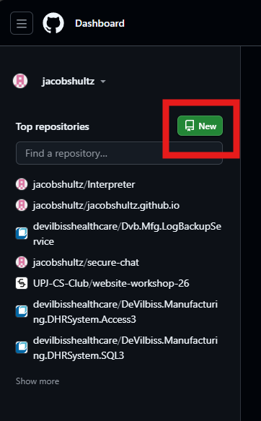
Name the repository <yourusername>.github.io

copy the following settings except for description and repository name:
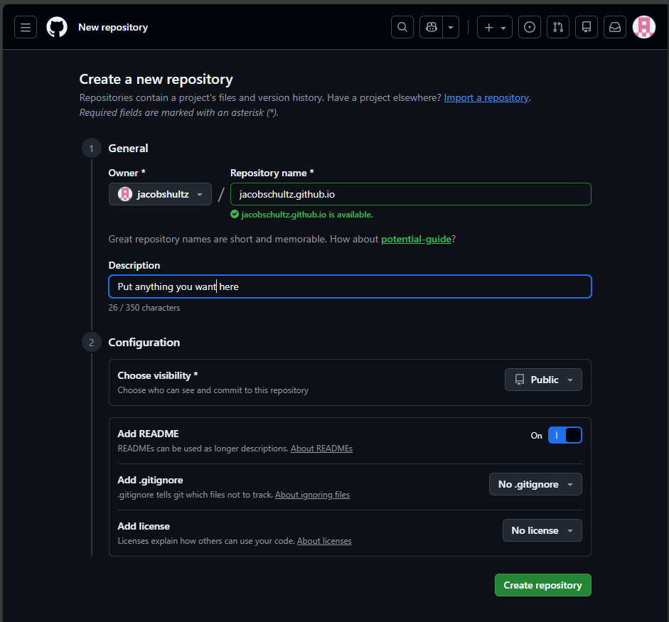
In your newly created repository, upload your project files by selecting Add File -> Upload files
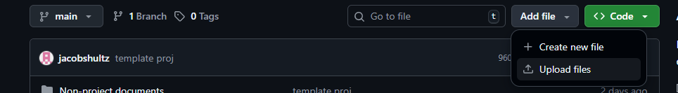
Drag all of these files into the box, at this directory level. You can exclude the ‘Non-project documents’ folder.
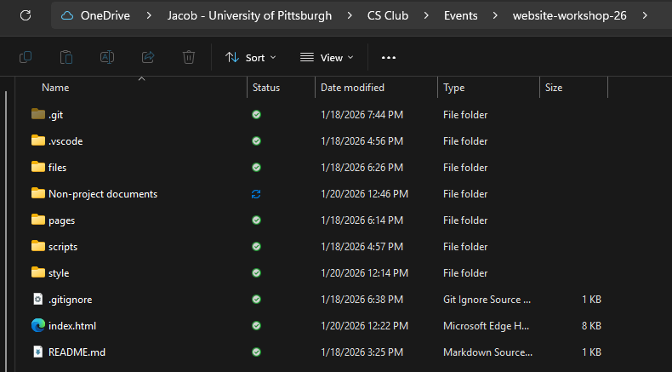
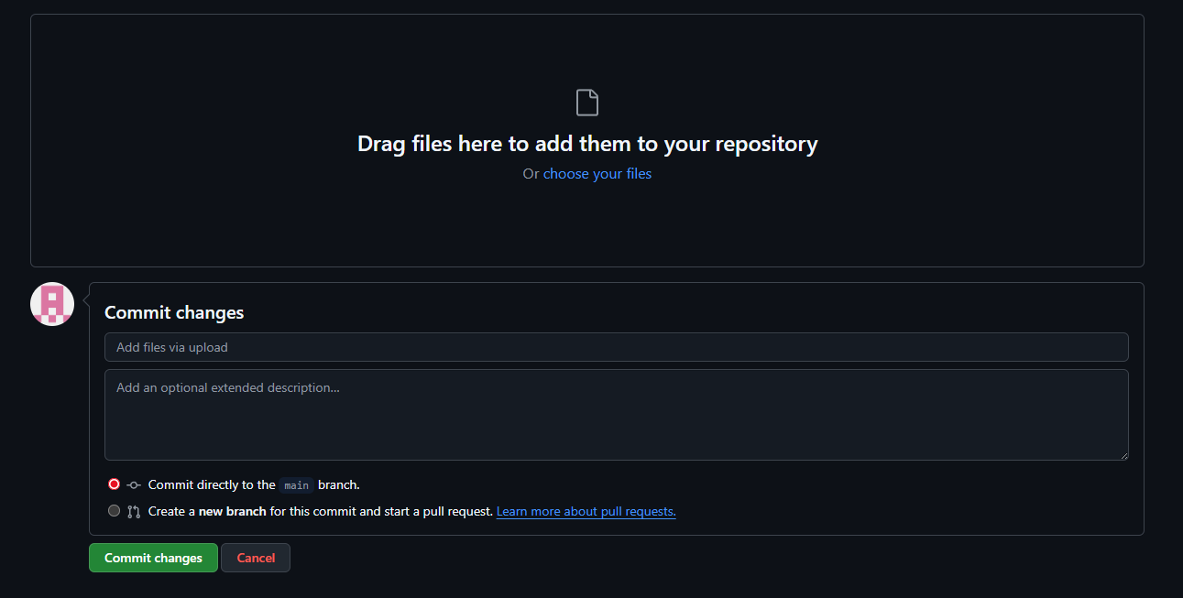
Then leave all the fields as is and select ‘Commit changes’ you may have to fill out the first box.
Select your repository’s settings
Navigate to pages
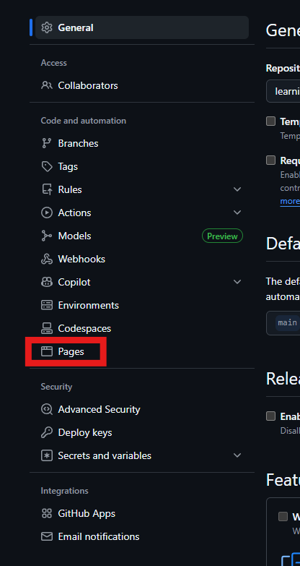
Set the source branch to main and select save
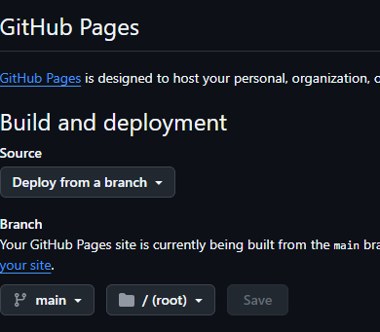
Wait 5 minutes, then go back to your repository view and select deployments
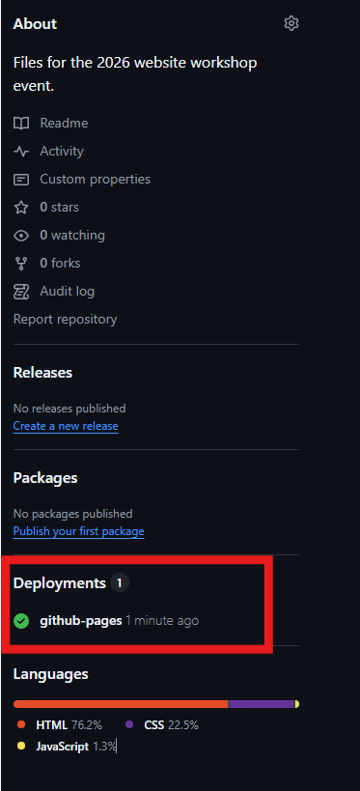
Click the link to go to your site. Your link should look different than mine.
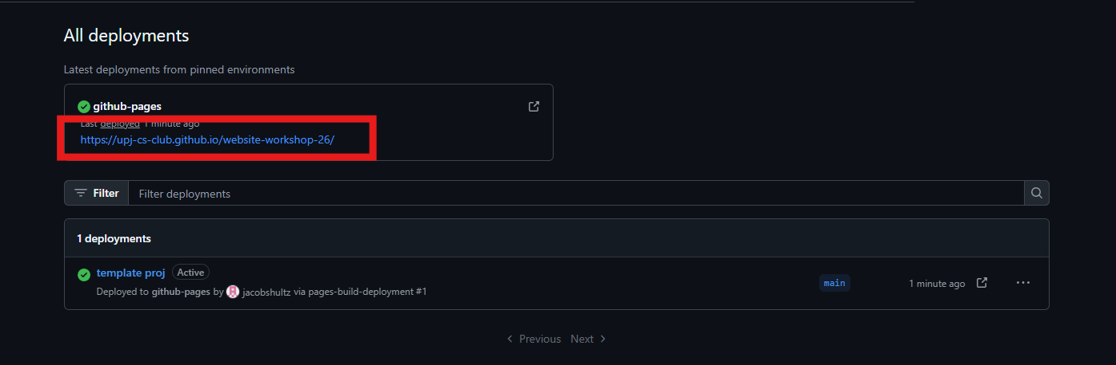
Congratulations, you have created you own website.

Connect with us!
If you enjoyed the event and want to participate in the club more, please connect with us!
Discord (Primary communication channel)
Instagram

