SkillSignalZA Market Findings V1
South African entry-level Software Engineering and Data Analytics evidence
Phase 7 • Final findings report • 12 August 2026
Central conclusion
The two tracks require different calibration logic. Software Engineering demand is broad across languages and stacks, while Data Analytics demand concentrates strongly around SQL and Power BI. Portfolio proof is useful product evidence, but its current rubric weight is weakly reflected in explicit employer requests.

Executive summary
Finding | Evidence | Meaning
Sample | 22 SE + 16 DA | Locked main sample; track-specific denominators retained
SE technical centre | C#, JavaScript and SQL: 13/22 each | No single language dominates
SE Git | 11/22 — 50.0% | Material signal; current absolute cap needs review
DA technical centre | SQL and Power BI: 13/16 each | Strong evidence for central rubric treatment
DA Python | 8/16 — 50.0% | Valuable, but not universal
Portfolio requested | SE 3/22; DA 1/16 | Clearest challenge to current 25% / 20% weights
Source: SkillSignalZA_Cleaned_Dataset_V1; final 38-post main sample.

1. Dataset and methodology
Phase 7 describes the market evidence and tests Rubric V1 assumptions. It does not change weights, score bands, penalties or hard rules; those decisions are carried into Phase 8.
Population | Records | Use
Software Engineering main sample | 22 | SE percentages and rubric evidence
Data Analytics main sample | 16 | DA percentages and rubric evidence
Adjacent evidence | 15 | Preserved; excluded from main percentages
Role-fit exclusions | 4 | Preserved for audit; excluded

Counting rules
Rule | Application
Denominators | 22 SE and 16 DA. Missing work-type data uses 21 SE and 14 DA.
Skill frequency | A skill counts at most once per post within its coding dimension.
Inference | No parent language, tool or skill is inferred from another technology.
Qualitative coding | Original phrase retained; a phrase may map to more than one documented theme.
Required/preferred | Classified only when captured wording supports it; otherwise unclear/not classified.
Evidence boundary | Direct employer evidence is separated from product judgment.

Known data limitations
Locked limitations
DA-010 remains in the main sample despite its Cape Town / Bangkok geography conflict. SE-002, DA-020 and DA-023 have unavailable work-type data; DA-023 also lacks a verified posting date. None of these values is imputed.

2. Software Engineering market profile
The SE sample is defined by breadth. Three languages tie for the highest frequency, and multiple stack combinations recur. This argues for scoring transferable, specifically named technical evidence rather than forcing one preferred stack.
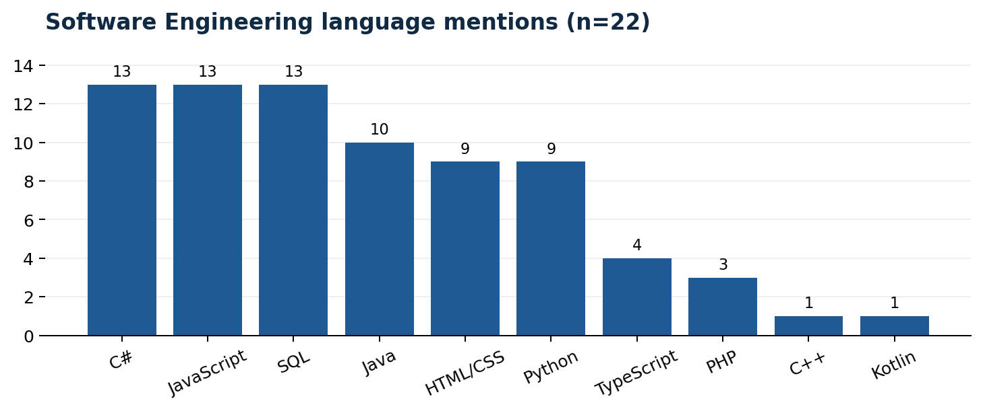
Figure 1. Each skill counts once per post; denominator = 22.
Language | Frequency
C# | 13/22 — 59.1%
JavaScript | 13/22 — 59.1%
SQL | 13/22 — 59.1%
Java | 10/22 — 45.5%
HTML/CSS | 9/22 — 40.9%
Python | 9/22 — 40.9%
TypeScript | 4/22 — 18.2%
PHP | 3/22 — 13.6%
C++ | 1/22 — 4.5%
Kotlin | 1/22 — 4.5%
Source: SE Track, Programming Languages Mentioned.

3. Software Engineering tools, proof and access
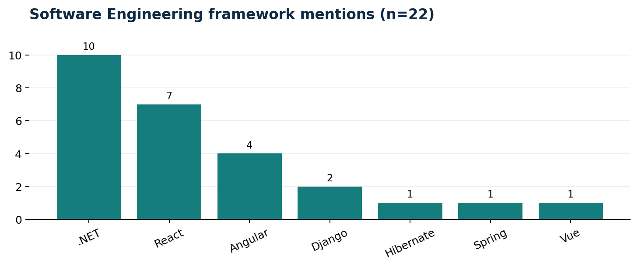
Figure 2. .NET is the leading framework family in this sample.
Tool / platform | Frequency
Git/GitHub | 11/22 — 50.0%
Azure | 6/22 — 27.3%
SQL Server | 5/22 — 22.7%
AWS | 4/22 — 18.2%
Linux | 3/22 — 13.6%
MySQL | 3/22 — 13.6%
Docker | 2/22 — 9.1%
Jira | 1/22 — 4.5%
PostgreSQL | 1/22 — 4.5%
Postman | 1/22 — 4.5%

Interpretation
Dimension | Evidence | Phase 7 interpretation
Git/GitHub | 11/22 | Important but not universal; partially supports a strong signal, not automatically an absolute cap.
Deployment tools | 8/22 | AWS, Azure or Docker appears often enough to support bonus treatment, not baseline treatment.
Portfolio/GitHub requested | 3/22 | Explicit demand is too low to justify 25 points by market frequency alone.
Degree required | 16/22 | Formal qualifications are prominent, although 6/22 specify none.
Hybrid work | 14/21 known | Hybrid dominates; remote-only roles are 2/21.

4. Data Analytics market profile
The DA market is more concentrated than SE. SQL and Power BI each appear in 81.3% of posts, and they co-occur in 11/16. This is the strongest direct evidence in the entire Phase 7 analysis.
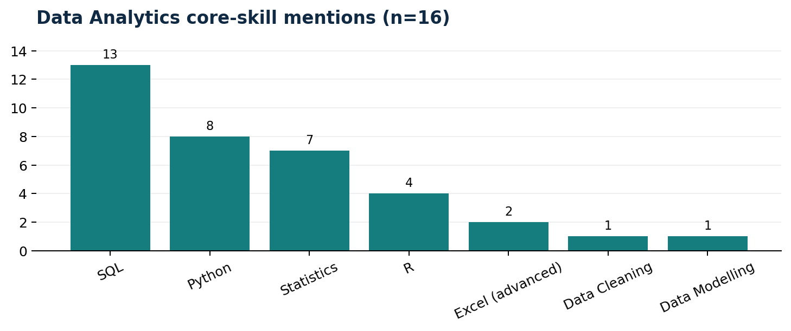
Figure 3. Core analytical skill mentions; denominator = 16.
Core skill | Frequency
SQL | 13/16 — 81.2%
Python | 8/16 — 50.0%
Statistics | 7/16 — 43.8%
R | 4/16 — 25.0%
Excel (advanced) | 2/16 — 12.5%
Data Cleaning | 1/16 — 6.2%
Data Modelling | 1/16 — 6.2%
Source: DA Track, Core Analytical Skills Mentioned.

5. Data Analytics tools, proof and access
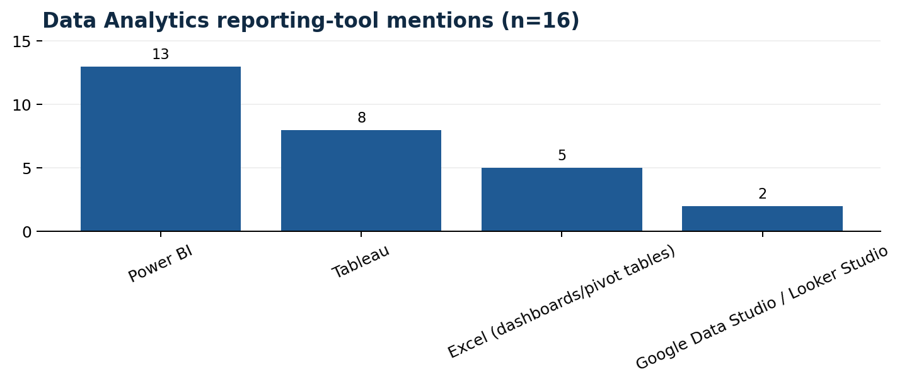
Figure 4. Reporting and visualisation tool mentions; denominator = 16.
Dimension | Evidence | Interpretation
SQL explicit | 13/16 — 81.3% | Supports central rubric treatment
Power BI | 13/16 — 81.3% | Leading BI tool; Tableau follows at 8/16
Excel anywhere | 10/16 — 62.5% | Foundational but not universal in captured fields
Python | 8/16 — 50.0% | Strong secondary skill
Portfolio/GitHub requested | 1/16 — 6.3% | Challenges a 20-point market-led weight
Degree required | 9/16 — 56.3% | Important, with more alternative pathways than SE
Hybrid work | 9/14 known — 64.3% | Similar work-pattern profile to SE
Important caution on data cleaning
Only 1/16 posts is explicitly coded with Data Cleaning in the structured core-skill field. This is insufficient evidence to remove the competency: the field may under-capture wording that appears elsewhere in full adverts.

6. Cross-track comparison
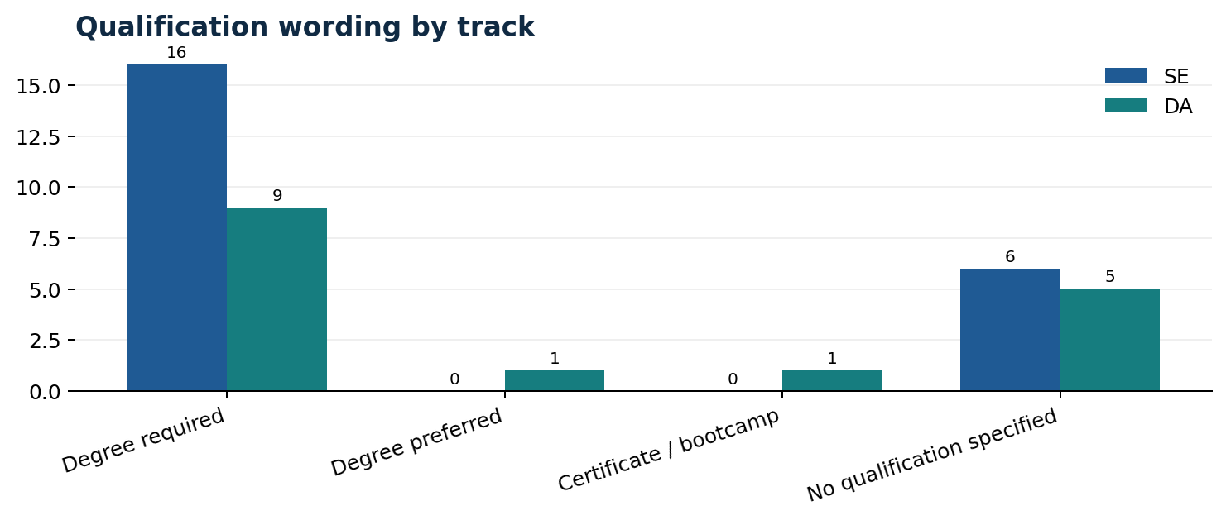
Figure 5. Qualification wording differs in degree, not direction.
Comparable dimension | SE | DA | Meaning
Degree required | 16/22 — 72.7% | 9/16 — 56.3% | More prevalent in SE
No qualification specified | 6/22 — 27.3% | 5/16 — 31.3% | Meaningful minority in both
Portfolio requested | 3/22 — 13.6% | 1/16 — 6.3% | Rarely explicit
Hybrid among known | 14/21 — 66.7% | 9/14 — 64.3% | Near-identical pattern
Remote among known | 2/21 — 9.5% | 1/14 — 7.1% | Minority pattern

Skill combinations
Track | Pair | Posts | Interpretation
SE | .NET + C# | 10/22 | Most repeated SE pair
SE | HTML/CSS + JavaScript | 9/22 | Common web foundation
SE | Git/GitHub + SQL | 9/22 | Version control and data access often coexist
DA | Power BI + SQL | 11/16 | Dominant DA combination
DA | Excel + Power BI | 9/16 | Spreadsheet-to-dashboard pathway
DA | Python + SQL | 7/16 | Technical analysis pathway

7. Soft skills and readiness signals
Themes were counted at post level. A post counts once per theme even when several phrases map to that theme. Original phrases and mappings remain available in the analysis workbook.
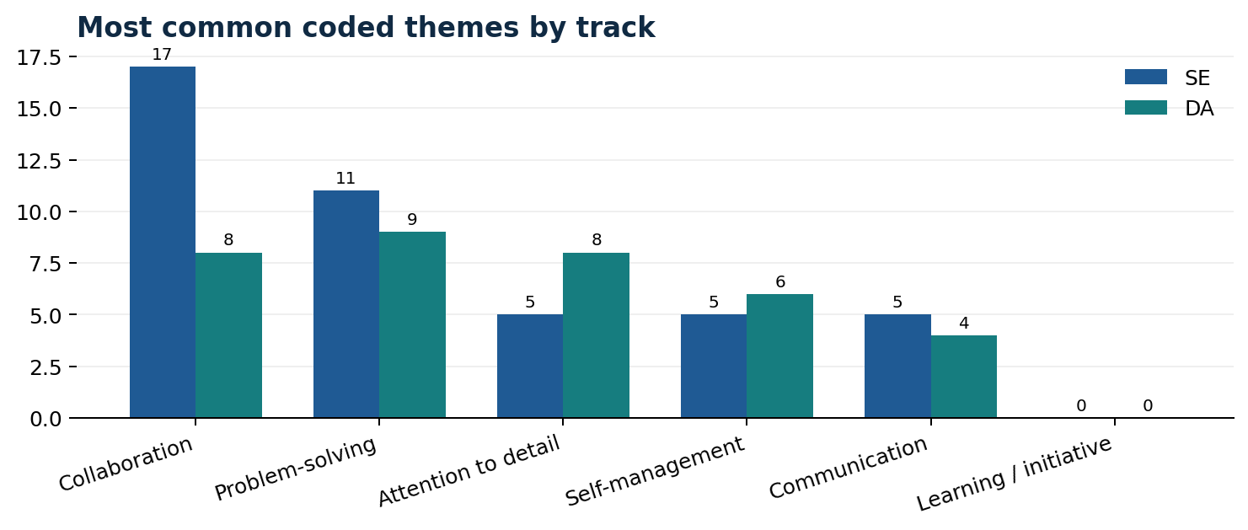
Figure 6. Counts represent posts with at least one coded phrase in the theme.
Theme | SE | DA
Collaboration | 17/22 — 77.3% | 8/16 — 50.0%
Problem-solving | 11/22 — 50.0% | 9/16 — 56.2%
Attention to detail | 5/22 — 22.7% | 8/16 — 50.0%
Self-management | 5/22 — 22.7% | 6/16 — 37.5%
Communication | 5/22 — 22.7% | 4/16 — 25.0%
Learning and initiative | 6/22 — 27.3% | 2/16 — 12.5%
Interpretation boundary
Job adverts show that employers mention behavioural capabilities, but they do not validate the rubric's rule that unsupported phrases such as “team player” must score zero. That remains an assessment-design judgment to test on candidate CVs.

8. Rubric V1 evidence matrix
Verdicts describe how well the job-post sample supports each assumption. They do not implement the Phase 8 decision.
Track | Rubric assumption | Evidence | Verdict
SE | A specifically named programming language is foundational. | Posts naming at least one programming language — 20/22 — 90.9% | Supported
SE | Missing Git should cap Core Technical Skills below the strong band. | Posts explicitly naming Git/GitHub — 11/22 — 50.0% | Partially supported
SE | A named framework is important for strong tool readiness. | Posts naming at least one framework/library — 14/22 — 63.6% | Partially supported
SE | Deployment awareness is a useful differentiator rather than a baseline requirement. | Posts naming AWS, Azure or Docker — 8/22 — 36.4% | Supported
SE | Project and portfolio proof warrants 25% of the total readiness score. | Posts explicitly requesting portfolio/GitHub proof — 3/22 — 13.6% | Challenged
SE | README quality, repository organisation and deployment quality indicate readiness. | Not directly observable in structured job-post fields | Not measurable from job-post data
DA | SQL is the most important entry-level technical skill and missing it should cap the strong band. | Posts explicitly naming SQL — 13/16 — 81.2% | Supported
DA | Excel or spreadsheet capability is foundational. | Posts naming Excel in any captured skill/tool field — 10/16 — 62.5% | Partially supported
DA | Power BI is the leading BI differentiator in the South African sample. | Power BI mentions (compared with Tableau) — 13/16 — 81.2% | Supported
DA | Python is valuable but not universally required. | Posts naming Python — 8/16 — 50.0% | Supported
DA | Data cleaning is a central market requirement. | Posts explicitly coded with Data Cleaning — 1/16 — 6.2% | Insufficient evidence
DA | Project and portfolio proof warrants 20% of the readiness score. | Posts explicitly requesting portfolio/GitHub proof — 1/16 — 6.2% | Challenged
Both | CV structure, clarity and specificity can be market-validated from job posts. | Candidate-CV quality is not observable in job adverts | Not measurable from job-post data
Source: Rubric V1 compared with the locked main-sample frequency tables.

9. Phase 8 decision queue
# | Track | Calibration question
1 | SE | Keep named-language evidence central, but avoid privileging one language without track-specific justification.
2 | SE | Should Git remain a material signal but lose the absolute category cap because only half of adverts name it?
3 | SE | Should framework evidence strengthen a score without being mandatory for every entry-level role?
4 | SE | Retain deployment as bonus evidence and define a modest maximum contribution.
5 | SE | Is 25 points proportionate, or should portfolio proof remain valuable without dominating direct employer evidence?
6 | SE | Retain as product judgment, validate through candidate testing, and avoid claiming market validation.
7 | DA | Keep SQL central; decide whether 81.3% prevalence justifies the current hard cap or a steep scoring penalty.
8 | DA | Keep Excel important but distinguish basic listing from advanced analytical use.
9 | DA | Keep Power BI prominent while allowing equivalent BI tools to earn substantial credit.
10 | DA | Keep Python as a strong secondary skill rather than a prerequisite for a strong overall score.
11 | DA | Do not remove the competency solely because the structured field captured it rarely; verify against fuller wording or candidate testing.
12 | DA | Reduce or reframe the weight unless candidate testing shows portfolio proof predicts report usefulness.
13 | Both | Retain only as an assessment-quality criterion and validate during end-to-end candidate testing.

Definition of Phase 7 completion
Completion test | Outcome
Frequency tables | Complete for track-specific skills, tools, qualifications, experience and work arrangements
Qualitative coding | Complete with original phrases, themes and unique post-theme flags
Cross-track comparison | Complete for genuinely comparable dimensions
Rubric evidence | Complete with supported, partial, challenged, insufficient and not-measurable verdicts
Reproducibility | Workbook formulas reproduce summary counts from auditable coding and source sheets
Rubric changes | None made; decision queue handed to Phase 8
Phase 7 status
Complete. The next authorised phase is evidence-based rubric revision; the current files do not alter Rubric V1.

