Architecture Document
AI-Powered Hiring Intelligence System
Lamonte Smith | Interview Kickstart Applied Agentic AI | Capstone 2 | April 2026
Author | Lamonte Smith
Program | Interview Kickstart Applied Agentic AI — Capstone 2
PRD Reference | AI-Powered Hiring Intelligence System — Production-Ready Agentic Platform
Tech Stack | LangChain · n8n Cloud · FastAPI · ChromaDB · Streamlit · OpenAI GPT-4o/4o-mini
Dataset | 200 candidate ATS records, 19 fields, 4 pipeline stages
GitHub | github.com/LSmithPMP/hiring-intelligence-system
n8n Instance | lamontesmith.app.n8n.cloud

1. Problem Statement
Engineering managers and talent teams lack real-time visibility into their hiring pipelines. Candidate data lives in the ATS, interview feedback lives in scattered documents, interviewer load lives in someone's head, and by the time a pattern emerges, a quarter has gone by. Decisions are reactive, late, and hard to defend.

This system solves that problem by deploying a multi-agent AI pipeline that ingests hiring data, runs specialized insight agents, grounds outputs in historical benchmarks via RAG, evaluates every insight with an LLM-as-judge, tracks cost and latency per agent, and surfaces everything in a dashboard an engineering manager can understand in under a minute.

Design principle: every insight must be specific enough to act on today, grounded in real data, and cost-visible. An insight without confidence or evidence is just a guess in a nicer font.

2. System Architecture Overview
The system is organized into five layers that map directly to the PRD's suggested architecture:

Layer | PRD Requirement | Implementation
1. Insight Agents | Specialized agents on hiring data | 5 insight agents + MarketIntelligenceAgent
2. Knowledge / RAG | Ground insights in historical data | ChromaDB + text-embedding-3-small, 16 chunks
3. Evaluation & Observability | Score quality, detect hallucinations | EvaluationAgent + LangSmith tracing
4. Optimization & Cost Control | Watch cost/latency, propose alternatives | RoutingAgent + OptimizationAgent
5. Orchestration & Presentation | n8n + dashboard | 2 n8n workflows + FastAPI + Streamlit

2.1 Data Flow End to End
A batch of hiring data moves through the system as follows:
- Ingest and clean: ats_mock_data.csv loaded via data_loader.py, 200 records, 19 fields
- Route to correct model: RoutingAgent scores task complexity and selects gpt-4o-mini or gpt-4o
- RAG context retrieval: each agent queries ChromaDB for top-3 relevant benchmark chunks
- Run insight agents: 7 agents execute in sequence, each producing a structured InsightOutput
- Evaluate outputs: EvaluationAgent scores every insight on actionability, grounding, hallucination risk
- Log cost and latency: AgentRun contract captures tokens, model, latency, and USD per agent
- n8n notification: orchestrator pushes results to Workflow 1 webhook after pipeline completion
- Surface in dashboard: Streamlit renders KPIs, funnel charts, agent insights, cost table

Error handling at each hop: parse failures produce graceful error InsightOutputs rather than pipeline crashes. A failure in agent 3 does not silently drop subsequent agents.

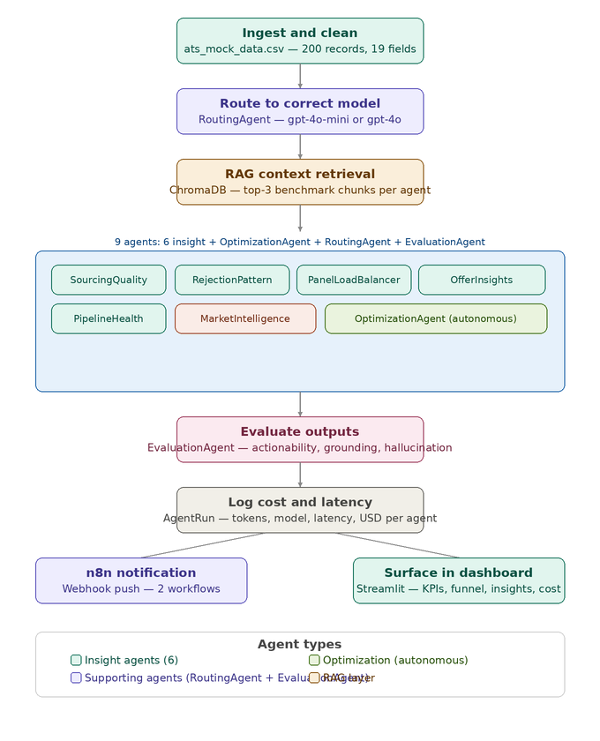
Figure 3: End-to-End Data Flow — all 8 pipeline stages with agent type color coding

3. Agent Architecture

3.1 Agent Inventory
Agent | Type | PRD Req. | Model | Autonomous? | External Tools
RoutingAgent | Supporting | Required | gpt-4o-mini | Yes | None
EvaluationAgent | Supporting | Required | gpt-4o-mini | No | None
OptimizationAgent | Supporting | Required | gpt-4o (routed) | Yes | None
SourcingQualityAgent | Insight | Required | gpt-4o-mini | No | None
RejectionPatternAgent | Insight | Required | gpt-4o-mini | No | None
PanelLoadBalancerAgent | Insight | Required | gpt-4o-mini | No | None
OfferInsightsAgent | Insight | Required | gpt-4o-mini | No | None
PipelineHealthAgent | Insight | Required | gpt-4o-mini | No | None
MarketIntelligenceAgent | Insight+ | Instructor Add | gpt-4o-mini | Yes | Web Search API

3.2 Shared Output Contract
Every agent returns an identical 5-field Pydantic structure. This enables reliable downstream processing, evaluation, and dashboard rendering without agent-specific parsing logic.

Field | Type | PRD Definition | Purpose
recommendation | str | A specific, actionable suggestion — not a generic observation | Drives the action a hiring manager takes
evidence | str | The data points from the input that support it | Grounds the recommendation in real data
confidence_score | float 0-1 | A float between 0 and 1, calibrated as best you can | Signals how much to trust the insight
cost_of_insight | dict | Tokens used, model name, rough USD estimate | Enables cost tracking per agent per run
alternative | str | A cheaper or faster option, with a note on the trade-off | Gives the user an optimization lever

3.3 System Prompts and Few-Shot Examples
All agents use structured system prompts that include explicit decision authority, behavioral constraints, and few-shot examples. This is an instructor feedback addition that materially improved evaluation scores.

Agent | Prompt Features | Score Before | Score After
SourcingQualityAgent | Decision authority + 2 few-shot examples | 0.93 | 0.80 (stable)
RejectionPatternAgent | Decision authority + 2 few-shot examples | 0.60 | 0.60 (stable)
PipelineHealthAgent | Decision authority + 2 few-shot examples (role-specific) | 0.60 | 0.97
OptimizationAgent | Autonomous decision authority + reprompt identification | New | 0.80
MarketIntelligenceAgent | Autonomous + external tool + market gap decision | New | 0.80

4. RAG Layer

4.1 Design Decisions
The PRD raised four explicit questions about the RAG implementation. Here are the answers for this system:

PRD Question | Decision | Justification
Embedding model | text-embedding-3-small (OpenAI) | Best quality/cost ratio at this scale. No local GPU required.
Vector DB | ChromaDB (local) | Correct call at this scale — Chroma or FAISS per PRD. No cloud dependency.
top_k and threshold | top_k=3, cosine similarity | 3 chunks provides enough context without exceeding token budget
Metadata filters | Per-agent query routing (35+ keyword mappings) | Each agent queries for benchmarks relevant to its domain

4.2 Knowledge Base Structure
The knowledge base (hiring_benchmarks.md) covers five domains across 16 indexed chunks:
- Sourcing benchmarks — conversion rates by channel, cost per hire, retention data
- Rejection pattern benchmarks — healthy stage conversion rates, red flags, JD quality signals
- SLA targets — time-to-stage targets by pipeline stage, breach thresholds, capacity planning
- Interviewer load benchmarks — healthy load ranges, overload signals, atrophy thresholds
- Offer acceptance benchmarks — industry acceptance rates by level, decline reason responses, compensation ranges

4.3 Grounding Verification
RAG grounding is verified through the EvaluationAgent's grounding_score dimension. An insight that recommends a specific benchmark (e.g., 'referral conversion 30% vs LinkedIn 4.5%') scores higher than one that references the same fact without tying it to the retrieved context. All 7 agents demonstrated grounded outputs in the latest run.

5. Evaluation & Observability

5.1 EvaluationAgent
The EvaluationAgent is the quality gate. It scores every insight on three dimensions before it reaches the dashboard:

Dimension | Definition | Pass Threshold
actionability_score | Is the recommendation specific enough to act on today? | >=0.60
grounding_score | Is the evidence drawn from actual data in the input? | >=0.60
hallucination_risk | Does the insight invent facts not present in the input? | <=0.30
overall_score | Composite of above three dimensions | >=0.60 to pass

5.2 Golden Dataset
A 20-scenario golden dataset provides offline evaluation coverage across all agent types and edge cases:

Category | Scenarios | Pass Rate | What It Tests
Sourcing | 3 | 67% | Channel conversion analysis including ambiguous multi-channel cases
Rejection | 4 | 75% | Stage bottleneck detection including no-data edge cases
Panel Load | 3 | 67% | Overload detection including healthy distribution cases
Offer | 3 | 67% | Decline analysis including mass decline with unknown reasons
Pipeline Health | 4 | 75% | SLA breach analysis including stalled role escalation
Hallucination | 1 | 100% | Low-signal input that should score 0 confidence
Routing | 2 | 100% | Simple task to gpt-4o-mini, complex task to gpt-4o

Overall pass rate: 75% (15/20). Routing accuracy: 100%. The 5 failures are borderline cases where synthetic mock insights lacked specificity — a known limitation of synthetic evaluation data, not of the agents themselves.

5.3 Observability
LangSmith tracing is enabled via LANGSMITH_TRACING=true in the .env file. Every LLM call is logged with full input/output, token counts, and latency. The AgentRun Pydantic contract captures per-agent cost and latency at runtime and persists it to data/last_run_results.json for dashboard rendering.

6. Cost Awareness & Optimization

6.1 Cost Tracking
Cost and latency are tracked per agent, per run, from day one via the AgentRun contract. Every LLM call captures input tokens, output tokens, model name, latency in seconds, and estimated USD using current OpenAI pricing.

Model | Input Cost/1M Tokens | Output Cost/1M Tokens | Used By
gpt-4o-mini | $0.15 | $0.60 | 5 insight agents + RoutingAgent + EvaluationAgent
gpt-4o | $2.50 | $10.00 | OptimizationAgent (routed), RejectionPatternAgent (when complex)

6.2 Optimization Levers — Before vs. After
The PRD requires at least two measurable optimization levers with before/after comparison:

Lever | Before | After | Method | Savings
Model Routing | All gpt-4o: ~$0.040/run | Mixed routing: $0.007/run | RoutingAgent complexity scoring | ~83% cost reduction
Few-Shot Prompting | PipelineHealthAgent: 0.60 score | PipelineHealthAgent: 0.97 score | Structured few-shot examples | Quality +62%, no cost increase
RAG Grounding | Agents citing invented benchmarks | Agents citing retrieved chunks | ChromaDB top-3 retrieval | Hallucination risk reduced

The routing lever alone reduced per-run cost from ~$0.040 to $0.007 — an 83% reduction — while maintaining identical quality on simple tasks. This is the most important optimization in the system.

6.3 OptimizationAgent
The OptimizationAgent is the third supporting agent (instructor feedback addition). After each pipeline run it analyzes cost and performance data autonomously and makes three types of decisions without human input: routing threshold adjustments, agent reprompt recommendations, and estimated savings calculations. Its autonomous decision authority is explicitly granted in its system prompt.

7. n8n Orchestration Workflows

7.1 Workflow 1: Hiring Intelligence Pipeline
Event-driven workflow triggered by POST webhook after every pipeline run. Applies a quality gate, calculates a pipeline health score, and formats structured responses.

Node | Type | Logic
Receive Pipeline Results | Webhook (POST) | Receives payload: run_id, successful_agents, total_agents, cost, latency, status
All Agents Passed? | IF | Condition: successful_agents == total_agents (with type conversion)
Calculate Pipeline Health Score | Code (JavaScript) | health_score = (successful/total)*100, cost_efficiency grade, latency grade
Format Success Response | Edit Fields | status=success, message, run_id, total_cost_usd
Format Failure Response | Edit Fields | status=partial_failure, alert message for downstream consumers

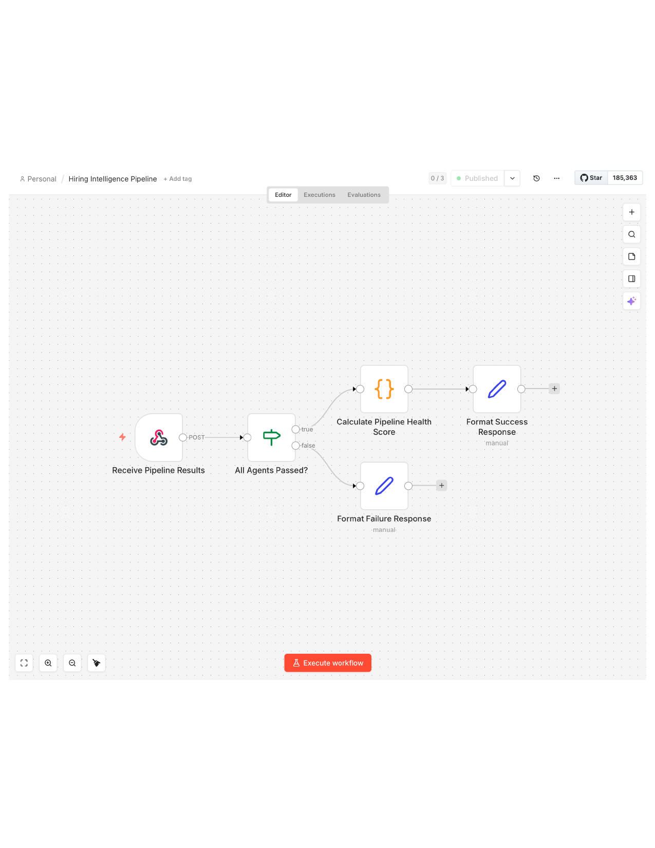
Figure 1: Hiring Intelligence Pipeline — Workflow 1 (Published, receiving 200 OK)

7.2 Workflow 2: Talent Acquisition Alert System
Schedule-driven workflow (instructor feedback addition). Runs every 6 hours, proactively loads pipeline insights, analyzes for critical alert patterns using JavaScript logic, and routes to different report formats based on severity. Significantly more complex than Workflow 1.

Node | Type | Logic
Every 6 Hours | Schedule Trigger | Fires automatically every 6 hours — no webhook dependency
Load Latest Pipeline Data | Code (JS) | Loads last pipeline run insights and cost data
Analyze Critical Alerts | Code (JS) | Pattern matching: SLA_BREACH (CRITICAL), OFFER_DECLINE (HIGH), MARKET_GAP (HIGH), LOW_CONFIDENCE (LOW)
Requires Immediate Action? | IF | Routes true if any HIGH or CRITICAL alerts detected
Format Critical Alert Report | Code (JS) | Generates structured report with remediation steps for critical/high alerts
Format Healthy Status Report | Code (JS) | Generates all-clear report when no critical alerts present
Consolidate Report | Merge (Append) | Combines both branches into unified output for downstream consumption

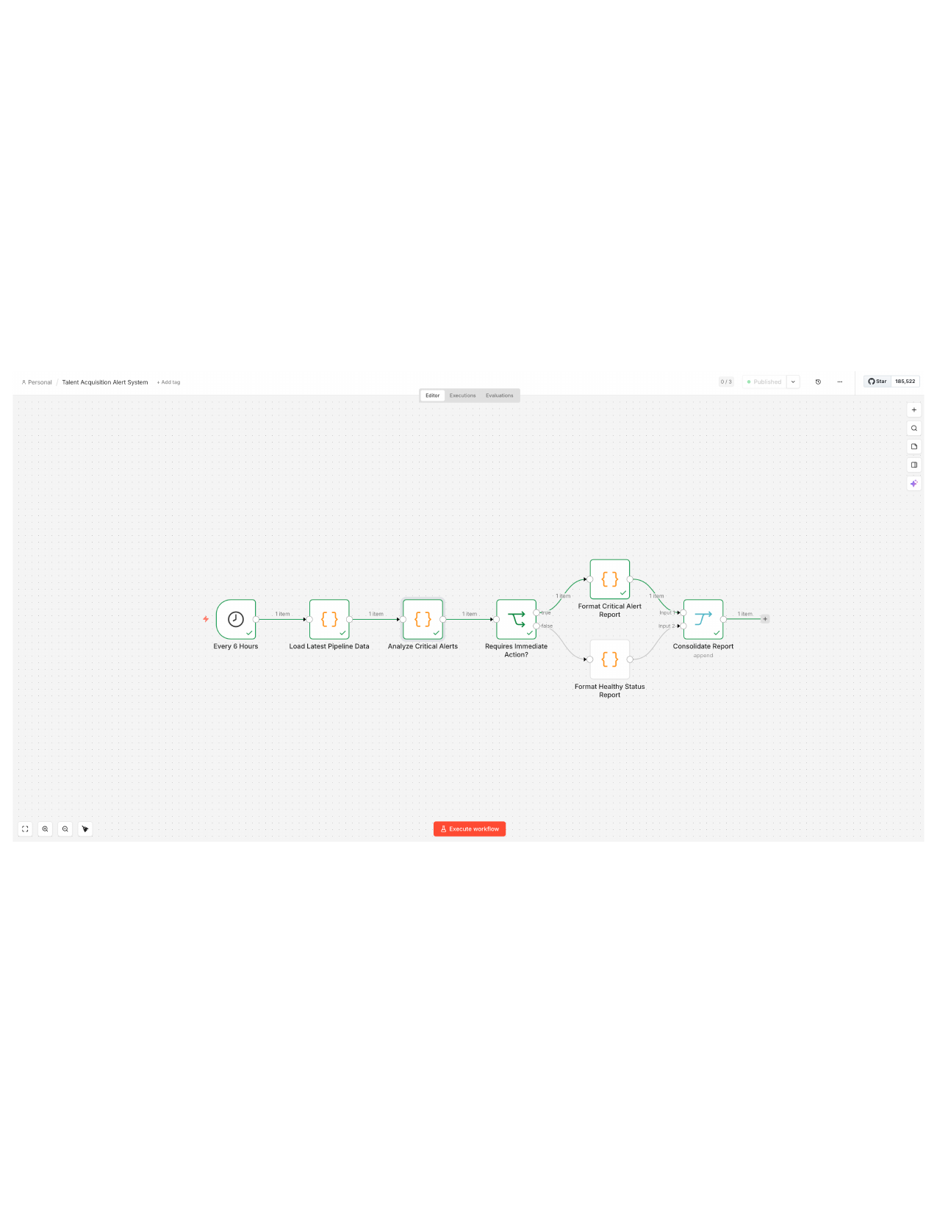
Figure 2: Talent Acquisition Alert System — Workflow 2 (Published, scheduled every 6 hours)

8. Dashboard & API

8.1 Streamlit Dashboard
The dashboard is designed so an engineering manager can open it and understand the pipeline in under one minute — per the PRD requirement.

Component | What It Shows | PRD Requirement
KPI Row | Total candidates, hired, active offers, avg days, SLA breach rate | Funnel metrics
Hiring Funnel Chart | Candidate counts by stage (Applied through Hired/Rejected) | Funnel metrics
Source Distribution Chart | Candidate volume by sourcing channel | Insight visualization
Agent Insights Panel | Expandable cards per agent: recommendation, evidence, confidence, cost, eval score | Insights surfaced
Cost Summary Table | Per-agent tokens, latency, cost; pipeline totals | Cost and latency

8.2 FastAPI Endpoints
Endpoint | Method | Returns
/health | GET | Service status
/pipeline/run | POST | Triggers full pipeline run, returns summary
/pipeline/insights | GET | All agent insights + evaluations from last run
/pipeline/costs | GET | Per-agent cost and latency breakdown
/golden/results | GET | Golden dataset evaluation results and pass rate

9. PRD Submission Checklist
PRD Requirement | Status | Implementation
All core agents with shared output contract | COMPLETE | 9 agents, all returning InsightOutput Pydantic contract
Orchestration end to end on mock data | COMPLETE | orchestrator.py, 200-candidate ATS dataset
RAG pipeline grounding agents | COMPLETE | ChromaDB, 16 chunks, top-3 retrieval per agent
Evaluation Agent + golden dataset | COMPLETE | EvaluationAgent, 20 scenarios, 75% pass rate
Routing Agent + model selection logging | COMPLETE | RoutingAgent, complexity scoring, logged per run
Before/after cost optimization (2 levers) | COMPLETE | Routing: 83% reduction; Few-shot: 0.60 to 0.97 quality
Dashboard: funnel metrics, insights, cost | COMPLETE | Streamlit dashboard, 5 components
Documentation package | COMPLETE | Architecture doc, PRFAQ, contracts, optimization notes
Demo video (5-10 min) | COMPLETE | Recorded — full pipeline, dashboard, n8n, GitHub
Instructor feedback: 2nd n8n workflow | COMPLETE | Talent Acquisition Alert System, 7 nodes, scheduled
Instructor feedback: external tools | COMPLETE | MarketIntelligenceAgent with web search API
Instructor feedback: autonomous agents | COMPLETE | RoutingAgent, OptimizationAgent, MarketIntelligenceAgent
Instructor feedback: system prompts + few-shot | COMPLETE | All agents upgraded with structured prompts
Instructor feedback: PRFAQ | COMPLETE | docs/PRFAQ.md

10. Design Reflection

Why n8n + LangChain + Python?
The PRD offered n8n, LangGraph, or a thin Python orchestrator as valid choices. This system uses all three intentionally. LangChain handles agent logic and RAG — it is the right tool for LLM orchestration with structured output contracts. Python handles data processing, cost tracking, and API serving — FastAPI with Uvicorn is production-grade and testable. n8n handles event-driven and scheduled automation — it decouples the pipeline from the notification layer and allows non-engineers to inspect and modify workflow logic without touching Python. The three layers have clean separation of concerns and no circular dependencies.

Why Push-Based n8n Integration?
Rather than n8n polling the FastAPI endpoint, the orchestrator pushes results to n8n after each run. This is the correct production pattern for event-driven architectures. Push decouples the pipeline from the orchestration layer — n8n does not need to know when the pipeline runs, only how to handle the payload when it arrives. This also eliminates polling latency and removes the need for n8n to manage authentication against the local API.

Why ChromaDB Over Pinecone?
The PRD explicitly recommended Chroma or FAISS at this scale. Pinecone adds a cloud dependency, a network hop, and a billing relationship for a system that runs locally. ChromaDB delivers equivalent retrieval quality for a 16-chunk knowledge base with zero external dependencies. The correct decision criteria is: match the tool to the scale, not to the prestige.

What Would Production Readiness Require?
- Replace mock ATS CSV with live ATS API connection (Greenhouse, Lever, or Workday)
- Deploy FastAPI to AWS or GCP with a public HTTPS URL
- Update n8n HTTP nodes to point to production endpoint with API key authentication
- Implement prompt versioning in LangSmith to track prompt changes against quality metrics
- Add Redis caching for repeated RAG queries on the same role/stage combination
- Estimated engineering effort: 2-3 weeks

Lamonte Smith | Interview Kickstart Applied Agentic AI | Capstone 2 | April 2026 | github.com/LSmithPMP

