To start the project, I first made the player controls  
The player is a circular object fixed in the middle of the x axis, and only moves up and down, hence only Y axis movement values have to be changed

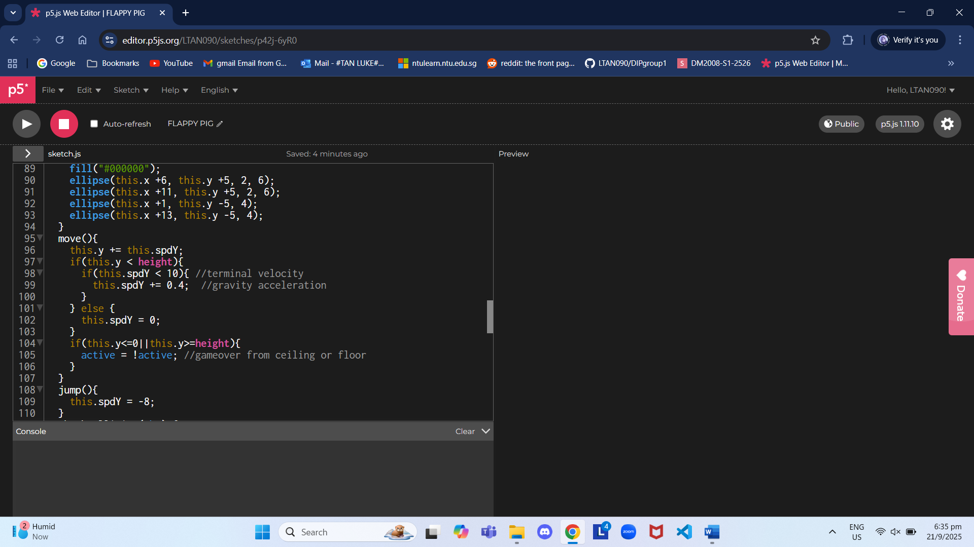

The player will constantly move downwards at an accelerating speed up to a certain value, until space is pressed which turns the vertical speed into a negative value, causing it to move upwards for a short time. A game over is caused if player height exceeds the boundaries of the screen.

Objects are spawned in using the constructor given by the sample code, and move from right to left on the x axis, and disappear after going off screen

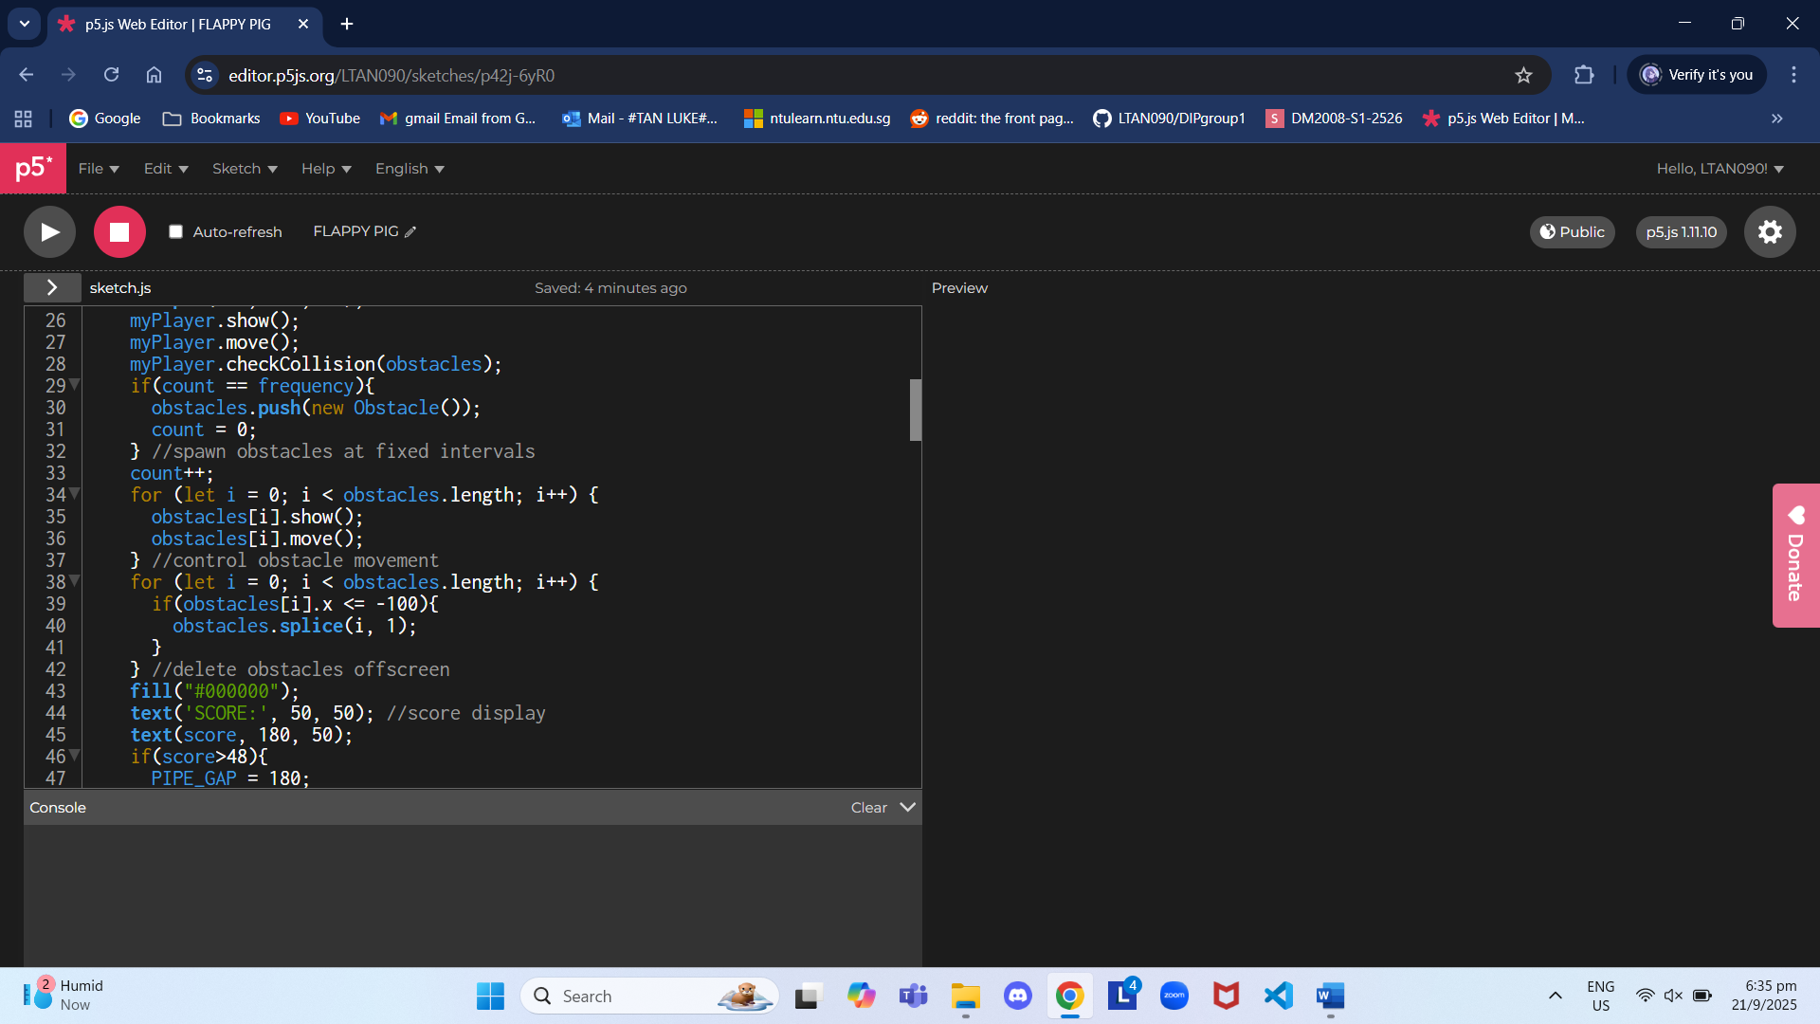

Player collision was made by checking the x axis distance from the obstacle, and then the y axis distance from the center of the gap. Due to the circular player model, the x axis detection is made slightly less than the sum of player and obstacle size to allow the rounded edge to pass

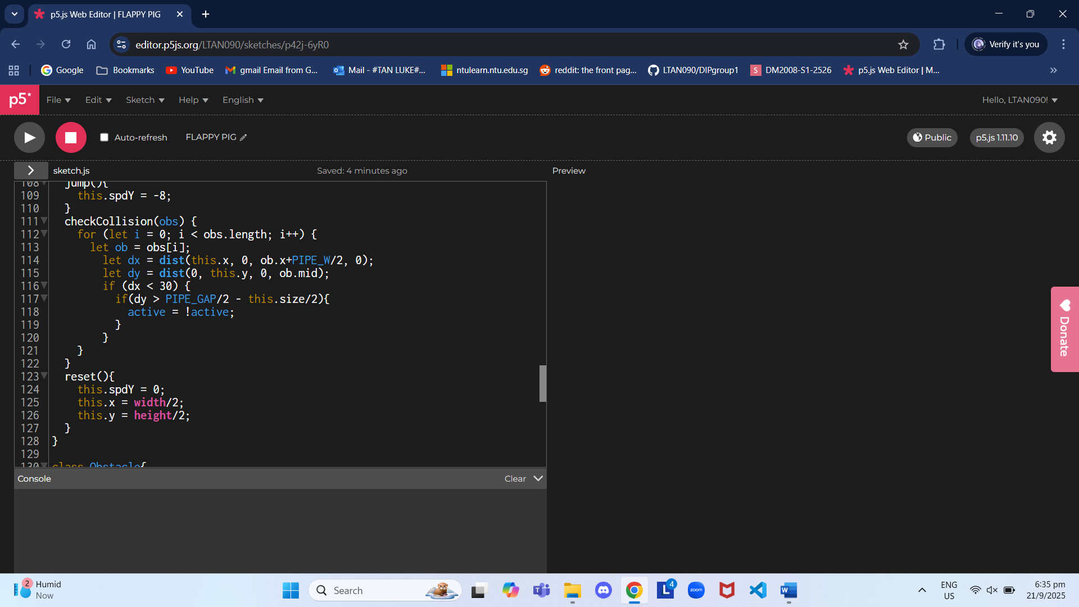

Score is incremented when the player can no longer collide with the obstacle

The game is toggled between active and inactive states by clicking from the start screen and getting a game over

