Национальный исследовательский ядерный университет «МИФИ»

ОТЧЁТ

о выполнении контрольного домашнего задания

«Связные списки и структуры, деревья»

Выполнил: студент 1 курса группы С19-103 Оленников В.Д.

Преподаватель: Пчелинцев А.В.

Москва 2020г.

**Текст** **задачи**

Необходимо разработать программу, которая реализует алгоритм выбора вариантов с помощьюдеревьев, построенных на структурах.

1. Для создания программы должны быть использованы связные списки структур.

2. Структуры образуют дерево с **тремя** и более уровнями, число пунктов меню от 2 до 5 плюс пункт возврата в меню предыдущего уровня.

3. После выбора пункта меню самого нижнего уровня программа завершает работу, и на экран выводится перечень выбранных пунктов. В случае отказа от данного меню (возврат в меню верхнего уровня) необходимо исключить из списка выбора пункт, соответствующий меню, в которое вернулась программа.

4. В программе используются четыре вида деревьев (пункт **«Вид дерева»**). Нужно реализовать один из них.

5. Деревья создаются динамически и подлежат редактированию (пункты **«Листья»** и

**«Поддеревья»**).

6. В созданном дереве провести расчет элементов (пункт **«Расчёт»**).

7. Продемонстрировать «путешествие» по уровням дерева, а также вывести на экран

информацию об элементах (пункт **«Вывод»**).

8. Название элементов должно соответствовать одной тематике (пункт **«Тема»**).

**Вариант 29**

А) **Вид дерева** – двоичное

Б) **Листья** - удалить «лист» дерева

В) **Поддеревья** - выделить поддерево из дерева (удалить все остальные элементы)

Г) **Расчёт** - подсчитать количество ветвей

Д) **Вывод** - ветви с минимальным числом узлов

Е) **Тема** - план работы менеджера футбольной команды

**Алгоритм решения**

1. Разработать алгоритмы обработки данных. Каждый алгоритм реализовать в отдельной

функции. Также должны быть дополнительные функции.

2. Подготовить алгоритм работы меню.

3. Подготовить алгоритм (блок-схему) работы программы.

4. Подготовить текст программы, провести отладку программы, используя возможности

встроенного отладчика интегрированной среды программирования.

5. Подготовить два варианта программы: в виде отдельных функций, расположенных в одном файле; в виде библиотеки функций, расположенных в разных файлах.

6. Подготовить отчёт о проделанной работе

.

**Блок-схемы алгоритма**

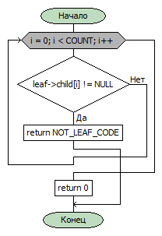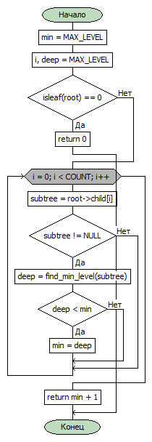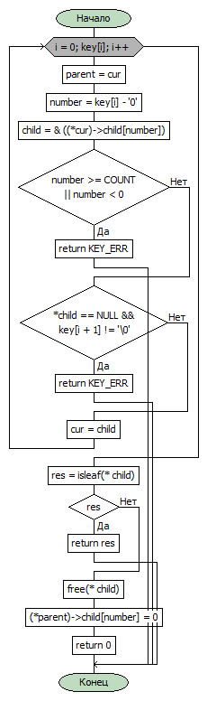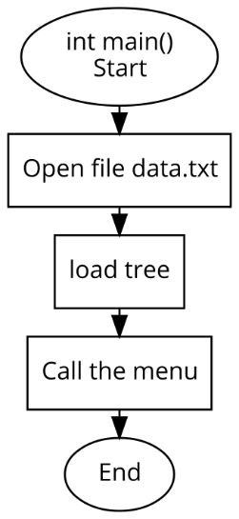

isleaf

find_min_level

delete_leaf

Функция int main()

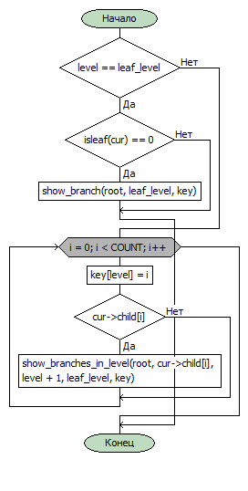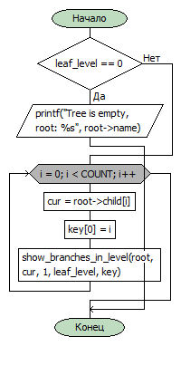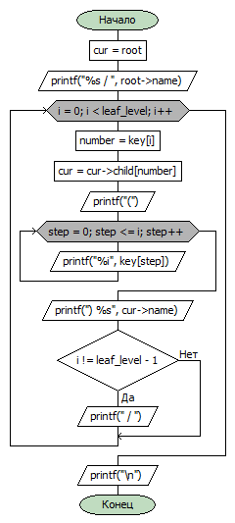

show_branch

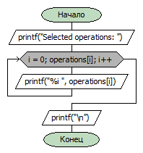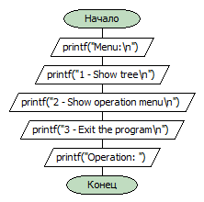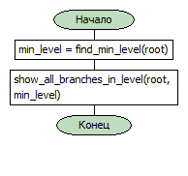

show_menu_main

show_selected_operations

show_all_branches_min_nodes

show_all_branches_in_level

show_branches_in_level

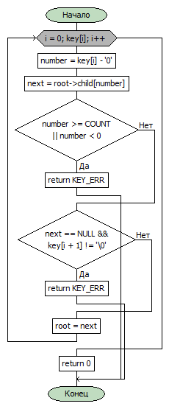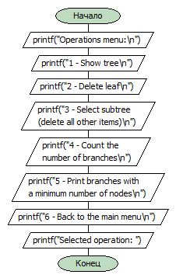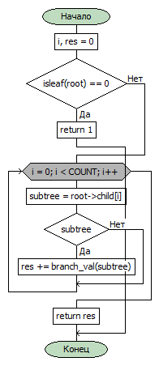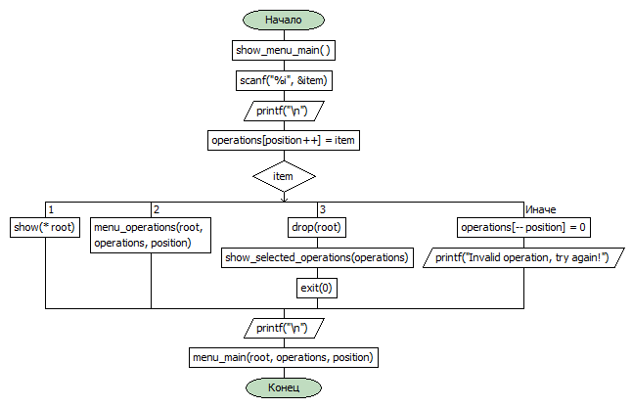

check_key

branch_val

show_menu_operation

menu_main

**Текст программы**

**Вариант в виде отдельных функций, расположенных в одном файле. Файл main.cpp**

/*

Name: BDZ3 Trees, variant 29

Author: Vadim Olennikov

*/

#define COUNT ( 2 ) /*maximum number of children per node */

#define LENGTH ( 100 )/* max name's length */

#define TEMPL_SIZE ( 20 )/* characters to read string */

#define KEY ( 8 ) /* max key length */

#define NOT_LEAF_CODE ( -4 )/* if node is not leaf */

#define KEY_ERR ( -2 )/* if key is wrong */

#define MEMORY_ERR ( -1 )

#define FILE_OPEN_ERR ( -5 )

#define MAX_LEVEL ( 100 )/*max tree level*/

#define OPERATIONS ( 100 )/* The number of operations selected by the user */

#include <stdio.h>

#include <stdlib.h>

#include <string.h>

typedef struct _node node;

struct _node

{

char name[ LENGTH ];

node *child[ COUNT ];

};

int add( node **root, char *key, char *name);/* add new element to tree */

int load(node ** root, char * filename);/* load tree from file */

node *create_leaf( char *name );/* create new leaf of tree */

void show( node *root );/* show tree */

void show_subtree( node *root, int level );/* help function for show */

void drop( node **cur );/*delete tree */

int load_exept_root( FILE *file, node **root );

int isleaf( node *leaf );

int delete_leaf( node **root, char *key );

int highlight_subtree( node **root, char *key );

int check_key( node *cur, char *key );

int branch_val( node *root );

int find_min_level( node *root );

void show_all_branches_in_level( node *root, int level_leaf );

void show_branches_in_level( node *root, node *cur, int level, int leaf_level, int *key );

void show_branch( node *root, int leaf_level, int *key );

void show_all_branches_min_nodes( node *root );

void menu_main( node **root, int *operations, int position );

void show_menu_main();

void menu_operations( node **root, int *operations, int position );

void show_selected_operations( int *operations );

void show_menu_operation();

void putNULL( int *operations );

int main()

{

int res;

int operations[ OPERATIONS ];

node *root = 0;

char filename[] = "data.txt";

putNULL( operations );

res = load( &root, filename );

if( res == 0 )

menu_main( &root, operations, 0 );//start position in arr is 0

else

{

printf( "File open error");

exit FILE_OPEN_ERR;

}

return 0;

}

void putNULL( int *operations )

{

int i;

for( i = 0; i < OPERATIONS; i++ )

operations[ i ] = 0;

}

int add( node **cur, char *key, char *name)/* add new element to tree */

{

int i, number;

node **next;/* next level pointer */

/* create new leaf */

node * element;

element = create_leaf( name );

if( element == NULL )/* if a memory allocation error occurred */

return MEMORY_ERR;

for( i = 0; key[ i ]; i++ )

{

number = key[ i ] - '0';/* number of child; convert char to int */

next = &( ( *cur )->child[ number ] );/* next level pointer */

if( number >= COUNT || number < 0 )//if key is wrong

return KEY_ERR;;

if( *next == NULL && key[ i + 1 ] != '\0' )/* if parent of our element doesn't exist */

return KEY_ERR;

cur = next;/* go to child number key[ i ] */

}

( *cur ) = element;

return 0;/* successful execution */

}

int load (node ** root, char * filename)/* load tree from file */

{

int res_load;/* result of scanning subtree*/

FILE * file;

char name[ LENGTH ];

char templateSTR[ TEMPL_SIZE ];/* to read a given number of characters */

sprintf( templateSTR, "%%%is", LENGTH );

file = fopen( filename, "r" );

if( file == NULL )

return -3;/* file open error */

if( fscanf( file, templateSTR, name ) > 0 )/* put data in root */

*root = create_leaf( name );

res_load = load_exept_root( file, root );

fclose( file );

return res_load;/* result of scanning */

}

int load_exept_root( FILE *file, node **root )

{

int res_add, res_scan = 1;/* result of scanning */

char key[ KEY ], name[ LENGTH ];

char templateSTR[ TEMPL_SIZE ];/* to read a given number of characters */

sprintf( templateSTR, "%%%is", LENGTH );

for( ; res_scan > 0; )

{

res_scan = fscanf( file, templateSTR, key );

res_scan = fscanf( file, templateSTR, name );

if( res_scan > 0 )/* if name is scanned successful */

res_add = add( root, key, name );/*root is pointer to pointer and it doesn't change here*/

if( res_add != 0 )//not success add

return res_add;

}

return 0;

}

node *create_leaf ( char *name )/* create new leaf of tree */

{

int i;

node *element;

element =( node* ) malloc( sizeof( node ) );

if( element == NULL )/* if a memory allocation error occurred */

return NULL;

strcpy( element->name, name );

for( i = 0; i < COUNT; i++ )

element->child[ i ] = NULL; /* because element doesn't have children */

return element;

}

/*-------------------------------------------------------------------

Example of result:

-> root

|-> 1

| |-> 4

| | |-> 5

| | |-> 6

| |-> 7

|-> 2

|-> 3

*/

void show( node *root )

{

int i;

if( root == NULL )

return;/* tree is empty */

printf( "-> %s\n", root->name );

for( i = 0; i < COUNT; i++ )

show_subtree( root->child[ i ], 1 );/* next level is 1 */

}

void show_subtree( node *root, int level )/* help function for tree, for formatted output */

{

int i;

if( root == NULL )

return;/* subtree is empty, exit from recursing */

for( i = 0; i < level; i++ )/* print | to display the level */

printf( "%4c", '|');

printf( "-> %s\n", root->name );

for( i = 0; i < COUNT; i++ )

show_subtree( root->child[ i ], level + 1 );/* next recursion level */

}

void drop( node **cur ){

int i;

if( *cur == NULL )

return;/* exit from recursion */

for( i = 0; i < COUNT; i++ )

drop( &( ( *cur )->child[ i ] ) );

free( *cur );

*cur = 0;

}

int delete_leaf( node **cur, char *key )

{

int i, number, res;

node **parent, **child;

for( i = 0; key[ i ]; i++ )//go to element number key

{

parent = cur;

number = key[ i ] - '0';/* number of child; convert char to int */

child = &( ( *cur )->child[ number ] );/* next level pointer */

if( number >= COUNT || number < 0 )//if key is wrong

return KEY_ERR;

if( *child == NULL && key[ i + 1 ] != '\0' )/* if parent of our element doesn't exist */

return KEY_ERR;

cur = child;

}

res = isleaf( *child );

if( res )//if key is not for leaf

return res;

free( *child );//delete leaf

( *parent )->child[ number ] = 0;

return 0;

}

/*--------------------------------------------------

Checks if node is leaf (hasn't children)

Returns NOT_LEAF_CODE if node is note leaf

Returns 0 if success

leaf - pointer to node

*/

int isleaf( node *leaf ){

int i;

for( i = 0; i < COUNT; i++ )

{

if( leaf->child[ i ] != NULL )

return NOT_LEAF_CODE;

}

return 0;

}

/*

Select subtree from tree (delete all other items)

Returns KEY_ERR if node with code doesn't exist

Returns 0 if success

root - pointer to pointer to tree root

( we have to change pointer to tree )

*/

int highlight_subtree( node **root, char *key )

{

int i, step, number;

node *parent;

/*we have no right to make a mistake */

if( check_key( *root, key ) )

return KEY_ERR;

for( i = 0; key[ i ]; i++ )

{

number = key[ i ] - '0';/* number of child we need; convert char to int */

for( step = 0; step < COUNT; step++ )

if( step != number )

drop( &( ( *root )->child[ step ] ) );//delete brothers of element

parent = *root;

*root = ( *root )->child[ number ];//go to next level

free( parent );//delete parent

}

return 0;

}

/*--------------------------------------------------------------------

Checks the correctness of the key

If the node with the given number does not exist,

returns KEY_ERR

root - pointer to tree root, main node

key - code of node in tree

*/

int check_key( node *root, char *key ){

int i, number;

node *next;

for( i = 0; key[ i ]; i++ )

{

number = key[ i ] - '0';/* number of child; convert char to int */

next = root->child[ number ];/* next level pointer */

if( number >= COUNT || number < 0 )//if key is wrong

return KEY_ERR;

if( next == NULL && key[ i + 1 ] != '\0')/* if parent of our element doesn't exist */

return KEY_ERR;

root = next;/* go to child number key[ i ] */

}

return 0;

}

/*----------------------------------------------------------

Return the number of branches in tree

the number of branches is equal to the number of leaves

root - pointer to tree root

*/

int branch_val( node *root ){

int i, res = 0;

node *subtree;

/* the number of branches is equal to the number of leaves */

if( isleaf( root ) == 0 )

return 1;//exit from recursion

for( i = 0; i < COUNT; i++ )

{

subtree = root->child[ i ];//pointers to subtrees

if( subtree )//if pointer is not NULL

res += branch_val( subtree );//call next recursion level

}

return res;

}

/*---------------------------------------------------------------

Shows all branches with a minimum number of nodes

root - pointer to tree root

*/

void show_all_branches_min_nodes( node *root )

{

int min_level;

min_level = find_min_level( root );

show_all_branches_in_level( root, min_level );

}

/*----------------------------------------------

Finds the minimum branch length in a tree

root - pointer to tree root

*/

int find_min_level( node *root ){

node *subtree;

int min = MAX_LEVEL;

int i, deep = MAX_LEVEL;

if( isleaf( root ) == 0 )

return 0;/* exit from recursion */

for( i = 0; i < COUNT; i++ )

{

subtree = root->child[ i ];//pointer to child

if( subtree != NULL )//if child exists

{

deep = find_min_level( subtree );/* subtree depth */

if( deep < min )

min = deep;

}

}

return min + 1;

}

/*-----------------------------------------------------

Displays all branches with leaves at the leaf_level

root - pointer to tree root

leaf_level - the level at which the leaves of

the tree should be; branch length

*/

void show_all_branches_in_level( node *root, int leaf_level ){

int i;

int key[ leaf_level ];

node *cur;

if( leaf_level == 0 )//if tree is only root

{

printf( "Tree is empty, root: %s", root->name );

return;

}

for( i = 0; i < COUNT; i++ )

{

cur = root->child[ i ];

key[ 0 ] = i;//code of first node

show_branches_in_level( root, cur, 1, leaf_level, key );//because next level is 1

}

}

/*-------------------------------------------------------------

Recursive function shows all branches with leaf on leaf_level

root - pointer to tree root

cur - pointer to node

level - level of node with pointer cur

leaf_level - the level at which the leaves of the tree should be

key - code of node with pointer cur

*/

void show_branches_in_level( node *root, node *cur,

int level, int leaf_level,

int *key )

{

int i;

if( level == leaf_level )

{

if( isleaf( cur ) == 0 )//if elem from leaf_level is leaf

show_branch( root, leaf_level, key );

return;//exit from recursion

}

for( i = 0; i < COUNT; i++ )//next recursion level

{

key[ level ] = i;

if( cur->child[ i ] )//if child exists

show_branches_in_level( root, cur->child[ i ],

level + 1, leaf_level,

key );

}

}

/*------------------------------------------------------------------

The function displays the branch on the screen

along with the data in the nodes and their code

root - pointer to tree root

leaf_level - branch length, leaf level

key - pointer to arr with code of leaf on branch

*/

void show_branch( node *root, int leaf_level, int *key ){

int i, step, number;

node *cur = root;

printf( "%s / ", root->name );//show root name

for( i = 0; i < leaf_level; i++ )

{

number = key[ i ];

cur = cur->child[ number ];

printf( "(" );

for( step = 0; step <= i; step++ )

printf( "%i", key[ step ] );//show element's code

printf( ") %s", cur->name );//show data from node

if( i != leaf_level - 1 )//formatted output,

printf( " / " );//not required for last element

}

printf( "\n" );

}

/*--------------------------------------------------------

Shows transaction information

processes the operation code selected by the user

root - pointer to pointer to tree root( we can change pointer to tree )

operations - pointer to int arr with operations data

position - number of next filling position in operations array

*/

void menu_main( node **root, int *operations, int position )

{

int item;

show_menu_main();

scanf( "%i", &item );

printf( "\n" );

operations[ position++ ] = item;

switch( item )

{

case 1 :

show( *root );

break;

case 2 :/*Show operation menu*/

menu_operations( root, operations, position );

break;

case 3 :/*Exit the program*/

drop( root );

show_selected_operations( operations );//show list with selected menu items

exit( 0 );

default :

operations[ --position ] = 0;//deselection

printf( "Invalid operation, try again!" );

}

printf( "\n" );

menu_main( root, operations, position );

}

/*------------------------------------------------------

Function shows main program menu

*/

void show_menu_main(){

printf( "Menu:\n" );

printf( "1 - Show tree\n" );

printf( "2 - Show operation menu\n" );

printf( "3 - Exit the program\n" );

printf( "Operation: " );

}

/*--------------------------------------------------------

Shows transaction information

processes the operation selected by the user

root - pointer to pointer to tree root( we can change pointer to tree )

operations - pointer to int arr with operations data

position - number of next filling position in operations array

*/

void menu_operations( node **root, int *operations, int position )

{

int item;/* selected code */

char key[ KEY ];

show_menu_operation();

scanf( "%i", &item );

printf( "\n" );

operations[ position++ ] = item;/*fill operation arr */

switch( item ){

case 1 :/*Show tree */

show( *root );

break;

case 2 :/*Delete leaf */

printf( "Enter key of leaf: " );

scanf( "%s", key );

delete_leaf( root, key );

break;

case 3 :/*Select subtree from tree (delete all other items) */

printf( "To cancel, enter -1. Enter key of node: " );

scanf( "%s", key );/* subtree root key */

highlight_subtree( root, key );

break;

case 4 :/*Count the number of branches */

printf( "Number of branches = %i\n", branch_val( *root ) );

break;

case 5 :/* Print branches with a minimum number of nodes */

show_all_branches_min_nodes( *root );

break;

case 6 :/* Back to the main menu */

if( operations[ position - 1 ] == 2 )/* delete operation from history */

operations[ --position ] = 0;

menu_main( root, operations, position );

default :

if( operations[ position] )

operations[ --position ] = 0;/* deselection */

printf( "Invalid operation, try again!" );

}

printf( "\n" );

menu_operations( root, operations, position );

}

/*----------------------------------------------

Print on display user selected operations

Example: 1 1 2 3 3 5 3

operations - pointer to int arr with operations data

*/

void show_selected_operations( int *operations ){

int i;

printf("Selected operations: " );

for( i = 0; operations[ i ]; i++ )

printf( "%i ", operations[ i ] );

printf("\n" );

}

/*------------------------------------------------------

Function shows information about operations in program

*/

void show_menu_operation(){

printf( "Operations menu:\n" );

printf( "1 - Show tree\n" );

printf( "2 - Delete leaf\n" );

printf( "3 - Select subtree (delete all other items)\n" );

printf( "4 - Count the number of branches\n" );

printf( "5 - Print branches with a minimum number of nodes\n" );

printf( "6 - Back to the main menu\n" );

printf( "Selected operation: " );

}

**Данные текстового файла**

**Файл data.txt**

Plan

0 finance

00 players

000 defenders

0000 midfielders

0001 goalkeeper

01 inventory

010 balls

011 uniform

1 management

10 match

100 comand

101 briefing

11 media

110 advertising

111 interview

**Результат работы программы**

*Данные, введенные пользователем, подчеркнуты*

**Демонстрация главного меню, меню операций и вывода дерева:**

Menu:

1 - Show tree

2 - Show operation menu

3 - Exit the program

Operation: 1

-> Plan

|-> finance

| |-> players

| | |-> defenders

| | | |-> midfielders

| | | |-> goalkeeper

| |-> inventory

| | |-> balls

| | |-> uniform

|-> management

| |-> match

| | |-> comand

| | |-> briefing

| |-> media

| | |-> advertising

| | |-> interview

Menu:

1 - Show tree

2 - Show operation menu

3 - Exit the program

Operation: 2

**Демонстрация операции удаления листа (здесь и далее для краткости не показан переход в меню операций)**

Operations menu:

1 - Show tree

2 - Delete leaf

3 - Select subtree (delete all other items)

4 - Count the number of branches

5 - Print branches with a minimum number of nodes

6 - Back to the main menu

Selected operation: 2

Enter key of leaf: 0000

**Изменения дерева, удаленный лист выделен:**

|  |  |
| --- | --- |
| До операции | После |
| -> Plan  |-> finance  | |-> players  | | |-> defenders  | | | |-> midfielders  | | | |-> goalkeeper  | |-> inventory  | | |-> balls  | | |-> uniform  |-> management  | |-> match  | | |-> comand  | | |-> briefing  | |-> media  | | |-> advertising  | | |-> interview | -> Plan  |-> finance  | |-> players  | | |-> defenders  | | | |-> goalkeeper  | |-> inventory  | | |-> balls  | | |-> uniform  |-> management  | |-> match  | | |-> comand  | | |-> briefing  | |-> media  | | |-> advertising  | | |-> interview |

**Демонстрация операции выделения поддерева**

Operations menu:

1 - Show tree

2 - Delete leaf

3 - Select subtree (delete all other items)

4 - Count the number of branches

5 - Print branches with a minimum number of nodes

6 - Back to the main menu

Selected operation: 3

To cancel, enter -1. Enter key of node: 0

**Изменения дерева, выбранный пользователем корень поддерева выделен:**

|  |  |
| --- | --- |
| До операции | После |
| -> Plan  |-> finance  | |-> players  | | |-> defenders  | | | |-> midfielders  | | | |-> goalkeeper  | |-> inventory  | | |-> balls  | | |-> uniform  |-> management  | |-> match  | | |-> comand  | | |-> briefing  | |-> media  | | |-> advertising  | | |-> interview | -> finance  |-> players  | |-> defenders  | | |-> midfielders  | | |-> goalkeeper  |-> inventory  | |-> balls  | |-> uniform |

**Подсчет количества ветвей в исходном дереве:**

Operations menu:

1 - Show tree

2 - Delete leaf

3 - Select subtree (delete all other items)

4 - Count the number of branches

5 - Print branches with a minimum number of nodes

6 - Back to the main menu

Selected operation: 4

Number of branches = 8

**Демонстрация операции вывода ветвей с минимальным числом узлов:**

Operations menu:

1 - Show tree

2 - Delete leaf

3 - Select subtree (delete all other items)

4 - Count the number of branches

5 - Print branches with a minimum number of nodes

6 - Back to the main menu

Selected operation: 5

finance / (1) inventory / (10) balls

finance / (1) inventory / (11) uniform

**Выход из программы:**

Operations menu:

1 - Show tree

2 - Delete leaf

3 - Select subtree (delete all other items)

4 - Count the number of branches

5 - Print branches with a minimum number of nodes

6 - Back to the main menu

Selected operation: 6

Menu:

1 - Show tree

2 - Show operation menu

3 - Exit the program

Operation: 3

Selected operations: 1 2 2 1 3 1 4 5 6 3

Process returned 0 (0x0) execution time : 64.618 s

Press any key to continue.

**Заключение**

Цель работы - научиться составлять отчеты. В результате работы создан отчет о проделанной работе на 22 страницы. Недостатком программы является наличие синтаксиса языка C в блок-схемах.