1. **编译安装php-5.6.8**

yum -y install libxml2 libxml2-devel bzip2-devel libcurl libcurl-devel readline readline-devel gmp-devel libpng-devel freetype-devel libjpeg-devel mcrypt libmcrypt-devel

wget http://cn2.php.net/distributions/php-5.6.8.tar.gz

tar zxf php-5.6.8.tar.gz

配置php，测试环境可开启debug功能：--enable-debug

./configure --prefix=/data/install/phpcluster/php1 --with-config-file-path=/data/install/phpcluster/php1/etc --with-config-file-scan-dir=/data/install/phpcluster/php1/etc --with-mysql=mysqlnd --with-mysqli=mysqlnd --with-pdo-mysql=mysqlnd --enable-opcache --enable-fpm --enable-static --enable-inline-optimization --enable-sockets --enable-wddx --enable-zip --enable-calendar --enable-bcmath --enable-soap --with-zlib --with-iconv --with-gd --enable-gd-native-ttf --with-xmlrpc --enable-mbstring --without-sqlite3 --without-pdo-sqlite --with-curl --enable-ftp --with-mcrypt --with-freetype-dir=/usr/include/ --with-jpeg-dir=/usr/include/ --with-png-dir=/usr/include/ --with-openssl --with-fpm-user=www --with-fpm-group=www --disable-maintainer-zts --disable-fileinfo --disable-ipv6 --disable-debug

make && make install

cp php.ini-production /data/install/php/etc/php.ini

cp /data/install/php/etc/php-fpm.conf.default /data/install/php/etc/php-fpm.conf

cp sapi/fpm/init.d.php-fpm /etc/init.d/php-fpm

chmod +x /etc/init.d/php-fpm

groupadd www

useradd -M -s /sbin/nologin -g www www

**使用unix sock与nginx通信**

sed -i 's%127.0.0.1:9000%/data/install/phpcluster/php1/php1.sock%g' /data/install/phpcluster/php1/etc/php-fpm.conf

sed -i 's%127.0.0.1:9000%/data/install/phpcluster/php2/php2.sock%g' /data/install/phpcluster/php2/etc/php-fpm.conf

sed -i 's%127.0.0.1:9000%/data/install/phpcluster/php3/php3.sock%g' /data/install/phpcluster/php3/etc/php-fpm.conf

sed -i 's%127.0.0.1:9000%/data/install/phpcluster/php4/php4.sock%g' /data/install/phpcluster/php4/etc/php-fpm.conf

sed -i '71 i\ chmod o+w /data/install/phpcluster/php1/php1.sock' /data/install/phpcluster/php1/php-fpm

sed -i '71 i\ chmod o+w /data/install/phpcluster/php2/php2.sock' /data/install/phpcluster/php2/php-fpm

sed -i '71 i\ chmod o+w /data/install/phpcluster/php3/php3.sock' /data/install/phpcluster/php3/php-fpm

sed -i '71 i\ chmod o+w /data/install/phpcluster/php4/php4.sock' /data/install/phpcluster/php4/php-fpm

sed -i 's%;listen.allowed_clients%listen.allowed_clients%g' /data/install/phpcluster/php*/etc/php-fpm.conf

sed -i 's#;rlimit_files = 1024#rlimit_files = 4096#g' /data/install/phpcluster/php*/etc/php-fpm.conf

进程数设置

#生产环境的配置

sed -i 's/pm.max_children = 5/pm.max_children = 200/g' /data/install/phpcluster/php*/etc/php-fpm.conf

sed -i 's/pm.start_servers = 2/pm.start_servers = 10/g' /data/install/phpcluster/php*/etc/php-fpm.conf

sed -i 's/pm.min_spare_servers = 1/pm.min_spare_servers = 5/g' /data/install/phpcluster/php*/etc/php-fpm.conf

sed -i 's/pm.max_spare_servers = 3/pm.max_spare_servers = 200/g' /data/install/phpcluster/php*/etc/php-fpm.conf

**13的配置**

sed -i 's/pm.max_children = 5/pm.max_children = 50/g' /data/install/phpcluster/php*/etc/php-fpm.conf

sed -i 's/pm.start_servers = 2/pm.start_servers = 20/g' /data/install/phpcluster/php*/etc/php-fpm.conf

sed -i 's/pm.min_spare_servers = 1/pm.min_spare_servers = 10/g' /data/install/phpcluster/php*/etc/php-fpm.conf

sed -i 's/pm.max_spare_servers = 3/pm.max_spare_servers = 30/g' /data/install/phpcluster/php*/etc/php-fpm.conf

**sed -i 's/expose_php = On/expose_php = Off/g' /data/install/phpcluster/php*/etc/php.ini**

**echo -e "disable_functions = system,exec,shell_exec,passthru,popen,dl,phpinfo" >> /data/install/phpcluster/php1/etc/php.ini**

**echo -e "disable_functions = system,exec,shell_exec,passthru,popen,dl,phpinfo" >> /data/install/phpcluster/php2/etc/php.ini**

**echo -e "disable_functions = system,exec,shell_exec,passthru,popen,dl,phpinfo" >> /data/install/phpcluster/php3/etc/php.ini**

**echo -e "disable_functions = system,exec,shell_exec,passthru,popen,dl,phpinfo" >> /data/install/phpcluster/php4/etc/php.ini**

**sed -i 's/allow_url_fopen = On/allow_url_fopen = Off/g' /data/install/phpcluster/php*/etc/php.ini**

**sed -i 's/sql.safe_mode = Off/ql.safe_mode = On/g' /data/install/phpcluster/php*/etc/php.ini**

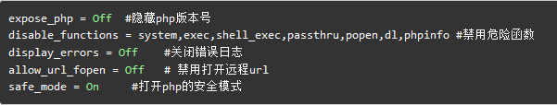

1. **配置Nginx支持php**

**location ~ \.php$ {**

**root /data/php;**

**fastcgi_pass php-pool;**

**fastcgi_index index.php;**

**fastcgi_param SCRIPT_FILENAME $document_root$fastcgi_script_name;**

**include fastcgi_params;**

**}**

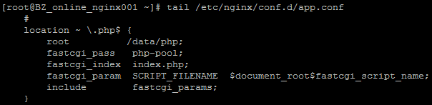

**Nginx配置负载均衡**

**upstream php-pool {**

**server unix:/data/install/phpcluster/php1/php1.sock max_fails=3 fail_timeout=5s;**

**server unix:/data/install/phpcluster/php2/php2.sock max_fails=3 fail_timeout=5s;**

**server unix:/data/install/phpcluster/php3/php3.sock max_fails=3 fail_timeout=5s;**

**server unix:/data/install/phpcluster/php3/php3.sock max_fails=3 fail_timeout=5s;**

**}**

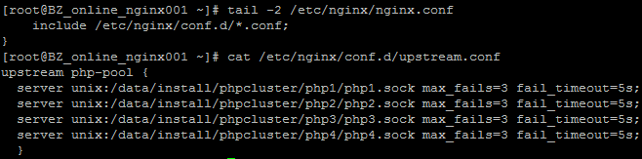

1. **测试phpinfo、php连接mysql**

phpinfo是函数：

<?php

phpinfo();

?>

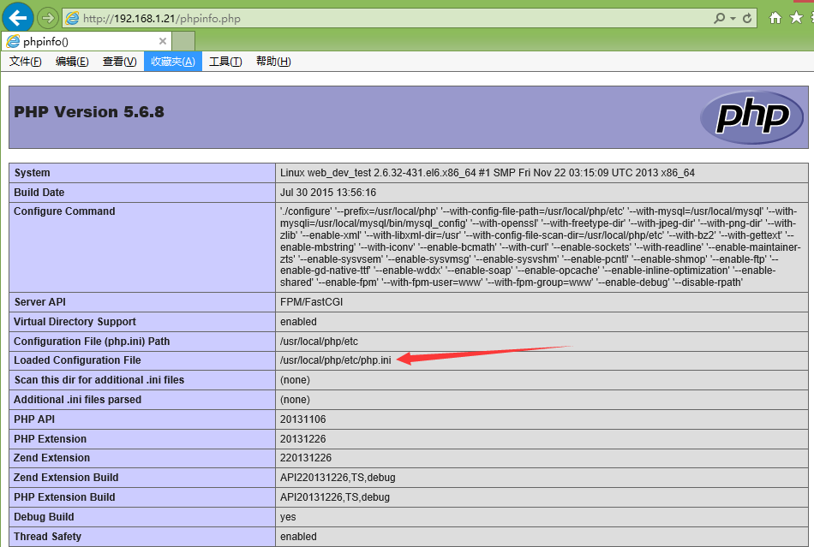

在php官网的mysql栏<http://php.net/manual/zh/set.mysqlinfo.php>下的<http://php.net/manual/zh/function.mysql-connect.php>可以查阅mysql_connect函数打开mysql连接的用法：

<?php  
$link = mysql_connect('localhost', 'mysql_user', 'mysql_password');  
if (!$link) {  
    die('Could not connect: ' . mysql_error());  
}  
echo 'Connected successfully';  
mysql_close($link);  
?>

<?php

$link = mysql_connect('localhost', 'root', '123456');

if (!$link) {

die('Could not connect: ' . mysql_error());

}

echo 'Connected successfully';

mysql_close($link);

?>



1. **安装扩展**

**安装redis扩展**

**不是要安装redis-3，而是安装redis的php pecl**

**下载链接：http://pecl.php.net/get/redis-2.2.7.tgz**

**tar zxvf redis-2.2.7.tgz**

**cd redis-2.2.7**

**/data/install/php/bin/phpize**

**./configure --with-php-config=/data/install/php/bin/php-config**

**make && make install**

**在/data/install/php/etc/增加redis.ini**

**echo extension = redis.so >> /data/install/php/etc/redis.ini**

**重启php-fpm**

**service php-fpm restart**



**安装yaf扩展**

**进入yaf源代码目录，执行phpize命令**

**phpize**

**./configure --with-php-config=/data/install/php/bin/php-config**

**make && make install**

**加入yaf.ini到php配置文件目录下**

**echo extension = yaf.so >> /data/install/php/etc/yaf.ini**

**重启php**

**安装swoole扩展**

**下载swoole-src-master.zip**

**unzip swoole-src-master.zip**

**cd swoole-src-master**

**phpize**

**./configure --with-php-config=/data/install/php/bin/php-config**

**make && make install**

**echo extension = swoole.so >> /data/install/php/etc/swoole.ini**

**重启php-fpm**

安装memcache扩展

tar zxf memcache-3.0.8.tgz

cd memcache-3.0.8

/data/install/phpcluster/php1/bin/phpize

./configure --enable-memcache --with-php-config=/data/install/phpcluster/php1/bin/php-config

make && make install

/data/install/phpcluster/php2/bin/phpize

./configure --enable-memcache --with-php-config=/data/install/phpcluster/php2/bin/php-config

make && make install

/data/install/phpcluster/php3/bin/phpize

./configure --enable-memcache --with-php-config=/data/install/phpcluster/php3/bin/php-config

make && make install

echo extension = memcache.so >> /data/install/phpcluster/php1/etc/memcache.ini

echo extension = memcache.so >> /data/install/phpcluster/php2/etc/memcache.ini

echo extension = memcache.so >> /data/install/phpcluster/php3/etc/memcache.ini

vim /data/install/phpcluster/php3/etc/memcache.ini

extension_dir = "/data/install/phpcluster/php3/lib/php/extensions/no-debug-non-zts-20131226/"

session.save_handler = memcache

session.save_path = "tcp://127.0.0.100:11211"

sed -i 's%; extension_dir = "./"%extension_dir = "/data/install/phpcluster/php1/lib/php/extensions/debug-non-zts-20131226/"%g' /data/install/phpcluster/php1/etc/php.ini

sed -i 's%; extension_dir = "./"%extension_dir = "/data/install/phpcluster/php2/lib/php/extensions/debug-non-zts-20131226/"%g' /data/install/phpcluster/php2/etc/php.ini

安装memcached扩展

必须先安装了libmemcached-1.0.18.tar.gz

这里我禁用了memcached的sasl认证

tar zxf libmemcached-1.0.18.tar.gz

cd libmemcached-1.0.18

./configure --prefix=/data/install/libmemcached --with-memcached

make && make install

tar zxf memcached-2.2.0.tgz

cd memcached-2.2.0

/data/install/phpcluster/php1/bin/phpize

./configure --with-libmemcached-dir=/data/install/libmemcached --with-php-config=/data/install/phpcluster/php1/bin/php-config --enable-memcached --disable-memcached-sasl

make && make install

/data/install/phpcluster/php2/bin/phpize

./configure --with-libmemcached-dir=/data/install/libmemcached --with-php-config=/data/install/phpcluster/php2/bin/php-config --enable-memcached --disable-memcached-sasl

make && make install

/data/install/phpcluster/php3/bin/phpize

./configure --with-libmemcached-dir=/data/install/libmemcached --with-php-config=/data/install/phpcluster/php3/bin/php-config --enable-memcached --disable-memcached-sasl

make && make install

安装yar扩展

yar-1.2.4.tgz

**tar zxvf** yar-1.2.4**.tgz**

**cd** yar-1.2.4

**/data/install/php/bin/phpize**

**./configure --with-php-config=/data/install/php/bin/php-config**

**make && make install**

**在/data/install/php/etc/增加redis.ini**

**echo extension = yar.so >> /data/install/php/etc/yar.ini**

**重启php-fpm**

**service php-fpm restart**

echo extension = memcached.so >> /data/install/phpcluster/php1/etc/memcached.ini

echo extension = memcached.so >> /data/install/phpcluster/php2/etc/memcached.ini

echo extension = memcached.so >> /data/install/phpcluster/php3/etc/memcached.ini

1. **单个安装php脚本**

tar zxf php-5.6.8.tar.gz

./configure --prefix=/data/install/phpcluster/php1 --with-config-file-path=/data/install/phpcluster/php1/etc --with-config-file-scan-dir=/data/install/phpcluster/php1/etc --with-mysql=mysqlnd --with-mysqli=mysqlnd --with-pdo-mysql=mysqlnd --enable-opcache --enable-fpm --enable-static --enable-inline-optimization --enable-sockets --enable-wddx --enable-zip --enable-calendar --enable-bcmath --enable-soap --with-zlib --with-iconv --with-gd --enable-gd-native-ttf --with-xmlrpc --enable-mbstring --without-sqlite3 --without-pdo-sqlite --with-curl --enable-ftp --with-mcrypt --with-freetype-dir=/usr/include/ --with-jpeg-dir=/usr/include/ --with-png-dir=/usr/include/ --with-openssl --with-fpm-user=www --with-fpm-group=www --disable-maintainer-zts --disable-fileinfo --disable-ipv6 --enable-debug

make && make install

cp php.ini-production /data/install/phpcluster/php1/etc/php.ini

cp /data/install/php/etc/php-fpm.conf.default /data/install/phpcluster/php1/etc/php-fpm.conf

cp sapi/fpm/init.d.php-fpm /data/install/phpcluster/php1/php-fpm

chmod +x /data/install/phpcluster/php1/php-fpm

groupadd www

useradd -M -s /sbin/nologin -g www www

sed -i 's%127.0.0.1:9000%/data/install/phpcluster/php1/php1.sock%g' /data/install/phpcluster/php1/etc/php-fpm.conf

sed -i 's%;listen.allowed_clients%listen.allowed_clients%g' /data/install/phpcluster/php*/etc/php-fpm.conf

sed -i '71 i\ chmod o+w /data/install/phpcluster/php1/php1.sock' /data/install/phpcluster/php1/php-fpm

**echo -e '[yaf]\nyaf.environ = product\nyaf.library = NULL\nyaf.cache_config = 0\nyaf.name_suffix = 1\nyaf.name_separator = ""\nyaf.forward_limit = 5\nyaf.use_namespace = 0\nyaf.use_spl_autoload = 0\n' >> /data/install/phpcluster/php1/etc/php.ini**

sed -i 's/max_execution_time = 30/max_execution_time = 60/g' /data/install/phpcluster/php{1,2,3}/etc/php.ini

sed -i 's/display_errors = Off/display_errors = On/g' /data/install/phpcluster/php{1,2,3}/etc/php.ini

sed -i 's/post_max_size = 8M/post_max_size = 64M/g' /data/install/phpcluster/php{1,2,3}/etc/php.ini

sed -i 's/upload_max_filesize = 2M/upload_max_filesize = 64M/g' /data/install/phpcluster/php{1,2,3}/etc/php.ini

sed -i 's%;date.timezone =%date.timezone = PRC%g' /data/install/phpcluster/php{1,2,3}/etc/php.ini

**sed -i 's/pm.max_children = 5/pm.max_children = 50/g' /data/install/phpcluster/php*/etc/php-fpm.conf**

**sed -i 's/pm.start_servers = 2/pm.start_servers = 20/g' /data/install/phpcluster/php*/etc/php-fpm.conf**

**sed -i 's/pm.min_spare_servers = 1/pm.min_spare_servers = 10/g' /data/install/phpcluster/php*/etc/php-fpm.conf**

**sed -i 's/pm.max_spare_servers = 3/pm.max_spare_servers = 30/g' /data/install/phpcluster/php*/etc/php-fpm.conf**

tar zxf libmemcached-1.0.18.tar.gz

cd libmemcached-1.0.18

./configure --prefix=/data/install/libmemcached --with-memcached

make && make install

cd /root

tar zxf memcached-2.2.0.tgz

cd memcached-2.2.0

/data/install/phpcluster/php1/bin/phpize

./configure --with-libmemcached-dir=/data/install/libmemcached --with-php-config=/data/install/phpcluster/php1/bin/php-config --enable-memcached --disable-memcached-sasl

make && make install

cd /root

tar zxf memcache-3.0.8.tgz

cd memcache-3.0.8

/data/install/phpcluster/php1/bin/phpize

./configure --enable-memcache --with-php-config=/data/install/phpcluster/php1/bin/php-config

make && make install

cd /root

tar zxf yaf-2.3.5.tgz

cd yaf-2.3.5

/data/install/phpcluster/php1/bin/phpize

./configure --with-php-config=/data/install/phpcluster/php1/bin/php-config

make && make install

cd /root

unzip swoole-src-master.zip

cd swoole-src-master

/data/install/phpcluster/php1/bin/phpize

./configure --with-php-config=/data/install/phpcluster/php1/bin/php-config

make && make install

cd /root

tar zxf redis-2.2.7.tgz

cd redis-2.2.7

/data/install/phpcluster/php1/bin/phpize

./configure --with-php-config=/data/install/phpcluster/php1/bin/php-config

make && make install

cd /root

echo extension = memcache.so >> /data/install/phpcluster/php1/etc/memcache.ini

echo extension = memcached.so >> /data/install/phpcluster/php1/etc/memcached.ini

echo extension = redis.so >> /data/install/phpcluster/php1/etc/redis.ini

echo extension = yaf.so >> /data/install/phpcluster/php1/etc/yaf.ini

echo extension = swoole.so >> /data/install/phpcluster/php1/etc/swoole.ini

cd /root

rm -rf memcache-3.0.8 memcached-2.2.0 php-5.6.8 redis-2.2.7 swoole-src-master yaf-2.3.5

1. **测试环境安装脚本**

yum -y install libxml2 libxml2-devel bzip2-devel libcurl libcurl-devel readline readline-devel gmp-devel libpng-devel freetype-devel libjpeg-devel

groupadd www

useradd -g www -M -s /sbin/nologin www

mkdir /data/install/phpcluster

tar zxf php-5.6.8.tar.gz

cd php-5.6.8

./configure --prefix=/data/install/phpcluster/php1 --with-config-file-path=/data/install/phpcluster/php1/etc --with-config-file-scan-dir=/data/install/phpcluster/php1/etc --with-mysql=mysqlnd --with-mysqli=mysqlnd --with-pdo-mysql=mysqlnd --enable-opcache --enable-fpm --enable-static --enable-inline-optimization --enable-sockets --enable-wddx --enable-zip --enable-calendar --enable-bcmath --enable-soap --with-zlib --with-iconv --with-gd --enable-gd-native-ttf --with-xmlrpc --enable-mbstring --without-sqlite3 --without-pdo-sqlite --with-curl --enable-ftp --with-mcrypt --with-freetype-dir=/usr/include/ --with-jpeg-dir=/usr/include/ --with-png-dir=/usr/include/ --with-openssl --with-fpm-user=www --with-fpm-group=www --disable-maintainer-zts --disable-fileinfo --disable-ipv6 --enable-debug

make && make install

cp /data/install/phpcluster/php1/etc/php-fpm.conf.default /data/install/phpcluster/php1/etc/php-fpm.conf

cp php.ini-production /data/install/phpcluster/php1/etc/php.ini

cp sapi/fpm/init.d.php-fpm /data/install/phpcluster/php1/php-fpm

chmod +x /data/install/phpcluster/php1/php-fpm

cd /root

rm -rf php-5.6.8

tar zxf php-5.6.8.tar.gz

cd php-5.6.8

./configure --prefix=/data/install/phpcluster/php2 --with-config-file-path=/data/install/phpcluster/php2/etc --with-config-file-scan-dir=/data/install/phpcluster/php2/etc --with-mysql=mysqlnd --with-mysqli=mysqlnd --with-pdo-mysql=mysqlnd --enable-opcache --enable-fpm --enable-static --enable-inline-optimization --enable-sockets --enable-wddx --enable-zip --enable-calendar --enable-bcmath --enable-soap --with-zlib --with-iconv --with-gd --enable-gd-native-ttf --with-xmlrpc --enable-mbstring --without-sqlite3 --without-pdo-sqlite --with-curl --enable-ftp --with-mcrypt --with-freetype-dir=/usr/include/ --with-jpeg-dir=/usr/include/ --with-png-dir=/usr/include/ --with-openssl --with-fpm-user=www --with-fpm-group=www --disable-maintainer-zts --disable-fileinfo --disable-ipv6 --enable-debug

make && make install

cp /data/install/phpcluster/php2/etc/php-fpm.conf.default /data/install/phpcluster/php2/etc/php-fpm.conf

cp php.ini-production /data/install/phpcluster/php2/etc/php.ini

cp sapi/fpm/init.d.php-fpm /data/install/phpcluster/php2/php-fpm

chmod +x /data/install/phpcluster/php2/php-fpm

cd /root

rm -rf php-5.6.8

tar zxf php-5.6.8.tar.gz

cd php-5.6.8

./configure --prefix=/data/install/phpcluster/php3 --with-config-file-path=/data/install/phpcluster/php3/etc --with-config-file-scan-dir=/data/install/phpcluster/php3/etc --with-mysql=mysqlnd --with-mysqli=mysqlnd --with-pdo-mysql=mysqlnd --enable-opcache --enable-fpm --enable-static --enable-inline-optimization --enable-sockets --enable-wddx --enable-zip --enable-calendar --enable-bcmath --enable-soap --with-zlib --with-iconv --with-gd --enable-gd-native-ttf --with-xmlrpc --enable-mbstring --without-sqlite3 --without-pdo-sqlite --with-curl --enable-ftp --with-mcrypt --with-freetype-dir=/usr/include/ --with-jpeg-dir=/usr/include/ --with-png-dir=/usr/include/ --with-openssl --with-fpm-user=www --with-fpm-group=www --disable-maintainer-zts --disable-fileinfo --disable-ipv6 --enable-debug

make && make install

cp /data/install/phpcluster/php3/etc/php-fpm.conf.default /data/install/phpcluster/php3/etc/php-fpm.conf

cp php.ini-production /data/install/phpcluster/php3/etc/php.ini

cp sapi/fpm/init.d.php-fpm /data/install/phpcluster/php3/php-fpm

chmod +x /data/install/phpcluster/php3/php-fpm

cd /root

rm -rf php-5.6.8

tar zxf php-5.6.8.tar.gz

cd php-5.6.8

./configure --prefix=/data/install/phpcluster/php4 --with-config-file-path=/data/install/phpcluster/php4/etc --with-config-file-scan-dir=/data/install/phpcluster/php4/etc --with-mysql=mysqlnd --with-mysqli=mysqlnd --with-pdo-mysql=mysqlnd --enable-opcache --enable-fpm --enable-static --enable-inline-optimization --enable-sockets --enable-wddx --enable-zip --enable-calendar --enable-bcmath --enable-soap --with-zlib --with-iconv --with-gd --enable-gd-native-ttf --with-xmlrpc --enable-mbstring --without-sqlite3 --without-pdo-sqlite --with-curl --enable-ftp --with-mcrypt --with-freetype-dir=/usr/include/ --with-jpeg-dir=/usr/include/ --with-png-dir=/usr/include/ --with-openssl --with-fpm-user=www --with-fpm-group=www --disable-maintainer-zts --disable-fileinfo --disable-ipv6 --enable-debug

make && make install

cp /data/install/phpcluster/php4/etc/php-fpm.conf.default /data/install/phpcluster/php4/etc/php-fpm.conf

cp php.ini-production /data/install/phpcluster/php4/etc/php.ini

cp sapi/fpm/init.d.php-fpm /data/install/phpcluster/php4/php-fpm

chmod +x /data/install/phpcluster/php4/php-fpm

cd /root

echo -e '[yaf]\nyaf.environ = product\nyaf.library = NULL\nyaf.cache_config = 0\nyaf.name_suffix = 1\nyaf.name_separator = ""\nyaf.forward_limit = 5\nyaf.use_namespace = 0\nyaf.use_spl_autoload = 0\n' >> /data/install/phpcluster/php1/etc/php.ini

echo -e '[yaf]\nyaf.environ = product\nyaf.library = NULL\nyaf.cache_config = 0\nyaf.name_suffix = 1\nyaf.name_separator = ""\nyaf.forward_limit = 5\nyaf.use_namespace = 0\nyaf.use_spl_autoload = 0\n' >> /data/install/phpcluster/php2/etc/php.ini

echo -e '[yaf]\nyaf.environ = product\nyaf.library = NULL\nyaf.cache_config = 0\nyaf.name_suffix = 1\nyaf.name_separator = ""\nyaf.forward_limit = 5\nyaf.use_namespace = 0\nyaf.use_spl_autoload = 0\n' >> /data/install/phpcluster/php3/etc/php.ini

sed -i 's/max_execution_time = 30/max_execution_time = 60/g' /data/install/phpcluster/php{1,2,3}/etc/php.ini

sed -i 's/display_errors = Off/display_errors = On/g' /data/install/phpcluster/php{1,2,3}/etc/php.ini

sed -i 's/post_max_size = 8M/post_max_size = 64M/g' /data/install/phpcluster/php{1,2,3}/etc/php.ini

sed -i 's/upload_max_filesize = 2M/upload_max_filesize = 64M/g' /data/install/phpcluster/php{1,2,3}/etc/php.ini

sed -i 's%;date.timezone =%date.timezone = PRC%g' /data/install/phpcluster/php{1,2,3}/etc/php.ini

sed -i 's/pm.max_children = 5/pm.max_children = 50/g' /data/install/phpcluster/php*/etc/php-fpm.conf

sed -i 's/pm.start_servers = 2/pm.start_servers = 20/g' /data/install/phpcluster/php*/etc/php-fpm.conf

sed -i 's/pm.min_spare_servers = 1/pm.min_spare_servers = 10/g' /data/install/phpcluster/php*/etc/php-fpm.conf

sed -i 's/pm.max_spare_servers = 3/pm.max_spare_servers = 30/g' /data/install/phpcluster/php*/etc/php-fpm.conf

sed -i 's%;listen.allowed_clients%listen.allowed_clients%g' /data/install/phpcluster/php*/etc/php-fpm.conf

sed -i 's#;rlimit_files = 1024#rlimit_files = 4096#g' /data/install/phpcluster/php*/etc/php-fpm.conf

sed -i s'%127.0.0.1:9000%/data/install/phpcluster/php1/php1.sock%g' /data/install/phpcluster/php1/etc/php-fpm.conf

sed -i s'%127.0.0.1:9000%/data/install/phpcluster/php2/php2.sock%g' /data/install/phpcluster/php2/etc/php-fpm.conf

sed -i s'%127.0.0.1:9000%/data/install/phpcluster/php3/php3.sock%g' /data/install/phpcluster/php3/etc/php-fpm.conf

sed -i 's%;listen.allowed_clients%listen.allowed_clients%g' /data/install/phpcluster/php*/etc/php-fpm.conf

cd /root

rm -rf memcache-3.0.8 memcached-2.2.0 php-5.6.8 redis-2.2.7 swoole-src-master yaf-2.3.5

**sed -i 's/expose_php = On/expose_php = Off/g' /data/install/phpcluster/php*/etc/php.ini**

**echo -e "disable_functions = system,exec,shell_exec,passthru,popen,dl,phpinfo\nsafe_mode = On" >> /data/install/phpcluster/php1/etc/php.ini**

**echo -e "disable_functions = system,exec,shell_exec,passthru,popen,dl,phpinfo\nsafe_mode = On" >> /data/install/phpcluster/php2/etc/php.ini**

**echo -e "disable_functions = system,exec,shell_exec,passthru,popen,dl,phpinfo\nsafe_mode = On" >> /data/install/phpcluster/php3/etc/php.ini**

**echo -e "disable_functions = system,exec,shell_exec,passthru,popen,dl,phpinfo\nsafe_mode = On" >> /data/install/phpcluster/php4/etc/php.ini**

**sed -i 's/allow_url_fopen = On/allow_url_fopen = Off/g' /data/install/phpcluster/php*/etc/php.ini**

**unix sock注意**

**每次php-fpm重启后，php*.sock就会变成660权限，导致nginx 502**

**chmod 664 /data/install/phpcluster/php*/php*.sock**

**chmod o+w /data/install/phpcluster/php*/php*.sock**

**或者批量修改php-fpm启动脚本，在第71行加上**

sed -i '71 i\ chmod o+w /data/install/phpcluster/php1/php1.sock' /data/install/phpcluster/php1/php-fpm

sed -i '71 i\ chmod o+w /data/install/phpcluster/php2/php2.sock' /data/install/phpcluster/php2/php-fpm

sed -i '71 i\ chmod o+w /data/install/phpcluster/php3/php3.sock' /data/install/phpcluster/php3/php-fpm

sed -i '71 i\ chmod o+w /data/install/phpcluster/php4/php4.sock' /data/install/phpcluster/php4/php-fpm

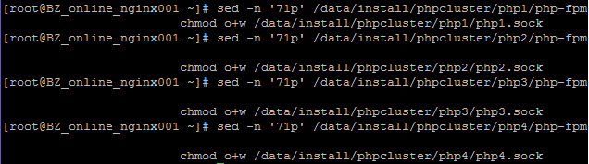

这样，php-fpm启动后，nginx就能修改unix sock文件

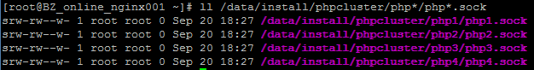

1. **生产环境php安装脚本**

yum -y install libxml2 libxml2-devel bzip2-devel libcurl libcurl-devel readline readline-devel gmp-devel libpng-devel freetype-devel libjpeg-devel mcrypt libmcrypt-devel

groupadd www

useradd -g www -M -s /sbin/nologin www

mkdir /data/install/phpcluster

tar zxf php-5.6.8.tar.gz

**cd** php-5.6.8

**./configure --prefix=/data/install/phpcluster/php1 --with-config-file-path=/data/install/phpcluster/php1/etc --with-config-file-scan-dir=/data/install/phpcluster/php1/etc --with-mysql=mysqlnd --with-mysqli=mysqlnd --with-pdo-mysql=mysqlnd --enable-opcache --enable-fpm --enable-static --enable-inline-optimization --enable-sockets --enable-wddx --enable-zip --enable-calendar --enable-bcmath --enable-soap --with-zlib --with-iconv --with-gd --enable-gd-native-ttf --with-xmlrpc --enable-mbstring --without-sqlite3 --without-pdo-sqlite --with-curl --enable-ftp --with-mcrypt --with-freetype-dir=/usr/include/ --with-jpeg-dir=/usr/include/ --with-png-dir=/usr/include/ --with-openssl** --with-fpm-user=www --with-fpm-group=www **--disable-maintainer-zts --disable-fileinfo --disable-ipv6 --disable-debug**

**make && make install**

cp /data/install/phpcluster/php1/etc/php-fpm.conf.default /data/install/phpcluster/php1/etc/php-fpm.conf

cp php.ini-production /data/install/phpcluster/php1/etc/php.ini

cp sapi/fpm/init.d.php-fpm /data/install/phpcluster/php1/php-fpm

chmod +x /data/install/phpcluster/php1/php-fpm

**cd** /root

**rm -rf php-5.6.8**

tar zxf php-5.6.8.tar.gz

**cd** php-5.6.8

**./configure --prefix=/data/install/phpcluster/php2 --with-config-file-path=/data/install/phpcluster/php2/etc --with-config-file-scan-dir=/data/install/phpcluster/php2/etc --with-mysql=mysqlnd --with-mysqli=mysqlnd --with-pdo-mysql=mysqlnd --enable-opcache --enable-fpm --enable-static --enable-inline-optimization --enable-sockets --enable-wddx --enable-zip --enable-calendar --enable-bcmath --enable-soap --with-zlib --with-iconv --with-gd --enable-gd-native-ttf --with-xmlrpc --enable-mbstring --without-sqlite3 --without-pdo-sqlite --with-curl --enable-ftp --with-mcrypt --with-freetype-dir=/usr/include/ --with-jpeg-dir=/usr/include/ --with-png-dir=/usr/include/ --with-openssl** --with-fpm-user=www --with-fpm-group=www **--disable-maintainer-zts --disable-fileinfo --disable-ipv6 --disable-debug**

**make && make install**

cp /data/install/phpcluster/php2/etc/php-fpm.conf.default /data/install/phpcluster/php2/etc/php-fpm.conf

cp php.ini-production /data/install/phpcluster/php2/etc/php.ini

cp sapi/fpm/init.d.php-fpm /data/install/phpcluster/php2/php-fpm

chmod +x /data/install/phpcluster/php2/php-fpm

**cd** /root

**rm -rf php-5.6.8**

tar zxf php-5.6.8.tar.gz

**cd** php-5.6.8

**./configure --prefix=/data/install/phpcluster/php3 --with-config-file-path=/data/install/phpcluster/php3/etc --with-config-file-scan-dir=/data/install/phpcluster/php3/etc --with-mysql=mysqlnd --with-mysqli=mysqlnd --with-pdo-mysql=mysqlnd --enable-opcache --enable-fpm --enable-static --enable-inline-optimization --enable-sockets --enable-wddx --enable-zip --enable-calendar --enable-bcmath --enable-soap --with-zlib --with-iconv --with-gd --enable-gd-native-ttf --with-xmlrpc --enable-mbstring --without-sqlite3 --without-pdo-sqlite --with-curl --enable-ftp --with-mcrypt --with-freetype-dir=/usr/include/ --with-jpeg-dir=/usr/include/ --with-png-dir=/usr/include/ --with-openssl** --with-fpm-user=www --with-fpm-group=www **--disable-maintainer-zts --disable-fileinfo --disable-ipv6 --disable-debug**

**make && make install**

cp /data/install/phpcluster/php3/etc/php-fpm.conf.default /data/install/phpcluster/php3/etc/php-fpm.conf

cp php.ini-production /data/install/phpcluster/php3/etc/php.ini

cp sapi/fpm/init.d.php-fpm /data/install/phpcluster/php3/php-fpm

chmod +x /data/install/phpcluster/php3/php-fpm

**cd** /root

**rm -rf php-5.6.8**

tar zxf php-5.6.8.tar.gz

**cd** php-5.6.8

**./configure --prefix=/data/install/phpcluster/php4 --with-config-file-path=/data/install/phpcluster/php4/etc --with-config-file-scan-dir=/data/install/phpcluster/php4/etc --with-mysql=mysqlnd --with-mysqli=mysqlnd --with-pdo-mysql=mysqlnd --enable-opcache --enable-fpm --enable-static --enable-inline-optimization --enable-sockets --enable-wddx --enable-zip --enable-calendar --enable-bcmath --enable-soap --with-zlib --with-iconv --with-gd --enable-gd-native-ttf --with-xmlrpc --enable-mbstring --without-sqlite3 --without-pdo-sqlite --with-curl --enable-ftp --with-mcrypt --with-freetype-dir=/usr/include/ --with-jpeg-dir=/usr/include/ --with-png-dir=/usr/include/ --with-openssl** --with-fpm-user=www --with-fpm-group=www **--disable-maintainer-zts --disable-fileinfo --disable-ipv6 --disable-debug**

**make && make install**

cp /data/install/phpcluster/php4/etc/php-fpm.conf.default /data/install/phpcluster/php4/etc/php-fpm.conf

cp php.ini-production /data/install/phpcluster/php4/etc/php.ini

cp sapi/fpm/init.d.php-fpm /data/install/phpcluster/php4/php-fpm

chmod +x /data/install/phpcluster/php4/php-fpm

cd /root

**echo -e '[yaf]\nyaf.environ = product\nyaf.library = NULL\nyaf.cache_config = 0\nyaf.name_suffix = 1\nyaf.name_separator = ""\nyaf.forward_limit = 5\nyaf.use_namespace = 0\nyaf.use_spl_autoload = 0\n' >> /data/install/phpcluster/php1/etc/php.ini**

**echo -e '[yaf]\nyaf.environ = product\nyaf.library = NULL\nyaf.cache_config = 0\nyaf.name_suffix = 1\nyaf.name_separator = ""\nyaf.forward_limit = 5\nyaf.use_namespace = 0\nyaf.use_spl_autoload = 0\n' >> /data/install/phpcluster/php2/etc/php.ini**

**echo -e '[yaf]\nyaf.environ = product\nyaf.library = NULL\nyaf.cache_config = 0\nyaf.name_suffix = 1\nyaf.name_separator = ""\nyaf.forward_limit = 5\nyaf.use_namespace = 0\nyaf.use_spl_autoload = 0\n' >> /data/install/phpcluster/php3/etc/php.ini**

**echo -e '[yaf]\nyaf.environ = product\nyaf.library = NULL\nyaf.cache_config = 0\nyaf.name_suffix = 1\nyaf.name_separator = ""\nyaf.forward_limit = 5\nyaf.use_namespace = 0\nyaf.use_spl_autoload = 0\n' >> /data/install/phpcluster/php4/etc/php.ini**

sed -i 's/max_execution_time = 30/max_execution_time = 60/g' /data/install/phpcluster/php*/etc/php.ini

sed -i 's/display_errors = Off/display_errors = On/g' /data/install/phpcluster/php*/etc/php.ini

sed -i 's/post_max_size = 8M/post_max_size = 64M/g' /data/install/phpcluster/php*/etc/php.ini

sed -i 's/upload_max_filesize = 2M/upload_max_filesize = 64M/g' /data/install/phpcluster/php*/etc/php.ini

sed -i 's%;date.timezone =%date.timezone = PRC%g' /data/install/phpcluster/php*/etc/php.ini

cd /root

rm -rf memcache-3.0.8 memcached-2.2.0 php-5.6.8 redis-2.2.7 swoole-src-master yaf-2.3.5

sed -i 's/pm.max_children = 5/pm.max_children = 200/g' /data/install/phpcluster/php*/etc/php-fpm.conf

sed -i 's/pm.start_servers = 2/pm.start_servers = 10/g' /data/install/phpcluster/php*/etc/php-fpm.conf

sed -i 's/pm.min_spare_servers = 1/pm.min_spare_servers = 5/g' /data/install/phpcluster/php*/etc/php-fpm.conf

sed -i 's/pm.max_spare_servers = 3/pm.max_spare_servers = 200/g' /data/install/phpcluster/php*/etc/php-fpm.conf

sed -i '71 i\ chmod o+w /data/install/phpcluster/php1/php1.sock' /data/install/phpcluster/php1/php-fpm

sed -i '71 i\ chmod o+w /data/install/phpcluster/php2/php2.sock' /data/install/phpcluster/php2/php-fpm

sed -i '71 i\ chmod o+w /data/install/phpcluster/php3/php3.sock' /data/install/phpcluster/php3/php-fpm

sed -i '71 i\ chmod o+w /data/install/phpcluster/php4/php4.sock' /data/install/phpcluster/php4/php-fpm

**sed -i 's/expose_php = On/expose_php = Off/g' /data/install/phpcluster/php*/etc/php.ini**

**echo -e "disable_functions = system,exec,shell_exec,passthru,popen,dl,phpinfo\nsafe_mode = On" >> /data/install/phpcluster/php1/etc/php.ini**

**echo -e "disable_functions = system,exec,shell_exec,passthru,popen,dl,phpinfo\nsafe_mode = On" >> /data/install/phpcluster/php2/etc/php.ini**

**echo -e "disable_functions = system,exec,shell_exec,passthru,popen,dl,phpinfo\nsafe_mode = On" >> /data/install/phpcluster/php3/etc/php.ini**

**echo -e "disable_functions = system,exec,shell_exec,passthru,popen,dl,phpinfo\nsafe_mode = On" >> /data/install/phpcluster/php4/etc/php.ini**

**sed -i 's/allow_url_fopen = On/allow_url_fopen = Off/g' /data/install/phpcluster/php*/etc/php.ini**

1. **安装扩展脚本**

tar zxf libmemcached-1.0.18.tar.gz

cd libmemcached-1.0.18

./configure --prefix=/data/install/libmemcached --with-memcached

make && make install

cd /root

tar zxf memcached-2.2.0.tgz

cd memcached-2.2.0

/data/install/phpcluster/php1/bin/phpize

./configure --with-libmemcached-dir=/data/install/libmemcached --with-php-config=/data/install/phpcluster/php1/bin/php-config --enable-memcached --disable-memcached-sasl

make && make install

/data/install/phpcluster/php2/bin/phpize

./configure --with-libmemcached-dir=/data/install/libmemcached --with-php-config=/data/install/phpcluster/php2/bin/php-config --enable-memcached --disable-memcached-sasl

make && make install

/data/install/phpcluster/php3/bin/phpize

./configure --with-libmemcached-dir=/data/install/libmemcached --with-php-config=/data/install/phpcluster/php3/bin/php-config --enable-memcached --disable-memcached-sasl

make && make install

/data/install/phpcluster/php4/bin/phpize

./configure --with-libmemcached-dir=/data/install/libmemcached --with-php-config=/data/install/phpcluster/php4/bin/php-config --enable-memcached --disable-memcached-sasl

make && make install

cd /root

tar zxf memcache-3.0.8.tgz

cd memcache-3.0.8

/data/install/phpcluster/php1/bin/phpize

./configure --enable-memcache --with-php-config=/data/install/phpcluster/php1/bin/php-config

make && make install

/data/install/phpcluster/php2/bin/phpize

./configure --enable-memcache --with-php-config=/data/install/phpcluster/php2/bin/php-config

make && make install

/data/install/phpcluster/php3/bin/phpize

./configure --enable-memcache --with-php-config=/data/install/phpcluster/php3/bin/php-config

make && make install

/data/install/phpcluster/php4/bin/phpize

./configure --enable-memcache --with-php-config=/data/install/phpcluster/php4/bin/php-config

make && make install

cd /root

tar zxf yaf-2.3.5.tgz

cd yaf-2.3.5

/data/install/phpcluster/php1/bin/phpize

./configure --with-php-config=/data/install/phpcluster/php1/bin/php-config

make && make install

/data/install/phpcluster/php2/bin/phpize

./configure --with-php-config=/data/install/phpcluster/php2/bin/php-config

make && make install

/data/install/phpcluster/php3/bin/phpize

./configure --with-php-config=/data/install/phpcluster/php3/bin/php-config

make && make install

/data/install/phpcluster/php4/bin/phpize

./configure --with-php-config=/data/install/phpcluster/php4/bin/php-config

make && make install

cd /root

unzip swoole-src-master.zip

cd swoole-src-master

/data/install/phpcluster/php1/bin/phpize

./configure --with-php-config=/data/install/phpcluster/php1/bin/php-config

make && make install

/data/install/phpcluster/php2/bin/phpize

./configure --with-php-config=/data/install/phpcluster/php2/bin/php-config

make && make install

/data/install/phpcluster/php3/bin/phpize

./configure --with-php-config=/data/install/phpcluster/php3/bin/php-config

make && make install

/data/install/phpcluster/php4/bin/phpize

./configure --with-php-config=/data/install/phpcluster/php4/bin/php-config

make && make install

cd /root

tar zxf redis-2.2.7.tgz

cd redis-2.2.7

/data/install/phpcluster/php1/bin/phpize

./configure --with-php-config=/data/install/phpcluster/php1/bin/php-config

make && make install

/data/install/phpcluster/php2/bin/phpize

./configure --with-php-config=/data/install/phpcluster/php2/bin/php-config

make && make install

/data/install/phpcluster/php3/bin/phpize

./configure --with-php-config=/data/install/phpcluster/php3/bin/php-config

make && make install

/data/install/phpcluster/php4/bin/phpize

./configure --with-php-config=/data/install/phpcluster/php4/bin/php-config

make && make install

cd /root

tar zxf yar-1.2.4.tgz

cd yar-1.2.4

/data/install/phpcluster/php1/bin/phpize

./configure --with-php-config=/data/install/phpcluster/php1/bin/php-config

make && make install

/data/install/phpcluster/php2/bin/phpize

./configure --with-php-config=/data/install/phpcluster/php2/bin/php-config

make && make install

/data/install/phpcluster/php3/bin/phpize

./configure --with-php-config=/data/install/phpcluster/php3/bin/php-config

make && make install

/data/install/phpcluster/php4/bin/phpize

./configure --with-php-config=/data/install/phpcluster/php4/bin/php-config

make && make install

cd /root

echo extension = memcache.so >> /data/install/phpcluster/php1/etc/memcache.ini

echo extension = memcache.so >> /data/install/phpcluster/php2/etc/memcache.ini

echo extension = memcache.so >> /data/install/phpcluster/php3/etc/memcache.ini

echo extension = memcache.so >> /data/install/phpcluster/php4/etc/memcache.ini

echo extension = memcached.so >> /data/install/phpcluster/php1/etc/memcached.ini

echo extension = memcached.so >> /data/install/phpcluster/php2/etc/memcached.ini

echo extension = memcached.so >> /data/install/phpcluster/php3/etc/memcached.ini

echo extension = memcached.so >> /data/install/phpcluster/php4/etc/memcached.ini

echo extension = redis.so >> /data/install/phpcluster/php1/etc/redis.ini

echo extension = redis.so >> /data/install/phpcluster/php2/etc/redis.ini

echo extension = redis.so >> /data/install/phpcluster/php3/etc/redis.ini

echo extension = redis.so >> /data/install/phpcluster/php4/etc/redis.ini

echo extension = yaf.so >> /data/install/phpcluster/php1/etc/yaf.ini

echo extension = yaf.so >> /data/install/phpcluster/php2/etc/yaf.ini

echo extension = yaf.so >> /data/install/phpcluster/php3/etc/yaf.ini

echo extension = yaf.so >> /data/install/phpcluster/php4/etc/yaf.ini

echo extension = swoole.so >> /data/install/phpcluster/php1/etc/swoole.ini

echo extension = swoole.so >> /data/install/phpcluster/php2/etc/swoole.ini

echo extension = swoole.so >> /data/install/phpcluster/php3/etc/swoole.ini

echo extension = swoole.so >> /data/install/phpcluster/php4/etc/swoole.ini

echo extension = yar.so >> /data/install/phpcluster/php1/etc/yar.ini

echo extension = yar.so >> /data/install/phpcluster/php2/etc/yar.ini

echo extension = yar.so >> /data/install/phpcluster/php3/etc/yar.ini

echo extension = yar.so >> /data/install/phpcluster/php4/etc/yar.ini

cd /root

rm -rf memcache-3.0.8 memcached-2.2.0 php-5.6.8 redis-2.2.7 swoole-src-master yaf-2.3.5

1. **mysqlnd驱动**

**1). 什么是mysqlnd驱动?**

**mysqldnd即mysql native driver简写,即是由PHP源码提供的mysql驱动连接代码.它的目的是代替旧的libmysql驱动.**

**传统的安装php的方式中,我们在编译PHP时,一般需要指定以下几项:**

**--with-mysql=/usr/local/mysql**

**--with-pdo-mysql=/usr/local/mysql**

**这实际上就是使用了mysql官方自带的libmysql驱动, 这是比较老的驱动, PHP 5.3开始已经不建议使用它了, 而建议使用mysqlnd.**

**2). PDO与mysqlnd, libmysql又是何种关系?**

**PDO是一个应用层抽象类,底层和mysql server连接交互需要mysql驱动的支持. 也就是说无论你使用了何种驱动,都可以使用PDO.**

**PDO是提供了PHP应用程序层API接口,而mysqlnd, libmysql则负责与mysql server进行网络协议交互(它并不提供php应用程序层API功能)**

**3). 为何要使用mysqlnd驱动?**

**PHP官方手册描述:**

**A.libmysql驱动是由mysql AB公司(现在是oracle公司)编写, 并按mysql license许可协议发布,所以在PHP中默认是被禁用的.而mysqlnd是由php官方开发的驱动,以php license许可协议发布,故就规避了许可协议和版权的问题**

**B.因为mysqlnd内置于PHP源代码,故你在编译安装php时就不需要预先安装mysql server也可以提供mysql client API (mysql_connect, pdo , mysqli), 这将减化一些工作量.**

**C. mysqlnd是专门为php优化编写的驱动,它使用了PHP本身的特性,在内存管理,性能上比libmysql更有优势. php官方的测试是:libmysql将每条记录在内存中保存了两份,而mysqlnd只保存了一份**

**D. 一些新的或增强的功能**

**增强的持久连接**

**引入特有的函数mysqli_fetch_all()**

**引入一些性能统计函数 mysqli_get_cache_stats(), mysqli_get_client_stats(), mysqli_get_connection_stats(),**

**使用上述函数,可很容易分析mysql查询的性能瓶颈!**

**SSL支持(从php 5.3.3开始有效)**

**压缩协议支持**

**命名管道支持(php 5.4.0开始有效)**

**如果使用mysqlnd,并不需要预先安装mysql，编译php时,修改以下几个项参数即可**

**--with-mysql=mysqlnd --with-mysqli=mysqlnd --with-pdo-mysql=mysqlnd**

**phpinfo页面**

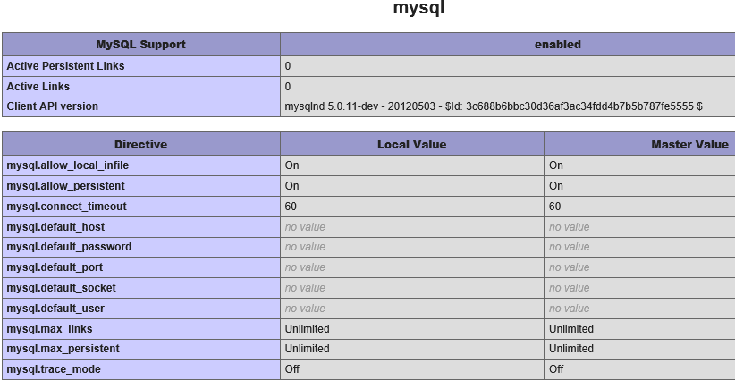

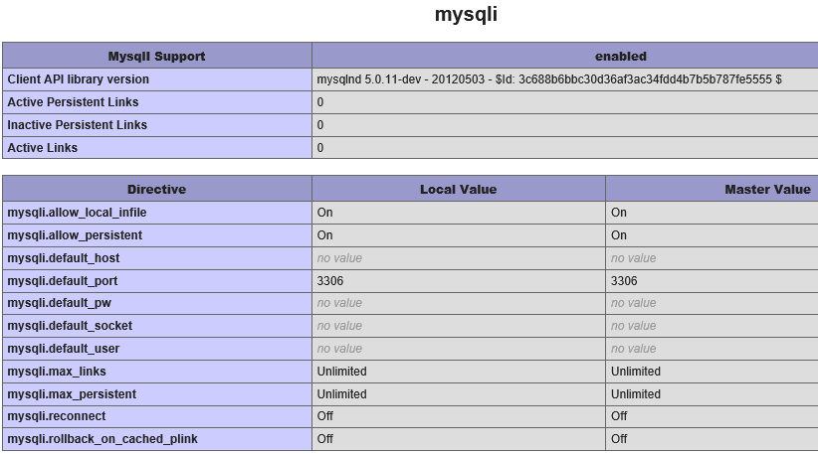

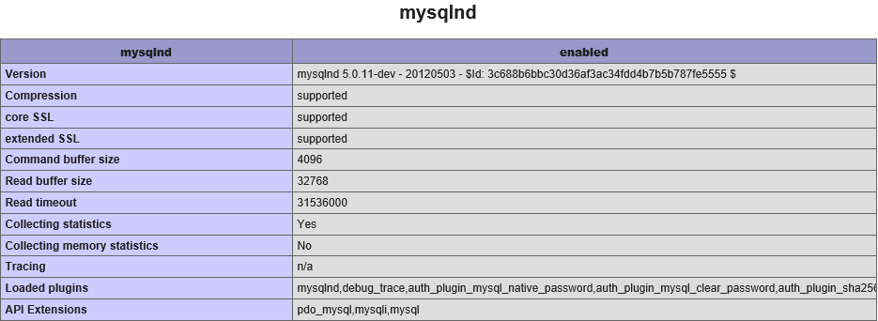

**mysqlnd_ms**

**mysqlnd的插件:mysqlnd_ms,** [**http://pecl.php.net/package/mysqlnd_ms**](http://pecl.php.net/package/mysqlnd_ms)**这个插件主要实现了, 连接保持和切换, 负载均衡和读写分离等, 也就是说, 这个扩展会去分别PHP发给MySQL的query, 如果是”读”的query, 就会把query发送给从库(配置中指明), 并且支持负载均衡; 而如果是”写”的query, 就会把query发送给主库.**

**不过这个扩展需要搭配mysqlnd一起使用(从PHP5.4 beta1开始, 我们已经把mysqlnd作为mysql, mysqli, pdo的默认链接目标, 当然, 你也可以通过–with-mysql=***来制定你想要链接到libmysql).**

**这个扩展使用的方法也很简单, 首先在php.ini中定义配置:**

mysqlnd_ms.enable=1

mysqlnd_ms.ini_file=/path/to/mysqlnd_ms_plugin.ini

**之后, 在你指明的mysqlnd_ms_plugin.ini中配置好MySQL的主从库就好了:**

**[myapp]**

**master[]=localhost:/tmp/mysql.sock**

**slave[]=192.168.2.27:3306**

**从1.1.0开始, 配置文件改为JSON格式:**

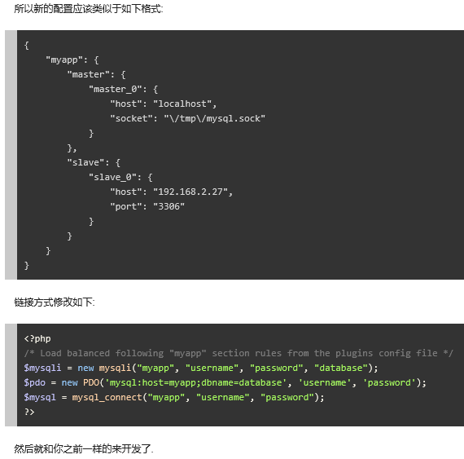

1. **错误解决**

**$PHP_AUTOHEADER**

**现象：**

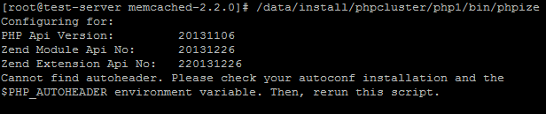

**原因：**

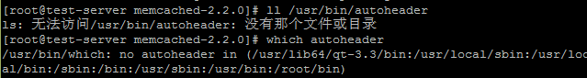

**解决方法：**

**rpm -e autoconf –nodeps**

**yum install autoconf**

**验证解决：**

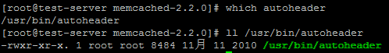

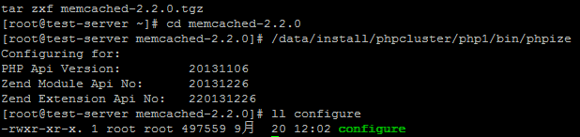

1. **nginx访问控制**