1. tengine示例

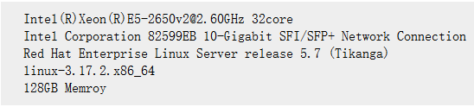

net.ipv4.tcp_mem = 3097431 4129911 6194862

net.ipv4.tcp_rmem = 4096 87380 6291456

net.ipv4.tcp_wmem = 4096 65536 4194304

net.ipv4.tcp_max_tw_buckets = 262144

net.ipv4.tcp_tw_recycle = 0

net.ipv4.tcp_tw_reuse = 1

net.ipv4.tcp_syncookies = 1

net.ipv4.tcp_fin_timeout = 15

net.ipv4.ip_local_port_range = 1024 65535

net.ipv4.tcp_max_syn_backlog = 65535 #默认值为1024

net.core.somaxconn = 65535 #默认值为128

net.core.netdev_max_backlog = 200000 #默认值为1000



参考：http://tengine.taobao.org/document_cn/benchmark_cn.html