Reading and processing data for use in the LTER-LIFE digital twins - the weather data

Karline Soetaert

first version: 01-10-2023; current version: 30 January 2024

This document prepares the weather data that are to be used in the LTER life dtWad package. These data are made available from the KNMI (Royal netherlands meteorological institute). Data from the KNMI that are close to or in the Wadden area are read, and units converted. A file that has the station positions of the KNMI (Royal netherlands meteorological institute).

# KNMI metadata

SOURCE: ROYAL NETHERLANDS METEOROLOGICAL INSTITUTE (KNMI) <https://www.knmi.nl/nederland-nu/klimatologie/uurgegevens> <https://www.knmi.nl/nederland-nu/klimatologie/uurgegevens_Noordzee>

KNMIstations <- read.csv("../raw_data/knmi/csv_knmi_nl_20230623.csv")  
  
names(KNMIstations) <- c("station", "WSI", "startTime", "stopTime",   
 "location", "type", "height",   
 "pos_x", "pos_y", "latitude", "longitude")  
  
stn_wad <- c(208, 235, 242, 251, 270, 277) # stations from the Wadden area  
KNMIstations$Wadden <- KNMIstations$station %in% stn_wad  
  
save(file="../processed_data/KNMIstations.rda", KNMIstations)

# KNMI datasets

Several datasets were manually downloaded from the KNMI website; the data that are in the wadden area are selected; they are read and combined in a data.frame. This data.frame is in long format.

# stations from the wadden area  
STused <- subset(KNMIstations, subset=station %in% stn_wad)

dir="../raw_data/knmi/"  
  
# several files read at once  
files <- paste("uurgeg", stn_wad, "2021-2030.txt", sep="_")  
  
WeatherData <- readKNMI(dir=dir, file=files)

The measured variables in this data set are:

knitr::kable(attributes(WeatherData)$variables, align='l')

| variable | description | unit | original |
| --- | --- | --- | --- |
| windspeed | Mean wind speed for the hour preceding the observation time stamp | m/s | FH |
| winddirection | Mean wind direction for 10-minutes before time (360=N, 90=E, 0=calm, 990=variable) | dg | DD |
| temperature | Temperature at 1.50 m at the time of observation | dgC | T |
| dewpoint | Dew point temperature at 1.50 m at the time of observation | dgC | TD |
| radiation | Global radiation during the hourly division | J/m2/s | Q |
| pressure | Air pressure reduced to mean sea level, at the time of observation | mbar (hPa) | P |
| cloudcover | Cloud cover (in octants), at the time of observation (9=sky invisible) | octants | N |
| humidity | Relative atmospheric humidity at 1.50 m at the time of observation | - | U |
| seatemperature | Sea surface temperature at the time of observation | dgC | TZ |

The stations in this data set are:

knitr::kable(attributes(WeatherData)$stations[,c(1,3,5:7,10:11)],   
 digits=c(0,0,0,0,1,2,2), align='l')

| station | startTime | location | type | height | latitude | longitude |
| --- | --- | --- | --- | --- | --- | --- |
| 208 | 1946-05-31 | AWG-1 | Platform/AWS | 40.5 | 53.49 | 5.94 |
| 235 | 1955-12-25 | DE KOOY VK | AWS/Aerodrome | 0.6 | 52.93 | 4.78 |
| 242 | 1956-04-01 | VLIELAND | AWS/Aerodrome | 1.7 | 53.24 | 4.92 |
| 251 | 1968-01-01 | TERSCHELLING HOORN AWS | AWS | 0.7 | 53.39 | 5.35 |
| 270 | 1991-10-01 | LEEUWARDEN | AWS/Aerodrome | 0.3 | 53.22 | 5.75 |
| 277 | 2006-11-27 | LAUWERSOOG AWS | AWS | 2.9 | 53.41 | 6.20 |

## Subsettting the data

From this dataset, only the 2021 data are retained, and the number of variables is restricted:

toselect <- c("station", "datetime", "windspeed", "temperature", "radiation")  
Weather2021 <- subset(WeatherData,   
 subset = datetime < "2022-01-01")[, toselect]  
  
save(file="../processed_data/WeatherData.rda", WeatherData)  
save(file="../processed_data/Weather2021.rda", Weather2021)

stats <- attributes(Weather2021)$stations  
plotBathymetry(WadDepth,   
 pts=stats[,c("longitude", "latitude")],   
 ptlist=list(cex=4, col= "white"), NAcol="grey", type="image",  
 main="Meteorological stations")  
text(stats$longitude, stats$latitude, labels=stats$station, cex=0.7)  
legend("bottomright", legend = c(stats$station, stats$location),   
 ncol=2, cex=0.7)

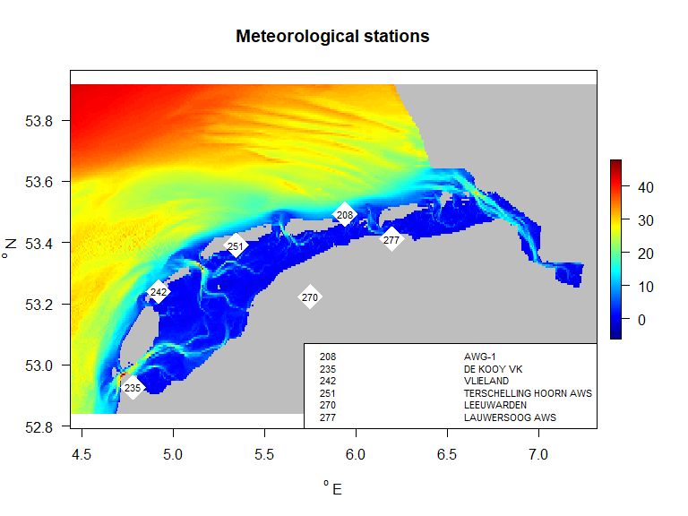

# Showing some data

st277 <- subset(Weather2021, subset=station==277)  
par(mfrow=c(3,1), las=1)  
with(st277,{  
 plot(datetime, windspeed, type="l",   
 main="wind speed", ylab="m/s")  
 plot(datetime, temperature, type="l",   
 main="temperature", ylab="dgC")  
 plot(datetime, radiation, type="l",   
 main="solar radiation", ylab="W/m2")  
})

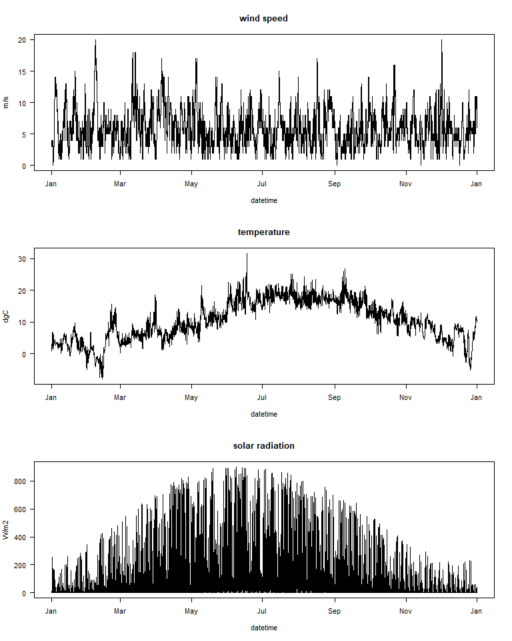

weather data for station 277

# References

The following R-sources were used for this work:

R-core:

* R Core Team (2022). R: A language and environment for statistical computing. R Foundation for Statistical Computing, Vienna, Austria. URL <https://www.R-project.org/>.

R-package dtWad,

* Soetaert K (2024). dtWad: Waddensea Digital Twin: general utilities. R package version 0.0.1.

# Appendix: all KNMI stations

knitr:::kable(KNMIstations[,c(1,3,5:7,10:12)], digits=c(0,0,0,0,1,2,2,1))

| station | startTime | location | type | height | latitude | longitude | Wadden |
| --- | --- | --- | --- | --- | --- | --- | --- |
| 201 | 2009-02-10 | D15-FA-1 | Platform/AWS | 42.7 | 54.33 | 2.94 | FALSE |
| 203 | 1990-01-01 | P11-B | Platform/AWS | 41.8 | 52.36 | 3.34 | FALSE |
| 204 | 1976-12-25 | K14-FA-1C | Platform/AWS | 41.8 | 53.27 | 3.63 | FALSE |
| 205 | 2009-02-10 | A12-CPP | Platform/AWS | 48.4 | 55.40 | 3.81 | FALSE |
| 206 | 1979-12-25 | F16-A | Platform/AWS | 43.4 | 54.12 | 4.01 | FALSE |
| 207 | 2006-11-27 | L9-FF-1 | Platform/AWS | 45.3 | 53.61 | 4.96 | FALSE |
| 208 | 1946-05-31 | AWG-1 | Platform/AWS | 40.5 | 53.49 | 5.94 | TRUE |
| 209 | 2001-01-29 | IJMOND WP | Wind mast KNMI | 0.0 | 52.46 | 4.52 | FALSE |
| 210 | 1951-01-01 | VALKENBURG VK | AWS/Aerodrome | -0.2 | 52.17 | 4.43 | FALSE |
| 211 | 1926-12-25 | J6-A | Platform/AWS | 45.7 | 53.82 | 2.95 | FALSE |
| 212 | 1990-01-01 | HOORN-A | Platform/AWS | 50.9 | 52.92 | 4.15 | FALSE |
| 213 | 1900-01-01 | Hollandse Kust Noord (HNA) | AWS | 39.7 | 52.70 | 4.29 | FALSE |
| 214 | 2016-03-01 | BG-OHVS2 | Platform/AWS | 43.6 | 54.04 | 6.04 | FALSE |
| 215 | 2014-07-15 | VOORSCHOTEN AWS | AWS | -1.1 | 52.14 | 4.44 | FALSE |
| 216 | 1900-01-01 | Hollandse Kust Zuid Alfa (HKZA) | AWS | 44.0 | 52.32 | 4.04 | FALSE |
| 225 | 2001-01-29 | IJMUIDEN WP | Wind mast KNMI | 4.4 | 52.46 | 4.56 | FALSE |
| 229 | 1968-01-01 | TEXELHORS WP | Wind mast KNMI | 1.0 | 52.99 | 4.72 | FALSE |
| 233 | 2009-07-08 | Assendelft BTP | Mistpost | -1.6 | 52.48 | 4.73 | FALSE |
| 235 | 1955-12-25 | DE KOOY VK | AWS/Aerodrome | 0.6 | 52.93 | 4.78 | TRUE |
| 236 | 1900-01-01 | Muiden BTP | Mistpost | -0.9 | 52.34 | 5.09 | FALSE |
| 237 | 1900-01-01 | Nieuw Vennep BTP | Mistpost | -4.8 | 52.26 | 4.65 | FALSE |
| 238 | 1900-01-01 | Nieuwkoop BTP | Mistpost | -5.8 | 52.15 | 4.76 | FALSE |
| 239 | 2006-11-27 | F3-FB-1 | Platform/AWS | 50.6 | 54.85 | 4.70 | FALSE |
| 240 | 1990-07-01 | AMSTERDAM/SCHIPHOL AP | AWS/Aerodrome | -3.9 | 52.32 | 4.79 | FALSE |
| 242 | 1956-04-01 | VLIELAND | AWS/Aerodrome | 1.7 | 53.24 | 4.92 | TRUE |
| 248 | 1994-07-08 | WIJDENES WP | Wind mast KNMI | 0.8 | 52.63 | 5.17 | FALSE |
| 249 | 1998-10-01 | BERKHOUT AWS | AWS | -2.4 | 52.64 | 4.98 | FALSE |
| 251 | 1968-01-01 | TERSCHELLING HOORN AWS | AWS | 0.7 | 53.39 | 5.35 | TRUE |
| 252 | 1992-12-25 | K13-A | Platform/AWS | 37.7 | 53.22 | 3.22 | FALSE |
| 257 | 2001-04-01 | WIJK AAN ZEE AWS | AWS | 8.5 | 52.51 | 4.60 | FALSE |
| 258 | 2006-03-09 | HOUTRIBDIJK WP | Wind mast KNMI | 7.2 | 52.65 | 5.40 | FALSE |
| 260 | 1896-04-01 | DE BILT AWS | AWS | 1.9 | 52.10 | 5.18 | FALSE |
| 265 | 1951-09-10 | SOESTERBERG | AWS/Aerodrome | 14.0 | 52.13 | 5.27 | FALSE |
| 267 | 1994-05-10 | STAVOREN AWS | AWS | -1.3 | 52.90 | 5.38 | FALSE |
| 269 | 1950-12-01 | LELYSTAD AP | AWS/Aerodrome | -4.5 | 52.45 | 5.51 | FALSE |
| 270 | 1991-10-01 | LEEUWARDEN | AWS/Aerodrome | 0.3 | 53.22 | 5.75 | TRUE |
| 273 | 1991-01-01 | MARKNESSE AWS | AWS | -3.4 | 52.70 | 5.89 | FALSE |
| 275 | 1949-10-01 | DEELEN | AWS/Aerodrome | 45.2 | 52.05 | 5.87 | FALSE |
| 277 | 2006-11-27 | LAUWERSOOG AWS | AWS | 2.9 | 53.41 | 6.20 | TRUE |
| 278 | 1990-01-01 | HEINO AWS | AWS | 3.6 | 52.43 | 6.26 | FALSE |
| 279 | 1990-01-01 | HOOGEVEEN AWS | AWS | 15.8 | 52.75 | 6.57 | FALSE |
| 280 | 1948-08-01 | GRONINGEN AP EELDE | AWS/Aerodrome | 3.2 | 53.12 | 6.58 | FALSE |
| 283 | 1991-01-01 | HUPSEL AWS | AWS | 29.1 | 52.07 | 6.66 | FALSE |
| 285 | 1980-10-07 | HUIBERTGAT WP | Wind mast KNMI | 0.0 | 53.57 | 6.40 | FALSE |
| 286 | 2009-11-09 | NIEUW BEERTA AWS | AWS | -0.2 | 53.19 | 7.15 | FALSE |
| 290 | 1937-11-01 | TWENTHE AWS | AWS | 33.0 | 52.27 | 6.89 | FALSE |
| 308 | 1971-04-19 | CADZAND WP | Wind mast KNMI | 0.0 | 51.38 | 3.38 | FALSE |
| 310 | 1855-12-25 | VLISSINGEN AWS | AWS | 8.0 | 51.44 | 3.60 | FALSE |
| 312 | 1980-12-25 | OOSTERSCHELDE WP | Wind mast KNMI | 0.0 | 51.77 | 3.62 | FALSE |
| 313 | 1900-01-01 | VLAKTE VAN DE RAAN |  | 0.0 | 51.50 | 3.24 | FALSE |
| 315 | 1900-01-01 | HANSWEERT | Wind mast KNMI | 0.0 | 51.45 | 4.00 | FALSE |
| 316 | 1900-01-01 | OOSTERSCHELDE 4 | Wind mast KNMI | 0.0 | 51.66 | 3.69 | FALSE |
| 317 | 1900-01-01 | BORSSELE ALFA (BSA) | Wind mast KNMI | 43.4 | 51.70 | 3.06 | FALSE |
| 319 | 1991-06-24 | WESTDORPE AWS | AWS | 1.7 | 51.22 | 3.86 | FALSE |
| 320 | 1991-01-01 | LICHTEILAND GOEREE | Platform/AWS | 24.6 | 51.93 | 3.67 | FALSE |
| 321 | 1998-12-01 | EURO PLATFORM | Platform/AWS | 19.0 | 52.00 | 3.28 | FALSE |
| 323 | 1991-01-01 | WILHELMINADORP AWS | AWS | 1.6 | 51.53 | 3.88 | FALSE |
| 324 | 1900-01-01 | STAVENISSE | Wind mast KNMI | 0.0 | 51.60 | 4.01 | FALSE |
| 330 | 1991-01-01 | HOEK VAN HOLLAND AWS | AWS | 11.9 | 51.99 | 4.12 | FALSE |
| 331 | 1900-01-01 | MAROLLEGAT |  | 0.0 | 51.48 | 4.19 | FALSE |
| 340 | 1981-07-10 | WOENSDRECHT | AWS/Aerodrome | 15.0 | 51.45 | 4.34 | FALSE |
| 343 | 1935-12-25 | ROTTERDAM GEULHAVEN | Wind mast KNMI | 3.5 | 51.89 | 4.31 | FALSE |
| 344 | 1990-01-01 | ROTTERDAM THE HAGUE AP | AWS/Aerodrome | -5.1 | 51.96 | 4.45 | FALSE |
| 348 | 1971-12-25 | CABAUW TOWER AWS | AWS | -0.7 | 51.97 | 4.93 | FALSE |
| 350 | 1993-01-01 | GILZE RIJEN | AWS/Aerodrome | 11.9 | 51.56 | 4.94 | FALSE |
| 356 | 1991-01-01 | HERWIJNEN AWS | AWS | 0.7 | 51.86 | 5.15 | FALSE |
| 370 | 1945-10-01 | EINDHOVEN AP | AWS/Aerodrome | 20.7 | 51.45 | 5.38 | FALSE |
| 375 | 1951-12-25 | VOLKEL | AWS/Aerodrome | 19.9 | 51.66 | 5.71 | FALSE |
| 377 | 1947-12-25 | ELL AWS | AWS | 30.0 | 51.20 | 5.76 | FALSE |
| 380 | 1991-01-01 | MAASTRICHT AACHEN AP | AWS/Aerodrome | 112.7 | 50.91 | 5.76 | FALSE |
| 391 | 2006-11-09 | ARCEN AWS | AWS | 19.5 | 51.50 | 6.20 | FALSE |
| 871 | 2016-01-01 | JUANCHO E. YRAUSQUIN AIRPORT, SABA | AWS/Aerodrome | 31.0 | 17.65 | -63.22 | FALSE |
| 873 | 2016-01-01 | F.D. ROOSEVELT AIRPORT, ST. EUSTATIUS | AWS/Aerodrome | 36.0 | 17.50 | -62.98 | FALSE |
| 990 | 2013-01-01 | FLAMINGO AIRPORT, BONAIRE | AWS/Aerodrome | 2.1 | 12.13 | -68.28 | FALSE |