Written Part:

Q.1

* What is the bit-rate produced by the camera?

Solution:

450 × 520 × 25 = 5, 850,000 pixels / second

As mentioned in the question, each sample of Y, Cr, Cb is quantized with 8 bits and the color sub sampling scheme is 4:2:0(as known as 4:1:1)

4×8 + 8 + 8 = 48bits per 4 pixels

Then 48/4 =12bits/pixel

So, Bit rate is:

12 ×5,850,000 = 70,200,000bits/second

* Suppose we want to store the video signal on a hard disk, and, in order to save space, re-quantize each chrominance (Cr, Cb) signals with only 6 bits per sample. What is the minimum size of the hard disk required to store 10 minutes of video(3 points)

Solution: because at this time each chrominance (Cr, Cb) signals with only 6 bits per sample, then

(4×8 + 6 + 6)/4 = 11 bits/pixel

Then,

450 × 520 ×25 = 5, 850,000 pixels / second

So, the minimum size of the hard disk required to store 10 minutes of video

11 × 5,850,000 × 60 × 10 = 3.861×

Q.2

1)Write down the quantized sequence

Solution: to quantize this sequence by dividing the interval [-4,4] into 32 uniformly distributed levels, the length of each interval of [-4,4] is 0.25,

So, the quantized sequence is

{1.75, 2.25, 2.25, 3.25,3.25,3.25,2.5,2.75,2.75,2.75, 1.5,1.0,1.25,1.25,1.75,2.25,2.25,2.25,2.0,2.25,1.25,0.25, -1.25, -1.25,-1.75,-1.0,-2.25,-1.5,-1.5,-0.75,0.0,1.0}

2) How many bits do you need to transmit it? *(1 points)*

Solution:

Because there are 32 distributed levels, so we need 5 bits to represent each level. And there are 32 numbers here, so the total number of bits we need is 160.

**Analysis Questions for part 1**

1. Let’s try an experiment where s (scale factor) remains constant and n (number of lines) is allowed to vary.

1)When s = 2.0 aliasing = 0

n = 32

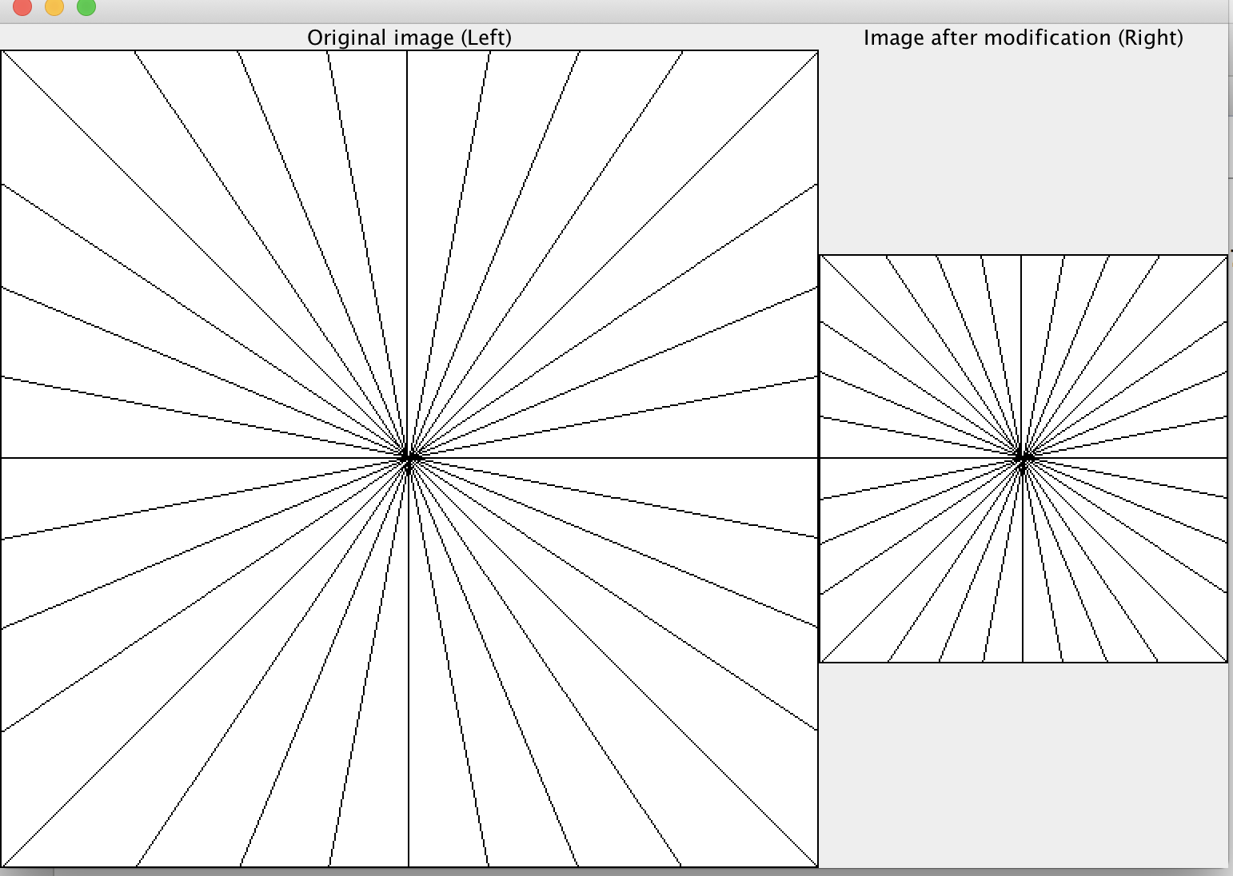

n = 64

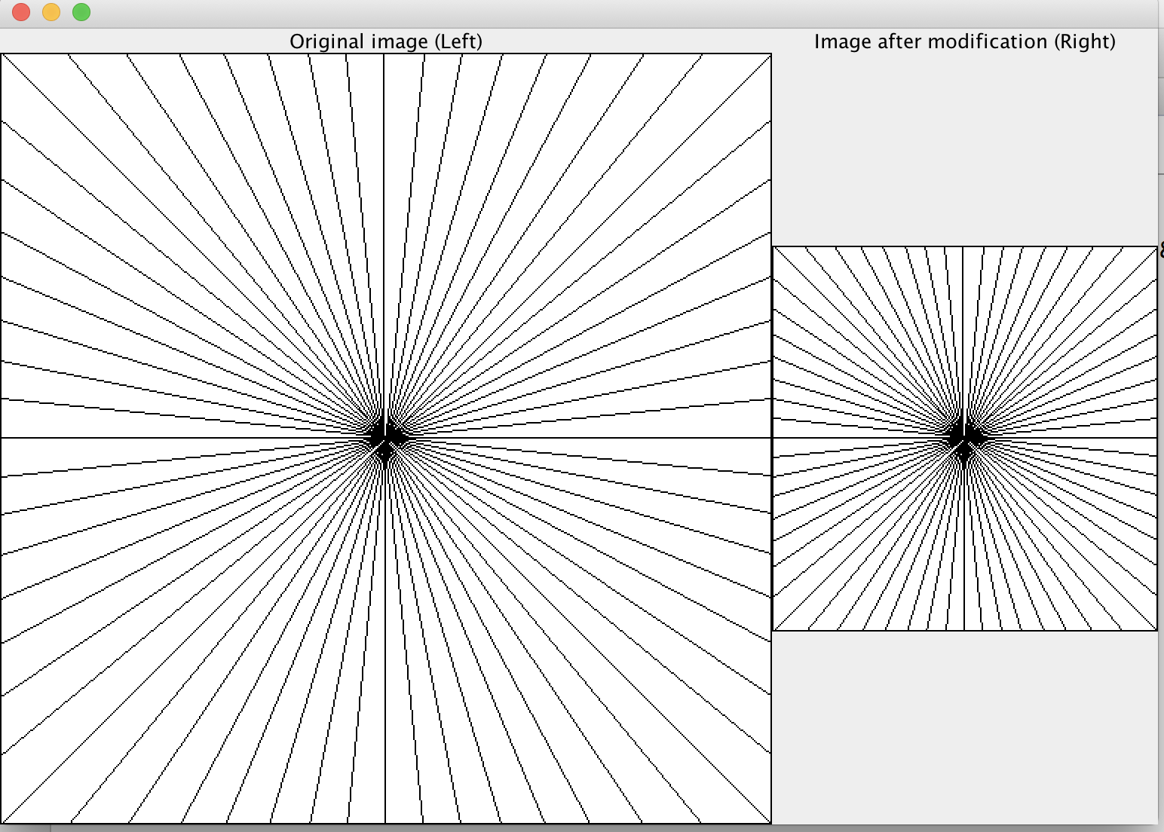

n =128

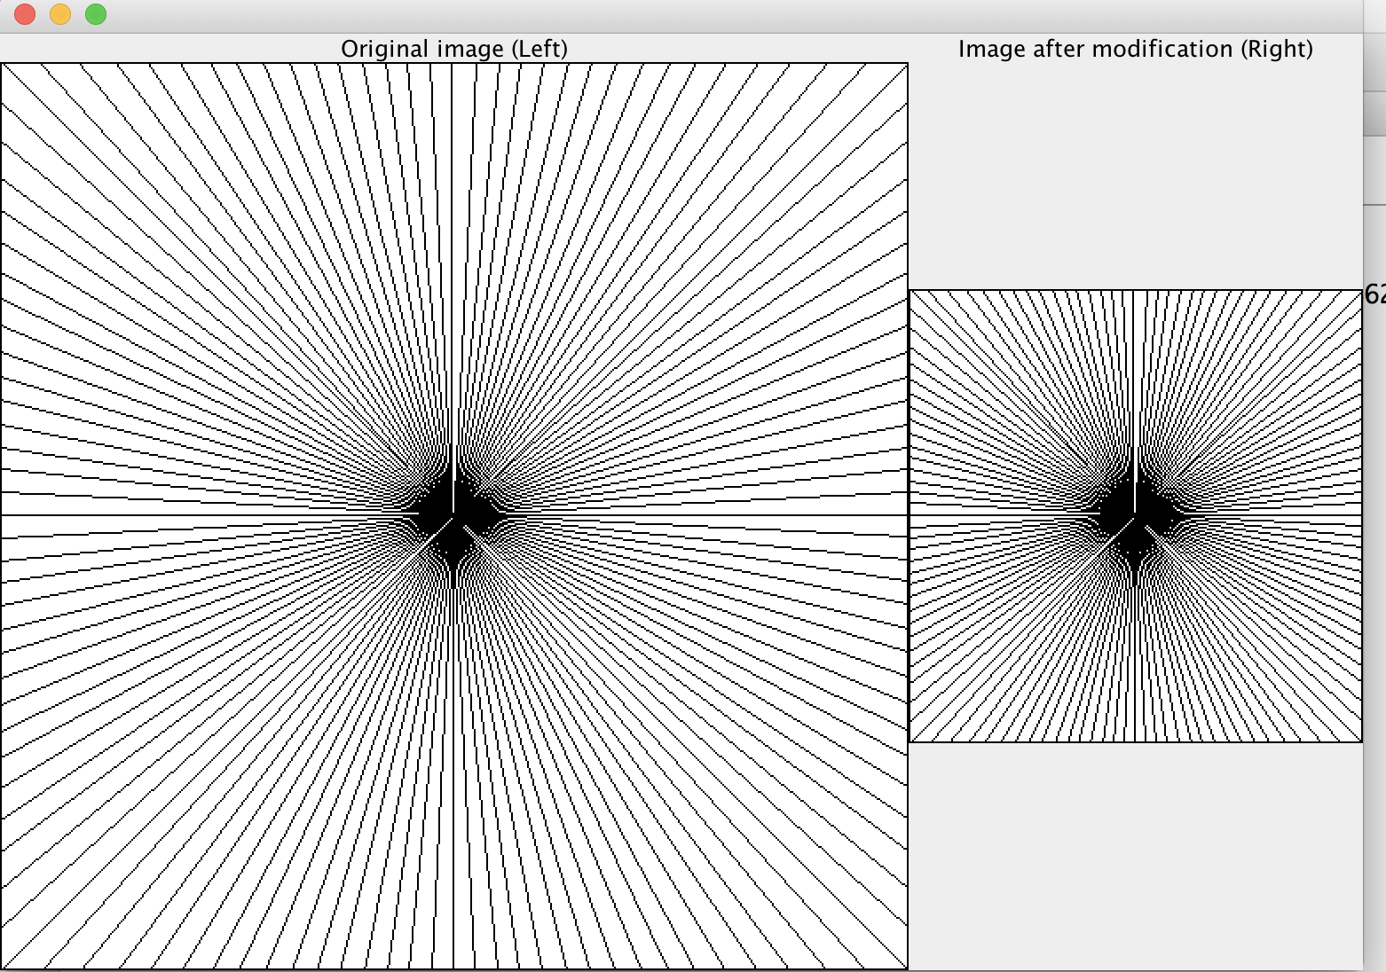

n =256

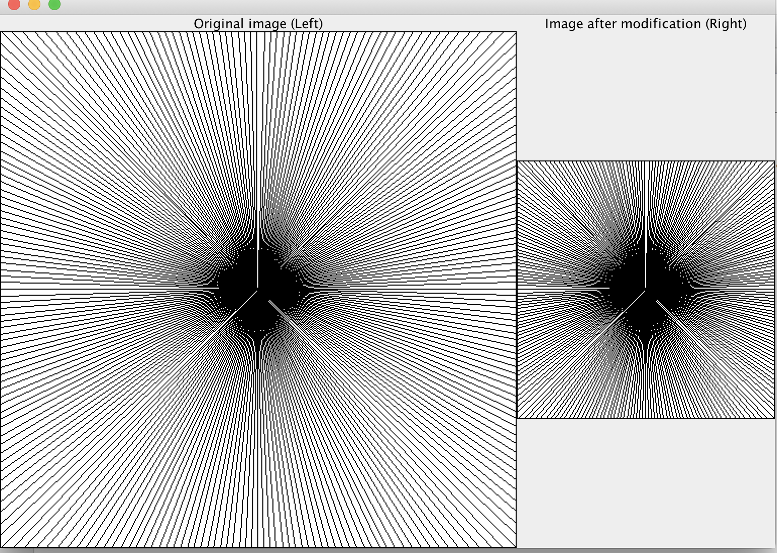

n = 360

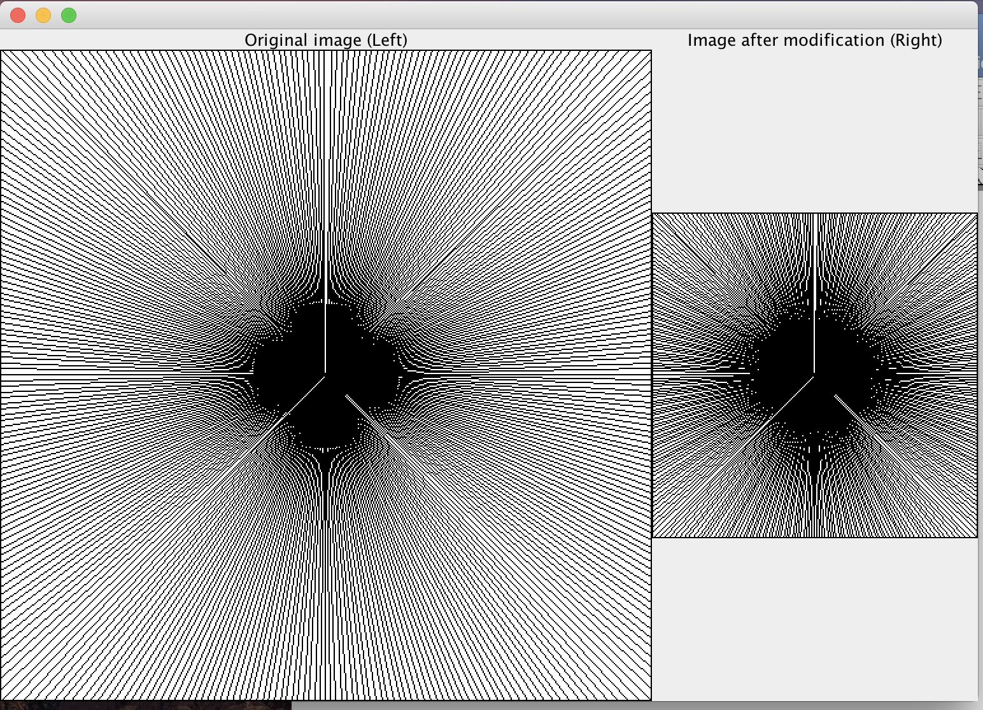

2) When s =4, aliasing = 0

n = 32

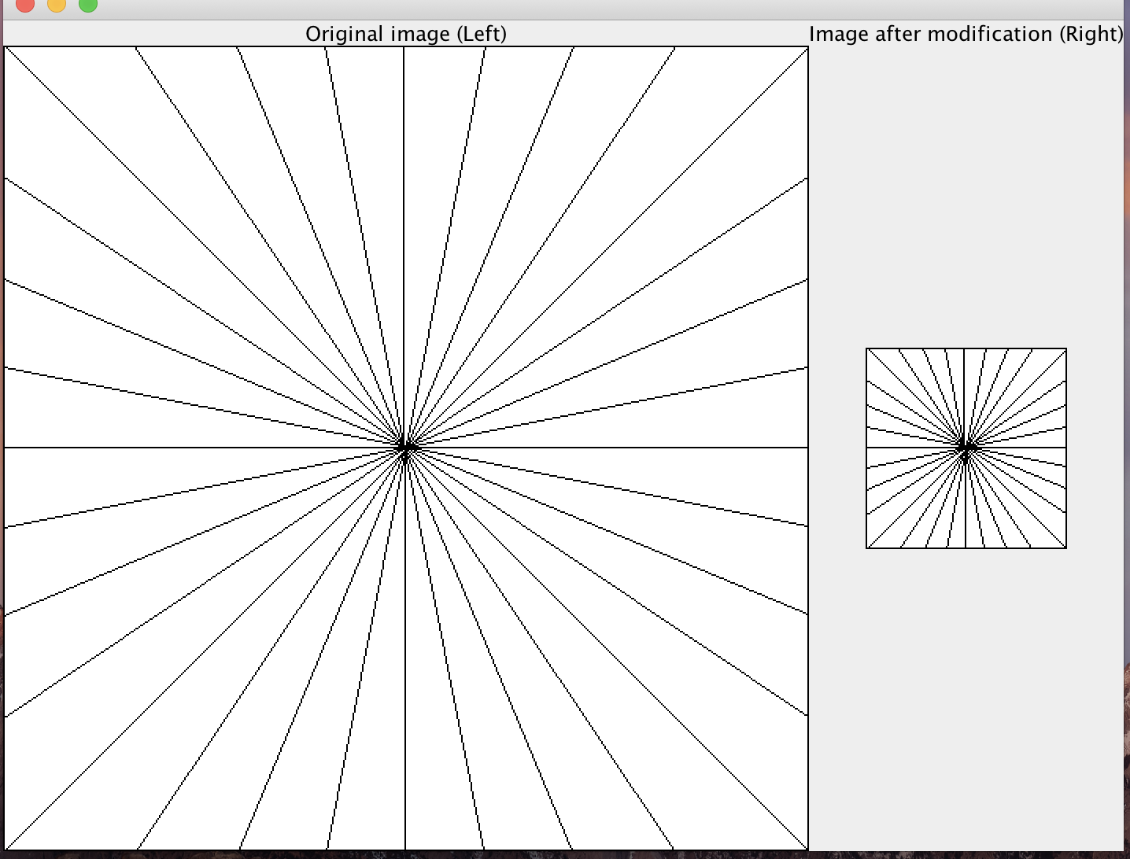

n = 64

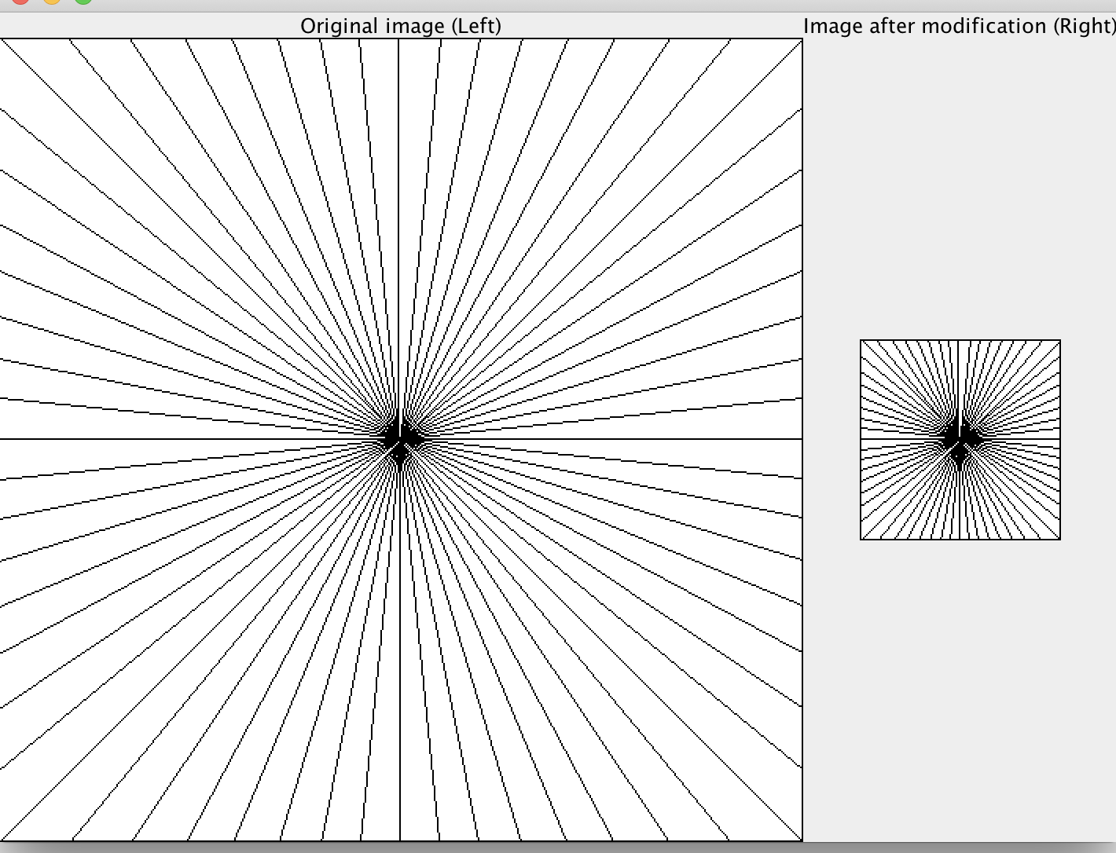

n = 128

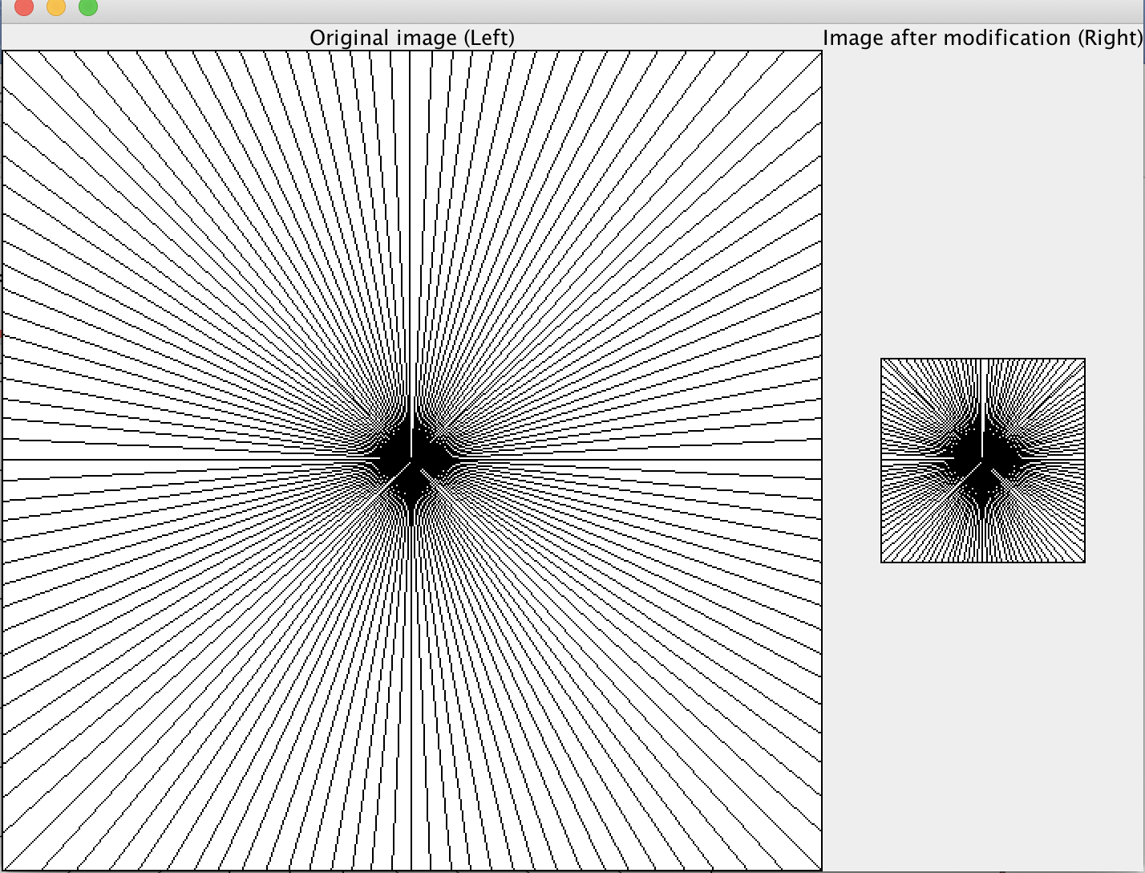

n = 256

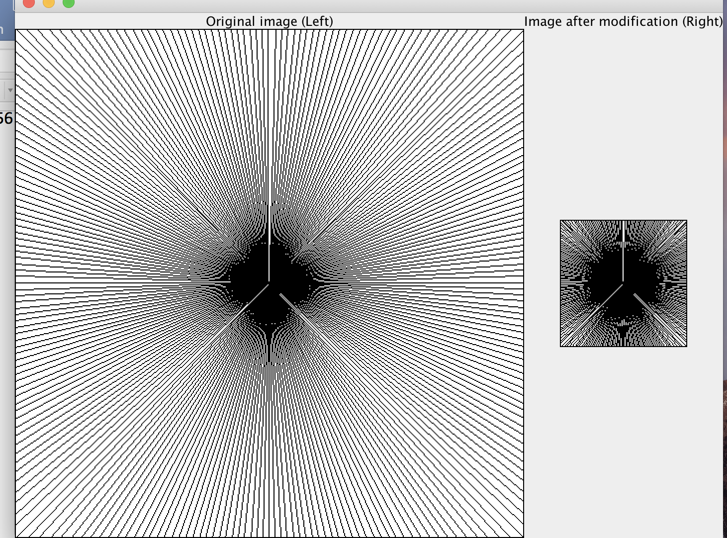

n = 360

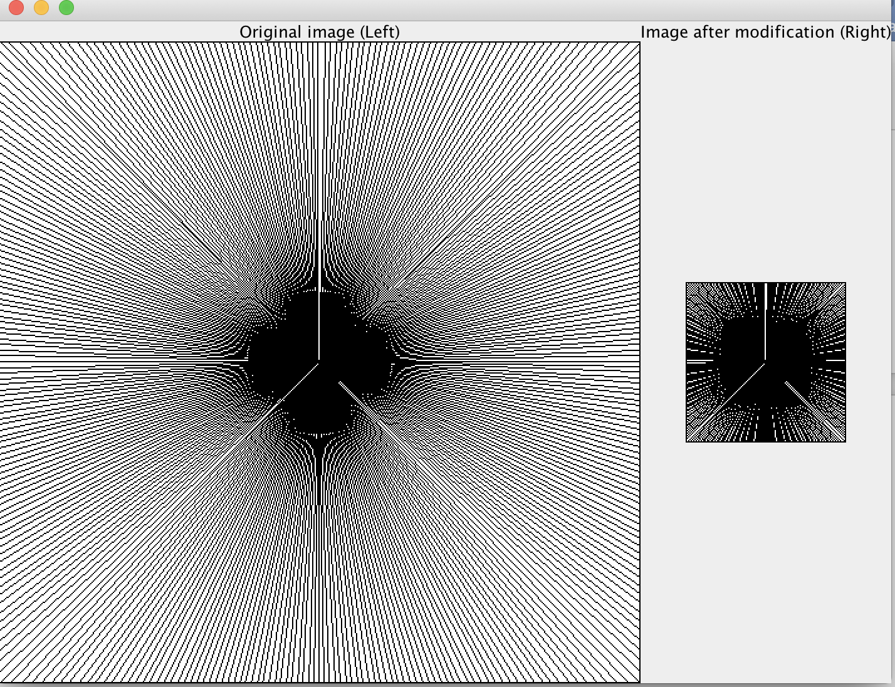

3) When s =6, aliasing =0

n = 32

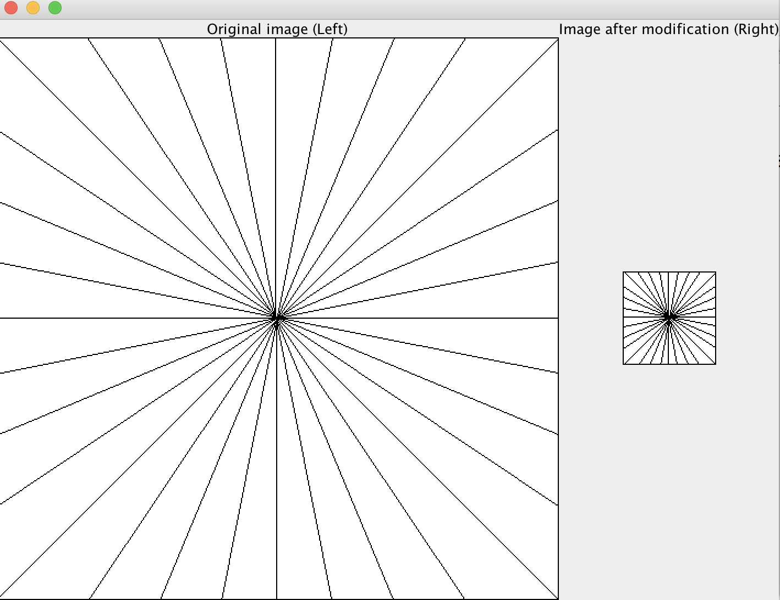

n = 64

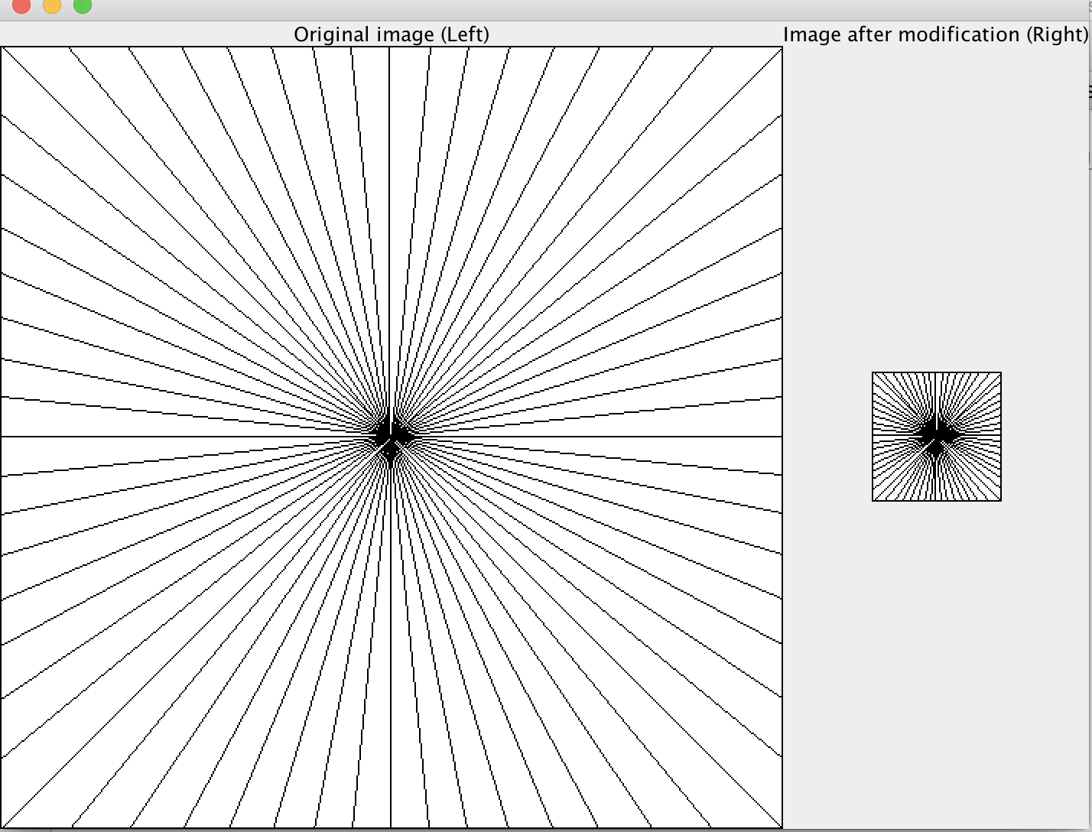

n = 128

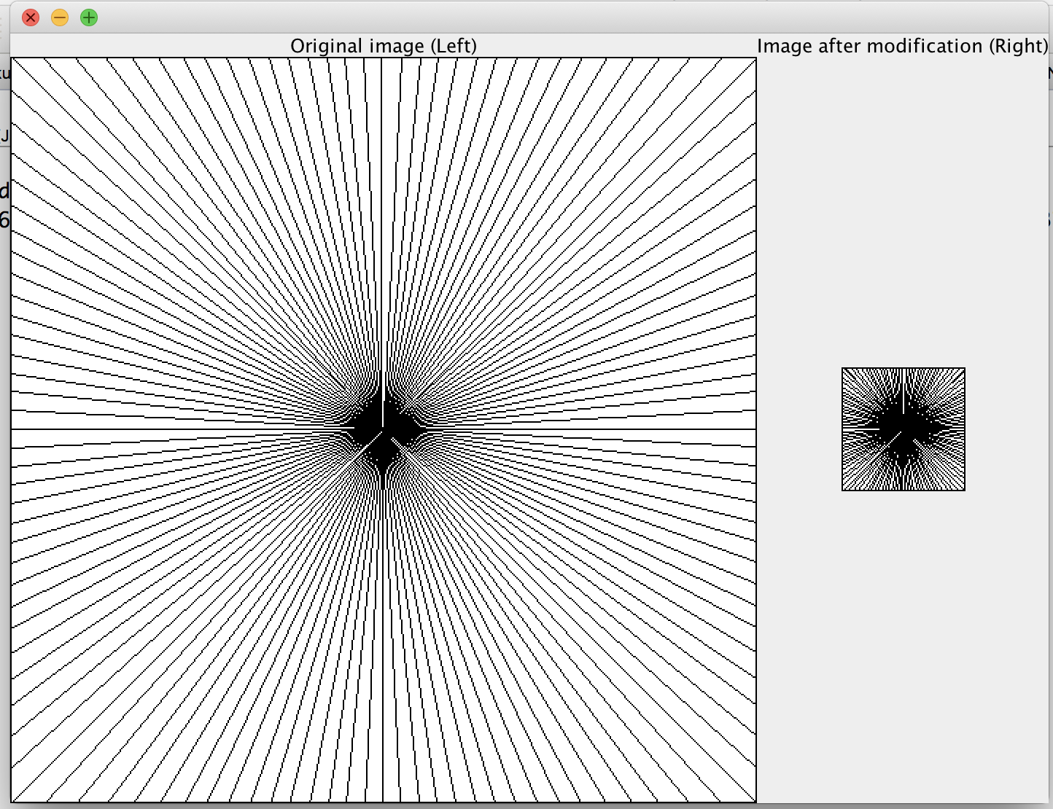

n = 256

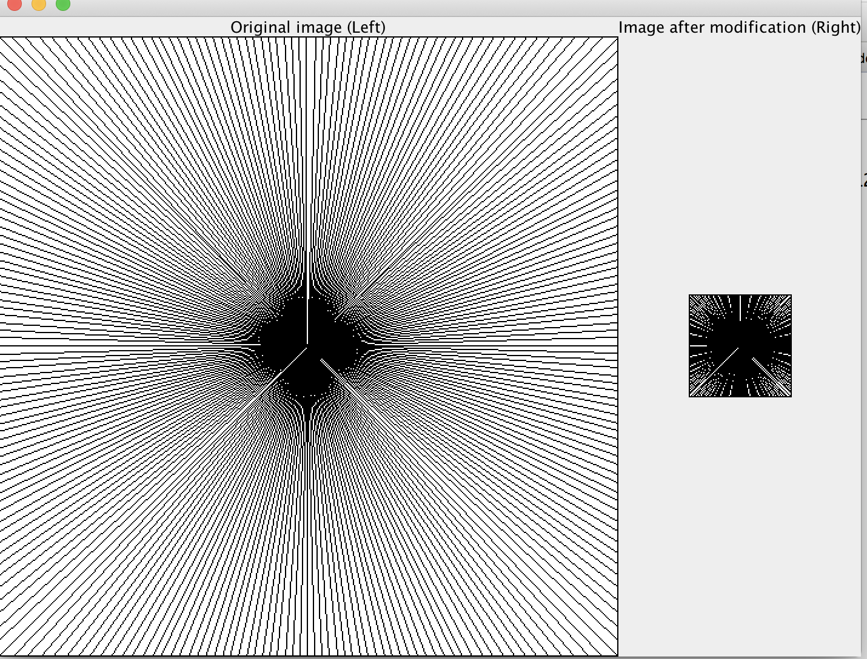

n = 360

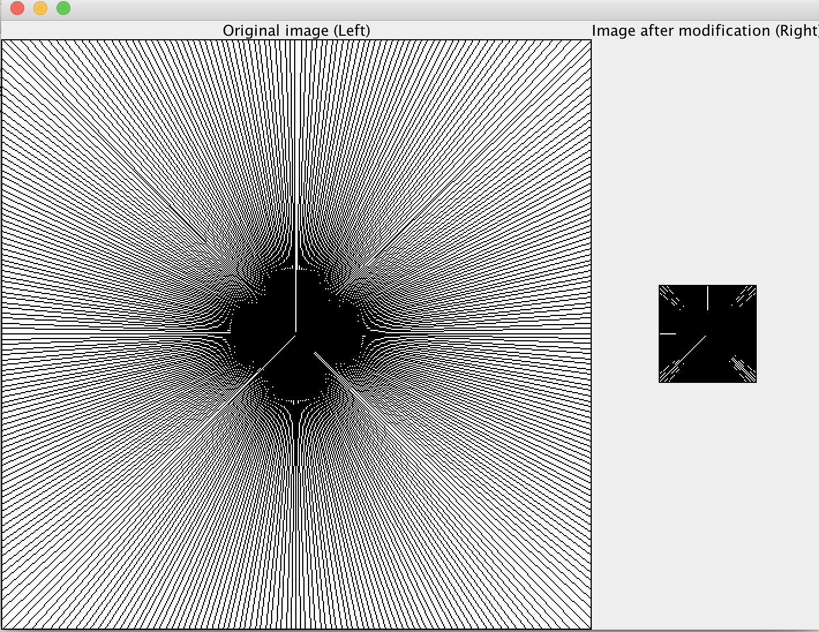

**Analysis:**

**From the above pictures, we can find that when s is constant and n varies, aliasing becomes more and more obvious when the number of lines increases.**

1. Let’s try another experiment, this time keep n (number of lines) constant and varying s (scale factor).
   1. when n = 32, aliasing = 0

s = 2



s = 4



s= 6



* 1. When n = 64, aliasing = 0

s = 2



s = 4



s = 6



3）when n = 128, aliasing = 0

s = 2



s = 4



s = 6



1. When n = 360, aliasing

s = 2



s = 4



s = 6



Analysis: From the above pictures, we can find that when n is constant and s varies, aliasing becomes more and more obvious when s is larger.

**Analysis Questions for part 2**

Let’s try an experiment where *s* (speed of rotation) remains constant and *fps* is allowed to vary. Study the value of the *os* (observed speed of rotation), especially when there is temporal aliasing.

1. Can you design a formula relating *s*, *fps* and *os*.

The default fps in the left picture is 30

The formula relating s, fps, and os is:

fps/30 * s = os

Evaluate if your formula works for certain values of *s* and *fps*. If *s* = 10 rotations per second,

1. What is the observed speed *os* for an *fps* of 25?

25/30 * 10 ≈ 8.3

1. What is the observed speed *os* for an *fps* of 16?

16/30 * 10≈ 5.3

1. What is the observed speed *os* for an *fps* of 10?

10/30 * 10 ≈ 3.3

1. What is the observed speed *os* for an *fps* of 8?

8/30 *10 ≈ 2.7