**必须在项目文件夹下运行**

https://github.com/GMvandeVen/brain-inspired-replay

**Demo 1: Brain-inspired replay on split MNIST**

D:/anaconda3/envs/pytorch/python.exe D:/lth/GitHub/brain-inspired-replay/main_cl.py --experiment=splitMNIST --scenario=class --replay=generative --brain-inspired --pdf

saved model mM-splitMNIST5-class--VAE=F-784x400x400_z100-GMM10pc_c10_cg0.8--i2000-lr0.001-b128--gen-Di2.0--BCE to ./store/models

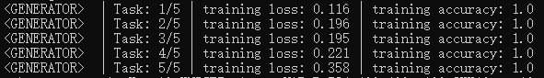Generated plot: ./store/plots/splitMNIST5-class--VAE=F-784x400x400_z100-GMM10pc_c10_cg0.8--i2000-lr0.001-b128--gen-Di2.0--BCE.pdf

Accuracy of final model on test-set:

- For classes from task 1: 0.8624

- For classes from task 2: 0.8883

- For classes from task 3: 0.9349

- For classes from task 4: 0.9763

- For classes from task 5: 0.9854

=> Average accuracy over all 10 classes: 0.9295

**Demo 2: Comparison of continual learning methods**

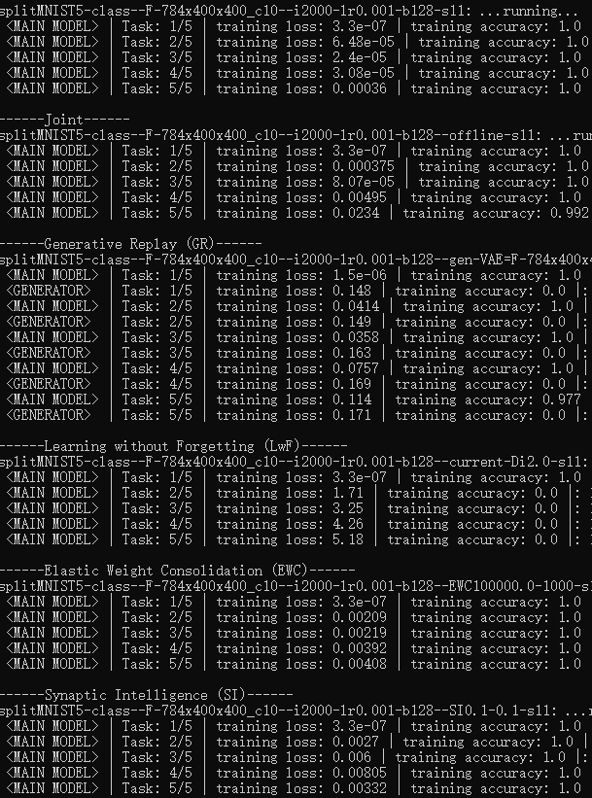D:/anaconda3/envs/pytorch/python.exe ./compare_MNIST.py --scenario=class

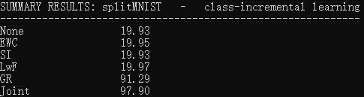

Generated plot: ./store/plots/summary-splitMNIST5-class.pdf

Demo3