Linh Nguyen

B04

ENCM 369 – Computer Organization

Lab 6

Ex. A) Part I

1. 160 is 10*16, so the 16-bit representation of 160 is

0000_0000_1010_0000

And the 16-bit representation of -160 is

1111_1111_0101_1111 + 1 = 1111_1111_0110_0000

$sp ($29) is both the source and destination GPR, therefore both register fields are 11101. The op-code for addiu is 001001.

Therefore, the machine code for this instruction in base two is

001001_11101_11101_1111_1111_0110_0000

1. The adder inputs are the $sp value and the 32-bit sign-extension of -160:

Carry-in: 1111_1111_1111_1111_1111_1111_1000_0000

$sp: 0111_1111_1111_1111_1110_1000_1100_0000

-160: 1111_1111_1111_1111_1111_1111_0110_0000

--------------------------------------------------

output: 0111_1111_1111_1111_1110_1000_0010_0000

Part II

1. To use the address of 0x1002_b000, the offset for the lw instruction would need to be the unsigned 16-bit number 0xb000, but offsets in load and stores are signed 16-bit integers, with the largest number in that set being 0x7fff which is smaller than 0xb000.
2. The pseudoinstruction can be implemented by giving lui an address greater than 0x1002_0000 to put into $at and then using a negative offset with lw to get the desired address of 0x1002_b000.

If the address given to lui is 0x1003, then the negative offset needed to get to 0x1002_b000 would be -0x5000. In base ten, that is –(5*(16^3)) = -20480. Therefore the correct instructions is

lui $at, 0x1003

lw $s0, -20480($at)

Ex B)

Part I

Carry in: 0000_0000

a: 1001_0000

b: 1100_0000

----------

Sum: 0101_0000

Signed overflow: Yes. a and b are both negative numbers, but sum is a positive number, therefore there is overflow.

Unsigned overflow: Yes. Sum < a

Part II

Carry in: 0000_0000

a: 0100_0101

b: 0011_1000

----------

Sum: 0111_1101

Signed overflow: No. a and b are both positive numbers, and so is sum.

Unsigned overflow: No, sum > a

Part III

Carry in: 1000_0000

a: 0100_0101

b: 0100_1000

----------

Sum: 1000_1101

Signed overflow: Yes. a and b are both positive numbers, but sum is a negative number, therefore there is overflow.

Unsigned overflow: No. Sum > a

Part IV

Carry in: 1110_0100

a: 1111_0010

b: 1111_0011

----------

Sum: 1110_0101

Signed overflow: No. a and b are both negative numbers, and so is sum.

Unsigned overflow: Yes. Sum < a

Ex E)

Part I

Carry in: 1110_0001

a: 0111_0000

inverted bits of b: 0001_0110

----------

result: 1000_0111

Signed overflow: Yes. a is positive and b is negative, but the result seems to be negative.

Unsigned overflow: Yes, result > a

Part II

Carry in: 0000_0111

a: 1001_0011

inverted bits of b: 1110_1011

----------

result: 0111_1111

Signed overflow: Yes. a is negative and b is positive, but the result seems to be positive.

Unsigned overflow: No, result < a

Part III

Carry in: 1001_1011

a: 1100_0101

inverted bits of b: 0100_1101

----------

result: 0001_0011

Signed overflow: No. a is negative and b is negative, so the result could be negative or positive.

Unsigned overflow: No, result < a

Part IV

Carry in: 0000_0011

a: 0100_0001

inverted bits of b: 0000_0001

----------

result: 0100_0011

Signed overflow: No. a is positive and b is negative, and the result is to be positive.

Unsigned overflow: Yes, result > a

Ex F)

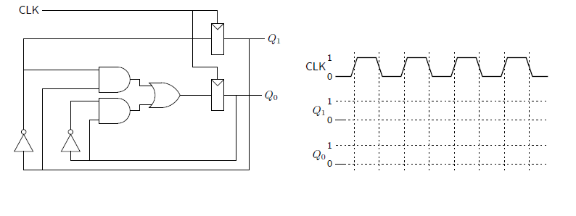 Part I

Part II

