NullState: a reference-anchored framework for detecting, diagnosing, and quantifying the off-target compartment of human neural organoids
  - Voiland College of Engineering and Architecture, Washington State University, Pullman, WA, USA. Correspondence: l.takahashidosreis@wsu.edu
Luiz Takahashi
2026-06-18
Abstract
Human neural organoids reproducibly generate cell types that lie outside the developmental trajectories they are intended to model, but the field lacks a principled, atlas-anchored way to quantify this off-target compartment and ask whether it carries reproducible structure. We present NullState, a reference-based pipeline that maps the 1,767,346-cell Human Neural Organoid Atlas (HNOCA) onto a harmonized 2,615,898-cell first-trimester human fetal reference (HDBCA $+$ a fetal-body atlas) by variational reference surgery, assigns each organoid cell a pair of calibrated mapping scores (off-manifold distance and label entropy), and classifies it into a six-state off-target taxonomy. Across the atlas, $38.4\%$ of cells fall into a large, largely neural ambiguous-novel (off-manifold) compartment; quantifying and explaining it is the work of Aim 2. Four orthogonal diagnostics show it is not a projection artifact but a structured mixture of a reference-coverage gap and a pervasive in-vitro stress program: off-manifold cells lose neural-progenitor identity while gaining hypoxia and unfolded-protein-response signatures, their burden rises monotonically with maturation and metabolic load, varies $∼$240-fold across differentiation protocols ($0.4\%$ to $96.8\%$), and concentrates into coherent transcriptomic clusters; projecting these cells onto an independent prenatal cortex atlas confirms a genuine in-vitro-divergence component beyond the reference gap (ambiguous-novel cells sit further from that atlas than clean cells, Cliff’s $δ=0.30$). Asking next whether lineage can be separated from the organoid-versus-primary shift, we report a reproducible negative result: a shared-latent contrastive model cannot. An origin-decoding adversary recovers organoid-versus-primary identity from the putatively dish-stripped latent at $≥​0.998$ balanced accuracy, robustly across latent-capacity and batch-conditioning interventions. Because the two sources occupy near-disjoint expression manifolds, this shift—biological in-vitro state and technical platform differences combined—is pervasive and encoder-visible, not a separable nuisance subspace; we therefore state the result methodologically (shared-latent methods cannot yield a source-invariant lineage axis here) and read the specifically in-vitro biology from the stress diagnostics rather than from the adversary. Finally, on the non-neural contaminant populations—where, unlike the reference-limited neural compartment, we are statistically powered—we show the geometry method works as an instrument: pairwise distances clear a matched-$N$ noise floor ($14$–$105×$) and their rank order recovers the primary lineage geometry (distance-matrix $r=0.90$). A direct test, however, finds the per-lineage source offsets are not constant (mutual cosine $0.15$), so the individual distances are confounded rather than clean lineage metrics—a validated ordering, not yet a clean geometry. NullState thus provides a reference-anchored, comparative off-target measurement—to be read against the reference’s own domain, not as an absolute fidelity score—and an identifiability boundary for when latent calibration without anchoring is attainable at all.

Introduction
Human pluripotent-stem-cell-derived neural organoids have become a central model of human brain development^{1,2}, capturing cortical cytoarchitecture, diverse neuronal and glial identities, and functional network activity^{3–5}. Yet a recurring concern limits their interpretation: organoids also produce cells that do not correspond to any bona fide in-vivo neural state. These include non-neural lineages arising from incomplete germ-layer restriction and aberrant states driven by the culture environment itself. A landmark observation is that metabolic and endoplasmic-reticulum (ER) stress in organoids impairs the specification of correct molecular subtypes⁶, and cross-protocol comparisons against fetal tissue have repeatedly surfaced protocol-dependent, off-target differentiation routes^{7,8}. The recent Human Neural Organoid Atlas (HNOCA)—an integrated transcriptomic atlas of $>$1.7 million organoid cells spanning dozens of protocols⁹—makes it possible, for the first time, to study this off-target compartment at scale and against a common coordinate system.
What has been missing is a principled, reference-anchored way to (i) decide which organoid cells are off-target, (ii) explain why they are off-target, and (iii) ask whether the off-target compartment is merely noise or carries reproducible biological structure. Reference-based mapping provides the natural substrate: by projecting organoid cells onto a comprehensive fetal atlas, cells that map confidently to a fetal identity can be separated from those that do not. Two recently completed human references make such anchoring feasible—a comprehensive first-trimester human brain cell atlas (HDBCA)¹⁰ and a human fetal-body gene-expression atlas¹¹—together spanning neural and non-neural developmental origins.
Here we introduce NullState, a pipeline that operationalizes this idea (Fig. 1). We harmonize the two fetal atlases into a single 2,615,898-cell reference, map the 1,767,346-cell HNOCA query onto it by variational reference surgery^{12–14}, and assign every organoid cell two calibrated mapping scores—an off-manifold reconstruction distance and a label-assignment entropy—that jointly define a six-state off-target taxonomy. We organize the analysis around three questions: (Aim 1) is the off-target measurement well-posed and adequately powered? (Aim 2) what is the dominant, largely neural off-manifold compartment, and can lineage be separated from the in-vitro state so that those cells can be placed on a “dish-stripped” lineage axis? and (Aim 3) do off-target populations occupy distinct, reproducible geometry? The division of labor between the last two is deliberate and worth stating up front. Aim 2 quantifies and explains the neural off-manifold compartment, the bulk of the off-target signal but one that the present first-trimester reference cannot yet resolve into clean lineage geometry; Aim 3 then turns to the non-neural contaminant populations (skeletal and cardiac muscle, fibroblast, adrenal-cortical cells), the compartment where the reference is complete and the cell numbers are sufficient, and asks whether the method recovers real lineage structure there. Our central findings are that the off-manifold compartment is a structured biological mixture rather than an artifact; that shared-latent disentanglement provably fails here for an interpretable reason, so the negative is stated methodologically and the biology read from the diagnostics; and that off-target geometry, demonstrated on the powered non-neural compartment, is recoverable and biologically coherent.

Results

A harmonized fetal reference supports confident organoid mapping
We assembled a fetal reference by combining the first-trimester HDBCA¹⁰ with the non-neural compartments of a human fetal-body atlas¹¹, retrieving raw unique-molecular-identifier (UMI) counts from the CZ CELLxGENE Discover Census¹⁵. The merged reference comprises 2,615,898 cells $×$ 61,497 genes, with $32/33$ lineage origins resolved. We trained a single-cell variational model (scVI) for 400 epochs (evidence lower bound, ELBO, $695.6$), refined it into a label-aware model (scANVI, ELBO $736.1$), and projected the HNOCA query onto the reference by architectural surgery (scArches; query-surgery ELBO $920.2$)^{12–14,16}. Surgery required two stabilizers that we found essential at atlas scale: excluding $9,229$ non-UMI (full-length read-count) cells whose library sizes destabilize the negative-binomial encoder, and filtering to cells with $≥​50$ counts across highly variable genes ($1,767,346→1,689,762$; $4.4\%$ removed).
Donor-level batch integration improved cross-batch mixing while preserving biological structure: the integration local inverse Simpson’s index (iLISI) rose from $6.10$ (unintegrated principal components) to $8.10$ after scVI, with only a modest change in the cell-type cLISI ($1.31→1.44$)^{17,18} (Fig. 2c). We calibrated two decision thresholds on held-out reference cells—a label-entropy threshold $τ_{H}=0.96$ and an off-manifold threshold $τ_{R}=1.93$—and used them to assign each organoid cell to one of six states (Fig. 2a,b). The resulting partition is dominated by an ambiguous-novel (off-manifold) compartment ($677,783$ cells; $38.4\%$), followed by clean on-target ($459,441$; $26.0\%$), poorly differentiated on-target ($281,217$; $15.9\%$), ambiguous ($167,838$; $9.5\%$), true off-target ($93,795$; $5.3\%$), and quality-control-dropped cells ($86,813$; $4.9\%$).
Three feasibility gates confirmed the measurement is well-posed (Fig. 2d). The off-target taxonomy is internally consistent (Gate A, pass); an in-vitro “dish-vector” computed on clean on-target cells is highly self-consistent (Gate B, mean cosine $0.855>0.70$), justifying a single shared in-vitro axis; and the true off-target compartment is adequately powered for downstream geometry (Gate C, green; $93,795$ cells). NullState thus yields a calibrated, adequately powered off-target measurement over the entire organoid atlas.

The off-manifold compartment is a structured mixture of reference gap and in-vitro stress
The size of the ambiguous-novel compartment ($38.4\%$) raises an essential question: is it a mapping artifact, or does it reflect real biology? Four orthogonal diagnostics, computed on the neural subset, converge on the latter (Fig. 3).
Identity and stress programs (Fig. 3a). Relative to clean on-target neural cells, ambiguous-novel neural cells show markedly reduced neural-progenitor identity (NPC score $1.11→0.61$) while gaining canonical stress signatures: hypoxia ($0.60→0.96$)¹⁹ and the unfolded-protein/ER-stress response ($0.12→0.56$, a $∼$5-fold increase). An independent, atlas-precomputed glycolysis hallmark score is correspondingly elevated ($0.46→0.65$). This is the transcriptional signature of culture stress described by Bhaduri et al. ⁶, here resolved at atlas scale and tied directly to off-manifold status.
Maturation and metabolic load (Fig. 3b). The off-manifold fraction rises monotonically with a per-cell potency/complexity proxy (number of detected genes; quintile fractions $0.13→0.78$) and is highest in the oldest organoids (age quintile fraction $0.62$; median off-manifold score $1.84→2.12$ across age)²⁰. Off-target burden therefore accrues with culture time and metabolic demand, consistent with a stress-driven mechanism rather than random misassignment.
Protocol dependence (Fig. 3c). Across 26 differentiation protocols, the ambiguous-novel fraction spans nearly the entire range ($0.4\%$ to $96.8\%$; standard deviation $0.28$). Guided cortical protocols sit at the low end (e.g., DAPT-patterned cortico-motor²¹, $0.4\%$;², $10\%$), whereas regionally divergent or barrier-forming protocols dominate the high end—choroid-plexus organoids²² reach $96.8\%$, midbrain-dopaminergic²³ and thalamic²⁴ protocols $85$–$90\%$. The off-manifold signal thus partly tracks reference coverage: the first-trimester, cortex-rich HDBCA under-represents later and non-cortical neural states, which are then read as off-manifold.
Cluster coherence (Fig. 3d,e). Ambiguous-novel cells are not scattered. Across 30 Leiden communities in the atlas embedding²⁵, the off-manifold fraction is bimodal (per-cluster s.d. $0.29$ about an overall mean of $0.55$); $20\%$ of cells reside in near-pure off-manifold clusters ($≥​80\%$) and $21\%$ in near-pure clean clusters ($≤​20\%$). Off-manifold status is a coherent population-level property, visible as contiguous territory in the scPoli UMAP²⁶.
Direct cross-atlas test (Fig. 6). The protocol gradient argues for a coverage-gap contribution indirectly; we tested it directly by asking whether off-manifold neural cells map onto an independent, non-HDBCA reference—the prenatal human cortex of Velmeshev et al.²⁷—reasoning that cells merely missing from HDBCA should be recoverable there, whereas genuinely divergent cells should not. The experiment exposes, and is bounded by, the same pervasiveness that defeats Aim 2: the organoid-versus-primary source gap displaces every organoid cell from the independent atlas, including clean on-target cells that map confidently to HDBCA (clean median off-manifold distance $4.0$ versus reference-self $2.2$), under both scArches projection and joint scVI integration. Absolute “mapped-on” fractions are therefore confounded, and we do not report them. Instead the clean control quantifies that shared displacement, and—exactly as in the Aim 3 cancellation argument—the clean-versus-ambiguous-novel contrast removes it: ambiguous-novel neural cells are significantly and consistently further from the independent cortex manifold than clean cells (area under the curve $0.65$, Cliff’s $δ=0.30$, $p<{10}^{−300}$; $70\%$ exceed the clean median and $15\%$ lie beyond the clean $95$th percentile). This is direct, confound-controlled evidence for a genuine in-vitro-divergence component in the off-manifold compartment, over and above the coverage gap implied by the protocol gradient.
Together these diagnostics establish that the dominant off-target compartment is a reproducible biological mixture: a reference-coverage gap (non-cortical and later neural states absent from a first-trimester reference) superimposed on a pervasive in-vitro stress program (hypoxia, unfolded-protein response, glycolysis) that intensifies with maturation.

Lineage cannot be disentangled from in-vitro state in a shared latent (a characterized negative)
If the in-vitro state were a low-dimensional nuisance, one could subtract it and place off-target cells on a clean lineage axis. We tested this directly with contrastiveVI, which factorizes a background (shared) latent $z_{lin}$ from a salient latent $z_{iv}$²⁸, training the background on primary fetal cells and the salient on organoid cells, so that $z_{lin}$ should encode dish-stripped lineage. We evaluated disentanglement with a held-out adversary: a classifier that attempts to recover organoid-versus-primary origin from $z_{lin}$ (balanced accuracy $0.5$ is ideal; $<0.6$ would indicate success) (Fig. 4a).
Disentanglement failed, and did so robustly. The baseline model ($dimz_{iv}=10$) yielded adversary balanced accuracy $0.998$; tripling salient capacity ($dimz_{iv}=30$) gave $0.999$; and adding a source batch covariate to the decoder—the textbook remedy for a nuisance axis confounded with a condition—gave $0.998$. Training converged normally in every case (Fig. 4b), so this is not an optimization failure. The mechanism is structural and, given how different the two sources are, largely expected: the contribution here is to characterize precisely why a shared latent cannot work, not to present the failure as a surprise. When organoid and fetal cells occupy near-disjoint regions of expression space, source identity is almost definitionally decodable and there is no overlap region in which a shared lineage axis is even well defined—the background encoder $q(z_{lin}​∣​x)$ observes and encodes the organoid-versus-primary difference directly, and conditioning the decoder on a batch label cannot undo what the encoder has already written into $z_{lin}$ (Fig. 4c). Two scope limits on the interpretation follow, and we are explicit about them. First, the adversary establishes only that this difference is decodable, not what it is made of: organoid and primary datasets differ in biological in-vitro state and in laboratory, dissociation, platform, and ambient-RNA profile, every one of which is transcriptome-pervasive and would on its own render source decodable. The experiment therefore supports a claim we can fully defend—shared-latent contrastive methods cannot produce a source-invariant lineage axis in this regime—whereas the specifically in-vitro character of the dominant axis is established not by the adversary but by the stress diagnostics of the previous section (Fig. 3). Second, the donor-keyed integration used for mapping does not correct the far deeper organoid-versus-primary divide, so that divide is precisely what the background latent inherits. We accordingly state the negative result methodologically and read its biology from Aim 2’s signatures. The substantive claim is therefore not that a domain gap exists—that is assumed—but a sharper, identifiability-flavoured one: shared-latent calibration without anchoring is feasible only where the two domains share an overlap region in which a common lineage axis is even defined, and the fetal-versus-organoid regime lies past that boundary. Naming this boundary condition—rather than restating the bare fact that source is decodable—is the contribution, and it identifies encoder-side or distributional methods as the only routes that could cross it.

Off-target populations occupy distinct, biologically coherent geometry
Having quantified the largely neural off-manifold compartment in Aim 2, we turn to the part of the off-target landscape where the reference is complete and the populations are large enough to support geometry: the non-neural contaminant lineages. This division of labor is deliberate. The neural off-manifold cells are the larger compartment, but, as Aim 2 showed, a first-trimester reference cannot yet resolve them into clean lineage structure (it conflates genuine in-vitro divergence with its own coverage gaps); the non-neural contaminants—skeletal and cardiac muscle, fibroblast, and adrenal-cortical cells—instead map to a complete fetal-body reference and number in the thousands, making them the compartment on which the geometry method can be put to a fair test. The disentanglement failure does not invalidate the geometry of these populations relative to one another. Aim 3 compares off-target organoid populations against each other; if all such cells share the same organoid-versus-primary offset $c$ in $z_{lin}$, that offset is a constant translation that cancels exactly in pairwise sliced-Wasserstein distances ($W(A+c,B+c)=W(A,B)$)²⁹, so the shared contamination does not distort relative structure.
This cancellation rests on one explicit assumption that we state plainly because the entire Aim 3 result depends on it: the source offset $c$ must be approximately the same vector across the populations compared. That constancy is not guaranteed, and it is not the constancy Gate B verified—Gate B established offset-consistency among on-target neural cell types (cosine $0.855$), whereas the cancellation is applied to off-target non-neural populations, a different set of cells. The stress biology cuts against strict constancy: if the unfolded-protein-response component scales with secretory demand, the offset should be larger for secretory lineages (e.g., adrenal-cortical) than for muscle, so part of a recovered “lineage” distance could in principle be differential-stress distance. Rather than rely on the constant-offset assumption, we tested it directly—measuring the per-lineage dish vector (organoid minus primary) for each of the four lineages and asking whether they coincide (Methods)—and report the outcome with the distances below, where it bounds how the geometry may be read.
We computed pairwise lineage distances among the true off-target populations, controlling for sample size by a rarefaction-derived minimum ($N_{min}=2000$) and a matched-$N$ self-distance noise floor; a pair is called only if its cross-distance confidence interval clears the floor (Fig. 5). Of the $17$ off-target populations, four non-neural contaminant lineages are well powered (cortical-adrenal $49,338$; skeletal-muscle $30,629$; fibroblast $6,349$; cardiac-muscle $2,534$). All six pairwise comparisons are real differences, each clearing the noise floor by $14$ to $105×$ ($W$ from $0.32$ to $0.99$ against floors of $0.007$–$0.026$); the remaining $130$ small-$N$ comparisons are correctly returned as underpowered.
The direct test, however, shows the constant-offset assumption does not hold for these populations. The per-lineage dish vectors are mutually inconsistent (mean pairwise cosine $0.15$ versus $0.855$ for on-target neural types; only the two myogenic lineages align, at $0.55$), and each pairwise offset difference is comparable in magnitude to the lineage separation itself (ratio $≈​1$). The individual distances are thus confounded by a lineage-dependent offset and cannot be read as clean lineage metrics—the inter-lineage direction survives only weakly (cosine $0.29$ between the organoid and primary inter-lineage vectors). What does survive is the rank structure: across the six pairs the organoid and primary pairwise-distance matrices correlate $r=0.90$, so the metric still orders the lineages as the primary reference does (the two myogenic populations closest at $W=0.32$, fibroblast most distant at $W≈0.96$–$0.99$, the steroidogenic adrenal-cortical population between; Fig. 5a,d). We therefore present Aim 3 as a capability with a reference-validated ordering, not a clean lineage geometry: the instrument produces statistically real, floor-clearing distances whose rank recovers primary lineage structure, whereas recovering true per-pair lineage distances would require per-lineage offset removal or a matched-primary embedding. Ordering grossly distinct lineages is in any case a low-bar capability check rather than a biological finding; its value is to license turning the same construction on questions whose answer is not known in advance (below).

Discussion
NullState turns the off-target problem of neural organoids into a quantitative, atlas-anchored measurement. Three results have practical consequences. First, the off-manifold compartment is large ($38.4\%$) but legible: it decomposes into a reference-coverage gap and an in-vitro stress program, each separately actionable. The reference-gap component argues for extending fetal references beyond the first trimester and beyond cortex before off-manifold scores are interpreted as “aberrant” for non-cortical protocols; the stress component, intensifying with age and metabolic load and mirroring⁶, provides a per-cell readout for evaluating stress-mitigation strategies. The $∼$240-fold protocol spread is tempting to read as a fidelity ranking, and we caution explicitly against that misuse: off-manifold burden measures distance from a first-trimester, cortex-rich reference, so a choroid-plexus protocol at $96.8\%$ off-manifold is largely reference-absent—non-cortical and later than HDBCA covers—rather than $96.8\%$ aberrant. The axis ranks “how far from early cortex,” conflating genuine in-vitro defect with region and stage mismatch; it is a fidelity axis only for protocols that target the reference’s own domain, or once the reference is broadened. Read otherwise, it would mis-rank faithfully regionalized organoids (choroid plexus, midbrain, thalamus) as the worst performers, which they are not.
Second, our negative disentanglement result is useful precisely because it is characterized, and we are deliberate about what it does and does not claim. The widespread intuition that a contrastive or batch-aware latent can “subtract the dish” presupposes that the organoid-versus-primary difference is a separable nuisance subspace. We show that in this regime it is not—it is a pervasive, encoder-visible shift—so shared-latent methods cannot produce a source-invariant lineage axis regardless of salient capacity or decoder batch conditioning. That methodological conclusion holds whether the shift is biological or technical in origin; the separate evidence that its dominant component is specifically the in-vitro stress state comes from the Aim 2 diagnostics, not from the adversary, and the two should not be conflated. Methods that intervene at the encoder (e.g., adversarial or invariance-penalized encoders) or that operate distributionally rather than per-cell are the appropriate next step.
Third, the quantity Aim 3 needs—the relative geometry of off-target populations—survives the disentanglement failure only in part. The cancellation argument requires a per-lineage-constant source offset, and a direct test shows that offset is not constant for these populations (mutual cosine $0.15$, against $0.855$ for on-target neural types), so the recovered distances are confounded. What is validated is their rank order, which recovers the primary lineage structure (distance-matrix $r=0.90$). Aim 3 is therefore a working capability with a reference-anchored ordering—a comparison axis whose ranking can be trusted today—rather than a clean lineage geometry or a finished biological result; its metric awaits per-lineage offset removal or a matched-primary embedding.
Limitations follow directly from the analysis. Off-manifold status conflates reference gap with biological aberrance, so absolute off-target rates are reference-dependent and should be read comparatively; indeed the pervasive organoid-versus-primary source gap displaces even clean, HDBCA-validated cells from an independent atlas, so the absolute coverage-gap fraction is not directly measurable (Fig. 6). The protocol gradient and the clean-calibrated cross-atlas contrast are the available evidence, and they agree on a mixture rather than on either pole. The dish-vector and stress scores are signature-based proxies, partially corroborated by the maturation correlation and the independent-atlas divergence signal. The well-powered Aim 3 populations are non-neural off-target lineages; neural off-target geometry awaits a reference that closes the coverage gap. And, as shown in the Results, the cancellation that licenses Aim 3 assumes a per-lineage-constant source offset that a direct test finds does not hold (mutual cosine $0.15$); the recovered distances are accordingly confounded, and only their rank order—validated against the primary reference ($r=0.90$)—should be relied on.
Finally, and most consequentially, the disentanglement wall does not close the convergence question that motivated this work—it reroutes it. The same translation invariance that rescues Aim 3 is itself a way to ask whether cell types of different developmental origin converge, without ever constructing a source-invariant per-cell coordinate: to test whether, say, brain-derived and kidney-derived mesenchyme have arrived at the same state, one needs only their relative geometry in a space where the shared source offset cancels—the construction demonstrated here, with the proviso, made concrete by Aim 3, that the shared offset must actually be constant across the compared populations or be explicitly removed: a checkable condition, not a free lunch. A cross-germ-layer convergence study therefore runs through the cancellation logic and an offset-constancy check, not through repairing contrastive disentanglement; the negative result is not a detour away from that goal but the identification of which road does not reach it, together with a partly working vehicle—and a clear specification of the remaining repair—for the road that does. Framed as a statement about what is recoverable from which data—an identifiability boundary for calibration without anchoring—the characterized negative is a methods contribution in its own right.

Methods

Reference construction.
Raw-count fetal data were retrieved from the CZ CELLxGENE Discover Census¹⁵: the full first-trimester HDBCA¹⁰ as the neural core, and non-neural compartments of a fetal-body atlas¹¹ filtered at the Census level to the relevant ontology cell types (mesoderm, endoderm, neural-crest origins). Gene identifiers were harmonized to Ensembl; counts were verified as integer UMIs prior to training. A lineage origin label was assigned to each reference cell through a curated cell-type$→$origin map; only the generic “cell” type was permitted to remain unmapped.

Mapping by reference surgery.
We trained scVI (400 epochs, donor batch key) and scANVI on the reference, then mapped the HNOCA query⁹ by scArches architectural surgery, using the implementations in scvi-tools^{12–14,16}. Organoid raw UMI counts were taken from the CELLxGENE HNOCA copy. Surgery stability at atlas scale required (i) dropping non-UMI read-count cells (per-cell maximum count $>1000$) and (ii) a learning-rate, gradient-clipping, and KL-warmup schedule; without these the negative-binomial encoder diverged to NaN.

Scoring and classification.
For each query cell we computed a label-assignment entropy $H$ over scANVI posteriors and an off-manifold reconstruction distance $ρ$ in the latent space. Thresholds $τ_{H}$ and $τ_{R}$ were calibrated on a held-out $10\%$ of reference cells (off-manifold nearest-neighbor distances fit excluding the held-out set to avoid self-neighbor deflation). The six-state taxonomy combines on/off-manifold status ($ρ$ vs. $τ_{R}$), label confidence ($H$ vs. $τ_{H}$), and the lineage origin of the assigned label.

Diagnostics.
Gene-set scores (neural progenitor, neuron, glia, hypoxia¹⁹, unfolded-protein response, glycolysis) were computed with scanpy.tl.score_genes on log-normalized expression. Maturation was assessed against organoid age and a detected-gene potency proxy²⁰; protocol stratification used the atlas assay_differentiation annotation; cluster coherence used Leiden communities²⁵ on the scPoli embedding.

Disentanglement.
contrastiveVI²⁸ was trained with primary fetal on-target cells as background and organoid on-target cells as target ($100,000$ each, 2000 highly variable genes, raw-count layer). Disentanglement was scored by a five-fold cross-validated logistic-regression adversary predicting organoid-versus-primary origin from the background latent $z_{lin}$ (balanced accuracy). Interventions: salient dimension $10​→​30$, and a source batch covariate registered through setup_anndata.

Second-reference test.
To probe coverage gap versus divergence directly, we jointly integrated $30,000$ ambiguous-novel and $15,000$ clean-on-target neural organoid cells with $100,000$ prenatal cells of an independent cortical atlas (Velmeshev et al.²⁷; gestational “LMP-month” stages, drawn from the CELLxGENE Census) using scVI with the dataset as batch key ($3000$ shared highly variable genes, $30$-dimensional latent). Each organoid cell’s off-manifold score is its mean distance to the $15$ nearest reference cells in the integrated latent. Because clean and ambiguous-novel cells share the same organoid-versus-reference displacement, the absolute on-manifold fraction is confounded; we therefore calibrate against the clean distribution and report the clean-versus-ambiguous-novel effect size (Mann–Whitney AUC, Cliff’s $δ$) and the fraction of ambiguous-novel cells beyond clean percentiles.

Geometry.
For each off-target population pair we estimated the sliced-Wasserstein distance²⁹ between background-latent embeddings, with a per-population minimum sample size from rarefaction ($N_{min}=2000$) and a matched-$N$ self-distance noise floor (95th percentile). A pair was called a real difference when its bootstrap cross-distance interval exceeded the floor; multiplicity was controlled by Benjamini–Hochberg³⁰. Sliced-Wasserstein pairwise distances are invariant to a translation shared by both populations, which is what makes the comparison valid despite the residual source offset in $z_{lin}$—provided that offset is the same across the populations compared.

Offset-constancy test.
For each of the four well-powered off-target lineages we drew up to $2500$ organoid cells (true-off-target, by predicted label) and the matched primary cells (same CELLxGENE ontology label), selected $2000$ highly variable genes on the pooled raw counts, log-normalized (CP10k, $log1p$), and computed the per-lineage dish vector as the difference of organoid and primary centroids. We report the mutual cosine of these dish vectors (offset consistency), the cosine between the organoid and primary inter-lineage centroid vectors (geometry preservation), the ratio of the offset difference to the primary lineage separation, and the Pearson correlation of the organoid and primary pairwise-distance matrices across the six pairs (scripts/dishvec_consistency.py).

Compute and code.
Models were trained on a single NVIDIA H100 GPU. All quantitative panels are generated directly from pipeline artifacts (docs/manuscript/make_figures.py); numerical values are exported to numbers.json.
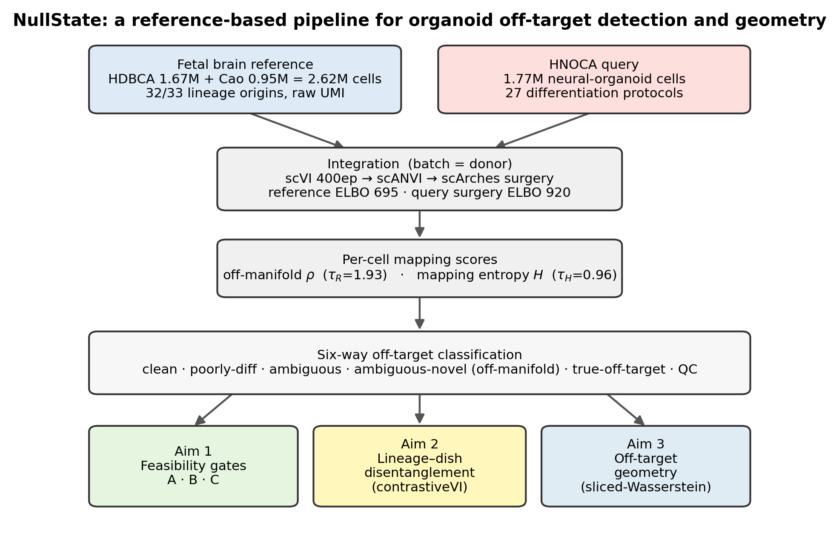
The NullState pipeline. A harmonized first-trimester fetal reference (HDBCA $+$ fetal-body atlas; 2,615,898 cells, raw UMIs) and the HNOCA organoid query (1,767,346 cells, 27 protocols) are co-embedded by scVI/scANVI followed by scArches reference surgery. Each organoid cell receives two calibrated mapping scores—off-manifold distance $ρ$ ($τ_{R}=1.93$) and label entropy $H$ ($τ_{H}=0.96$)—that define a six-state off-target taxonomy, which feeds three analyses: feasibility gates (Aim 1), lineage–dish disentanglement (Aim 2), and off-target geometry (Aim 3).
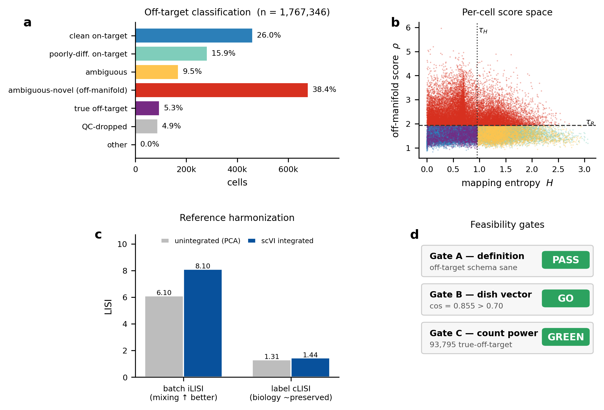
Harmonized mapping and the off-target landscape (Aim 1). (a) Six-state classification of all 1,767,346 organoid cells; the off-manifold ambiguous-novel state dominates ($38.4\%$). (b) Per-cell score space: mapping entropy $H$ versus off-manifold score $ρ$ (subsample), coloured by class, with the calibrated thresholds $τ_{H}$ (dotted) and $τ_{R}$ (dashed). (c) Donor-batch integration improves mixing (iLISI $6.10​→​8.10$) while preserving biology (cLISI $1.31​→​1.44$). (d) The three feasibility gates pass: definition (A), dish-vector self-consistency (B, cosine $0.855$), and off-target power (C, green).
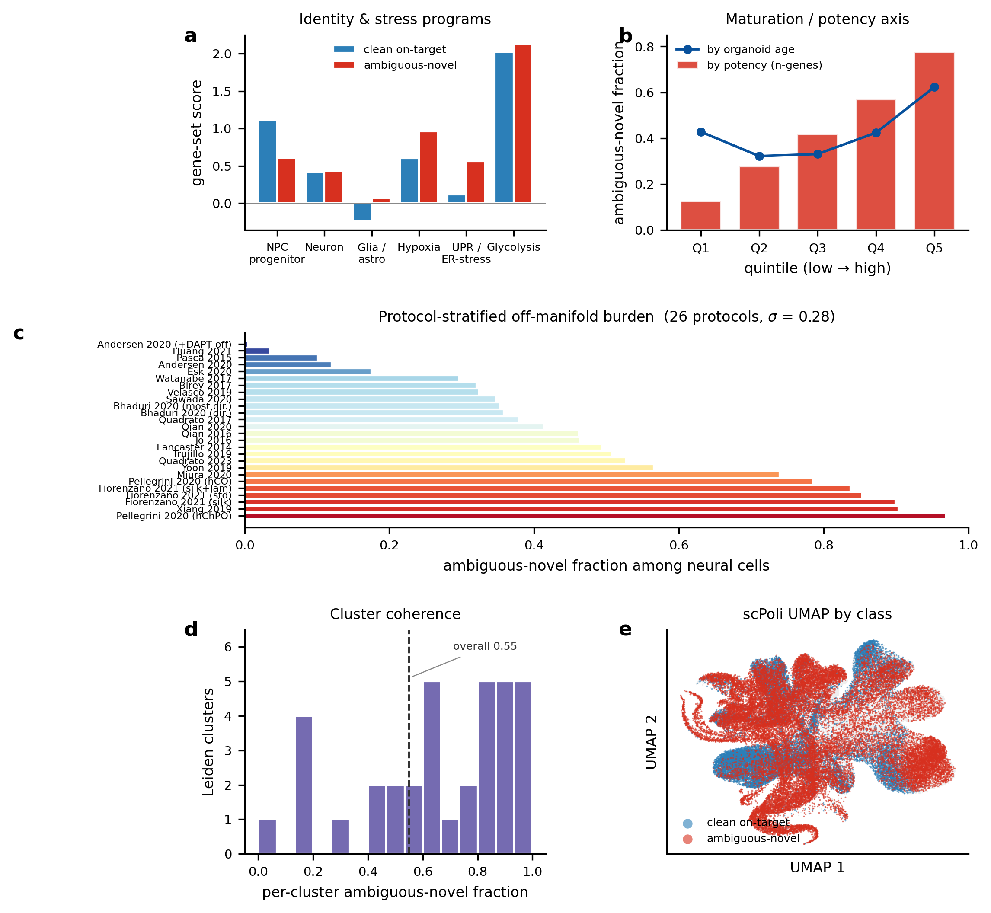
The off-manifold compartment is structured, not artifactual. (a) Ambiguous-novel neural cells lose neural-progenitor identity and gain hypoxia and unfolded-protein/ER-stress signatures relative to clean on-target neural cells. (b) Off-manifold fraction increases monotonically with a detected-gene potency proxy (bars) and with organoid age (line). (c) Protocol-stratified off-manifold burden spans $0.4\%$–$96.8\%$ across 26 protocols (colour $=$ fraction); guided cortical protocols are lowest, choroid-plexus/midbrain/thalamic highest. (d) Per-cluster off-manifold fraction across 30 Leiden communities is bimodal (coherent populations, not scatter). (e) scPoli UMAP coloured by class: ambiguous-novel cells occupy contiguous territory.
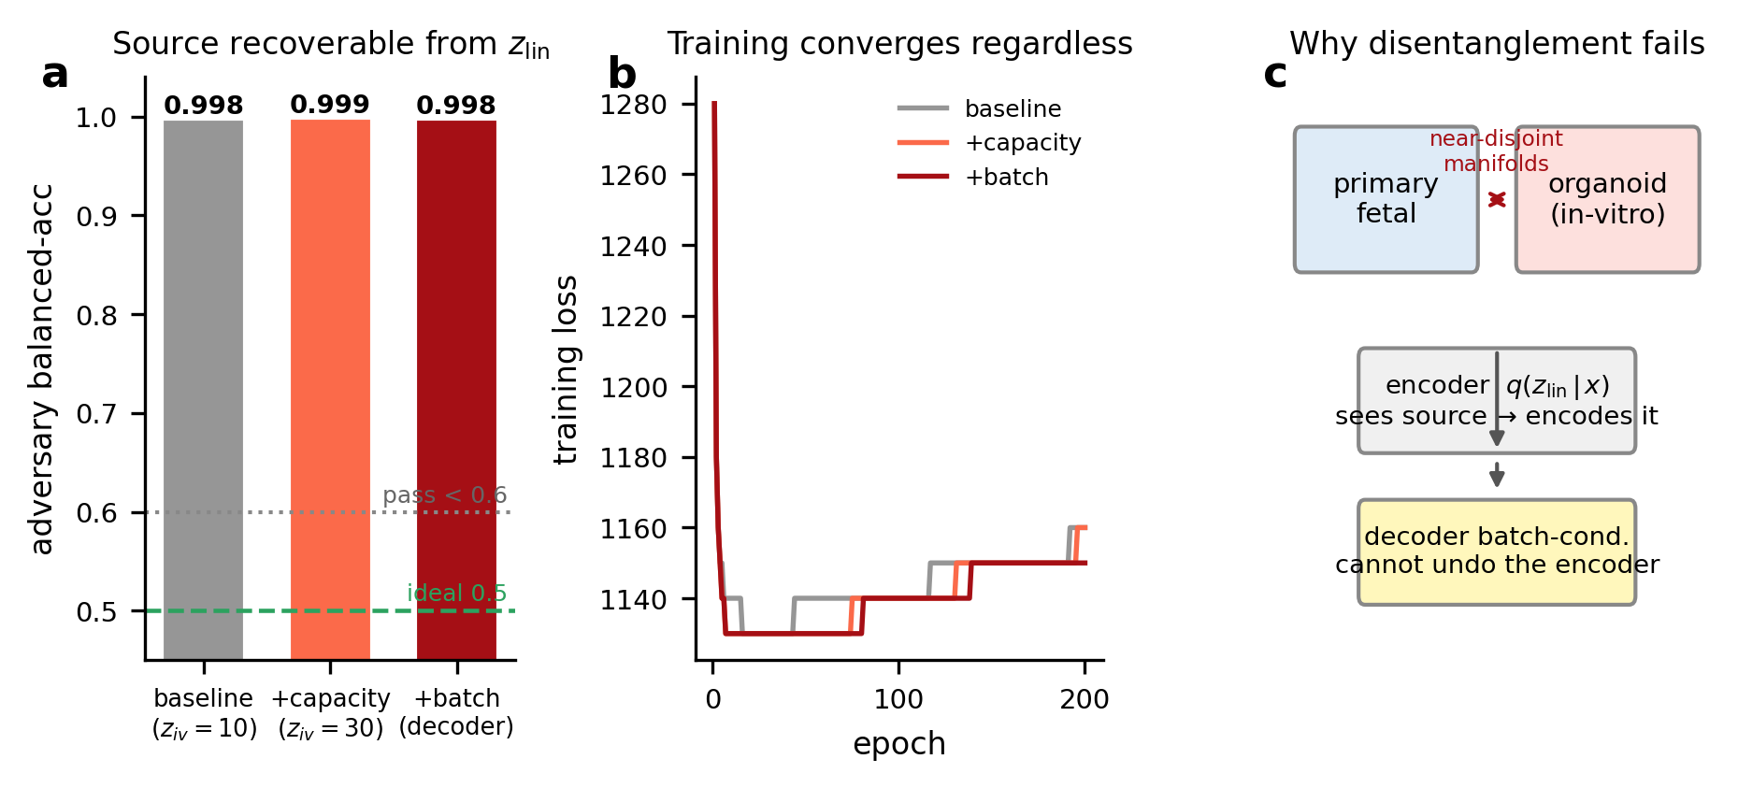
Lineage–dish disentanglement is not attainable (characterized negative; Aim 2). (a) An origin-decoding adversary recovers organoid-versus-primary identity from the “dish-stripped” latent $z_{lin}$ at $≥​0.998$ balanced accuracy across all interventions (ideal $0.5$; pass $<0.6$). (b) Training converges normally in every run, so the failure is structural, not optimization-related. (c) Mechanism: near-disjoint primary/organoid manifolds make the background encoder encode source directly; decoder batch-conditioning cannot remove it.
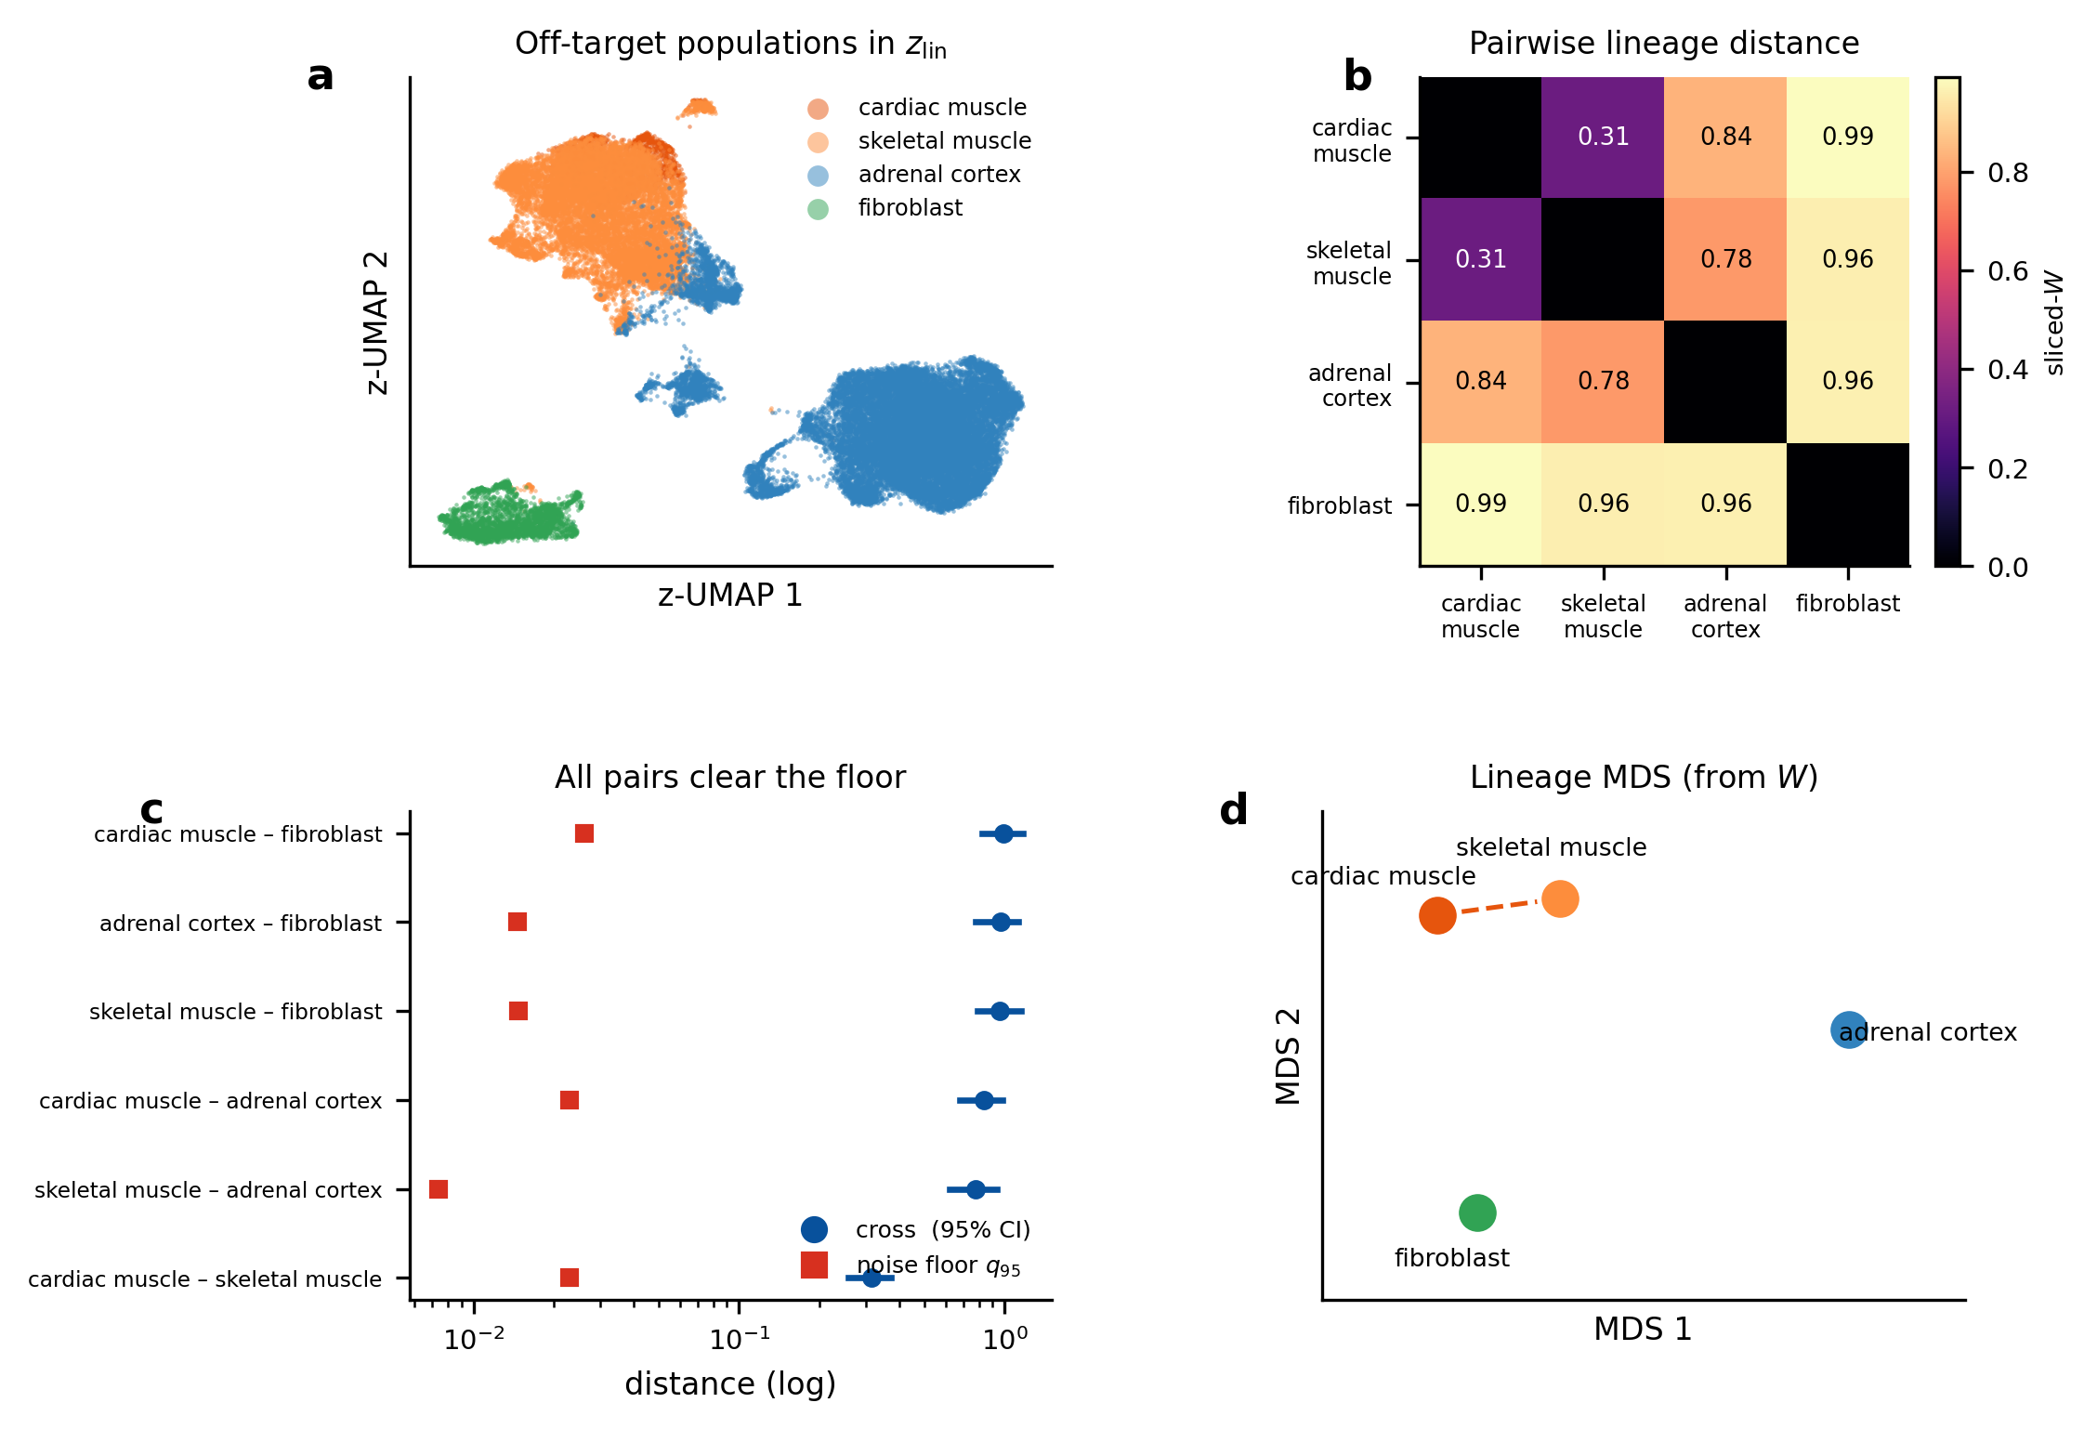
Off-target geometry: distances clear the noise floor and their rank recovers primary lineage order (Aim 3). (a) Background-latent ($z_{lin}$) embedding of the off-target populations; the four well-powered lineages separate. (b) Pairwise sliced-Wasserstein distance matrix. (c) Every well-powered pair clears its matched-$N$ noise floor ($q_{95}$, red) by $14$–$105×$ (cross-distance with $95\%$ CI, blue; log axis). (d) Multidimensional scaling of the distance matrix: the two myogenic populations (cardiac, skeletal muscle) are closest, fibroblast most distant. The rank order matches the primary lineage geometry (distance-matrix $r=0.90$); the individual distances, however, are confounded by lineage- dependent source offsets (mutual cosine $0.15$; see text), so the ordering is validated but the metric is not a clean lineage distance.
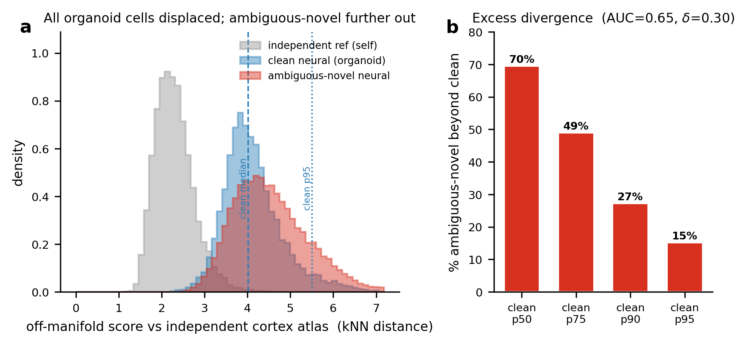
Direct cross-atlas test of coverage gap versus divergence. Ambiguous-novel and clean-on-target neural organoid cells were jointly integrated with an independent prenatal cortical atlas (Velmeshev et al. 2023²⁷). (a) Off-manifold score (kNN distance to the independent reference) for reference-self (grey), clean neural (blue), and ambiguous-novel neural (red). The organoid-versus-reference source gap displaces all organoid cells—including clean cells—far from the reference (clean/ambiguous medians $4.0/4.4$ versus reference-self $2.2$), so absolute mapped-on fractions are confounded; the clean distribution (dashed median, dotted $95$th percentile) is the calibrator. (b) The clean-versus-ambiguous contrast cancels the shared displacement: $70\%$ of ambiguous-novel cells exceed the clean median and $15\%$ lie beyond the clean $95$th percentile (overall $AUC=0.65$, Cliff’s $δ=0.30$), isolating a genuine in-vitro-divergence component.
1. Lancaster, M. A. et al. Cerebral organoids model human brain development and microcephaly. Nature 501, 373–379 (2013).
2. Paşca, A. M. et al. Functional cortical neurons and astrocytes from human pluripotent stem cells in 3D culture. Nature Methods 12, 671–678 (2015).
3. Quadrato, G. et al. Cell diversity and network dynamics in photosensitive human brain organoids. Nature 545, 48–53 (2017).
4. Velasco, S. et al. Individual brain organoids reproducibly form cell diversity of the human cerebral cortex. Nature 570, 523–527 (2019).
5. Trujillo, C. A. et al. Complex oscillatory waves emerging from cortical organoids model early human brain network development. Cell Stem Cell 25, 558–569.e7 (2019).
6. Bhaduri, A. et al. Cell stress in cortical organoids impairs molecular subtype specification. Nature 578, 142–148 (2020).
7. Tanaka, Y., Cakir, B., Xiang, Y., Sullivan, G. J. & Park, I.-H. Synthetic analyses of single-cell transcriptomes from multiple brain organoids and fetal brain. Cell Reports 30, 1682–1689.e3 (2020).
8. Kanton, S. et al. Organoid single-cell genomic atlas uncovers human-specific features of brain development. Nature 574, 418–422 (2019).
9. He, Z. et al. An integrated transcriptomic cell atlas of human neural organoids. Nature 635, 690–698 (2024).
10. Braun, E. et al. Comprehensive cell atlas of the first-trimester developing human brain. Science 382, eadf1226 (2023).
11. Cao, J. et al. A human cell atlas of fetal gene expression. Science 370, eaba7721 (2020).
12. Lopez, R., Regier, J., Cole, M. B., Jordan, M. I. & Yosef, N. Deep generative modeling for single-cell transcriptomics. Nature Methods 15, 1053–1058 (2018).
13. Xu, C. et al. Probabilistic harmonization and annotation of single-cell transcriptomics data with deep generative models. Molecular Systems Biology 17, e9620 (2021).
14. Lotfollahi, M. et al. Mapping single-cell data to reference atlases by transfer learning. Nature Biotechnology 40, 121–130 (2022).
15. CZI Cell Science Program. CZ CELLxGENE Discover: A single-cell data platform for scalable exploration, analysis and modeling of aggregated data. Nucleic Acids Research 53, D886–D900 (2025).
16. Gayoso, A. et al. A Python library for probabilistic analysis of single-cell omics data. Nature Biotechnology 40, 163–166 (2022).
17. Korsunsky, I. et al. Fast, sensitive and accurate integration of single-cell data with Harmony. Nature Methods 16, 1289–1296 (2019).
18. Luecken, M. D. et al. Benchmarking atlas-level data integration in single-cell genomics. Nature Methods 19, 41–50 (2022).
19. Buffa, F. M., Harris, A. L., West, C. M. & Miller, C. J. Large meta-analysis of multiple cancers reveals a common, compact and highly prognostic hypoxia metagene. British Journal of Cancer 102, 428–435 (2010).
20. Gulati, G. S. et al. Single-cell transcriptional diversity is a hallmark of developmental potential. Science 367, 405–411 (2020).
21. Andersen, J. et al. Generation of functional human 3D cortico-motor assembloids. Cell 183, 1913–1929.e26 (2020).
22. Pellegrini, L. et al. Human CNS barrier-forming organoids with cerebrospinal fluid production. Science 369, eaaz5626 (2020).
23. Fiorenzano, A. et al. Single-cell transcriptomics captures features of human midbrain development and dopamine neuron diversity in brain organoids. Nature Communications 12, 7302 (2021).
24. Xiang, Y. et al. hESC-derived thalamic organoids form reciprocal projections when fused with cortical organoids. Cell Stem Cell 24, 487–497.e7 (2019).
25. Traag, V. A., Waltman, L. & Eck, N. J. van. From Louvain to Leiden: Guaranteeing well-connected communities. Scientific Reports 9, 5233 (2019).
26. McInnes, L., Healy, J. & Melville, J. UMAP: Uniform manifold approximation and projection for dimension reduction. arXiv preprint arXiv:1802.03426 https://doi.org/10.48550/arXiv.1802.03426 (2018) doi:10.48550/arXiv.1802.03426.
27. Velmeshev, D. et al. Single-cell analysis of prenatal and postnatal human cortical development. Science 382, eadf0834 (2023).
28. Weinberger, E., Lin, C. & Lee, S.-I. Isolating salient variations of interest in single-cell data with contrastiveVI. Nature Methods 20, 1336–1345 (2023).
29. Bonneel, N., Rabin, J., Peyré, G. & Pfister, H. Sliced and Radon Wasserstein barycenters of measures. Journal of Mathematical Imaging and Vision 51, 22–45 (2015).
30. Benjamini, Y. & Hochberg, Y. Controlling the false discovery rate: A practical and powerful approach to multiple testing. Journal of the Royal Statistical Society: Series B (Methodological) 57, 289–300 (1995).

