Lawrence Technological University
BME 3303 “Biomechanics”
Mastery Based Learning Quiz #1 (Vectors)

Name:_________________________

Determine the total acceleration on a ball (m= 0.05 kg) subjected to three forces (N) as shown in the figure below.

Lawrence Technological University
BME 3303 “Biomechanics”
Mastery Based Learning Quiz #1 (Vectors)

Name:_________________________

For the marker positions (x,y) given in the table of the subject shown below, compute the elbow flexion angle.
Marker | Position (cm)
Proximal Upper arm | (140, 160)
Distal Upper arm | (120, 150)
Proximal Forearm | (110, 140)
Distal Forearm | (120, 120)

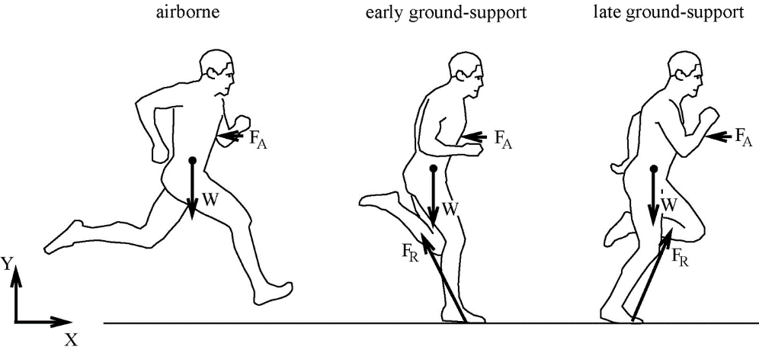

Lawrence Technological University
BME 3303 “Biomechanics”
Mastery Based Learning Quiz #1 (Vectors)

Name:_________________________

Determine the reaction force in the patellafemoral joint (PF) subjected to forces (N) in the Quadriceps tendon (Q) and Patellar ligament (P) when the knee is flexed at 80° as shown in the figure below.
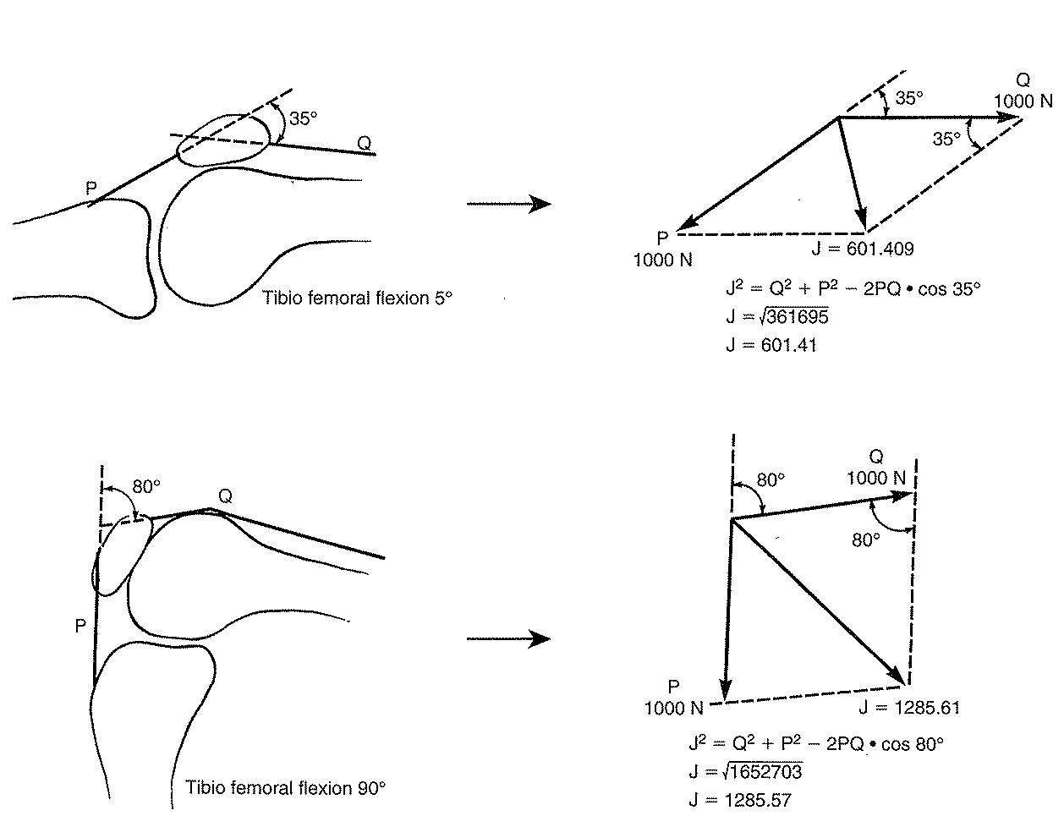
800 N
PF

Lawrence Technological University
BME 3303 “Biomechanics”
Mastery Based Learning Quiz #1 (Vectors)

Name:_________________________

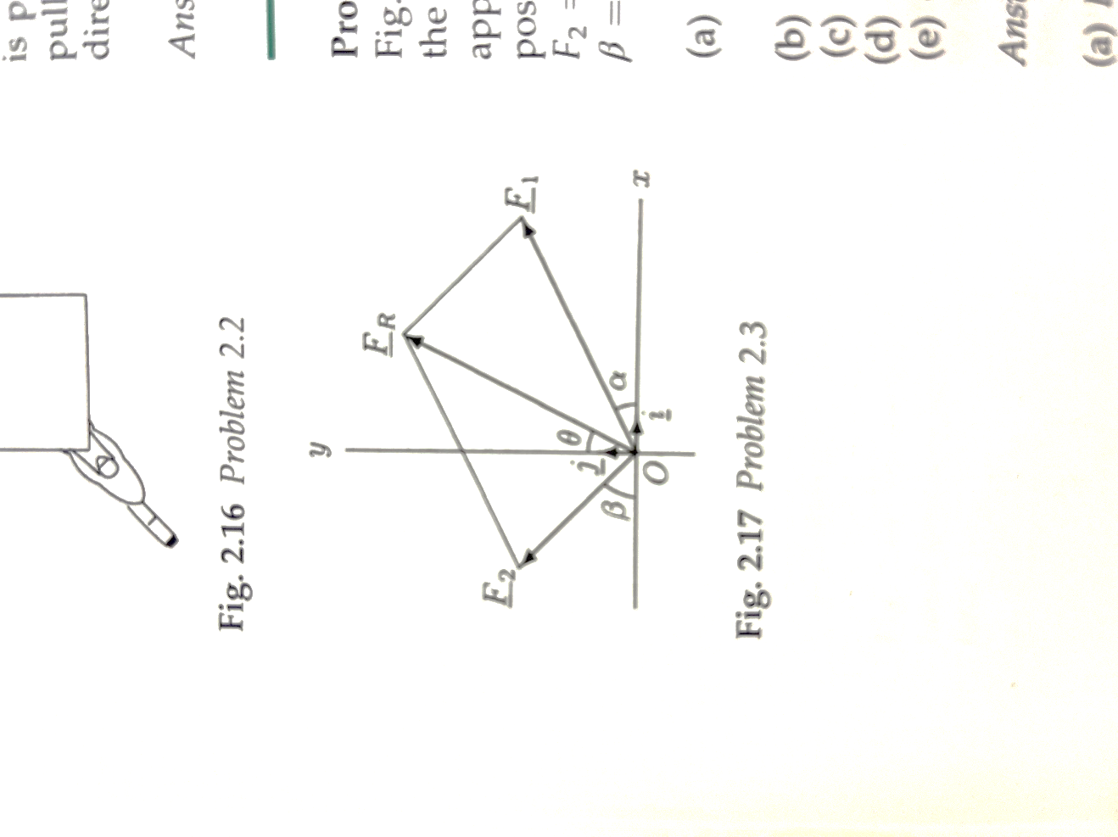
Determine the reaction force F_{R} for an object that has two forces; F₁ = 15 N at α = 30° and F₂ = 10 N at β = 45° applied as shown in the figure below.

Lawrence Technological University
BME 3303 “Biomechanics”
Mastery Based Learning Quiz #1 (Vectors)

Name:_________________________

Determine the normal (F_{Jn}) and shear (F_{Jt}) components of the neck joint reaction force F_{J} = 86 N if the angle β = 60° as shown in the figure below.
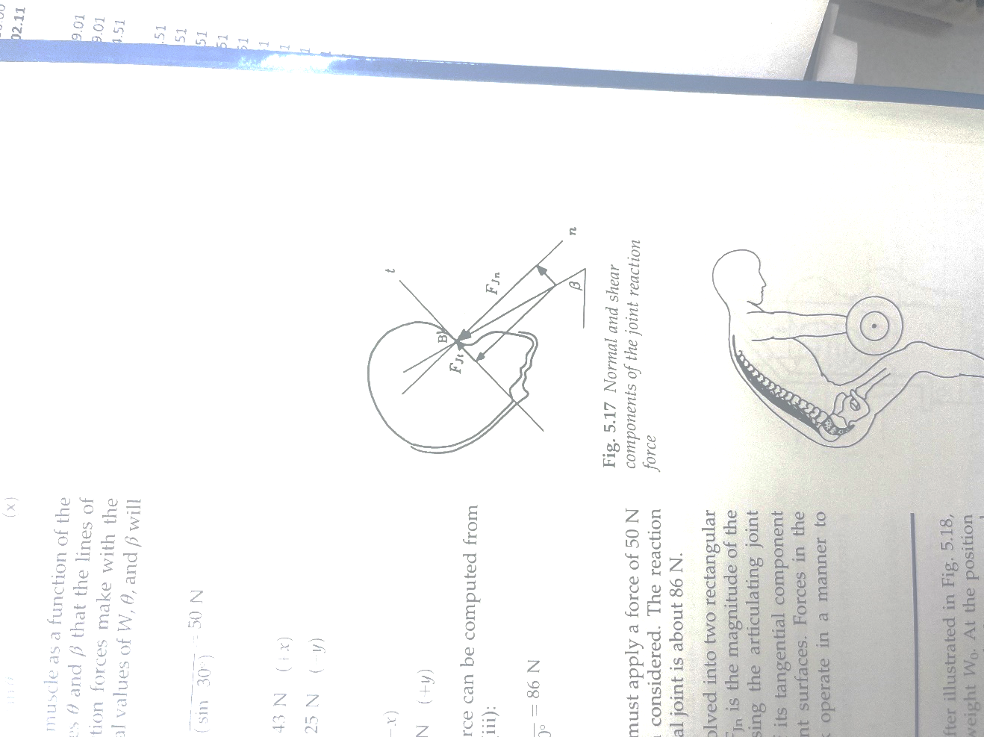

Lawrence Technological University
BME 3303 “Biomechanics”
Mastery Based Learning Quiz #1 (Vectors)

Name:_________________________

Determine the tension reaction force on the leg (R) that is subjected to traction forces T = 150 N in a cable with a weight attached as shown in the figure below. The angles between the cables and the leg θ = 150° are the same towards the upper and lower pulleys.
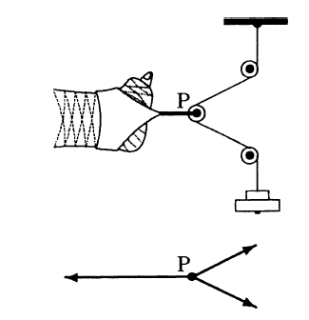
θ
T
T
R

