- Ubuntu installed and ran normally
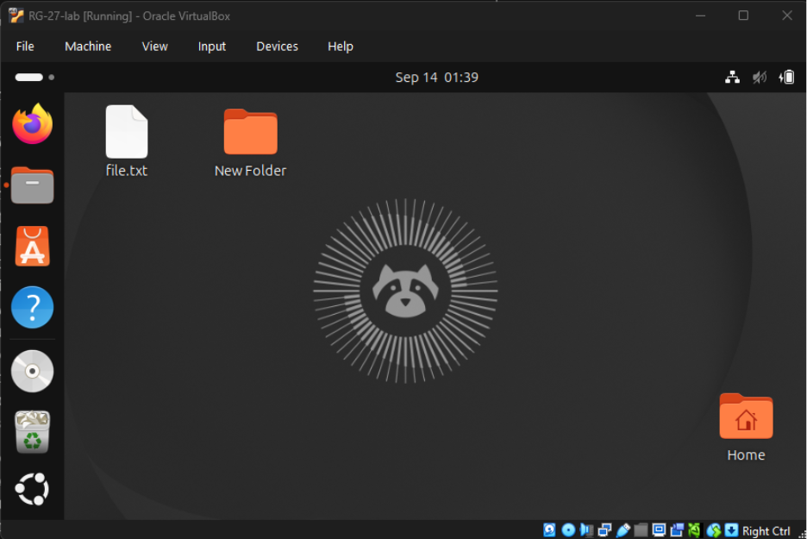
- Navigating with pwd, ls, cd
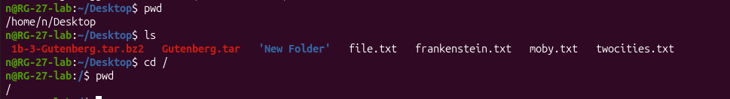
- Creating directory and file: mkdir, touch

- Listing all active service units and check status
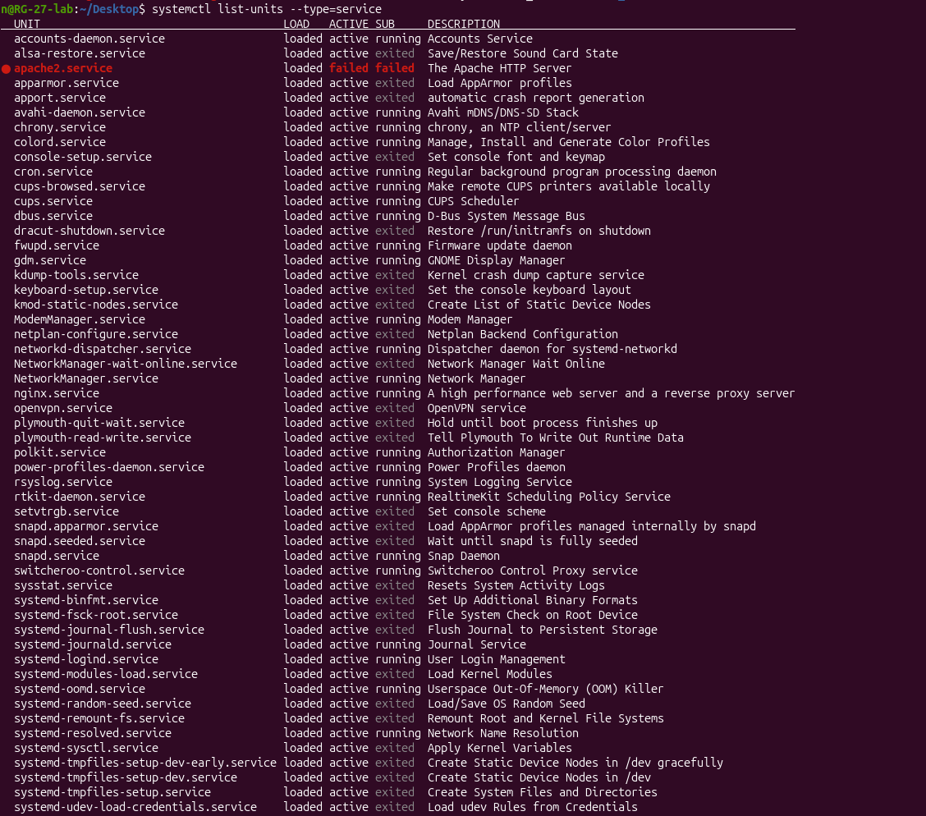
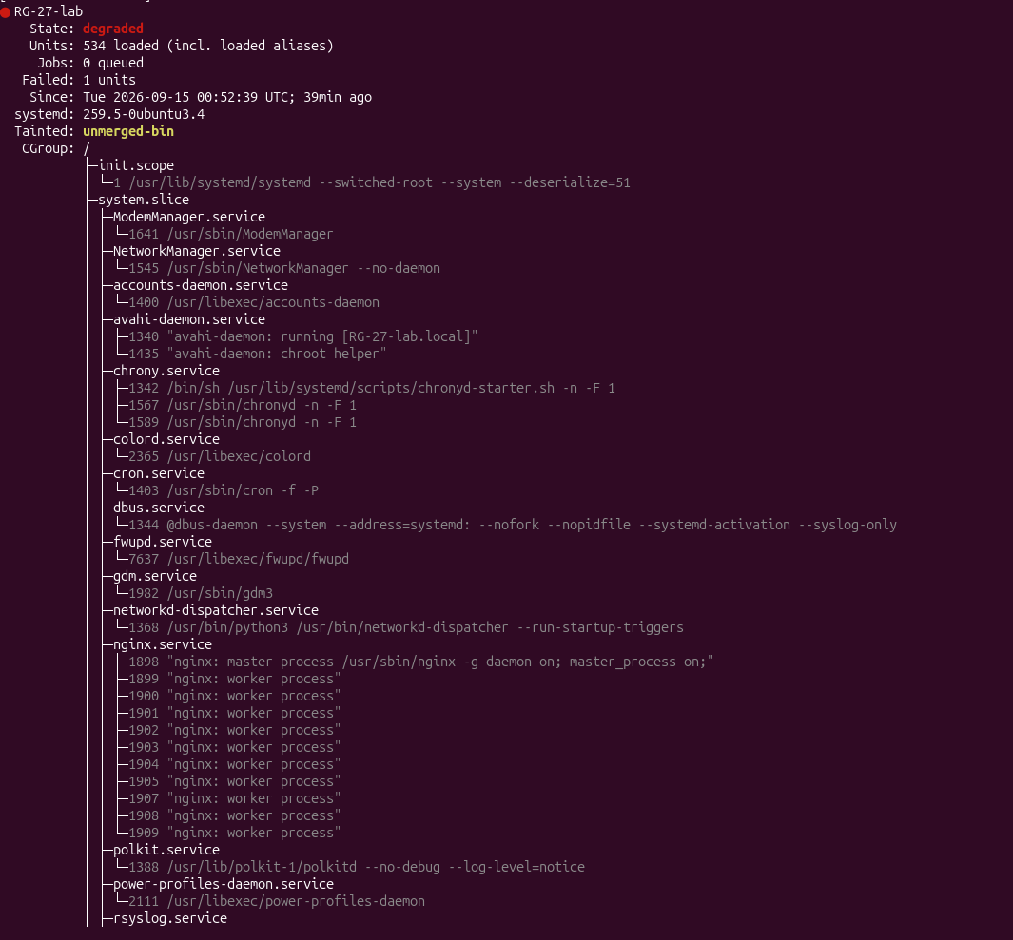
- Viewing permissions
