- Compare cloud vs on-prem cost
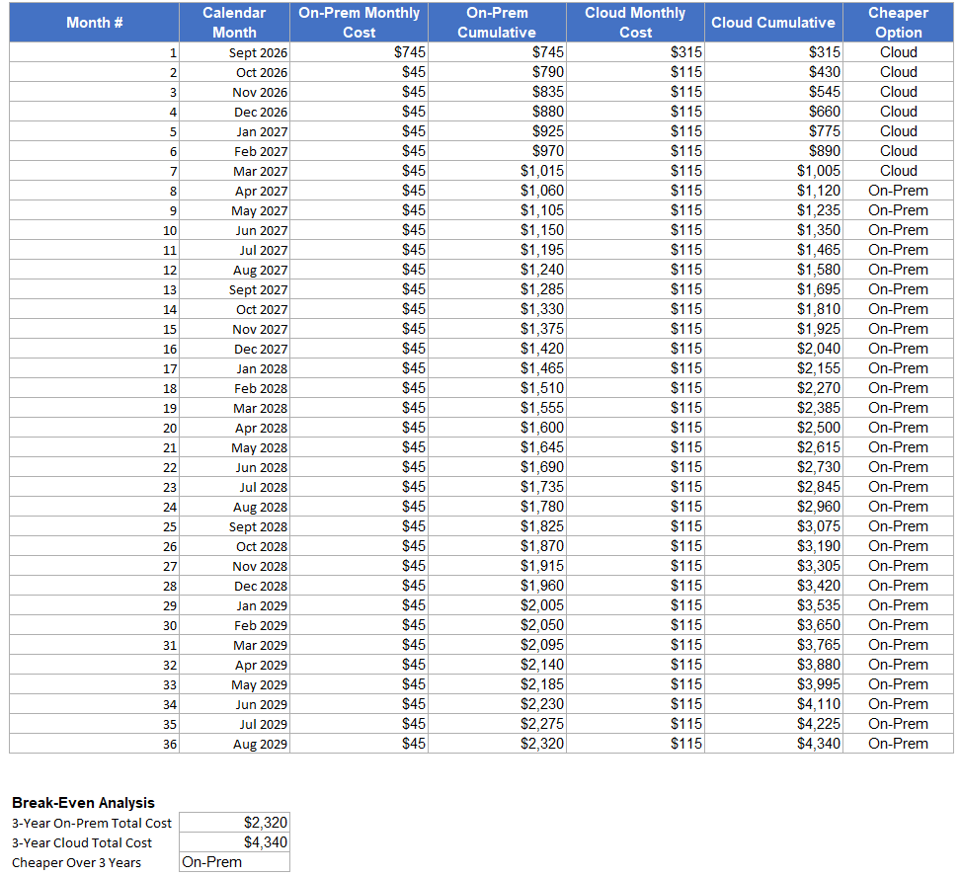
Assumptions for on-prem option (small project)
Server-hardware: $600
OS: $0 (using Ubuntu)
Installation: $100 (one-time)
Maintenance: $45 (per month)
Cloud suits short-term or uncertain workloads since there's no upfront investment to lose. On-prem pays off once a workload runs long-term, since the lower recurring cost recovers the initial hardware cost over time.

- Launching an Ubuntu instance
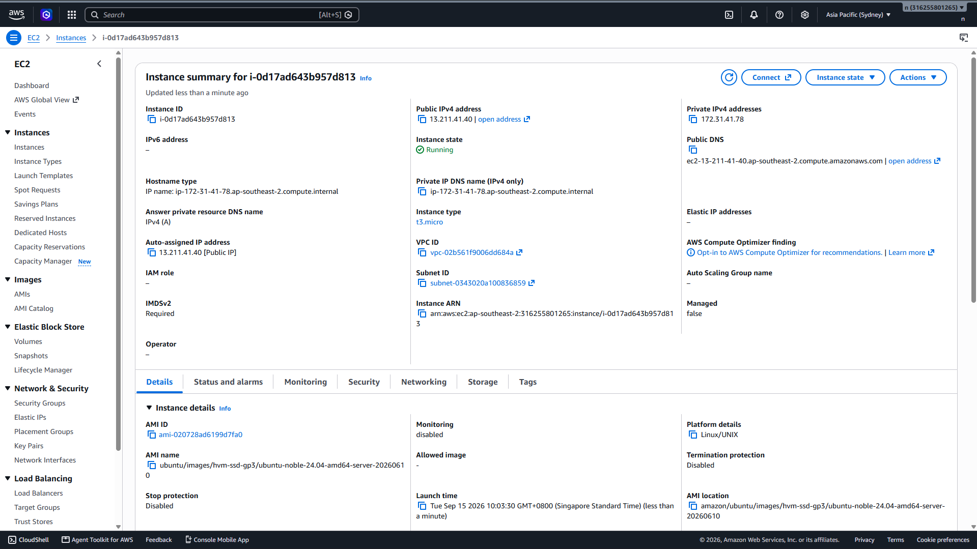
- System monitoring. Using loop to make it work automatically without refeshing
