- Registered a domain on DuckDNS and updated the IP to AWS server public IP address
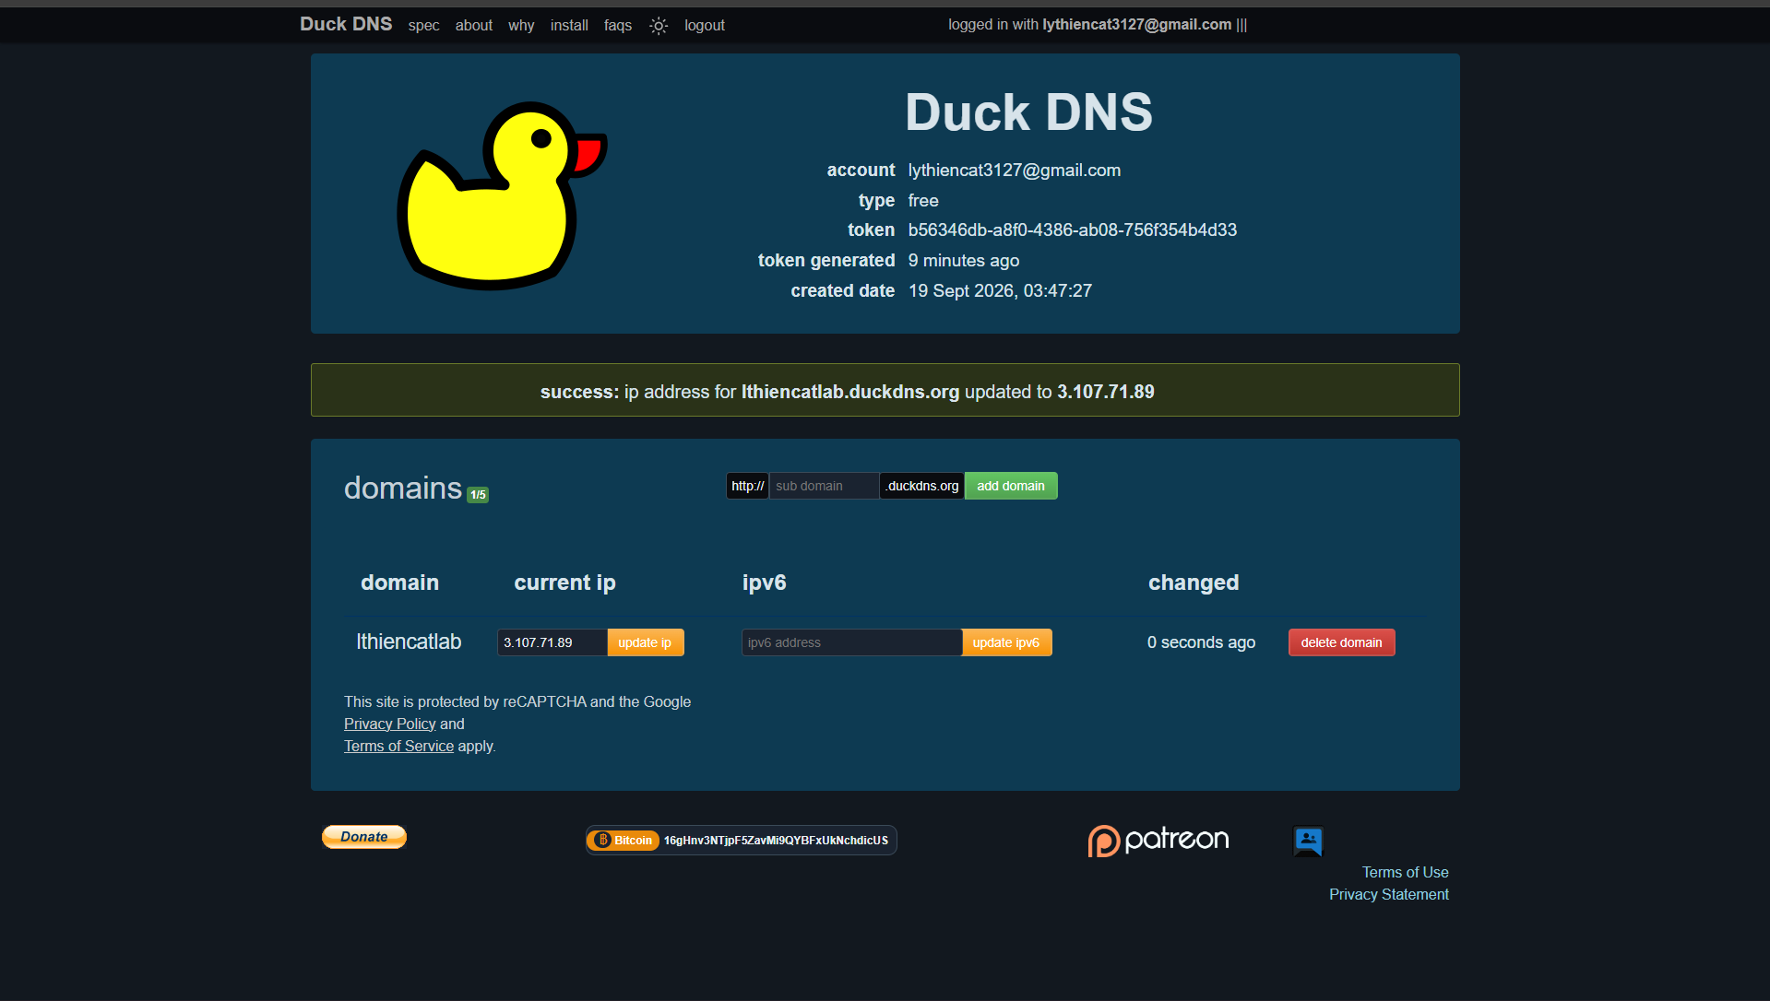
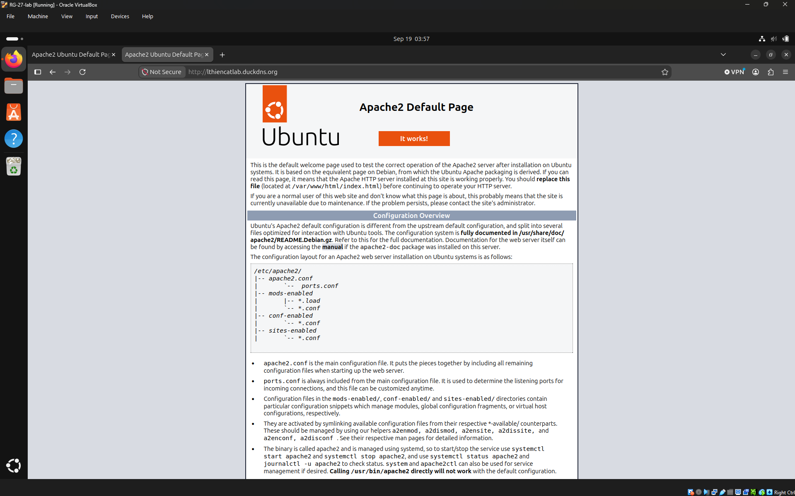
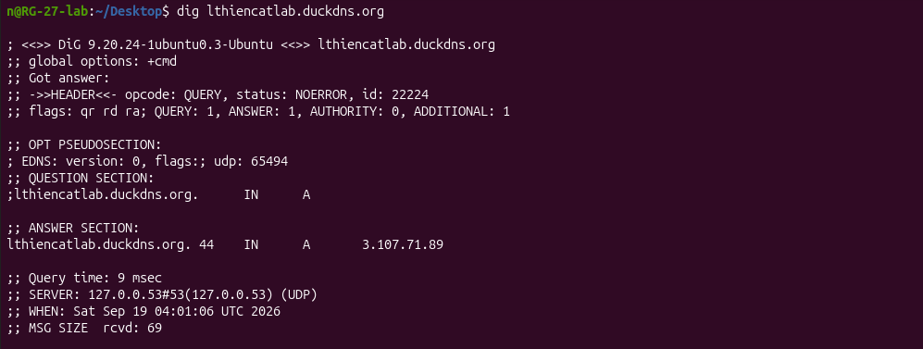
- Done setup digital certificate. The web confirm connection secured
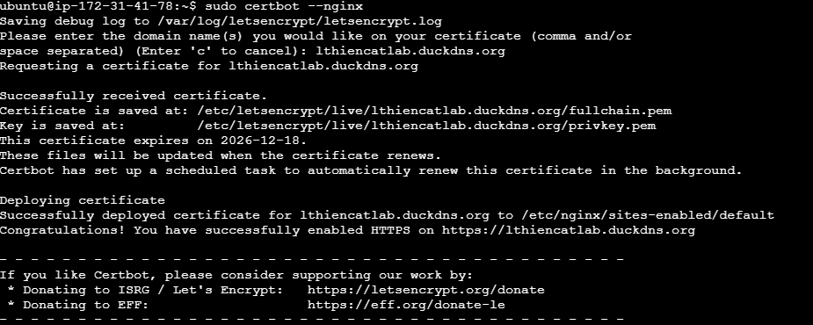
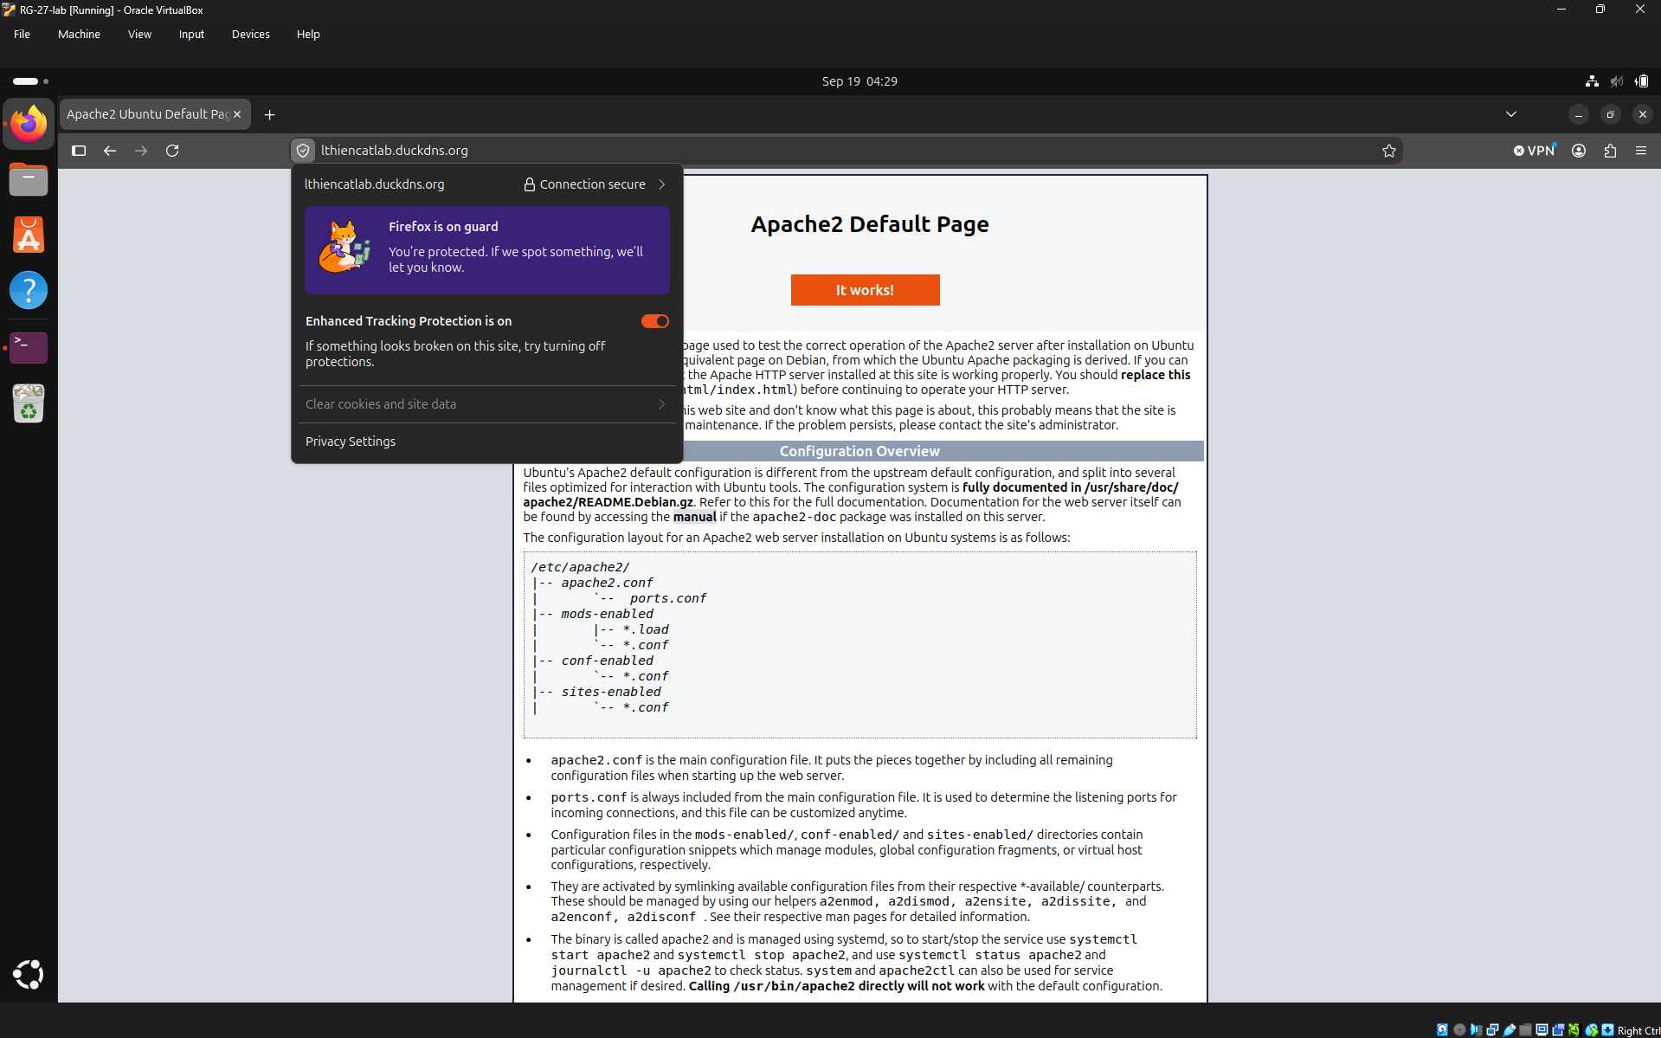
- Auto update for every Monday a week using ‘crontab -e’ and ‘0 2 * * 1 /home/n/Desktop/auto_update.sh’. Log output with ‘>> /var/log/task.log’
