Họ và tên :Lê Thiên Phúc

Lớp :CNPM2

Bài làm

Tạo View:

CREATE VIEW VW_SANPHAM

AS

SELECT MASP, TENSP, SOLUONG, MAUSAC, GIABAN, DONVITINH, MOTA

FROM SANPHAM INNER JOIN HANGSX ON SANPHAM.MAHANGSX = HANGSX.MAHANGSX

GO

SELECT * FROM VW_SANPHAM

GO

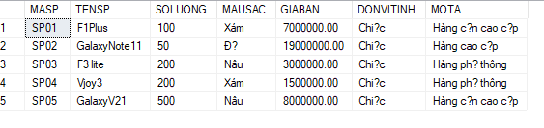

CREATE VIEW VW_HANGSX

AS

SELECT TENHANG, DIACHI, SODT, EMAIL

FROM SANPHAM INNER JOIN HANGSX ON HANGSX.MAHANGSX = SANPHAM.MAHANGSX

GO

SELECT * FROM VW_HANGSX

GO

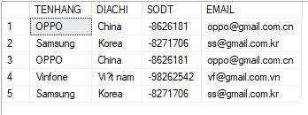

CREATE VIEW VW_NHAP

AS

SELECT SOHDN, MASP, NGAYNHAP, SOLUONGN, DONGGIA

FROM NHAP INNER JOIN NHANVIEN ON NHAP.MANV=NHANVIEN.MANV

GO

SELECT * FROM VW_NHAP

GO

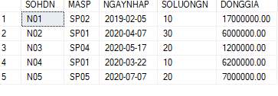

CREATE VIEW VW_XUAT

AS

SELECT SOHDX, MASP, NGAYXUAT, SOLUONGX

FROM XUAT INNER JOIN NHANVIEN ON XUAT.MANV=NHANVIEN.MANV

GO

SELECT * FROM VW_XUAT

GO

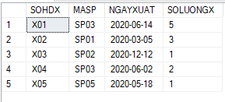

CREATE VIEW VW_NHANVIEN

AS

SELECT TENNV, GIOITINH, DIACHI, SODT, EMAIL, PHONG

FROM NHANVIEN INNER JOIN XUAT ON NHANVIEN.MANV=XUAT.MANV

GO

SELECT * FROM VW_NHANVIEN

GO

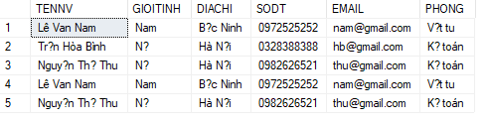

Câu 2:

CREATE VIEW View2 AS

SELECT TOP 100 PERCENT SanPham.masp, tensp, tenhang, soluong, mausac, giaban, donvitinh, mota

FROM SanPham

JOIN HANGSX ON SanPham.mahangsx = HANGSX.mahangsx

order by giaban desc

go

SELECT *

FROM View2

Go

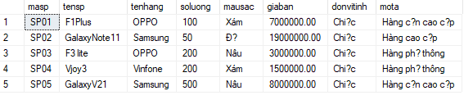

Câu 3:

CREATE VIEW View3 AS

SELECT TOP 100 PERCENT SanPham.masp, tensp, soluong, mausac, giaban, donvitinh, mota

FROM SanPham

JOIN HANGSX ON SanPham.mahangsx = HANGSX.mahangsx

WHERE HANGSX.tenhang = 'Samsung';

go

SELECT *

FROM View3;

Go

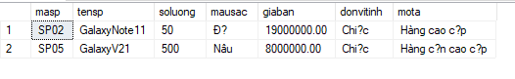

Câu 4:

Create View View4 as

Select * from Nhanvien

WHERE gioitinh = 'Nữ' AND phong = 'Kế toán'

Go

SELECT *

FROM View4;

Go

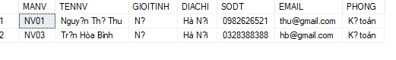

Câu 5:

Create View View5 as

Select top 100 percent Nhap.sohdn, Sanpham.masp, Sanpham.tensp, Hangsx.tenhang, Nhap.soluongN, Nhap.DONGGIA, Nhap.soluongN*Nhap.DONGGIA AS tiennhap, Sanpham.mausac, Sanpham.donvitinh, Nhap.ngaynhap, Nhanvien.tennv, Nhanvien.phong

from Nhap

JOIN Sanpham ON Nhap.masp = Sanpham.masp

JOIN Hangsx ON Sanpham.mahangsx = Hangsx.mahangsx

JOIN Nhanvien ON Nhap.manv = Nhanvien.manv

ORDER BY Nhap.sohdn ASC;

Go

SELECT *

FROM View5;

Go

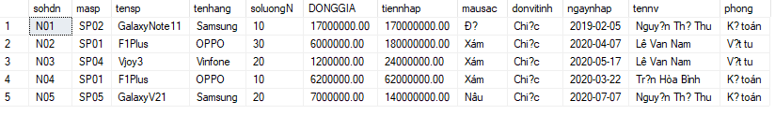

Câu 6:

Create View View6 as

SELECT top 100 percent Xuat.sohdx, Sanpham.masp, Sanpham.tensp, Hangsx.tenhang, Xuat.soluongX, Sanpham.giaban,

Xuat.soluongX*Sanpham.giaban AS tienxuat, Sanpham.mausac, Sanpham.donvitinh, Xuat.ngayxuat,

Nhanvien.tennv, Nhanvien.phong

FROM Xuat

INNER JOIN Sanpham ON Xuat.masp = Sanpham.masp

INNER JOIN Hangsx ON Sanpham.mahangsx = Hangsx.mahangsx

INNER JOIN Nhanvien ON Xuat.manv = Nhanvien.manv

WHERE MONTH(Xuat.ngayxuat) = 10 AND YEAR(Xuat.ngayxuat) = 2018

ORDER BY Xuat.sohdx ASC;

Go

SELECT *

FROM View6;

Go

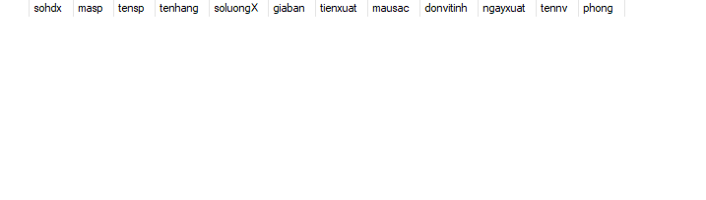

Câu 7:

Create View View7 as

SELECT top 100 percent sohdn, Sanpham.masp, tensp, soluongN, DONGGIA, ngaynhap, tennv, phong

FROM Nhap

JOIN Sanpham ON Nhap.masp = Sanpham.masp

JOIN Hangsx ON Sanpham.mahangsx = Hangsx.mahangsx

JOIN Nhanvien ON Nhap.manv = Nhanvien.manv

WHERE Hangsx.tenhang = 'Samsung' AND YEAR(ngaynhap) = 2017;

Go

SELECT *

FROM View7;

Go

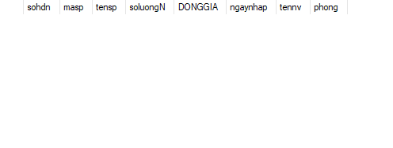

Câu 8:

Create View View8 as

SELECT TOP 10 Xuat.sohdx, Sanpham.tensp, Xuat.soluongX

FROM Xuat

INNER JOIN Sanpham ON Xuat.masp = Sanpham.masp

WHERE YEAR(Xuat.ngayxuat) = '2018'

ORDER BY Xuat.soluongX DESC;

Go

SELECT *

FROM View8;

Go

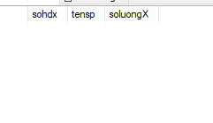

Câu 9:

Create View View9 as

SELECT TOP 10 tenSP, giaBan

FROM SanPham

ORDER BY giaBan DESC;

Go

SELECT *

FROM View9;

Go

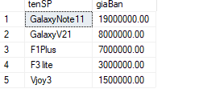

Câu 10:

Create View View10 as

SELECT top 100 percent Sanpham.masp, Sanpham.tensp, Hangsx.tenhang, Sanpham.soluong, Sanpham.mausac, Sanpham.giaban, Sanpham.donvitinh, Sanpham.mota

FROM Sanpham

JOIN Hangsx ON Sanpham.mahangsx = Hangsx.mahangsx

WHERE Hangsx.tenhang = 'Samsung' AND Sanpham.giaban >= 100000 AND Sanpham.giaban <= 500000

Go

SELECT *

FROM View10;

Go

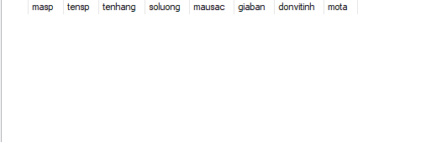

Câu 11:

Create View View11 as

SELECT SUM(soluongN * DONGGIA) AS tongtien

FROM Nhap

JOIN Sanpham ON Nhap.masp = Sanpham.masp

JOIN Hangsx ON Sanpham.mahangsx = Hangsx.mahangsx

WHERE Hangsx.tenhang = 'Samsung' AND YEAR(ngaynhap) = 2018

Go

SELECT *

FROM View11;

Go

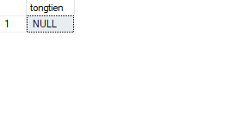

Câu 12:

Create View View12 as

SELECT SUM(Xuat.soluongX * Sanpham.giaban) AS Tongtien

FROM Xuat

INNER JOIN Sanpham ON Xuat.masp = Sanpham.masp

WHERE Xuat.ngayxuat = '2018-09-02'

Go

SELECT *

FROM View12;

Go

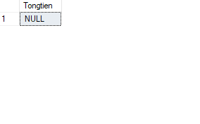

Câu 13:

Create View View13 as

SELECT TOP 1 sohdn, ngaynhap, DONGGIA

FROM Nhap

ORDER BY DONGGIA DESC

Go

SELECT *

FROM View13;

Go

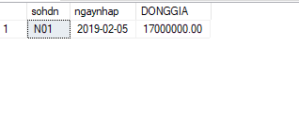

Câu 14:

Create View View14 as

SELECT TOP 10 Sanpham.tensp, SUM(Nhap.soluongN) AS TongSoLuongN

FROM Sanpham

INNER JOIN Nhap ON Sanpham.masp = Nhap.masp

WHERE YEAR(Nhap.ngaynhap) = 2019

GROUP BY Sanpham.tensp

ORDER BY TongSoLuongN DESC

Go

SELECT *

FROM View14;

Go

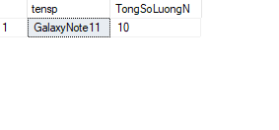

Câu 15:

Create View View15 as

SELECT Sanpham.masp, Sanpham.tensp

FROM Sanpham

INNER JOIN Hangsx ON Sanpham.mahangsx = Hangsx.mahangsx

INNER JOIN Nhap ON Sanpham.masp = Nhap.masp

INNER JOIN Nhanvien ON Nhap.manv = Nhanvien.manv

WHERE Hangsx.tenhang = 'Samsung' AND Nhanvien.manv = 'NV01';

Go

SELECT *

FROM View15;

Go

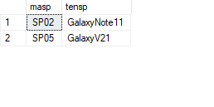

Câu 16:

Create View View16 as

SELECT sohdn, masp, soluongN, ngaynhap

FROM Nhap

WHERE masp = 'SP02' AND manv = 'NV02'

Go

SELECT *

FROM View16;

Go

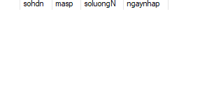

Câu 17:

Create View View17 as

SELECT Nhanvien.manv, Nhanvien.tennv

FROM Nhanvien

INNER JOIN Xuat ON Nhanvien.manv = Xuat.manv

WHERE Xuat.masp = 'SP02' AND Xuat.ngayxuat = '2020-03-02'

GO

SELECT *

FROM View17;

Go

