TAMP

Truck Asset Matchmaking Platform
Front-End Technical Documentation
Solution overview, architecture, traceability, testing summary, setup and demo guide
━━━━━━━━━━━━━━━━━━━━━━━━━━━━━━━━━━━━━━━━━━━━━━━━━━━━
Project | Truck Asset Matchmaking Platform (TAMP)
Assessment | TAMP MVP Development Assessment - Front-End track
Organisation | Industrial Computing Engineering (Pty) Ltd
Repository | LTshepoJr/Truck-Asset-Matchmaking-Platform
Branch reviewed | freight-owner
Document date | 29 July 2026
Repository: github.com/LTshepoJr/Truck-Asset-Matchmaking-Platform/tree/freight-owner
Status note: This document describes the public freight-owner branch as reviewed on 29 July 2026. It does not assume unpushed local changes.

1. Document Purpose and Assessment Cross-Check
Yes - technical documentation is explicitly required by the assessment brief. The brief asks for a concise README/setup guide, solution overview, front-end architecture/design, FR-01 to FR-12 traceability, testing summary, user/demo guide and known limitations. It also states that the submission package should include the required technical documents in PDF or Markdown. [A1]
Important format point: a Microsoft Word (.docx) file is not specifically mandated. This document consolidates the required technical material into a professional Word document and can be exported to PDF for submission.
Brief deliverable | What this document provides | Section
README / Setup Guide | Prerequisites, installation, commands, browser data and demo credentials | Section 11
Solution Overview | Purpose, scope, stack, components and design decisions | Sections 2-4
Architecture / Design | Page/component, service and state/data flow | Section 5
Requirements Traceability | FR-01 to FR-12 with evidence and implementation status | Section 8
Testing Summary | Static review findings plus executable test checklist | Section 9
User / Demo Guide | Role-based demonstration sequence | Section 10
Known Limitations | Incomplete UI, mock-only behaviour and technical debt | Section 12

1.1 Document Control
Version | Date | Basis | Notes
1.0 | 29 Jul 2026 | Assessment brief + public freight-owner branch | Initial consolidated front-end technical documentation.

2. Solution Overview
TAMP is a digital freight marketplace MVP that connects Freight Owners who need cargo moved with Transporters that have available truck capacity. The assessment objective is to demonstrate a simplified but traceable journey: registration/role selection, posting, rule-based matching, acceptance/rejection, confirmation, tracking, rating and administrative oversight. [A1]

2.1 Current Repository Scope
- Front-end application built with React and TypeScript.
- Role-aware navigation and protected Freight Owner, Transporter and Administrator route groups.
- Browser-based registration, authentication, session handling and password recovery.
- Typed TAMP domain model covering users, loads, trucks, matches, receipts, trips, tracking events, ratings, disputes and audit events.
- Browser-persisted mock database seeded from a South African JSON fixture.
- Service-layer support for load/truck creation, transparent matching, acceptance/rejection, receipt/trip creation, mock tracking, ratings, disputes, audit events and KPI calculations.
- Freight Owner pages/routes exist for dashboard, loads, new load, matches and tracking; the current public branch still shows placeholder content on at least the dashboard and Create Load page. [R3][R9][R10]

2.2 In-Scope Roles
Role | Assessment responsibility | Current code-level position
Freight Owner | Post loads, review trucks, accept/reject matches, track and rate. | Dedicated protected routes exist. Service layer supports the underlying domain workflow; visible pages are still partly placeholders.
Transporter | Post trucks, review suitable loads, accept/reject, update trip and rate. | Protected dashboard route exists. Truck and matching service functions exist; role UI is not yet developed beyond the dashboard route.
Administrator | Manage users/compliance, activity/disputes and KPI views. | Protected dashboard route exists. Dispute, audit and KPI service functions exist; admin management UI remains incomplete.

2.3 Explicit MVP Boundaries
The assessment explicitly permits mock/sample data and does not require a production backend for the front-end submission. Live telematics/GPS, payment gateways, production e-signature/SMS/OTP/email, AI/ML matching, native mobile applications and production-scale infrastructure are out of scope. [A1]

3. Technology Stack
Technology | Version in package.json | Use in TAMP
React | ^19.2.7 | UI composition and page/component rendering.
React DOM | ^19.2.7 | Browser rendering.
React Router DOM | ^7.18.1 | Public/protected routes and nested role layouts.
TypeScript | ^7.0.2 | Static typing and domain contracts.
Vite | ^8.1.1 | Development server and production build.
Oxlint | ^1.71.0 | Source linting.
Web Crypto API | Browser API | PBKDF2/SHA-256 password derivation and random salts/tokens.
localStorage / sessionStorage | Browser API | Mock persistence, registered users and session/reset state.
JSON fixture | Repository asset | Synthetic South African seed data for the local mock database.
Source: package.json and current service implementation. [R2][R5][R6]

4. Key Design Decisions
Front-end-only persistence: Use browser storage and a typed mock database rather than a production API/database. Rationale: Fits the one-week front-end MVP boundary and supports demonstrable state changes. [A1][R6]
Transparent matching: Use deterministic eligibility checks and a 100-point score instead of AI. Rationale: Directly aligns with the assessment requirement for transparent rule-based matching. [A1][R6]
Separate auth/domain stores: Keep registered credential records in tamp-users while the TAMP domain data lives in tamp_db. Rationale: Allows password hashing/session logic to stay separate from operational marketplace data. [R5][R6]
Role-based nested routing: Wrap each role area with ProtectedRoute and RoleLayout. Rationale: Keeps navigation and route access role-specific. [R3][R4]
Mock audit trail: Append audit events inside service operations. Rationale: Provides traceable state transitions without requiring a backend event store. [R6]

5. Architecture and Data Flow
The current solution is a layered front-end. Pages render UI, React Router controls access and nesting, services implement identity and marketplace operations, and browser storage acts as the persistence mechanism. [R3][R4][R5][R6]
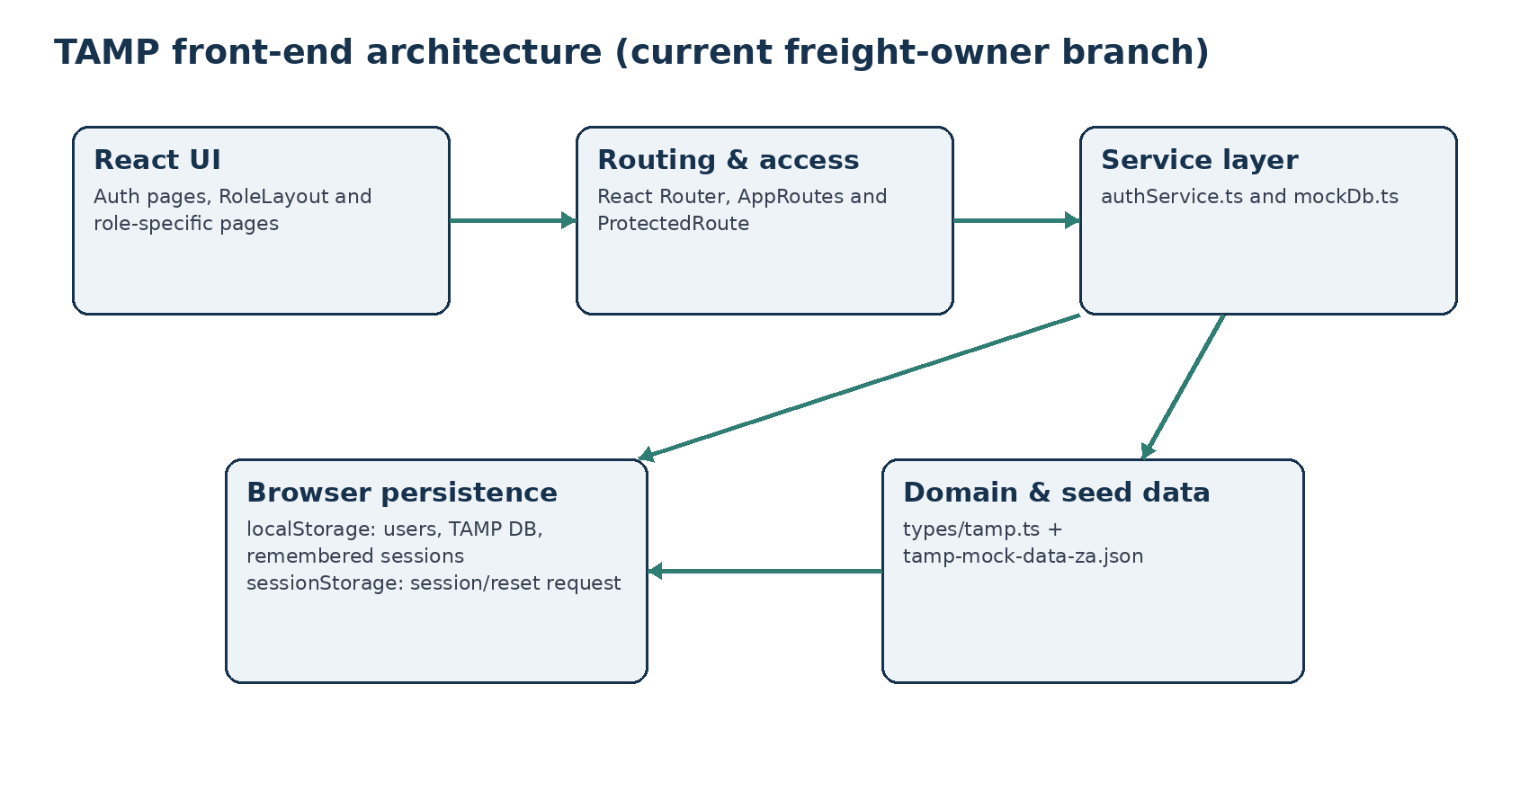
Figure 1. Current TAMP front-end architecture.

5.1 Page and Route Structure
Route | Access | Current component | Observed state
/login | Public | LoginPage | Functional authentication form.
/register | Public | RegisterPage | Registration route present.
/forgot-password | Public | ForgotPasswordPage | Recovery entry route present.
/reset-password | Recovery flow | ResetPasswordPage | Reset route present.
/freight-owner | Freight Owner | FreightOwnerDashboardPage | Placeholder dashboard copy in public branch.
/freight-owner/loads | Freight Owner | FreightOwnerLoadsPage | Route/component present; detailed runtime behaviour not independently verified.
/freight-owner/loads/new | Freight Owner | CreateLoadPage | Placeholder page in public branch.
/freight-owner/matches | Freight Owner | FreightOwnerMatchesPage | Route/component present; detailed runtime behaviour not independently verified.
/freight-owner/tracking | Freight Owner | FreightOwnerTrackingPage | Route/component present; detailed runtime behaviour not independently verified.
/transporter | Transporter | TransporterDashboardPage | Protected dashboard route.
/admin | Admin | AdminDashboardPage | Protected dashboard route.
Route evidence: AppRoutes.tsx and paths.ts. Placeholder evidence: FreightOwnerDashboardPage.tsx and CreateLoadPage.tsx. [R3][R9][R10]

5.2 Service and State Flow
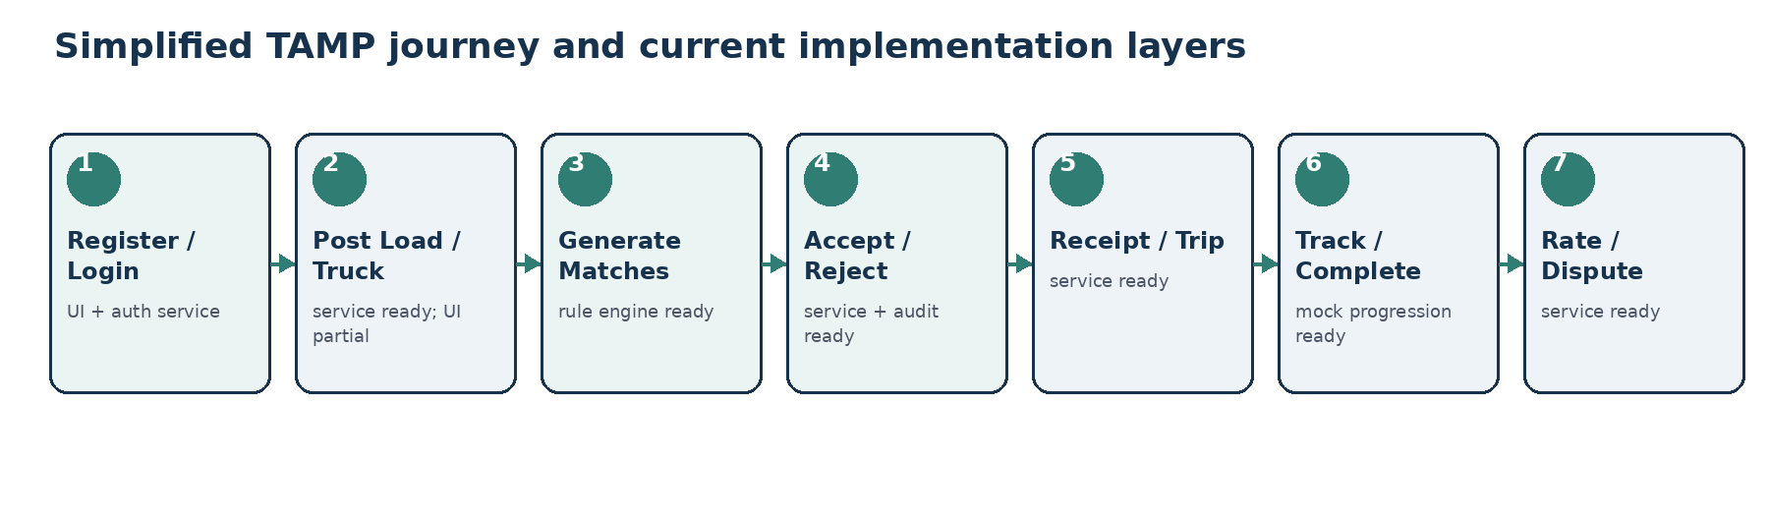
Figure 2. End-to-end journey mapped to current code layers.

6. Data Model, Persistence and Security

6.1 Domain Model
The typed domain model mirrors the mock JSON structure and defines the main entities and status values required by the assessment. [R7]
Entity | Core purpose | Code evidence
User | Identity, role, verification/compliance status and rating. | types/tamp.ts; mockDb user helpers
Load | Cargo, route, weight/volume, pickup window and status. | types/tamp.ts; createLoad/getLoadsByOwner
Truck | Vehicle type, capacity, location, availability and status. | types/tamp.ts; createTruck/getTrucksByTransporter
Match | Load/truck pair, score, rule checks, eligibility and decision. | evaluateMatch/generateMatchesForLoad
Receipt | Contract ID, match, decision, actor, timestamp and mock IP/user-agent. | acceptMatch
Trip / Tracking Event | Trip state, progress and mock route coordinates/status. | addTrackingEvent
Rating | Post-completion review score/comment. | createRating
Dispute | Raised issue, priority, status and admin assignment. | createDispute/resolveDispute
Audit Event | Actor, action, entity, timestamp and metadata. | appendAuditEvent/getAuditEvents

6.2 Browser Storage
Storage key | Store | Purpose
tamp-users | localStorage | Registered Freight Owner and Transporter credential/profile records.
tamp-session | sessionStorage or localStorage | Current authenticated session; location depends on Remember me.
tamp-password-reset | sessionStorage | Temporary password-reset token and expiry state.
tamp_db | localStorage | Operational mock TAMP database.
tamp_db_version | localStorage | Seed version used to trigger mock DB reinitialisation.

6.3 Authentication and Security Controls
Control | Current implementation | Assessment note
Password storage | PBKDF2 with SHA-256, 100,000 iterations, random 16-byte salt; derived 256-bit hash. | Better than plain-text storage, but still a client-side MVP mechanism. [R5]
Duplicate accounts | Registration rejects duplicate normalised email addresses. | Input/data integrity control. [R5]
Session storage | Remember me uses localStorage; otherwise sessionStorage. | Demonstrates persistent vs browser-session login state. [R8]
Password recovery | Random UUID reset token stored in sessionStorage with 15-minute TTL; reset generates a new salt/hash. | Simulated recovery only; no email/OTP gateway. [R5]
Role access | Route groups are wrapped by ProtectedRoute and nested RoleLayout. | Role-based navigation/access is present at routing level. [R3]
Admin demo credential | A seeded Admin credential exists in front-end source. | Acceptable for demo only; must not be treated as production security. [R8]

7. Matchmaking and Workflow Logic
The matching engine is transparent and deterministic. Capacity, vehicle compatibility and availability are hard requirements. Same-city location improves ranking but does not reject an otherwise eligible match. [R6]
Rule | Hard requirement? | Score | Behaviour
Weight + volume capacity | Yes | 30 | Truck capacity must cover both load weight and volume.
Vehicle type compatibility | Yes | 35 | Truck vehicle type must equal the load required vehicle type.
Availability overlap | Yes | 25 | Truck availability window must overlap the load pickup window.
Same-city location | No | 10 | Adds ranking score when truck city matches load origin city.
Maximum score: 100. A match can therefore be eligible with 90 points when all hard requirements pass but the truck is not in the same city. The service records rule-specific reasons so the recommendation can be explained to the user. [R6]

7.1 Acceptance to Completion State Flow
- Accepting a recommended eligible match sets the match to accepted, the load to matched and the truck to reserved.
- The same action creates a receipt with a generated TAMP-ZA contract ID plus mock IP address and user-agent, then creates a confirmed trip.
- Tracking updates map trip statuses to progress values: confirmed 0%, at pickup 10%, loaded 20%, in transit 60%, at delivery 90%, completed 100%.
- Completing a trip marks the match and load completed and returns the truck to available.
- Ratings are only accepted after a completed trip; users cannot rate themselves or submit a duplicate rating for the same trip.
- Disputes are assigned to an Administrator and can be resolved by an Admin role user.

8. Requirements Traceability (FR-01 to FR-12)
Status is based on the public freight-owner branch reviewed on 29 July 2026. “Partial” means code/service support exists but the complete user-facing assessment evidence is not yet present or could not be independently verified from the public branch.
ID | Requirement | Status | Evidence in current code | Gap / next evidence
FR-01 | Role-based registration/login for Freight Owner, Transporter and Admin. | Partial | Register/login services, seeded Admin login and protected role routes. | Admin is demo-seeded rather than self-registered; complete live role demo still required.
FR-02 | Basic identity/compliance information and simulated document upload/metadata. | Partial | Registration stores organisation/name/email/phone; domain model contains verification/compliance fields. | No verified user-facing compliance document upload/management flow in reviewed branch.
FR-03 | Freight Owner can create and view cargo loads. | Partial | createLoad/getLoadsByOwner service functions; Freight Owner load routes exist. | CreateLoadPage in reviewed branch is placeholder; saved-result UI not yet evidenced.
FR-04 | Transporter can create and view available trucks. | Partial | createTruck/getTrucksByTransporter service functions. | Transporter posting/list UI not evidenced.
FR-05 | Rule-based matching uses compatibility, location and availability. | Partial | evaluateMatch + generateMatchesForLoad implement scoring and reasons. | Readable match cards/table and integrated role flow still required.
FR-06 | Users can accept/reject a match and decision is logged. | Partial | acceptMatch/rejectMatch update status and append audit events. | Accept/Reject controls not evidenced in current role pages.
FR-07 | Accepted match produces a digital confirmation receipt. | Partial | acceptMatch creates receipt/contract and trip. | Dedicated receipt/confirmation view not evidenced.
FR-08 | Trip tracking is simulated using mock coordinates or status progression. | Partial | addTrackingEvent stores mock coordinates/status and updates progress. | Complete tracking UI not independently verified.
FR-09 | Parties can rate/review one another after completion. | Partial | createRating enforces completed trip and recalculates average rating. | 1-5 rating UI/comment flow not evidenced.
FR-10 | Admin can manage users, compliance status and flagged/disputed items. | Partial | User data + createDispute/resolveDispute service functions. | Admin management/compliance/dispute screens remain incomplete.
FR-11 | Admin can view basic platform metrics. | Partial | getAdminKpis calculates users, compliance, disputes, postings, matches and trips. | Admin KPI cards not evidenced.
FR-12 | Key actions are available in an audit trail. | Partial | Audit events created by profile/load/truck/match/trip/rating/dispute service paths. | Audit trail screen/filtering not evidenced.

9. Testing Summary
Verification level for this document: static repository review. The public repository could be inspected, but the application was not cloned/executed in this documentation environment. Therefore no runtime Pass/Fail result is invented. package.json defines dev, build, lint and preview scripts and does not define an automated test script. [R2]

9.1 Pre-Submission Test Matrix
# | Test case | Expected result | Current evidence | Result
1 | Register a Freight Owner with valid details. | Account saved; user profile added to mock DB; redirect/sign-in path available. | Registration/auth code path exists. | Pending runtime
2 | Register duplicate email. | Registration rejected with duplicate-account error. | Explicit duplicate email check in authService. | Pending runtime
3 | Login with registered account. | Session created and user redirected to role route. | authenticateRegisteredUser + LoginPage route map. | Pending runtime
4 | Login with seeded Admin credential. | Admin session created and /admin opens. | Seeded admin record in LoginPage. | Pending runtime
5 | Password reset within/after 15 minutes. | Valid token resets password; expired/invalid request rejected. | TTL and validation logic in authService. | Pending runtime
6 | Create load with invalid weight/window. | Invalid input rejected; valid load saved and audited. | createLoad validation + LOAD_CREATED event. | Pending runtime
7 | Generate matches. | Only capacity/type/availability passing trucks eligible; score/reasons returned. | evaluateMatch/generateMatchesForLoad. | Pending runtime
8 | Accept/reject recommendation. | Decision persisted; acceptance creates receipt/trip; audit recorded. | acceptMatch/rejectMatch. | Pending runtime
9 | Advance trip status to completed. | Progress updates; load/match completed; truck available. | addTrackingEvent state transitions. | Pending runtime
10 | Rate completed trip / duplicate rating. | First valid rating saved; self/duplicate/incomplete-trip rating rejected. | createRating rules. | Pending runtime
11 | Responsive navigation on mobile width. | Sidebar can open/close; controls remain usable. | RoleLayout mobile nav state; CSS must be runtime checked. | Pending runtime
12 | Run npm build and npm run lint. | Both commands complete without errors. | Scripts exist in package.json. | Pending runtime
Before submission, replace “Pending runtime” with Pass/Fail and record any observed defect. This is necessary to satisfy the assessment request for expected/actual outcomes and known defects. [A1]

10. User and Demonstration Guide
The assessment asks for a working demonstration of the main journey. The following sequence is structured to show the most valuable evidence quickly and in the same order as the business workflow. [A1]
1. Authentication - Open /register; create a Freight Owner or Transporter; sign in; show role-specific route and navigation. Also demonstrate seeded Admin login.
2. Freight Owner posting - Open Post Load; enter origin, destination, cargo type, weight/volume and pickup window; submit; show the saved load in My Loads.
3. Transporter posting - Sign in as Transporter; post an available truck with vehicle type, capacity, location and availability window; show the saved truck.
4. Matching - Generate/read recommendations; point out capacity, type, availability and location reasons plus score.
5. Accept / Reject - Use one recommendation to demonstrate a decision and show that the status/audit event changes.
6. Digital confirmation - After acceptance, show the contract/receipt ID, match ID, actor and timestamp.
7. Tracking - Advance the accepted trip through mock route/status progression and show progress.
8. Completion and rating - Complete the trip, submit a 1-5 rating and optional comment.
9. Admin oversight - Show users/compliance status, audit activity, disputes/flags and KPI summary.
Current branch warning: the public freight-owner branch does not yet provide complete visible UI evidence for this full demo. The service layer supports much of the workflow, but the assessment evaluates demonstrable interaction, not only service functions.

11. README / Setup Guide

11.1 Prerequisites
- Node.js installed locally.
- npm installed.
- A modern desktop browser.
- Git for cloning the repository.
The repository does not declare a Node engines field in package.json; use a Node.js release compatible with the installed Vite version. [R2]

11.2 Clone and Run
git clone --branch freight-owner https://github.com/LTshepoJr/Truck-Asset-Matchmaking-Platform.git
cd Truck-Asset-Matchmaking-Platform
npm install
npm run dev

11.3 Quality Commands
npm run build
npm run lint
npm run preview

11.4 Demo Credential
Role | Administrator
Email | tshepojr@kortestalkstech.co.za
Password | Password123!
This credential is hard-coded for the front-end demonstration and is not suitable for production. [R8]

11.5 Resetting Local Demo Data
The mock database service exposes reset/clear helpers and also reinitialises local data when the seed version changes. For a clean manual demo, browser site data can also be cleared before restarting the application. [R6]

12. Known Limitations and Recommended Next Steps
Limitation | Impact | Recommended next step
Several role pages are still placeholders or not fully evidenced in the public branch. | Core assessment journey cannot yet be demonstrated end-to-end from the UI. | Wire Freight Owner load/match/tracking pages to mockDb, then complete Transporter and Admin screens.
Browser storage is the only persistence layer. | Data is device/browser-profile specific and not suitable for concurrent users. | Keep for MVP; replace with backend/API + database in production.
Seeded Admin password is stored in client source. | Anyone with source access can read demo credentials. | Document as demo-only; move identity to trusted server-side authentication later.
Password recovery is browser-session simulation only. | No real identity verification or email delivery. | Keep as scope-limited MVP; integrate production recovery provider later.
No automated test script in package.json. | Regression confidence depends on manual testing. | Add Vitest/React Testing Library or equivalent for critical flows.
No live GPS/maps, payments or external integrations. | Tracking and operational confirmation are simulated. | Remain out of scope for assessment; capture as roadmap items.
Current location is a ranking preference rather than a hard rejection. | An eligible truck may be in another city and still score 90/100. | Keep if intentional; explain to assessors or change to distance threshold if required by BRS interpretation.

12.1 Priority Completion Order
1. Complete and persist the Freight Owner Create Load form, including validation and success state.
2. Render Freight Owner saved loads and dashboard KPIs from mockDb.
3. Connect match recommendations to generateMatchesForLoad and add Accept/Reject UI.
4. Add a confirmation/receipt view and connect tracking to trip events.
5. Implement Transporter truck posting and matching flow.
6. Implement ratings after completion.
7. Implement Admin user/compliance, dispute, audit and KPI screens.
8. Run and record the complete test matrix; fix defects; update FR statuses.

13. Source References
The document uses the following verifiable sources. Repository references refer to the public freight-owner branch reviewed on 29 July 2026.
Ref | Source | Use / link
A1 | ICE (Pty) Ltd, TAMP MVP Development Assessment, Version 1.0, 24 July 2026. | Uploaded assessment brief; especially pages 4, 6, 7 and 8.
R1 | GitHub repository - freight-owner branch | Repository snapshot and current README.  Open source
R2 | package.json | Dependencies and npm scripts.  Open source
R3 | src/routes/AppRoutes.tsx and src/routes/paths.ts | Role routes and Freight Owner route set.  Open source
R4 | src/layouts/RoleLayout.tsx | Role workspace shell, user display, sign-out and navigation.  Open source
R5 | src/services/authService.ts | Registration, PBKDF2 hashing, sessions and password reset.  Open source
R6 | src/services/mockDb.ts | Mock persistence, loads, trucks, matching, decisions, receipts, tracking, ratings, disputes, audit and KPIs.  Open source
R7 | src/types/tamp.ts | Typed domain contracts and status values.  Open source
R8 | src/pages/auth/LoginPage.tsx | Seeded Admin demo account and session storage behaviour.  Open source
R9 | src/pages/freight-owner/CreateLoadPage.tsx | Current public Create Load page state.  Open source
R10 | src/pages/freight-owner/FreightOwnerDashboardPage.tsx | Current public Freight Owner dashboard state.  Open source
End of document

