1 Does inhibitory control training have an indirect effect on automatic action tendencies for

2 unhealthy foods?

3 Loukia Tzavella1, Christopher D. Chambers1, Natalia Lawrence2, Katherine S. Button3,

4 Elizabeth Hart4, Natalie Holmes4, Kimberley Houghton4, Nina Badkar2, Ellie Macey2,

5 Amy-Jayne Braggins3, Felicity Murray2, & Rachel C. Adams1

6 1 Cardiff University Brain Research Imaging Centre, CF24 4HQ, UK

7 2 School of Psychology, University of Exeter, EX4 4QG, UK

8 3 Department of Psychology, University of Bath, BS2 7AY, UK

9 4 School of Psychology, Cardiff University, CF10 3AT, UK

10 Author Note

11 The research project was conducted as part of the GW4 Undergraduate Psychology

12 Consortium 2017/2018 and was partially supported by the European Research Council

13 (Consolidator 647893; C.D.C.). We also gratefully acknowledge Teaching Development

14 Funding, from the faculty of Humanities and Social Sciences at the University of Bath for

15 funding travel and room hire costs for the consortium meetings.

16 Correspondence concerning this article should be addressed to Loukia Tzavella, Cardiff

17 University Brain Research Imaging Centre, CF24 4HQ, UK. E-mail: [tzavellal@cardiff.ac.uk](mailto:tzavellal@cardiff.ac.uk)

18 Does inhibitory control training have an indirect effect on automatic action tendencies for

19 unhealthy foods?

# 20 Introduction

21 The recent rise in overweight and obesity rates can primarily be ascribed to the

22 over-consumption of energy-dense foods that are high in fat, sugar and salt content (WHO,

23 2018), as individuals are constantly exposed to visual cues of such foods in the environment

24 (e.g., through advertisements) and this often leads to increased food intake (Havermans,

25 2013). A theoretical explanation for this phenomenon has been provided by the dual-process

26 model frameworks which posit that behaviour is determined by the interaction of impulsive

27 (*automatic*) and reflective (*controlled*) cognitive processes (Kakoschke et al., 2015; Strack &

28 Deutsch, 2004). For example, over-consumption of unhealthy foods can be attributed to

29 heightened approach bias for food cues in the environment, which can result in increased

30 food intake if these automatic action tendencies are not regulated via controlled processes,

31 such as inhibitory control (Kakoschke et al., 2017b). Such theoretical frameworks have led to

32 the development of behaviour change interventions for unhealthy eating behaviours that

33 target either automatic or controlled processing, that is approach bias modification and

34 inhibitory control training respectively (see Kakoschke et al., 2017a; Jones, Hardman,

35 Lawrence, & Field, 2018 for recent reviews). The primary aim of the present study was to

36 investigate the interaction between automatic and controlled processing in the context of

37 inhibitory control training (ICT). It was assumed that strengthening inhibitory control could

38 influence automatic action tendencies towards unhealthy foods after training. To establish

39 whether the employed ICT paradigm was effective effects of training on impulsive food

40 choice and liking were also examined.

41 In the dual-process model frameworks, unhealthy eating behaviours may be explained

42 by a weak reflective system and/or a strong impulsive system (e.g., Lawrence, Hinton,

43 Parkinson, & Lawrence, 2012; Nederkoorn, Coelho, Guerrieri, Houben, & Jansen, 2012),

44 which can often be in conflict. For example, automatic attentional (e.g., attending to the

45 cue) and motivational (e.g., approaching the food) processes would antagonize the controlled

46 process of considering long-term goals such as losing weight when an individual has to decide

47 on an action, that is to eat or not eat the food (Kakoschke et al., 2015). This study focuses

48 on an automatic process known as approach bias, which is the automatic action tendency to

49 approach an appetitive (food) cue in the environment, rather than avoid it (C. E. Wiers et

50 al., 2013). Approach bias has been demonstrated for a variety of appetitive cues, such as

51 cigarettes (e.g., Bradley, Field, Healy, & Mogg, 2008), alcohol (e.g., Wiers, Rinck, Kordts,

52 Houben, & Strack, 2010) and cannabis (e.g., Field, Eastwood, Bradley, & Mogg, 2006). In

53 the food domain, there is evidence for the existence of approach bias for a variety of

54 energy-dense foods (Brignell, Griffiths, Bradley, & Mogg, 2009; Kemps & Tiggemann, 2015;

55 Kemps, Tiggemann, Martin, & Elliott, 2013; Veenstra & de Jong, 2010)1. Interestingly,

56 Kakoschke et al. (2015) found that approach bias alone did not predict increased intake of

57 unhealthy foods, but it was the interaction between approach bias and inhibitory control

58 that was the significant determinant of subsequent behaviour. The authors report that

59 approach bias had the expected effect on food intake only for participants with low inhibitory

60 control. As an important component of controlled processing, inhibitory control has been

61 defined as “the ability to inhibit a behavioural impulse in order to attain higher-order goals,

62 such as weight loss” (Houben, Nederkoorn, & Jansen, 2012, p. 550) and encompasses several

63 elements, such as response inhibition and cognitive flexibility (see Bartholdy, Dalton, O’Daly,

64 Campbell, & Schmidt, 2016). Inhibitory control capacity is often measured via response

65 inhibition paradigms, such as the go/no-go task and stop-signal task, and has been

66 associated with unhealthy eating behaviours (e.g., Jasinska et al., 2012; Guerrieri et al., 2007;

1 There is great variability in terms of methodology for the assessment of both approach bias and inhibitory control in reported studies and therefore the replicability of certain findings is questionable. This and similar issues are presented in the *Discussion.*

67 Hall, 2012). Nederkoorn, Houben, Hofmann, Roefs, and Jansen (2010) showed that strong

68 implicit preferences for snacks paired with low “inhibitory control capacity” predicted weight

69 gain over one year. Overall, there is evidence to suggest that both inhibitory control and

70 motivational processes are important determinants of eating-related behaviour.

71 Complementary evidence for the role of automatic and controlled processes in the

72 regulation of eating behaviours stems from the line of research dedicated to the development

73 of health behaviour change interventions. Approach bias modification training is commonly

74 delivered via an approach-avoidance task (AAT; Neumann & Strack, 2000; Rinck & Becker,

75 2007; Reinout W Wiers et al., 2013) and has been applied to several unhealthy behaviours

76 involving appetitive cues, such as alcohol consumption and cigarette smoking (e.g., Wiers,

77 Eberl, Rinck, Becker, & Lindenmeyer, 2011; Wittekind, Feist, Schneider, Moritz, & Fritzsche,

78 2015). The AAT is assumed to capture automatic action tendencies when participants are

79 instructed to respond to an irrelevant feature of a presented picture, such as the orientation

80 (portrait or landscape), by pulling or pushing a joystick (C. E. Wiers et al., 2013). The AAT

81 can also pair actions with visual feedback, so that the picture gets bigger when participant

82 pull the joystick towards them (zoom-in) and gets smaller when they push it away

83 (zoom-out). Arm extension could indicate an approach response towards an appetitive food

84 (object-reference) or an avoidance response where the food is pushed away from the

85 body/self (self-reference; Phaf, Mohr, Rotteveel, & Wicherts, 2014) and thus visual feedback

86 provides the self-reference attribute to the responses (e.g., object comes closer to one’s body).

87 The “zooming” feature disambiguates the mapping of responses to approach and avoidance

88 actions, whereby pulling the joystick represents approach and pushing it reflects avoidance

89 (Neumann & Strack, 2000). In AAT training, contingencies between actions and stimuli are

90 manipulated so that appetitive cues are associated with push actions (avoidance) and

91 neutral items are paired with pull actions (approach). Several studies employing various

92 AAT protocols have found that training can be effective in re-training approach bias for

93 foods (Brockmeyer, Hahn, Reetz, Schmidt, & Friederich, 2015; Kemps et al., 2013) and even

94 reduce food intake in the laboratory (Schumacher, Kemps, & Tiggemann, 2016; see

95 Kakoschke et al., 2017a for review).

96 In the context of controlled processes, ICT interventions involve cue-specific go/no-go

97 or stop-signal tasks whereby participants are instructed to make a speeded choice response

98 to appetitive stimuli such as foods or alcohol, but to withhold that response when a visual,

99 or auditory, signal is presented. Signal-stimulus mappings are manipulated so that appetitive

100 cues (e.g., unhealthy foods) are consistently paired with a stop signal. Stopping to unhealthy

101 foods has been shown to reduce food consumption (Adams, Lawrence, Verbruggen, &

102 Chambers, 2017; Houben & Jansen, 2011, 2015; N. S. Lawrence et al., 2015; Veling, Aarts, &

103 Papies, 2011; also see Allom, Mullan, & Hagger, 2016 for meta-analysis) and promote healthy

104 food choices in the laboratory (Veling et al., 2013a; Veling, Chen, et al., 2017) and has even

105 been associated with increased weight loss (N. S. Lawrence, O’Sullivan, et al., 2015; Veling,

106 van Koningsbruggen, Aarts, & Stroebe, 2014). A potential mechanism of action behind ICT

107 effects on food consumption is stimulus devaluation (Veling et al., 2017), whereby the

108 evaluations of appetitive foods are reduced during training to facilitate performance when

109 response inhibition is required (e.g., Chen, Veling, Dijksterhuis, & Holland, 2016). A possible

110 explanation for this devaluation effect is provided by the Behaviour Stimulus Interaction

111 (BSI) theory which posits that food stimuli are devalued when negative affect is induced to

112 resolve the ongoing conflict between triggered approach reactions to appetitive foods and the

113 need to inhibit responses towards those stimuli (Chen et al., 2016; Veling, Holland, & van

114 Knippenberg, 2008; Veling et al., 2017). When a food is devalued, the approach bias towards

115 that cue is reduced and therefore inhibition can successfully take place. Would it be possible

116 for this reduction in approach bias to be learned via ICT paradigms?

117 This study attempts to answer this question by employing a go/no-go training

118 paradigm with unhealthy food stimuli and measure automatic action tendencies via an AAT

119 before and after training to establish whether individuals show reduced approach bias for the

120 foods associated with response inhibition. If an approach action tendency is consistently

121 reduced through devaluation to facilitate inhibition of responses towards appetitive foods,

122 then ICT may have an indirect effect on approach bias. Additional theoretical ground for

123 this research question has been adopted from the concept of an “associative stop system”,

124 whereby stimuli associated with stopping can be devalued through an interaction of a stop

125 system and an aversive system (see Verbruggen, Best, Bowditch, Stevens, & McLaren, 2014).

126 Consistent with previous ICT literature, the study also examined impulsive food choice and

127 food liking (i.e., stimulus devaluation manipulation check) as secondary training outcomes.

128 **Hypotheses**

129 All hypotheses described in this section are confirmatory and have been pre-registered2

130 on the Open Science Framework (h[ttps://osf.io/wav8p/).](https://osf.io/wav8p/) Effects of ICT (go/no-go training;

131 see *Go/No-go training*) on automatic action tendencies (see *Approach avoidance task*) and

132 liking (see *Food liking ratings*) for unhealthy foods were investigated using change scores from

133 pre-to post-training for both outcomes (H1, H3). The training condition was also expected

134 to have an effect on food choice behaviour (H2; see *Food choice task*). The study assessed

135 contingency learning mechanisms for the training paradigm, as a manipulation check (H4).

# 136 Training effects on automatic action tendencies

137 The primary outcome measure in the study was the change in automatic action

138 tendencies from pre-to post- ICT training for the foods associated with different conditions

139 (go, no-go and control - see Figure 1). Action tendencies were indirectly measured via the

140 AAT and approach-avoidance bias scores were obtained by subtracting the median response

2 Exact hypotheses from the pre-registered protocol have been re-ordered according to outcomes for clarity. There were no deviations from the protocol for the hypotheses and corresponding statistical tests, with the exception of minor alterations regarding the supplementary frequentist statitics (see *Pre-registered analyses*).

141 times (RTs) in avoid trials (push action) from the RTs in approach trials (pull action) at the

142 participant level, for each training condition and then calculating the change from pre-to

143 post-training. It was hypothesized that ICT training would lead to a reduction in approach

144 bias for no-go goods and increase in approach bias for go goods compared to the control

145 foods.

146 H1. There will be *moderate* evidence for an effect of training condition (go, no-go, control)

147 on the change in approach-avoid bias scores from pre-to post-training.

148 H1a. Participants will show a reduction in approach bias for no-go foods compared to the

149 control foods, from pre-to post- training.

150 H1b. Participants will have increased approach bias towards go foods relative to the control

151 foods, from pre-to post- training.

# 152 Training effects on impulsive food choices

153 As a secondary outcome, the effects of ICT on impulsive food choices for unhealthy

154 foods were tested by comparing the probabilities of choosing a food from each training

155 condition. Specifically, it was expected that after ICT participants would show reduced

156 impulsive choices for no-go foods and increased choices for go foods relative to control foods.

157 H2. Two Bayesian paired samples t-tests were conducted for the mean proportions of

158 selected foods in the go and no-go training condition compared to the control.

159 H2a. Participants will show reduced choices for no-go foods relative to the control foods.

160 H2b. Participants will show increased choices for go foods relative to the control foods.

# 161 Manipulation check 1: Stimulus devaluation

162 The mean change in food liking ratings from pre-to post-training was examined for

163 each training condition in order to test whether no-go training led to the devaluation of

164 no-go foods compared to control foods. It should be noted that this was not a positive

165 control for training effectiveness, as the findings for stimulus devaluation outcomes remain

166 controversial (see Jones et al., 2016 for meta-analysis). Stimulus devaluation in this study

167 was therefore treated both as a manipulation check for the employed training paradigm and

168 a secondary outcome measure.

169 H3. There will be *moderate* evidence for an effect of training condition (go, no-go, control)

170 on the change in food liking from pre-to post-training.

reduced liking for no-go foods relative to the control foods, from

|  |  |
| --- | --- |
| 171 H3a. Participants will show | |
| 172 | pre-to post- training. |
| 173 H3b. Participants will sho | |
| 174 | pre-to post- training. |

w increased liking for go foods relative to the control foods, from

# 175 Manipulation check 2: Contingency learning

176 Training performance was examined in terms of contingency learning. ICT paradigms,

177 such as the go/no-go training task, might lead to stimulus-response associations and learning

178 can be observed in the reaction times and error rates for the different stimulus-response

179 mappings (e.g., N. S. Lawrence, O’Sullivan, et al., 2015). The percentage of successful signal

180 trials (i.e., successful stops) and the reaction times from no-signal (go) trials were compared

181 for specific training conditions, as stated in the hypotheses below.

182 H4. Go/no-go training will result in contingency learning in terms of reaction times on

183 no-signal trials and the percentage of successful inhibitions on signal trials.

184 H4a. Percentage of successful stops will be greater for no-go foods compared to the control

185 foods associated with a signal (controlnogo).

times will be faster for go foods compared to the no-signal control foods

|  |  |
| --- | --- |
| 186 | H4b. Go reaction |
| 187 | (controlgo). |
| 188 |  |
| 189 | **Participants** |

# Methods

190 255 participants were recruited in total from the University campuses of Cardiff, Bath

191 and Exeter via research participation schemes (e.g., Experimental Management system;

192 EMS) and advertisements (see Figure A1 for recruitment details). Participants recruited

193 through participation schemes received course credits, whereas other individuals were offered

194 entry into a prize draw for one of three £20 shopping vouchers. Participants were informed

195 about the study eligibility criteria and in order to ensure compliance they completed a

196 screening survey in the beginning of the study and provided their consent. They were asked

197 to refrain from eating for 3 hours before the study. Participants had to be at least 18 years

198 of age, be fluent in spoken and written English and have normal or corrected-to-normal

199 vision, including normal colour vision. Participants were excluded if they were dieting at the

200 time of the study, with a weight goal and time-frame in mind, had a current and/or past

201 diagnosis of any eating disorder(s) and had a body-mass-index (BMI) lower than 18.5 kg/m2

202 (i.e., underweight category). The study was approved by the Ethics Committees of Cardiff

203 University, University of Bath and the University of Exeter.

204 **Sampling plan**

205 The required sample size was estimated based on a frequentist power analysis

206 conducted for the primary outcome measure (i.e., change in approach-avoidance bias, from

207 pre-to post-training, between go and no-go foods; H1a and H1b) and the stimulus

208 devaluation manipulation check (i.e., change in food liking, from pre-to-post training,

209 between go and no-go foods; H3). Both of these effect sizes were in the medium range and

210 therefore calculations were based on the primary outcome measure. For an expected effect

211 size, other studies that have measured approach bias pre-and post-approach-avoidance

212 training (Becker, Jostmann, Wiers, & Holland, 2015; Schumacher et al., 2016) were

213 considered. Both studies reported an effect size of *ηp*2=0.07 which corresponds to a

214 “medium” effect size. Becker et al. (2015) also reported two non-significant results, although

215 effect sizes were not provided. Note, however, that Becker et al. (2015) compared an active

216 group with 90:10 mapping (i.e., avoidance of 90% for unhealthy trials and 10% healthy trials)

217 to a control group with 50:50 mapping whereas Schumacher et al. (2016) compared a 90:10

218 active group with a 10:90 control group. A conservative approach was followed for the

219 sample size calculation. Firstly, the effect size was reduced by 33% (i.e., *dz* = 0.34) to

220 account for publication bias (Button et al., 2013) and secondly an alpha of .005 was used,

221 which has recently been recommended for any research that cannot be considered a direct

222 replication and can increase the reliability of new discoveries (Benjamin et al., 2017). Based

223 on a priori power calculations using G*Power (Faul, Erdfelder, Buchner, & Lang, 2009) it

224 was estimated that a total sample of 149 participants3 was necessary for 90% power.

225 The sampling method and power analysis of the study adopted a conservative

226 frequentist approach, but the pre-registered analyses were based on a Bayesian framework

227 (see *Pre-registered analyses*). Frequentist analyses were also reported in a supplementary

228 fashion (*α* = .005). Bayes factors (BFs) informed the interpretations of the results and

229 although debate exists about labelling evidence in terms of BFs (Richard D. Morey, 2015),

230 the guidelines by (Lee & Wagenmakers, 2013) were followed. A threshold of *BF* 10 > 6 was

3 Due to the large number of participant exclusions based on mean error rates in the AAT (see Figure A1) and the group testing laboratory setting at Cardiff University, final recruitment led to the expected sample size including 14 more participants (N=163).

231 used to indicate *moderate* evidence for the alternative hypothesis relative to the null, and

232 *BF* 10 < 1/6 reflected *moderate* evidence for the null relative to the respective alternative

233 hypothesis. Bayes factor analyses were favoured for drawing conclusions from the study, as

234 they would allow us to interpret null outcomes as evidence of absence when traditional

235 analyses would not make such inferences feasible. For frequentist analyses, an alpha level of

236 0.005 was used.

237 **Procedure**

238 The study procedure can be seen in Figure 1 (panel A). After screening, eligible

239 participants were provided with a short survey (see *Survey & Questionnaires*) and proceeded

240 to rate all food categories on how much they like the taste (see *Food liking ratings*). Three

241 blocks of the approach-avoidance task (AAT) were completed before the go/no-go training

242 paradigm was performed. Rated food categories were randomly assigned to three conditions

243 for training: go, no-go and control, as shown in Figure 1 (panel B). Post-training,

244 participants were presented with another three blocks of the AAT, provided ratings for all

245 food stimuli again and finally completed a short food choice task (see *Food choice task*). At

246 the end of the study, several questionnaires were presented in random order (see *Survey &*

247 *Questionnaires*) and participants were debriefed about the aims of the study.

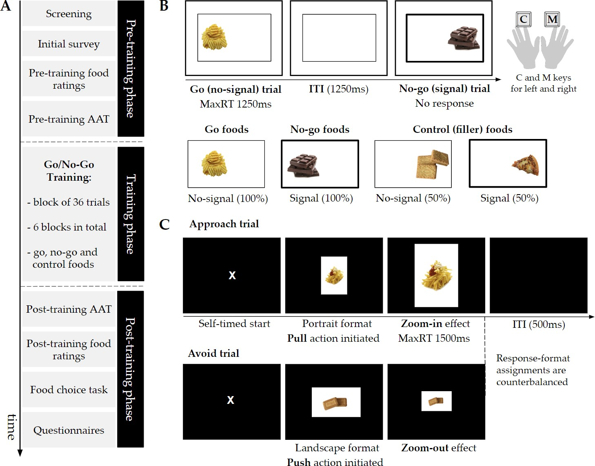

***Figure 1* . Schematic diagram of the study procedure, go/no-go training and approach- avoidance tasks. A.** After completing the screening and initial survey, participants rated all food stimuli (liking) and proceeded to perform the pre-training approach-avoidance task (AAT) blocks. In the training phase, participants completed six blocks of go/no-go training. The post-training AAT blocks were then presented and followed by food liking ratings. At the end of the study, participants completed a short food choice task and several questionnaires, in random order. **B.** The go/no-go training paradigm involved go (no-signal) and no-go (signal) trials that occurred with equal probability. On go trials, participants had to respond within 1250ms by pressing the "C" and "M" keys to indicate the picture location (left or right, respectively). On no-go trials, participants were instructed not to respond at all. The inter-trial interval (ITI) was 1250ms. Food categories were randomly assigned to three conditions. Go foods were only paired with no-signal trials and no-go foods were always associated with no-signal trials. Control, or filler, foods were presented in both signal and no-signal trials (50:50).

**C.** In the AAT, participants were asked to respond according to the format of the presented rectangle (portrait or landscape). Response-format assignments were approximately counterbalanced across participants. As an example, on approach trials a participant would have to pull the mouse towards them when the picture was in portrait format (approach trial) and push it away from them when the picture was in landscape format. Push and pull actions were paired with visual feedback, that is, zoom-out and zoom-in effects respectively. The maximum reaction time (maxRT) was 1500ms and the ITI was set to 500ms. Participants clicked on a central "X" to begin a trial (self-timed start).

# 248 Go/No-go training

249 The Go/No-Go (GNG) training paradigm involved go and no-go responses to six

250 pre-selected appetitive food categories. Food categories differed in terms of taste, so that

251 three foods were savoury (i.e., pizza, crisps, chips) and three foods were sweet (i.e., biscuits,

252 chocolate, cake)4. Two food categories were randomly assigned to each training condition

253 (go, no-go, filler foods) in the beginning of the experiment and food taste was

254 counterbalanced so that each condition had one sweet and one savoury food. There were

255 three training conditions according to the mapping of foods to signal (no-go) and no-signal

256 (go) trials in the GNG. All go foods appeared in go (no-signal) trials and all no-go foods

257 were presented in no-go (signal) trials (see Figure 1, panel C). Control, or filler, foods

258 appeared on both go and no-go trials with equal probability (i.e., 50:50). Each food category

259 had three exemplars which appeared twice in each block.

260 All foods were presented on either the left or right hand side of the screen within a

261 rectangle for 1250ms, which was the maximum reaction time (maxRT), as shown in Figure 1,

262 panel B. Participants were asked to respond to the location of the food as quickly and as

263 accurately as possible by pressing the “C” and “M” buttons on the keyboard with their left

264 and right index fingers, respectively. The central rectangle remained on the screen

4 All study materials are openly available at https://osf.io/wcf4r/

265 throughout the training, including the inter-trial-interval (ITI), which was 1250ms. On signal

266 trials, the rectangle turned bold, indicating that participants should withhold their response.

267 In line with the GNG training paradigm, this signal appeared on stimulus onset (i.e., no

268 delay between stimulus and signal) and stayed on the screen until the end of the trial. A

269 correct response on no-signal trials was registered when participants responded accurately to

270 the location of the food within the maxRT window and a successful stop (i.e., correct signal

271 trial) was considered when participants did not respond at all. Incorrect responses in

272 no-signal trials refer to either to a wrong location judgement or a missed response. Left and

273 right responses were counterbalanced across all manipulated variables for each type of trial.

274 Training was split into 6 blocks of 36 trials (216 trials in total) and lasted approximately 10

275 minutes with inter-block breaks (15s). Task practice included 12 trials of go and no-go

276 responses (50%-50%) and participants responded to the location of grey squares, instead of

277 food pictures. For the practice trials, accuracy feedback was provided during the ITI.

# 278 Approach avoidance task

279 The approach-avoidance task (AAT) was adapted from an existent paradigm (Rinck &

280 Becker, 2007; Wiers, Rinck, Dictus, & Van Den Wildenberg, 2009), which involves “pull” (i.e.,

281 towards self) and “push” (i.e, away from self) movements of a joystick. Each type of motor

282 response is paired with visual feedback so that when the joystick is pulled, the image gets

283 bigger (zoom-in) and when it is pushed, the image gets smaller (zoom-out). This “zooming”

284 effects acts as an exteroceptive cue of either an approach or avoidance response (Neumann &

285 Strack, 2000). This feature of the joystick AAT complements the proprioceptive properties of

286 the task, where responses requiring arm flexion and extension correspond to approach and

287 avoidance trials, respectively. This task also disambiguates approach and avoidance

288 responses by using the “zooming” feature (Wiers et al., 2009), as previously explained. The

289 evaluation-irrelevant feature of the paradigm was also incorporated and participants respond

290 according to the format of the picture (portrait or landscape; e.g., Wiers et al., 2010).

291 AAT responses involved “push” and “pull” movements of the computer mouse

292 (adaptation of the joystick version). Food stimuli were presented in the centre of the screen

293 and participants were instructed to pull the mouse towards them or push the mouse away

294 from them according to whether the image was in portrait or landscape format (see Figure 1,

295 panel C). Response-format assignments were approximately counterbalanced across

296 participants (45.4% portrait-approach, 54.6% landscape-approach). Instructions highlighted

297 moving the mouse cursor until it reaches the end of the screen (top or bottom edge) for a

298 correct response to be registered and making smooth whole-arm movements. Participants

299 had 1500ms to respond after the stimulus appeared. Each trial started with a central “X” on

300 the screen and participants had to click on it to begin (self-timed start). The ITI was 500 ms

301 and there was no delay between the “X” click response and the stimulus onset. In order to

302 account for the natural movement of the mouse, pixel tolerance was added to every mouse

303 movement (*±* 1.25% of display height), including movement initiation in the beginning of the

304 trial. A response in the AAT was registered as correct only when participants completed the

305 correct action (e.g., pull or push) within the maxRT window and also initiated a movement

306 towards the correct direction. Even if the final response was correct, participants could have

307 changed their movement after making an initial error (e.g., pull instead of push the mouse in

308 an “avoid” trial) and therefore the direction of their initial movement was also taken into

309 account. The complete RT for an AAT trial was defined as the time from the stimulus onset

310 to the successful completion of a response.

311 Each AAT block consisted of 72 trials and go, no-go and control foods appeared with

312 equal probability for both “pull” (approach) and “push” (avoid) responses. There were 12

313 approach and 12 avoid trials for each training condition (e.g., no-go) and within those trials,

314 there were six savoury and six sweet foods presented (i.e., three exemplars repeated twice).

315 Three AAT blocks were performed before training (AATpre) and three after training

316 (AATpost). There was a number of constraints placed on the quasi-random order of the trials

317 within an AAT block. There were no more than three images of the same food category

318 being presented consecutively and no more than three trials with the same picture format in

319 sequence. AAT practice consisted of 10 trials with grey rectangles instead of food stimuli

320 and accuracy feedback. The screen background for the AAT was black and the task lasted

321 approximately 15 minutes, including the inter-block 15s breaks, where participants received a

322 reminder of the main instructions.

# 323 Food liking ratings

324 Participants provided food liking ratings before and after training using a visual

325 analogue scale (VAS). They rated all foods included in the GNG paradigm according to how

326 much they liked the taste, ranging from 0 (“not at all”) to 100 (“very much”). Task

327 instructions encouraged participants to imagine they were tasting the food in their mouth

328 and then rate how much they liked the taste. The order of the presented foods was

329 randomised and each block consisted of 18 trials. Participants completed a block before

330 training (Likingpre) and a block after training (Likingpost).

# 331 Food choice task

332 Impulsive food choices were assessed using a food choice task adapted from Veling et al.

333 (2013a), which included all food categories from the GNG paradigm (two exemplars per

334 category). The twelve foods were presented on a grid layout and participants had ten

335 seconds to select three foods that they would like to consume the most at that specific time,

336 by clicking on them with the computer mouse. Participants were asked to click on a “start”

337 button to begin the trial and when a response was registered the selected food stimulus

338 disappeared from the screen. It was assumed that this task element would prevent

339 participants from deliberating on their choices and changing their initial responses, which

340 would mean that *impulsive* food choices were no longer measured. However, it should be

341 noted that although participants were not informed about the hypothetical nature of their

342 choices, it is highly probable that they would not consider their choices consequential (i.e.,

343 they would not think they would get a food item at the end of the study).

# 344 Survey & Questionnaires

345 Eligible participants were presented with an initial survey to record demographics and

346 other variables for exploratory analyses. The survey consisted of height and weight

347 measurements to calculate participant’s body-mass-index (BMI; kg/m2), the number of

348 hours since their last meal (“less than 3 hours ago”, “3-5 hours ago”, “5-10 hours ago”,

349 “more than 10 hours ago”) and hunger state at the the time of the study (VAS: 1=“Not at

350 all” to 9=“Very”). Gender was also recorded with the options of male, female, transgender

351 male, transgender female, gender variant/non-conforming, and an open ended text response

352 for “other”.

353 Several questionnaires were completed by the participants at the end of the study for

354 exploratory analyses, as part of the undergraduate student projects of the GW4

355 Undergraduate Psychology Consortium 2017/2018. The Barratt Impulsivity Scale (BIS-15;

356 Spinella, 2007) was introduced as a measure of impulsivity and the Stop Control Scale (SCS;

357 De Boer, van Hooft, & Bakker, 2011) was used to examine a distinctive element of general

358 trait self-control, referred to as stop control. Other administered questionnaires included the

359 Food Cravings Questionnaire - Trait - reduced (FCQ-T-r; Meule, Hermann, & Kübler, 2014),

360 Perceived Stress Scale (PSS; Cohen, Kamarck, & Mermelstein, 1983) and the “food” and

361 “money” subscales from the Delaying Gratification Inventory (DGI; Hoerger, Quirk, & Weed,

362 2011). A correlation matrix of main questionnaire measures and sample characteristics can

363 be found in Appendix B.

364 **Analyses**

# 365 Measures & indices

366 The mean error rates in no-signal and signal trials as well as mean reaction time in

367 no-signal trials (GoRT) from the GNG informed participant exclusions (see *Data exclusions*).

368 For the contingency learning manipulation check (H3, H4), measures included the proportion

369 of successful stops from signal trials for no-go and control foods which were paired with a

370 signal (control-nogo) and the mean GoRTs for each participant from correct go and

371 control-go trials.

372 Performance in the AATpre and AATpost blocks was considered only for correct

373 responses. Median RTs for “push” and “pull” responses from all training condition levels

374 were calculated at a participant level5. Medians were used instead of means as they are less

375 sensitive to outliers in RT distributions and in line with previous literature (Wiers et al.,

376 2009, 2010). The approach-avoid bias score for each condition was calculated as the

377 difference between the median RTs for “push” and’ pull’ responses (MedianRTpush-

378 MedianRTpull). Bias scores were computed for both AATpre and AATpost blocks. Positive

379 scores indicate an approach bias towards the foods of interest and negative scores reflect

380 avoidance for those foods. Change scores for approach-avoid biases from pre-to post-training

381 (∆AAT bias score) were calculated for pre-registered analyses (H1). The proportion of

382 correct responses for each AAT design cell informed participant exclusions.

5 RTs were recorded continuously from movement initiation to response completion with samples every 33ms (two display refresh rates) to allow dynamic zoom-in/zoom-out effects based on participants’ mouse movements. However, a bug was encountered with the version of the software and the temporal resolution at which coordinates and times were recorded was reduced. For this reason, linear interpolation was applied to increase the samples to 100 for every trial and obtain more precise RT measures. All details regarding this procedure and the software bug can be found in the analyses scripts.

383 Participants were required to choose three foods out of twelve in the food choice task

384 and selections could vary in their number for each training condition (go, no-go, control).

385 Food choices were therefore normalised according to the total number of responses per

386 participant (i.e., proportion). These calculated proportions, which were calculated for each

387 participant were then compared across training conditions. for example, if a participant had

388 chosen two go foods and one filler food, the probability (i.e., calculated proportion) of

389 choosing a go food would be 0.667, the probability of choosing a filler food would be 0.333

390 and the probability of choosing a no-go food would be 0. Food rating VAS scores were

391 averaged (mean) across the two foods per training condition (i.e., sweet and savoury foods

392 for go, no-go and control conditions) and the three exemplars of each food. Changes in food

393 liking were examined in terms of change scores (∆Food liking score) from pre-to-post

394 training.

395 **Data exclusions**

396 Participant-level data exclusions were conducted based on GNG training and AAT

397 performance and participants who met any of the following criteria were excluded from all

398 respective analyses. Participants who had a mean GoRT greater than three standard

399 deviations from the group mean and percentage of correct responses in no-signal trials less

400 than 85% were excluded. Participants were also excluded if their percentage of errors in

401 signal trials was greater than three standard deviations from the group mean and percentage

402 of errors in either pre- or post- AAT blocks greater than 0.25. Additionally, participants who

403 submitted a food rating of 50 (i.e., neutral) for 24 or more trials wither pre-or post-training

404 would not be included as it was assumed that multiple such responses would indicate that

405 participants used the default setting of the VAS and purposefully skipped the rating trials.

# 406 Pre-registered analyses

407

408

409

410

411

Data pre-processing and analyses were conducted in RStudio (RStudio Team, 2016) and JASP (JASP Team, 2018). Pre-registered analyses are described under their

pre-specified hypotheses, as presented in *Hypotheses*. For all Bayesian paired samples t-tests mentioned hereinafter, a prior with the 2*/*2 scale parameter for the half-Cauchy distribution was used.

412 H1. The effect of training condition on the change in approach-avoid bias scores from pre-to

413 post-training was examined using a Bayesian Repeated Measures ANOVA with the default

414 prior settings (Rouder, Engelhardt, McCabe, & Morey, 2016; Rouder, Morey, Speckman, &

415 Province, 2012) and participants treated as a nuisance term.

416 H1a. ∆AATnogo < ∆AATcontrol

417 H1b. ∆AATgo > ∆AATcontrol

418 H2. Two Bayesian paired samples t-tests were conducted for the mean proportions of

419 selected foods in the go and no-go training condition compared to the control.

420 H2a. p(no-go) < p(control)

421 H2b. p(go) > p(control)

422 H3. The effect of training condition on the change in food liking from pre-to post-training

423 was examined using a Bayesian Repeated Measures ANOVA, consistent with H1.

424 H3a. ∆Likingnogo < ∆Likingcontrol

425 H3b. ∆Likinggo > ∆Likingcontrol

426 H4. Contingency learning during go/no-go training was examined using Bayesian

427 paired-samples t-tests for the percentage of successful inhibition trials and go reaction times.

428 H4a. PCsignalnogo > PCsignalcontrol-nogo

429 H4b. GoRTgo < GoRTcontrol-go

430 The evidential value of confirmatory findings was solely determined by the Bayesian

431 tests outlined in this section, as previously explained (see *Sampling plan*. Frequentist tests

432 were conducted in order to further the reproducibility of findings (e.g., potential use in

433 meta-analyses). Paired samples t-tests were two-tailed, in line with the reported power

434 analysis6 Assumptions for repeated measures ANOVAs (H1 and H3) were checked in line

435 with the pre-registered analysis plan and no violations were observed. Contingency plans

436 were not considered in case the normality assumption was violated for paired t-tests (Shapiro

437 Wilk test: *p ≤* .005), but appropriate exploratory analyses were conducted and reported in

438 the *Robust statistics* section7. A minor deviation from the pre-registered frequentist analyses

439 was that paired sample t-tests for H1a and H1b were conducted irrespective of the Repeated

440 Measures ANOVA results (H1).

441 **Results**

# 442 Sample characteristics

443 The final sample for pre-registered analyses consisted of 163 participants (80.98%

444 female). Detailed participant-level exclusions are presented in Figure A1. Participants had

445 on average a healthy BMI (*M* = 22.88, *SD* = 2.98, range = 18.54 - 32.36) and their mean

6 Although Bonferroni corrections were pre-registered for paired sample t-tests for paired sample t-tests following Bayesian Repeated Measures ANOVAs, there were only two planned contrasts for each ANOVA and reflected distinct hypotheses about the data. Therefore, such corrections were not applied for the reported p-values.

7 For other analyses reported in the **??** section, p-values from Wilcoxon signed-rank tests are reported as *pW*

in a supplementary manner.

446 age was 22.39 (*SD* = 9.04, range = 18-59). 108 participants (66.26%) reported that they had

447 their last meal 3-5 hours before the study and hunger levels at the beginning of the study

448 were not particularly high (*M* = 5.70, *SD* = 2.22). However, 24 participants (14.72%) did

449 not adhere to the instruction not to eat three hours before the study, as they reported

450 having their last meal “less than 3 hours ago”.

# 451 Confirmatory findings

452 **Training outcomes.** There was *strong* evidence for the absence of a general effect

453 of go/no-go training condition on the change in approach-avoidance bias scores [*BF* 01 =

454 16.06; *F* (2, 324) = 1.01, *p* = 0.365]. Results for paired comparisons are shown in Table 1.

455 There was *moderate* evidence that the change in bias scores for no-go foods (∆AATnogo; *M*

456 = -3.31, *SD* = 62.91) was not reduced compared to the change for filler foods (∆AATcontrol;

457 *M* = -1.81, *SD* = 59.55). Similar to H1a, there was *strong* evidence for the null compared to

458 the alternative for H1b. The change in bias scores for go foods (∆AATgo; *M* = -10.47, *SD* =

459 59.57) was not greater than the change for filler foods. Approach-avoidance bias scores pre-

460 and post- training across training conditions can be visualised using rainclouds in Figure 2.

461 The raincloud plots have been created using existing code and guidelines (Allen, Poggiali,

462 Whitaker, Marshall, & Kievit, 2019, 2018).

463 The effect of training on impulsive food choices was examined for no-go and go foods

464 compared to control, as stated in H2a and H2b respectively. There was *extreme* evidence that

465 the probability of choosing a no-go food (*M* = 0.21, *SD* = 0.27) was reduced compared to

466 the probability of choosing a filler food (*M* = 0.36; *SD* = 0.31) after training8 (see Table 1).

467 In contrast, there was only *anecdotal* evidence that probability of choosing a go food (*M* =

468 0.44; *SD* = 0.33) was not greater than the probability of choosing a filler food after training.

8 There was a missing value for this analysis as one participant did not complete the food choice task.

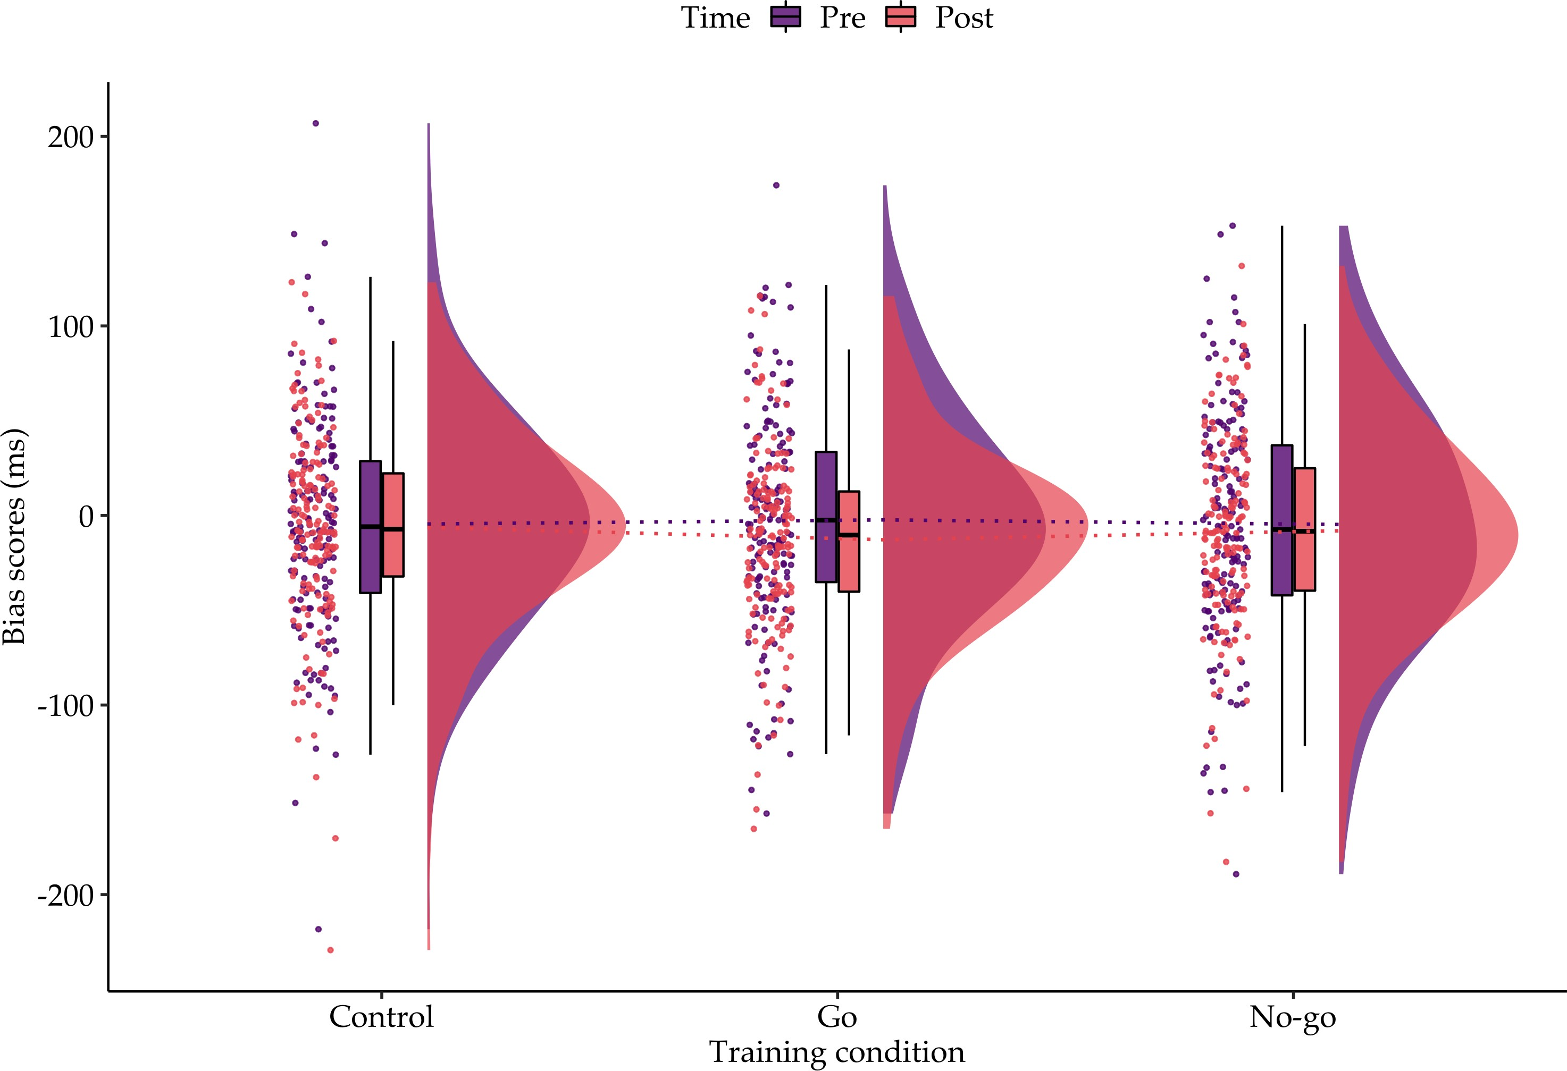

***Figure 2* . Raincloud plot of the approach-avoidance bias scores pre- and post- training across training conditions.** There were no differences between the sample mean changes in approach-avoidance bias scores for no-go and go foods compared to control (filler) foods, as shown by the dashed lines. At a closer inspection, individual bias scores do not seem to be clustered around the positive end of the distribution as it would be expected for for appetitive unhealthy foods, but actually show less dispersion around zero. Exploratory analyses confirmed that baseline bias scores did not statistically deviate from zero (see *Baseline**approach bias scores*). *Note.* The ‘split-half violin’ elements in the plot show smoothed distributions.

469 **Manipulation checks for training.** As a first manipulation check for training

470 outcomes, it was investigated whether GNG changed the evaluations of foods associated with

471 signal and no-signal trials compared to the evaluations of filler foods which were paired with

472 either type of trial with equal probability (control). There was only *anecdotal* evidence for

473 the absence of a general effect of training condition on the changes in liking from pre- to

474 post- training [H3; *BF* 01 = 2.89; *F* (2, 324) = 2.90, *p* = 0.057]. The change in liking scores

**Table 1**

*Results for all pre-registered hypotheses and respective statistical tests*

95% CI for *d*

|  |  |  |  |  |  |  |  |  |  |
| --- | --- | --- | --- | --- | --- | --- | --- | --- | --- |
|  | *BF* 10 | *t* | *df* | *p* | *d* | Lower | Upper | Evidence interpretation |  |
| H1a | 0.107 | -0.25 | 162 | 0.805 | -0.02 | -0.17 | 0.13 | *Moderate* evidence for H0 |  |
| H1b | 0.039 | -1.35 | 162 | 0.179 | -0.11 | -0.26 | 0.05 | *Strong* evidence for H0 |  |
| H2a | 247.782 | -3.93 | 161 | < .001 | -0.31 | -0.47 | -0.15 | *Extreme* evidence for H1 |  |
| H2b | 0.849 | 1.82 | 161 | 0.070 | 0.14 | -0.01 | 0.30 | *Anecdotal* evidence for H0 |  |
| H3a | 2.648 | -2.38 | 162 | 0.019 | -0.19 | -0.34 | -0.03 | *Anecdotal* evidence for H1 |  |
| H3b | 0.067 | -0.37 | 162 | 0.715 | -0.03 | -0.18 | 0.13 | *Strong* evidence for H0 |  |
| H4a | 140.254 | 3.77 | 162 | < .001 | 0.30 | 0.14 | 0.45 | *Extreme* evidence for H1 |  |
| H4b | 3973.214 | -4.66 | 162 | < .001 | -0.37 | -0.52 | -0.21 | *Extreme* evidence for H1 |  |

*Note.* Evidence is interpreted for the alternative hypothesis (H1) compared to the null (H0) and vice versa. All Bayesian paired samples t-tests were directional, as indicated in the *Pre-registered analyses* section and frequentist equivalents were non-directional (two-tailed). The effect size is represented by Cohen’s *d*.

475 from pre-to post-training for nogo foods (∆Likingnogo; *M* = -4.16; *SD* = 9.51) was only

476 slightly reduced compared to change in liking for filler foods (∆Likingcontrol; *M* = -2.61, *SD*

477 = 8.77), and there was only *anecdotal* evidence for this effect (H3a; see Table 1). The change

478 in liking scores from pre-to post-training for go foods (∆ Likinggo; *M* = -2.87, *SD* = 10.15),

479 however, was not greater than the change for filler foods as originally expected. Instead,

480 there was *strong* evidence for the null hypothesis compared to the alternative (H3b).

481 In order to validate whether the implemented go/no-go training paradigm led to

482 stimulus-response associations (i.e., contingency learning), it was tested whether the

483 percentage of correct responses for no-go foods (i.e., successful inhibitions) would be greater

484 compared to the percentage of correct responses for filler foods associated with signal trials

485 (H4a). There was *extreme* evidence that participants had on average more successful

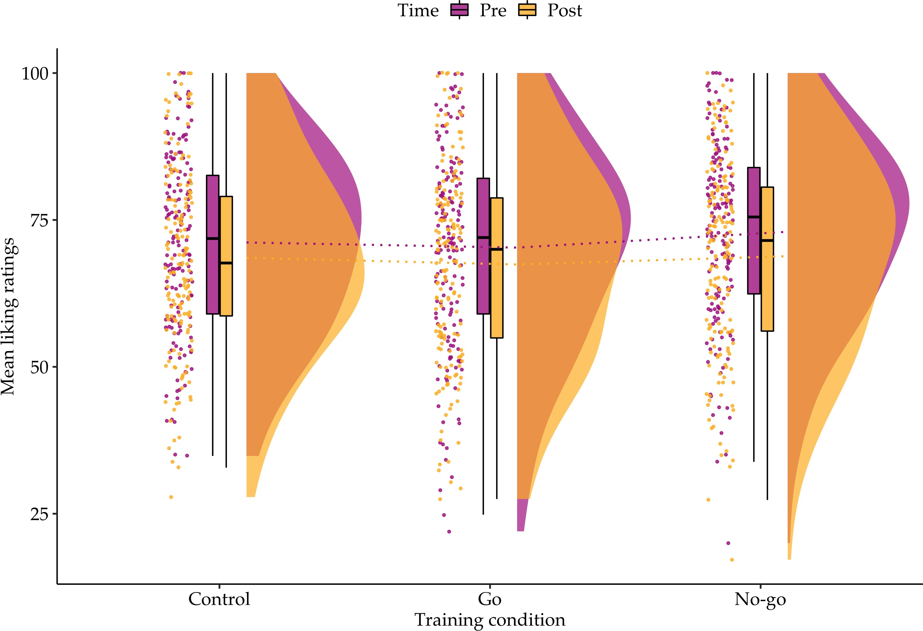

***Figure 3* . Raincloud plot of the mean liking ratings pre- and post- training across training conditions.** This visualisation of the mean liking ratings from all participants revealed that the distributions are more skewed than expected, towards the least liked range of the visual analogue scale (VAS). Taste (liking) ratings were registered on a VAS ranging from 0 to 100 (i.e., 50=neutral). Although there appears to be a small difference between the change in liking for no-go foods compared to the control, the trends presented in this plot were inspected further to establish whether observed effects were robust (see *Robust statistics*). Also, there appears to be a general trend of devaluation across training conditions and this was statistically supported (see *Devaluation trends across training conditions*). *Note.* The ‘split-half violin’ elements in the plot show smoothed and trimmed distributions.

486 inhibitions for no-go foods (PCsignalnogo; *M* = 0.97, *SD* = 0.03) than filler foods

487 (PCsignalcontrol-nogo; *M* = 0.96, *SD* = 0.04). For H4b, it was examined whether mean

488 reaction times would be reduced for go foods (GoRTgo; *M* = 507.00, *SD* = 70.48) compared

489 to filler foods associated with no-signal trials (GoRTcontrol-go; *M* = 515.00, *SD* = 75.51) and

490 there was *extreme* evidence for such an effect. Therefore, contingency learning was observed

491 in the employed GNG paradigm for both reaction time and accuracy outcomes.

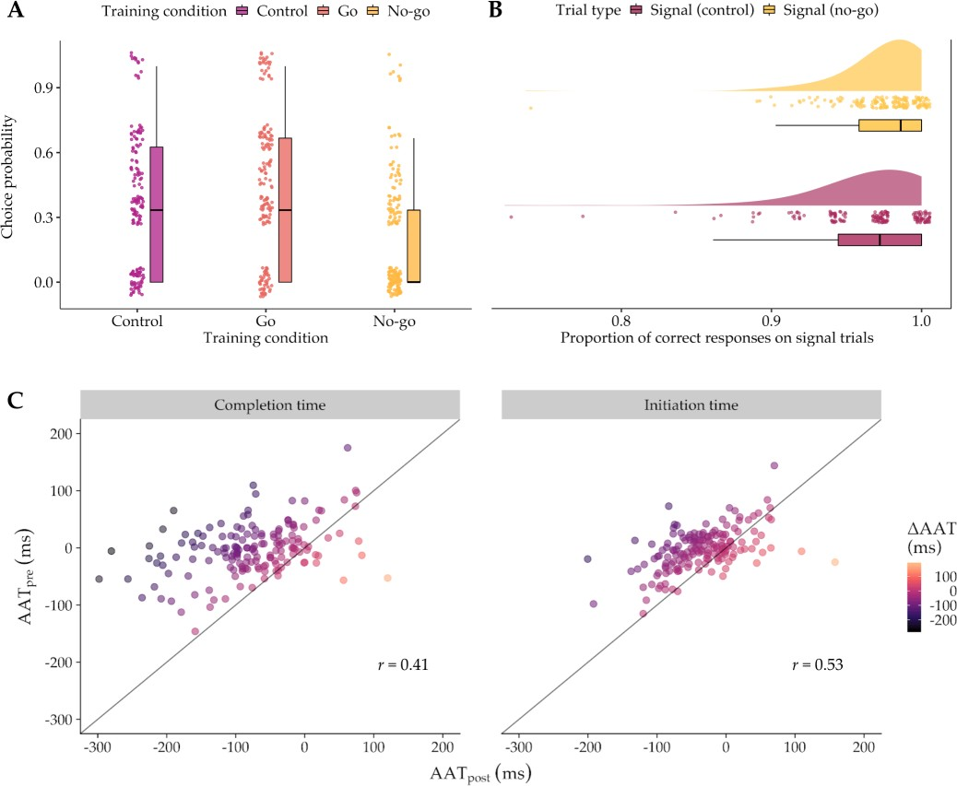

***Figure 4* . Plots for food choice outcomes, accuracy-based contingency learning in training and test-retest reliability of approach-avoidance bias scores. A.** The boxplots with corresponding jittered individual data points clearly show that the probability of choosing a no-go food after training is reduced compared to the probability of choosing control food [H2a]. Contrary to initial predictions, the average choice probability was not greater for go foods relative to the control [H2b]. **B.** The proportion of correct responses on signal trials (PCsignal) was relatively greater for no-go foods compared to control foods. The PCsignal distribution for control foods was heavily skewed and this observation warranted a robustness check for effect estimates, as presented in the *Robust statistics* section.

**C.** For the pre-registered analysis of training outcomes on automatic action tendencies [H1], approach- avoidance bias scores (∆AAT) were calculated based on median reaction times for correct pull and push responses from pre-to post-training (AATpost - AATpre). These reaction times refer to the time participants took to complete an action (i.e., completion time). TThe test-retest reliability for the calculated scores is poor (Pearson’s *r* coefficient = 0.41; see *Reliability of calculated bias scores* for detailed results). When bias scores are computed using the time when participants initiated a movement since stimulus onset on a correct trial (i..e, initiation times), the test-retest reliability was slightly improved (r = 0.53) and less dispersion was observed for ∆AAT across participants. *Note.* The ‘split-half violin’ elements in the plot show smoothed and trimmed distributions. Individual data points have been jittered to some degree due to overfitting, as it can be seen for the cluster of data points in panel B for very high proportions of correct responses on signal trials.

# 492 Exploratory findings

493 **Baseline approach bias scores.** Performance in the AAT was inspected further to

494 check if approach bias for foods was present in the final sample and whether error rates

495 differed across conditions. Although the sample means for AATpre bias scores are negative

496 for go foods (*M* = -2.32, *SD* = 58.14), no-go foods (*M* = -4.75, *SD* = 60.58) and filler foods

497 (*M* = -4.48, *SD* = 52.25), individual data points (see Figure 2 show less dispersion close to

498 zero, suggesting that neither approach or avoidance bias was captured by the AAT. In line

499 with previous literature (see Table 1 in Becker et al., 2015), this hypothesis was directly

500 tested by examining whether baseline bias scores statistically deviated from zero using

501 Bayesian one sample t-tests with the default prior settings for the two-sided alternative

502 hypothesis that the population mean was larger than the test value. Equivalent frequentist

503 tests were also conducted. Overall, conclusive evidence for the absence of baseline

504 approach/avoidance bias was obtained for any of the foods which were randomly assigned to

505 training conditions (see Table 2).

506 As baseline bias scores calculated from completion times may be “contaminated” by

507 motor demands in this version of the AAT that requires computer mouse movements and

508 arm flexion/extension, the possibility that motor initiation times may be more sensitive to

509 capturing automatic action tendencies was considered. Movement initiation was registered

510 when participants had moved their mouse cursor since starting a trial (i.e., stimulus onset),

511 including the pixel tolerance for natural movements of the mouse (see *Approach avoidance*

512 *task*). Therefore, tests were also conducted for baseline bias scores calculated using median

513 initiation times, instead of median completion times. Consistent with the results presented

514 above, there was strong evidence that baseline bias scores did not deviate from zero across

515 training conditions (see Table 2).

**Table 2**

*Results of Bayesian and frequentist one sample t-tests for baseline approach-avoidance bias scores*

95% CI for *d*

|  |  |  |  |  |  |  |  |
| --- | --- | --- | --- | --- | --- | --- | --- |
|  | *BF* 01 | *t*(162) | *p* | *d* | Lower | Upper |  |
| Completion time: AATpre for go foods | 10.08 | -0.51 | 0.611 | -0.04 | -0.19 | 0.11 |  |
| Completion time: AATpre for no-go foods | 7.01 | -1.00 | 0.318 | -0.08 | -0.23 | 0.08 |  |
| Completion time: AATpre for control foods | 7.02 | -1.00 | 0.319 | -0.08 | -0.23 | 0.08 |  |
| Initiation time: AATpre for go foods | 10.73 | -0.36 | 0.718 | -0.03 | -0.18 | 0.13 |  |
| Initiation time: AATpre for no-go foods | 10.18 | -0.49 | 0.626 | -0.04 | -0.19 | 0.12 |  |
| Initiation time: AATpre for control foods | 10.46 | -0.43 | 0.669 | -0.03 | -0.19 | 0.12 |  |

*Note.* AATpre: Pre-training approach avoidance task bias scores

516 **Sub-group analysis.** In an effort to show that training did not have an effect on

517 AAT outcomes was not due to the absence of baseline approach bias for unhealthy foods, a

518 sub-group analysis for participants with positive baseline bias scores (N=72) was conducted.

519 There was *very strong* evidence for the absence of a main effect of go/no-go training

520 condition on the change in approach-avoidance bias scores [*BF* 01 = 43.99; *F* (2, 142) = 0.01,

521 *p* = 0.987]. For this sub-group food-choice outcomes were consistent with the confirmatory

522 findings reported in *Training outcomes*. There was *strong* evidence that the probability of

523 choosing a no-go food (*M* = 0.20, *SD* = 0.27) was reduced relative to the probability of

524 choosing a control food (*M* = 0.37, *SD* = 0.33) [*BF* 10 = 13.97; *t*(70)] = -2.96, *p* = 0.004, *W*

525 = 0.004, *d* = -0.35, 95% CI for *d* = -0.59, -0.11]. There was *moderate* evidence for the

526 absence of a general effect of training condition on the change in liking scores from pre-to

527 post-training [*BF* 01 = 8.91; *F* (2, 142) = 0.94, *p* = 0.392]. With regards to the contingency

528 learning manipulation check, there was*very strong* evidence for a greater proportion of

529 correct responses in signal trials with no-go foods compared to control foods [*BF* 10 = 37.80;

530 *t*(71) = 3.33, *p* = 0.001,*W* < .001, *d* = 0.39, 95% CI for *d* = 0.15, 0.63]. However, there was

531 only *anecdotal* evidence that GoRTs were faster for go foods compared to control foods

532 [*BF* 10 = 3.52; *t*(71)) = -2.38, *p* = 0.020, *d* = -0.28, 95% CI for *d* = -0.52, -0.04].

533 **Accuracy in the approach-avoidance task.** Although reaction times are the

534 primary measure of interest for studies that utilise the AAT so that bias scores can be

535 calculated, an exploratory examination of error rates is also reported. At baseline, average

536 error rates were not increased for trials where participants were required to avoid an

537 appetitive food and complete a push action (*M* = 0.136; *SD* = 0.070) relative to trials where

538 an approach (pull) action was completed (*M* = 0.143; *SD* = 0.066) [*BF* 01 = 26.49; *t*(162) =

539 1.42, *p*= 0.159, *d* = 0.11, 95% CI for *d* = -0.04, 0.26]. However, after training participants

540 had on average more errors in approach trials (*M* = .124, *SD* = .074) compared to avoid

541 trials (*M* = 0.105, *SD* = 0.062) [*BF* 10 = 90.98, *t*(162) = 3.64, *p* < .001, *pW* < .001, *d* = 0.29,

542 95% CI for *d* = 0.13, 0.44]. It is possible that training had a “hidden” effect on accuracy, for

543 example it was more difficult to approach no-go foods compared to go and/or control foods

544 due to a learned association between response inhibition and these food stimuli. Difference

545 scores were calculated from the mean error rates post-training (pull - push) to check whether

546 this increase in error rates was general or specific to training conditions. There was very

547 strong evidence for the absence of a general effect of training condition on differences in

548 mean error rates between approach and avoid trials [H3; *BF* 01 = 37.16; *F* (2, 324) = 0.17, *p*

549 = 0.844]. RT differences between approach and avoid trials were inspected and there was

550 *strong* evidence for slower RTs on pull compared to push actions after training [*BF* 10 =

551 11.32; *t*(162) = 2.95, *p* = 0.004, *pW* = 0.002, *d* = 0.23, 95% CI for *d* = 0.08, 0.39]. Together

552 these results may indicate fatigue effects associated with bio-mechanical costs (e.g., arm

553 flexion muscle group activation).

554 **Reliability of calculated bias scores.** Given the absence of evidence for baseline

555 approach-avoidance bias scores deviating from zero and the variability in the distribution of

556 score from negative to positive bias (see Figure 2), the test-retest reliability of the task

557 measures was assessed. Considering that the the interval between pre- and post-training

558 AAT blocks was very short and there could be added variability (i.e. noise) due to the GNG

559 intervention, a test-retest reliability (or stability) coefficient *r* within the range of 0.6-0.7

560 would be considered adequate in this context. Test-retest reliability was assessed via

561 correlation pairs for AAT bias scores at baseline (AATpre) and after training (AATpost), as

562 shown in Figure **??** (panel C). Consistent with the previous analyses of baseline bias scores

563 (see *Baseline approach bias scores*), test-retest reliability was examined for both completion

564 time and initiation time AAT bias scores. Bayesian correlation pairs with the default prior

565 (stretched beta with *γ*=1; Wagenmakers, Verhagen, and Ly (2016)) were used for these

566 analyses. As expected, there was *extreme* evidence for a positive linear relationship between

567 completion time bias scores for pre- and post- training blocks, but the correlation coefficient

568 (Pearson’s rho) was only 0.41, indicating that there test-retest reliability of AAT bias scores

569 based on completion times was poor [log(*BF* 10) = 12.95, *p* < .001, 95% CI for *r* = 0.30, 1].

570 As discussed earlier, bias scores based on median completion times could be affected by noise

571 in motor times and scores based on median initiation times would better reflect underlying

572 cognitive processes, such as *automatic* action tendencies. The test-retest reliability for bias

573 scores based on initiation times however was only slightly better compared to completion

574 time bias scores with a stability coefficient of 0.53 [log(*BF* 10) = 24.34, *p* < .001, 95% CI for *r*

575 = 0.43, 1].

576 **Devaluation trends across training conditions.** As explained in Figure 3, there

577 was a general trend of devaluation in the data for all training conditions from pre- to

578 post-training. These observed differencesw were tested directly and there was conclusive

579 evidence that within each training condition cell, there is a negative change in mean liking

580 ratings from pre- to post-training, as observed in Figure 3. The control (filler) foods should

581 be unaffected in terms of affective evaluation changes, but participants rated filler foods

582 more negatively after training (*M* = 68.55, *SD* = 15.81) relative to baseline (*M* = 71.16, *SD*

583 = 14.80) [*BF* 10 = 156.54, *t*(162) = 3.80, *p* < .001, *pW* = 0.001, *d* = 0.30, 95% CI for *d* =

584 0.14, 0.45]. Contrary to predictions about the increase in positive evaluations for go foods

585 (relative to control), within that condition cell the evaluations of go foods were less positive

586 after training (*M* = 67.42, *SD* = 16.85) compared to before (*M* = 70.29, *SD* = 16.80) [*BF* 10

587 = 84.52, *t*(162) = 3.62, *p* < .001, *pW* < .001, *d* = 0.28, 95% CI for *d* = 0.13, 0.44]. The

588 effect was greater for no-go foods, but this is the only data trend that was theoretically

589 consistent with effects of training. Participants provided less positive ratings for no-go foods

590 after training (*M* = 68.83, *SD* = 16.81) compared to before (*M* = 72.99, *SD* = 15.38) [*BF* 10

591 = 211398.68, *t*(162) = 5.58, *p* < .001, *pW* < .001, *d* = 0.44, 95% CI for *d* = 0.28, 0.60].

592 **General linear model of food choice data.** As shown in Figure 4 and as

593 expected for counts data, food choice probabilities were not normally distributed and the

594 inferences based on paired t-tests would need to be validated further. Choice count data

595 from the impulsive food choice task were modelled using a general linear model (GLM) in R

596 (R Core Team, 2017). The error term of the model was specified with a Poisson distribution

597 and the link function log-transformed the linear predictor within the model (i.e., logarithms

598 of fitted means). The only predictor in this model was the training condition (i.e.., go, no-go,

599 or filler foods), with filler, or control, foods set as the reference point (i.e., intercept).

600 Diagnostic plots showed mild violations of the assumptions of homoskedasticity and

601 normality of residuals and thus robust standard errors for the parameter estimates were

602 computed (Cameron & Trivedi, 2009). An overdispersion test (Cameron & Trivedi, 2005;

603 Kleiber & Zeileis, 2008) showed that true dispersion was not greater than 1 and the

604 goodness-of-fit chi-squared test was not statistically significant, indicating that the model 605 had a good fit (Residual variance = 436.15, df = 486, *p* = 0.949). The GLM results are 606 consistent with the pre-registered statistical test results (see Table 1). The model showed 607 that impulsive choice probability for no-go foods was 0.53 times the choice probability for 608 control foods [Estimate (log) = -0.617, Robust SE = 0.119, *p* < .001, 95% CI = -0.851,

609 -0.383)]. The probability of choosing a go food after training was 1.22 times the probability 610 of choosing a control food [Esimate (log) = 0.197, Robust SE = 0.091, *p* = 0.030, 95% CI = 611 0.019, 0.374].

612 **Robust statistics.** For certain pre-registered paired comparisons, where the

613 difference scores were found to violate the normality assumption (Shapiro-Wilk test with *p* 614 *leq* .005), the possibility of biased effect size esimates was considered and therefore robust 615 statistics are also reported (Lakens, 2015). H2a and H2b have been ommitted as robust

616 analyses have already been implemented above (see *General linear model of food choice data*). 617 Yuen’s method of comparing trimmed means was applied via the WRS2 package, with the 618 recommended percentage of 20% trimming from both tails of the distribution (Mair &

619 Wilcox, 2019; Wilcox & Tian, 2011; Yuen, 1974). The exploratory measure of effect size, 620 represented by *ξ* is provided and can be conventionally interpreted as small, median and 621 large at 0.15, 0.35 and 0.50 (Mair & Wilcox, 2019). The null hypothesis in Yuen’s test for

622 paired sample comparisons is that there is no difference between the trimmed means (*µt*1 = 623 *µt*2). The test results are shown in Table 3 and are consistent withpre-registered findings. 624 The explanatory effect sizes do not deviated in their interpretation from Cohen’s *d* values 625 presented in Table **??** for frequentists paired-samples t-tests, as the observed effects are small 626 for both H3a and H4a.

**Table 3**

*Yuen’s tests of trimmed mean differences for paired comparisons that violated the normality assumption*

95% CI Comparison to Effect size

|  |  |  |  |  |  |  |  |  |  |
| --- | --- | --- | --- | --- | --- | --- | --- | --- | --- |
|  | *t*(98) | *p* | *MDt* | Lower | Upper | *ξ* | confirmatory test | interpretation |  |
| H1a | -0.90 | 0.37 | -5.12 | -16.37 | 6.14 | 0.07 | Consistent | None |  |
| H3a | -1.67 | 0.10 | -1.03 | -2.25 | 0.19 | 0.10 | Consistent | Very small |  |
| H3b | -0.09 | 0.93 | -0.06 | -1.50 | 1.38 | 0.01 | Consistent | None |  |
| H4a | -3.11 | 0.00 | -0.01 | -0.01 | 0.00 | 0.20 | Consistent | Small |  |

*Note.* The degrees of freedom for the robust *t* statistic are 98 because of trimming at 20% for both tails of the distribution (i.e., N = 99). Comparison to confirmatory test refers to whether or not the results from Yuen’s tests are consistent with the pre-registered, confirmatory test results. *MDt*: trimmed mean difference; *ξ*: explanatory measure of effect size

627 **Discussion**

# 628 No effects of training on automatic action tendencies

629 The primary aim of the study was to investigate whether inhibitory control training 630 (ICT) can have an indirect effect on automatic action tendencies. It was hypothesized that 631 approach bias for unhealthy foods associated with a no-go response during go/no-go training 632 (i.e., response inhibition) would be reduced compared to filler foods that were paired with 633 both go and no-go responses with an equal probability (control). Automatic action

634 tendencies were indirectly measured using a variant of the approach-avoidance task (AAT) 635 that includes a “zooming” feature for push/pull actions (Neumann & Strack, 2000) of the 636 computer mouse and requires participants to judge the orientation of the presented picture 637 (C. E. Wiers et al., 2013). Approach-avoidance bias scores were calculated from AAT blocks 638 before and after training by subtracting median RTs on approach trials (pull action) from 639 median RTs on avoid trials (push action). Positive scores would indicate an approach bias

640 towards unhealthy foods. As a primary outcome measure, the change in bias scores from

641 pre-to post-training was examined across training conditions. The results from the

642 pre-registered analyses showed that ICT did not have an effect on automatic action

643 tendencies, as there was *moderate* evidence that approach bias for no-go foods was not

644 reduced relative to control foods after training (H1a) and *strong* evidence that approach bias

645 for go foods was not increased compared to control foods after training (H1b). Although

646 such ICT effects may not have been previously investigated, or published due to selective 647 reporting of significant findings (e.g., see Carbine, Lindsey, Rodeback, & Larson, 2019), there 648 is empirical evidence to suggest that food stimuli included in AAT training protocols can be 649 associated with increased avoidance behaviour (or reduced approach) after training (e.g., 650 Dickson, Kavanagh, & MacLeod, 2016; Schumacher et al., 2016). A signidicant change in 651 approach-avoidance bias scores was not observed in another series of experiments (Becker et 652 al., 2015), but presence or absence of training effects may also depend on methodological 653 parameters of training and employed controls (see Jones et al., 2018 for review).

can we

mention here that this will be discussed further below in more detail?

654

# 655 Response inhibition & impulsive food choices

656 As a secondary outcome of training, the effects of go/no-go training on impulsive food 657 choices were assessed via an adapted food choice task (Veling et al., 2013a). Participants had 658 ten seconds to choose three food stimuli from all training conditions (go, no-go or control). 659 Pre-registered analyses showed that the probability of choosing a no-go food was reduced 660 compared to the probability of choosing a control food (H2a). Meanwhile, there was no

661 difference between the probability of choosing a go food relative to the probability of

662 choosing a control food (H2b). The findings that ICT can have an effect on impulsive food 663 choices is consistent with previous studies that have used both go/no-go and stop-signal task 664 paradigms (Veling et al., 2013b, 2013a), but cannot be directly compared to experiments

665 involving cue-approach training, which involves responding to go items in response to a cue 666 or signal. These studies have found increased food choices for go food items (Schonberg et 667 al., 2014; Veling, Chen, et al., 2017), but it cannot be inferred that the lack of increased

668 choice probability for go foods in this study contradicts previous findings.

# 669 Devaluation effects & design limitations

670 Another important training outcome which was also treated as manipulation check for 671 the ICT paradigm was the change in food evaluations from pre-to post-training. According 672 to the BSI theory of stimulus devaluation, as already discussed, successful inhibition of

673 responses on signal trials is facilitated by an underlying devaluation process for appetitive

674 foods, whereby approach bias for these foods is reduced (Veling et al., 2008, 2017).

675 Consistent with previous findings where go/no-go training led to robust food devaluation 676 effects (see Chen et al., 2016 for a series of pre-registered experiments), it was expected that 677 the change in mean tastiness ratings (i.e., food liking) for no-go foods from pre-to

678 post-training would be reduced compared to the change in ratings for filler foods.

679 Pre-registered analyses showed only *anecdotal* evidence that no-go foods were rated less

680 positively after training compared to filler foods (H3a). Similarly, participants did not show 681 increased liking for go foods relative to the filler foods, from pre-to post-training (H3b). It 682 should be noted that filler foods which were associated with both go and no-go responses 683 (50:50) are not an ideal control for devaluation effects, as Chen et al. (2016) correctly point 684 out that effects should be observed for two baselines in order for proper inferences to be

685 made. They compared changes in evaluation for no-go foods compared to changes for go

686 foods as well as changes for untrained food stimuli, which were never included in training. In

687 their design, food stimuli sets were matched in valence at the beginning of the study.

688 However, participants in this study were only presented with a fixed set of unhealthy foods

689 which were considered appetitive (e.g., pizza, cake, crisps) and this was a viable limitation

690 with regards to the examination of devaluation effects. There is evidence to suggest that 691 devaluation is observed only when highly appetitive foods are associated with response 692 inhibition (see Chen et al., 2016).

693 Exploratory analyses further showed that while on average no-go foods were rated less 694 positively after training compared to before, there was a general devaluation trend for both 695 go and control foods (see *Devaluation trends across training conditions*). It is possible that 696 ‘over-exposure’ to food stimuli from all training conditions during the phases of the study 697 (pre-training, training, and post-training) could have had a viable habituation effect on

698 participants’ affective evaluations of any presented foods at the end of the study. It is also 699 unclear whether stimulus-response mappings in the AAT affected GNG manipulations, as for 700 example a correct response on push trials may require response inhibition, whereby an initial 701 approach tendency towards an appetitive food cue is inhibited. This would mean that, at 702 least to a certain extent, all food stimuli were associated with an inhibitory control process. 703 It is therefore recommended that future studies only present outcome measures, such as the 704 AAT, only after training, which can reduce habituation effects, but also enhance the

705 experimental design if untrained food stimuli are included as additional controls. The

706 recommended design can also increase the number of observations without the need for great 707 data reduction, such as calculating a difference score of the AATpre and AATpost bias scores 708 which are also represented by difference scores between median RTs in approach and avoid 709 trials. The absence of devaluation effects specific to no-go foods could not be attributed to 710 ineffective training, as the second manipulation check for contingency learning during the 711 go/no-go task was positive. There was *extreme* evidence that GoRTs on correct no-signal 712 trials were reduced for go foods compared to control foods and that the percentage of correct 713 responses on signal trials were greater for no-go foods relative to control foods. Overall, ICT 714 outcomes for devaluation are generally consistent with prior expectations, while taking into 715 account that limitations of the experimental design may have had a significant impact on 716 observed effects.

# 717 Methodological considerations for the approach-avoidance task

718 There were several exploratory findings regarding the approach avoidance task that

719 may explain the absence of ICT effects on automatic action tendencies and yielded

720 methodological considerations for future studies. First, overall baseline bias scores did not 721 statistically deviate from zero (see *Baseline approach bias scores*), which suggests that either 722 participants did not have any approach bias for the selected foods or the employed variant of 723 the AAT was not sensitive enough to capture both baseline bias and potential indirect effects 724 of training. Sub-group analyses showed that even when participants had positive bias scores 725 for unhealthy foods, which reflect existing approach bias, there were still no effects of

726 training on automatic action tendencies (see *Sub-group analysis*). Consequently, the

727 test-retest reliability of the calculated bias scores for pre-and post-training AAT blocks was 728 examined and the stability coefficients showed poor reliability (see *Reliability of calculated*729 *bias scores*). Test-retest reliability was slightly improved when bias scores were calculated 730 using initiation times, instead of completion times, which may be due to individual

731 differences in action-associated motor demands (i.e.,biceps and triceps muscle activation for 732 pushing/pulling the computer mouse). It is suggested that initiation time would be a more 733 reliable measure to use for calculation AAT bias scores (e.g., see Seibt, Häfner, & Deutsch, 734 2007). It is also unclear whether any time of response latency measure derived from

735 sensorimotor tasks, such as the AAT variant employed in this study, can be indicative of

736 approach-avoidance bias, since the role of arm movements in these motivational processes 737 has recently been questioned for the controversial replicability of findings and the importance 738 of whole-body movements in real-world approach-avoidance behaviours (Rougier et al., 2018). 739 An element of the AAT variant that could have affected the reliability of the bias scores was 740 the use of a computer mouse instead of a joystick, as in the seminal version of this paradigm 741 (Rinck & Becker, 2007; Wiers et al., 2009). However, any motor demand differences between 742 the joystick and computer mouse would not affect the initiation times, which were also found

743 to have questionable test-retest reliability. The variability in methodology for the

744 measurement of motivational bias should be taken into account, as different parameters 745 might need to be examined further when the AAT is applied in the food domain (e.g., 746 explicit vs implicit task instructions; see Phaf et al., 2014 for meta-analysis).

747 Certainly, there are methodological issues with the application of the AAT as an

748 indirect measure of approach bias in ICT studies that have strict comparisons for outcomes 749 based only food stimuli. For example, one approach for making inferences based on AAT 750 scores is to calculate a *relative* bias based on the push-pull median RT differences from one 751 category (e.g., alcohol) versus another (e.g., non-alcohol), as reported in previous literature 752 (Sharbanee, Stritzke, Jamalludin, & Wiers, 2014; van Deursen, Salemink, Smit, Kramer, & 753 Wiers, 2013). However, in the present study design the AAT included only sweet and

754 savoury unhealthy foods and bias scores were based on the differences between push and pull

755 actions alone. The control for relative bias scores should be specific to the question of

756 interest, such as healthy foods, if approach bias and healthiness is to be examined, or

757 non-food stimuli if a general food approach bias is to be inferred. In any case, the control 758 stimuli need to be matched in liking (i.e., hedonic value) so that any resulting bias scores 759 reflect differences in motivational bias and not affective/hedonic bias (Kemps & Tiggemann, 760 2015). Setting aside the methodological utility of the AAT in this context, it is possible that 761 go/no-go training with the specific parameters applied in this study, did not have an effect 762 on automatic action tendencies.

need to make it clear that ICT could have had no effect but

it is difficult to draw such conclusions without more research.. taking into account

763

764

methodological limitations for both the GNG design and AAT measures

# 765 Concluding remarks & future directions

766 As thorough search of the literature did not indicate that the AAT has previously been

767 employed as an outcome measure in ICT studies utilising the go/no-go training paradigm,

768 the null findings presented in this study have shed light into methodological and theoretical 769 issues to be explored further. From a theoretical standpoint, there could be a link between 770 stimulus devaluation during ICT training and automatic action tendencies. If a tendency to 771 approach an appetitive food is reduced during go/no-go training in order for response

772 inhibition to be successful, the approach bias towards food stimuli associated with signal

773 trials could be indirectly affected by this process. The absence of devaluation effects in this 774 study could therefore explain the finding that ICT did not have any influence on automatic 775 action tendencies. Nevertheless, there are several methodological limitations regarding the 776 application of the AAT as an indirect measure of motivational bias that need to be

777 considered before drawing any conclusions and these would need to be addressed in future

778 studies. On a final note, it is worth mentioning that there are various methodological

779 parameters and protocols that can be implemented for both inhibitory control training and 780 measurement of approach-avoidance bias. This can pose an important replicability issue and 781 it is recommended that novel findings, even if null, are replicated and/or extended in a

782 rigorous and reproducible manner, in an effort to also reduce selective reporting and 783 publication bias in this line of research (e.g., see Aulbach, Knittle, & Haukkala, 2019; 784 Carbine et al., 2019).

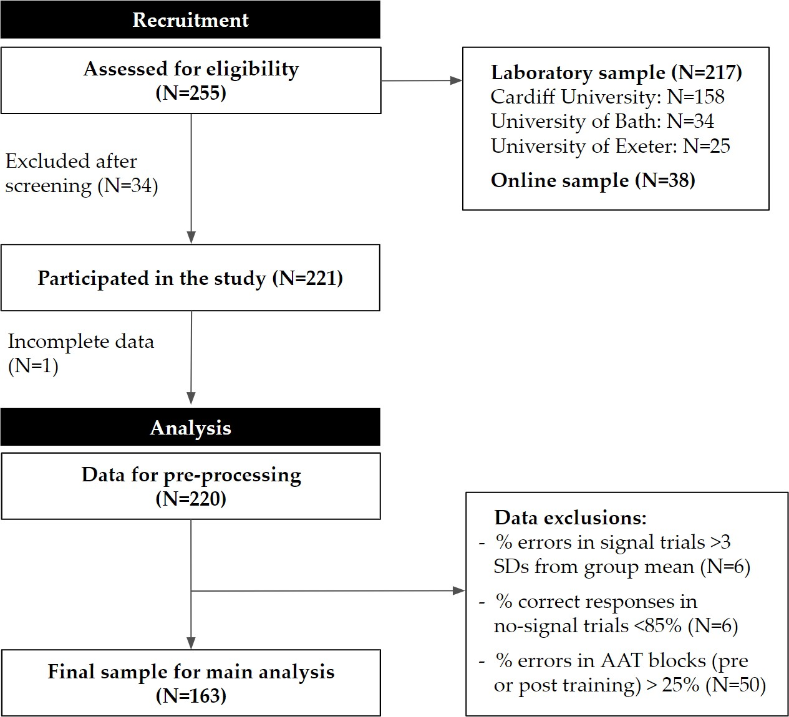Appendix A Recruitment & data exclusions

***Figure A1* . Flow diagram of recruitment and participant-level data exclusions.** There were 255 individuals recruited and assessed for eligibility across laboratory sites and online via personal communication. 34 participants were excluded after screening for not meeting the advertised inclusion/exclusion criteria and datasets were obtained from 221 participants. The online sample was recruited by the University of Bath and University of Exeter. One participant was excluded for providing incomplete data and 220 datasets were submitted for pre-processing and inspection. There were no participants with a mean reaction time on no-sginal trials (GoRT) greater than three standard deviations (SDs) from the group mean and there were no cases of consistently missed (i.e., default option of 50) responses on food rating trials. Six participants had a percentage of errors in signal trials was greater than three SDs from the group mean and six participants also had a percentage of correct responses in no-signal trials lower than 85%. Please note that some participants met more than one exclusion criterion. 50 participants were excluded as their percentage of errors in either the pre- or post-training approach-avoidance task (AAT) blocks was greater than 25%. The final sample consisted of 163 participants.

Appendix B

Sample characteristics & questionnaire measures

785 All sample characteristics, apart from gender and hours since last meal, are presented in the 786 Table B2 together with total scores from relevant questionnaire measures, as described in the 787 *Survey & Questionnaires* section. Descriptive statistics of the questionnaire scores can be 788 found in Table B1. Pearson’s *r* coefficients were conventionally interpreted as small, medium 789 and large at 0.10, 0.30 and 0.50. As it would be expected for the Food Cravings

790 Questionnaire Trait- reduced (FCQ-T-r) measure, there was a positive correlation, although 791 small, with BMI as well as medium-to-large positive correlations with total scores on the 792 Barratt Impulsivity Scale (BIS) and Perceived Stress Scale (PSS). Trait food cravings

793 negatively correlated with stop control, as measured by the Stop Control Scale (SCS) and

794 the food subscale of the Delaying Gratification Inventory (DGI).

**Table B1**

*Descriptive statistics of questionnaire scores from the final sample*

|  |  |  |  |  |  |
| --- | --- | --- | --- | --- | --- |
|  | FCQ-T-r total | BIS total | PSS total | SCS total | DGI - food |
| Mean | 45.362 | 32.773 | 19.896 | 40.951 | 22.245 |
| Median | 45.000 | 32.000 | 19.000 | 41.000 | 22.000 |
| Standard Deviation | 9.997 | 5.751 | 6.298 | 7.665 | 4.677 |
| Minimum | 20.000 | 21.000 | 4.000 | 20.000 | 10.000 |
| Maximum | 70.000 | 51.000 | 38.000 | 57.000 | 34.000 |

*Note.* For descriptions and abbreviations, please see the *Survey & Questionnaires* section.

**Table B2**

*Correlation matrix for sample characteristics and questionnaire measures*

|  |  |  |  |  |  |  |  |  |  |  |
| --- | --- | --- | --- | --- | --- | --- | --- | --- | --- | --- |
|  | | 1. | 2. | 3. | 4. | 5. | 6. | 7. | 8. |  |
| 1*.* Age | *r* | – |  |  |  |  |  |  |  |  |
|  | log(*BF* 10)  *p* | –  – |  |  |  |  |  |  |  |  |
| 2*.* Hunger | *r* | -0.064 | – |  |  |  |  |  |  |  |
|  | log(*BF* 10) | 0.352 | -2.322 | – |  |  |  |  |  |  |
|  | *p* | 0.420 | – |  |  |  |  |  |  |  |
| 3*.* BMI | *r* | 0.182 | 0.001 | – |  |  |  |  |  |  |
|  | log(*BF* 10) | 0.352 | -2.322 | – |  |  |  |  |  |  |
|  | *p* | 0.020 | 0.987 | – |  |  |  |  |  |  |
| 4*.* FCQ-T-r | *r* | -0.098 | 0.203 | 0.246* | – |  |  |  |  |  |
|  | log(*BF* 10) | -1.554 | 1.034 | 2.655 | – |  |  |  |  |  |
|  | *p* | 0.213 | 0.009 | 0.002 | – |  |  |  |  |  |
| 5*.* BIS | *r* | -0.089 | 0.129 | 0.161 | 0.491* | – |  |  |  |  |
|  | log(*BF* 10) | -1.690 | -0.991 | -0.245 | 19.572 | – |  |  |  |  |
|  | *p* | 0.259 | 0.101 | 0.041 | *<* .001 | – |  |  |  |  |
| 6*.* PSS | *r* | -0.138 | 0.040 | 0.125 | 0.462* | 0.316* | – |  |  |  |
|  | log(*BF* 10) | -0.782 | -2.195 | -1.067 | 16.754 | 6.043 | – |  |  |  |
|  | *p* | 0.078 | 0.611 | 0.111 | *<* .001 | *<* .001 | – |  |  |  |
| 7*.* SCS | *r* | 0.176 | -0.085 | -0.122 | -0.374* | -0.721* | -0.260* | – |  |  |
|  | log(*BF* 10) | 0.181 | -1.747 | -1.133 | 9.630 | 56.042 | 3.247 | – |  |  |
|  | *p* | 0.025 | 0.281 | 0.121 | *<* .001 | *<* .001 | *<* .001 | – |  |  |
| 8*.* DGI-food | *r* | 0.075 | -0.161 | -0.189 | -0.612* | -0.433* | -0.226 | 0.376* | – |  |
|  | log(*BF* 10) | -1.878 | -0.237 | 0.577 | 35.070 | 14.168 | 1.849 | 9.777 | – |  |
|  | *p* | 0.343 | 0.040 | 0.016 | *<* .001 | *<* .001 | 0.004 | *<* .001 | – |  |

*Note.* Age was self-reported in years and hunger ratings ranged from 1="Not at all" to 9="Very". Body-mass index (BMI; kg/m2); * Supported correlations at *BF* 10 > 10

795 **References**

796 Adams, R. C., Lawrence, N. S., Verbruggen, F., & Chambers, C. D. (2017). Training

797 response inhibition to reduce food consumption: Mechanisms, stimulus specificity and

798 appropriate training protocols. *Appetite*, *109*, 11–23.

799 <https://doi.org/10.1016/j.appet.2016.11.014>

800 Allen, M., Poggiali, D., Whitaker, K., Marshall, T., & Kievit, R. (2019). Raincloud plots: A 801 multi-platform tool for robust data visualization [version 1; peer review: 2 approved]. 802 *Wellcome Open Research*, *4* (63). <https://doi.org/10.12688/wellcomeopenres.15191.1>

803 Allen, M., Poggiali, D., Whitaker, K., Marshall, T. R., & Kievit, R. (2018). RainCloudPlots

804 tutorials and codebase. Zenodo. <https://doi.org/10.5281/zenodo.1402959>

805 Allom, V., Mullan, B., & Hagger, M. (2016). Does inhibitory control training improve health

806 behaviour? A meta-analysis. *Health Psychol. Rev.*, *10* (2), 168–186.

807 <https://doi.org/10.1080/17437199.2015.1051078>

808 Aulbach, M. B., Knittle, K., & Haukkala, A. (2019). Implicit process interventions in eating 809 behaviour: A meta-analysis examining mediators and moderators. *Health Psychology* 810 *Review*, *13* (2), 179–208. <https://doi.org/10.1080/17437199.2019.1571933>

811 Bartholdy, S., Dalton, B., O’Daly, O. G., Campbell, I. C., & Schmidt, U. (2016). A

812 systematic review of the relationship between eating, weight and inhibitory control

813 using the stop signal task. *Neurosci. Biobehav. Rev.*, *64*, 35–62.

814 <https://doi.org/10.1016/j.neubiorev.2016.02.010>

815 Becker, D., Jostmann, N. B., Wiers, R. W., & Holland, R. W. (2015). Approach avoidance

816 training in the eating domain: Testing the effectiveness across three single session

817 studies. *Appetite*, *85* (June 2015), 58–65. <https://doi.org/10.1016/j.appet.2014.11.017>

|  |  |
| --- | --- |
| 818 | Benjamin, D. J., Berger, J. O., Johannesson, M., Nosek, B. A., Wagenmakers, E.-J., Berk, |
| 819 | R., . . . Johnson, V. E. (2017). Redefine statistical significance. *Nat. Hum. Behav.* |
| 820 | <https://doi.org/10.1038/s41562-017-0189-z> |
| 821 | Bradley, B., Field, M., Healy, H., & Mogg, K. (2008). Do the affective properties of |
| 822 | smoking-related cues influence attentional and approach biases in cigarette smokers? |
| 823 | *Journal of Psychopharmacology*, *22* (7), 737–745. |
| 824 | <https://doi.org/10.1177/0269881107083844> |
| 825 | Brignell, C., Griffiths, T., Bradley, B. P., & Mogg, K. (2009). Attentional and approach |
| 826 | biases for pictorial food cues. Influence of external eating. *Appetite*, *52* (2), 299–306. |
| 827 | <https://doi.org/10.1016/j.appet.2008.10.007> |
| 828 | Brockmeyer, T., Hahn, C., Reetz, C., Schmidt, U., & Friederich, H. C. (2015). Approach |
| 829 | Bias Modification in Food Craving - A Proof-of-Concept Study. *Eur. Eat. Disord.* |
| 830 | *Rev.*, *23* (5), 352–360. <https://doi.org/10.1002/erv.2382> |
| 831 | Button, K. S., Ioannidis, J. P. A., Mokrysz, C., Nosek, B. A., Flint, J., Robinson, E. S. J., & |
| 832 | Munafò, M. R. (2013). Power failure: Why small sample size undermines the |
| 833 | reliability of neuroscience. *Nat. Rev. Neurosci.*, *14* (5), 365–376. |
| 834 | <https://doi.org/10.1038/nrn3475> |
| 835 | Cameron, A. C., & Trivedi, P. K. (2005). *Microeconometrics: Methods and Applications*. |
| 836 | Cambridge, New York: Cambridge University Press. |

837 Cameron, A. C., & Trivedi, P. K. (2009). *Microeconometrics Using Stata*. College Station,

838 TX: Stata Press.

839 Carbine, K. A., Lindsey, H. M., Rodeback, R. E., & Larson, M. J. (2019). Quantifying

840 evidential value and selective reporting in recent and 10-year past psychophysiological

841 literature: A pre-registered P-curve analysis. *International Journal of*

842 *Psychophysiology*, *142*, 33–49. <https://doi.org/10.1016/j.ijpsycho.2019.06.004>

843 Chen, Z., Veling, H., Dijksterhuis, A., & Holland, R. W. (2016). How does not responding to 844 appetitive stimuli cause devaluation: Evaluative conditioning or response inhibition? 845 *Journal of Experimental Psychology: General*, *145* (12), 1687–1701.

846 <https://doi.org/10.1037/xge0000236>

847 Cohen, S., Kamarck, T., & Mermelstein, R. (1983). A global measure of perceived stress.

848 *Journal of Health and Social Behavior*, *24* (4), 385–396.

849 De Boer, B. J., van Hooft, E. A. J., & Bakker, A. B. (2011). Stop and start control: A

850 distinction within self-control. *European Journal of Personality*, *25* (5), 349–362.

851 <https://doi.org/10.1002/per.796>

|  |  |
| --- | --- |
| 852 Dickson, H., Kavanagh, D. J., & MacLeod, C. (2016). The pulling power of chocolate: | |
| 853 | Effects of approach-avoidance training on approach bias and consumption. *Appetite*, |
| 854 | *99*, 46–51. <https://doi.org/10.1016/j.appet.2015.12.026> |
| 855 Faul, F., Erdfelder, E., Buchner, A., & Lang, A.-G. (2009). Statistical power analyses using | |
| 856 | G*Power 3.1: Tests for correlation and regression analyses. *Behav. Res. Methods*, |
| 857 | *41* (4), 1149–1160. <https://doi.org/10.3758/BRM.41.4.1149> |

858 Field, M., Eastwood, B., Bradley, B. P., & Mogg, K. (2006). Selective processing of cannabis

859 cues in regular cannabis users. *Drug and Alcohol Dependence*, *85* (1), 75–82.

860 <https://doi.org/10.1016/j.drugalcdep.2006.03.018>

861 Guerrieri, R., Nederkoorn, C., Stankiewicz, K., Alberts, H., Geschwind, N., Martijn, C., & 862 Jansen, A. (2007). The influence of trait and induced state impulsivity on food intake 863 in normal-weight healthy women. *Appetite*, *49* (1), 66–73.

864 <https://doi.org/10.1016/j.appet.2006.11.008>

|  |  |
| --- | --- |
| 865 Hall, P. A. (2012). Executive control resources and frequency of fatty food consumption: | |
| 866 | Findings from an age-stratified community sample. *Health Psychology: Official* |
| 867 | *Journal of the Division of Health Psychology, American Psychological Association*, |
| 868 | *31* (2), 235–241. <https://doi.org/10.1037/a0025407> |
| 869 Ha | vermans, R. C. (2013). Pavlovian Craving and Overeating: A Conditioned Incentive |
| 870 | Model. *Current Obesity Reports*, *2* (2), 165–170. |
| 871 | <https://doi.org/10.1007/s13679-013-0053-z> |

872 Hoerger, M., Quirk, S. W., & Weed, N. C. (2011). Development and validation of the

873 Delaying Gratification Inventory. *Psychological Assessment*, *23* (3), 725–738.

874 <https://doi.org/10.1037/a0023286>

875 Houben, K., & Jansen, A. (2011). Training inhibitory control. A recipe for resisting sweet

876 temptations. *Appetite*, *56* (2), 345–349. <https://doi.org/10.1016/j.appet.2010.12.017>

877 Houben, K., & Jansen, A. (2015). Chocolate equals stop: Chocolate-specific inhibition

878 training reduces chocolate intake and go associations with chocolate. *Appetite*, *87*,

879 318–323. <https://doi.org/10.1016/j.appet.2015.01.005>

880 Houben, K., Nederkoorn, C., & Jansen, A. (2012). Too tempting to resist? Past success at 881 weight control rather than dietary restraint determines exposure-induced disinhibited 882 eating. *Appetite*, *59* (2), 550–555. <https://doi.org/10.1016/j.appet.2012.07.004>

883 Jasinska, A. J., Yasuda, M., Burant, C. F., Gregor, N., Khatri, S., Sweet, M., & Falk, E. B.

884 (2012). Impulsivity and inhibitory control deficits are associated with unhealthy

885 eating in young adults. *Appetite*, *59* (3), 738–747.

886 <https://doi.org/10.1016/j.appet.2012.08.001>

887 JASP Team. (2018). JASP (Version 0.10.0)[Computer software].

888 Jones, A., Di Lemma, L. C., Robinson, E., Christiansen, P., Nolan, S., Tudur-Smith, C., &

889 Field, M. (2016). Inhibitory control training for appetitive behaviour change: A

890 meta-analytic investigation of mechanisms of action and moderators of effectiveness.

|  |  |
| --- | --- |
| 891 | *Appetite*, *97*, 16–28. <https://doi.org/10.1016/j.appet.2015.11.013> |
| 892 | Jones, A., Hardman, C. A., Lawrence, N., & Field, M. (2018). Cognitive training as a |
| 893 | potential treatment for overweight and obesity: A critical review of the evidence. |

894 *Appetite*, *124*, 50–67. <https://doi.org/10.1016/j.appet.2017.05.032>

895 Kakoschke, N., Kemps, E., & Tiggemann, M. (2017a). Approach bias modification training

896 and consumption: A review of the literature. *Addictive Behaviors*, *64*, 21–28.

897 <https://doi.org/10.1016/j.addbeh.2016.08.007>

898 Kakoschke, N., Kemps, E., & Tiggemann, M. (2017b). The effect of combined avoidance and

899 control training on implicit food evaluation and choice. *J. Behav. Ther. Exp.*

900 *Psychiatry*, *55*, 99–105. <https://doi.org/10.1016/j.jbtep.2017.01.002>

901 Kakoschke, N., Kemps, E., Tiggemann, M., Kakoschke, N., Kemps, E., & Tiggemann, M. 902 (2015). Combined effects of cognitive bias for food cues and poor inhibitory control 903 on unhealthy food intake. *Appetite*, *87* (JANUARY), 358–364.

904 <https://doi.org/10.1016/j.appet.2015.01.004>

905 Kemps, E., & Tiggemann, M. (2015). Approach bias for food cues in obese individuals.

906 *Psychol. Heal.*, *30* (3), 370–380. <https://doi.org/10.1080/08870446.2014.974605>

907 Kemps, E., Tiggemann, M., Martin, R., & Elliott, M. (2013). Implicit approachAvoidance

908 associations for craved food cues. *J. Exp. Psychol. Appl.*, *19* (1), 30–38.

909 <https://doi.org/10.1037/a0031626>

910 Kleiber, C., & Zeileis, A. (2008). *Applied Econometrics with R*. New York: Springer-Verlag.

911 Lakens, D. (2015). The 20% Statistician: The perfect t-test. *The 20% Statistician*.

912 Lawrence, N. S., Hinton, E. C., Parkinson, J. A., & Lawrence, A. D. (2012). Nucleus

913 accumbens response to food cues predicts subsequent snack consumption in women 914 and increased body mass index in those with reduced self-control. *NeuroImage*, *63* (1), 915 415–422. <https://doi.org/10.1016/j.neuroimage.2012.06.070>

916 Lawrence, N. S., O’Sullivan, J., Parslow, D., Javaid, M., Adams, R. C., Chambers, C. D., . . . 917 Verbruggen, F. (2015). Training response inhibition to food is associated with weight 918 loss and reduced energy intake. *Appetite*, *95*, 17–28.

919 <https://doi.org/10.1016/j.appet.2015.06.009>

920 Lawrence, N. S., Verbruggen, F., Morrison, S., Adams, R. C., & Chambers, C. D. (2015). 921 Stopping to food can reduce intake. Effects of stimulus-specificity and individual 922 differences in dietary restraint. *Appetite*, *85*, 91–103.

923 <https://doi.org/10.1016/j.appet.2014.11.006>

924 Lee, M. D., & Wagenmakers, E.-J. (2013). *Bayesian Cognitive Modeling: A Practical Course*.

925 Cambridge University Press. <https://doi.org/10.1017/CBO9781139087759>

926 Mair, P., & Wilcox, R. (2019). Robust statistical methods in R using the WRS2 package.

927 *Behavior Research Methods*. <https://doi.org/10.3758/s13428-019-01246-w>

928 Meule, A., Hermann, T., & Kübler, A. (2014). A short version of the food cravings

929 questionnaire-trait: The FCQ-T-reduced. *Front. Psychol.*, *5* (MAR), 1–10.

930 <https://doi.org/10.3389/fpsyg.2014.00190>

931 Nederkoorn, C., Coelho, J. S., Guerrieri, R., Houben, K., & Jansen, A. (2012). Specificity of

932 the failure to inhibit responses in overweight children. *Appetite*, *59* (2), 409–413.

933 <https://doi.org/10.1016/j.appet.2012.05.028>

934 Nederkoorn, C., Houben, K., Hofmann, W., Roefs, A., & Jansen, A. (2010). Control Yourself 935 or Just Eat What You Like? Weight Gain Over a Year Is Predicted by an Interactive 936 Effect of Response Inhibition and Implicit Preference for Snack Foods. *Health*

937 *Psychology : Official Journal of the Division of Health Psychology, American*

938 *Psychological Association*, *29*, 389–393. <https://doi.org/10.1037/a0019921>

939 Neumann, R., & Strack, F. (2000). Approach and Avoidance: The Influence of

940 Proprioceptive and Exteroceptive Cues on Encoding of Affective Information. *J.*

941 *Personal. Soc. Psychol.*, *79* (1), 39–48. <https://doi.org/10.1037//0022-3514.79.1.39>

942 Phaf, R. H., Mohr, S. E., Rotteveel, M., & Wicherts, J. M. (2014). Approach, avoidance, 943 and affect: A meta-analysis of approach-avoidance tendencies in manual reaction time 944 tasks. *Front. Psychol.*, *5* (378), 1–16. <https://doi.org/10.3389/fpsyg.2014.00378>

945 R Core Team. (2017). *R: A language and environment for statistical computing*. Vienna,

946 Austria: R Foundation for Statistical Computing. Retrieved from

947 <https://www.R-project.org/>

948 Richard D. Morey. (2015). On verbal categories for the interpretation of Bayes factors.

949 Rinck, M., & Becker, E. S. (2007). Approach and avoidance in fear of spiders. *Journal of*

950 *Behavior Therapy and Experimental Psychiatry*, *38* (2), 105–120.

|  |  |
| --- | --- |
| 951 | <https://doi.org/10.1016/j.jbtep.2006.10.001> |
| 952 | Rouder, J. N., Engelhardt, C. R., McCabe, S., & Morey, R. D. (2016). Model comparison in |
| 953 | ANOVA. *Psychon. Bull. Rev.*, *23* (6), 1779–1786. |
| 954 | <https://doi.org/10.3758/s13423-016-1026-5> |
| 955 | Rouder, J. N., Morey, R. D., Speckman, P. L., & Province, J. M. (2012). Default Bayes |
| 956 | factors for ANOVA designs. *Journal of Mathematical Psychology*, *56* (5), 356–374. |
| 957 | <https://doi.org/10.1016/j.jmp.2012.08.001> |

|  |  |
| --- | --- |
| 958 | Rougier, M., Muller, D., Ric, F., Alexopoulos, T., Batailler, C., Smeding, A., & Aubé, B. |
| 959 | (2018). A new look at sensorimotor aspects in approach/avoidance tendencies: The |
| 960 | role of visual whole-body movement information. *Journal of Experimental Social* |
| 961 | *Psychology*, *76*, 42–53. <https://doi.org/10.1016/j.jesp.2017.12.004> |
| 962 | RStudio Team. (2016). *RStudio: Integrated Development Environment for R*. Boston, MA: |
| 963 | RStudio, Inc. |
| 964 | Schonberg, T., Bakkour, A., Hover, A. M., Mumford, J. A., Nagar, L., Perez, J., & Poldrack, |
| 965 | R. A. (2014). Changing value through cued approach: An automatic mechanism of |
| 966 | behavior change. *Nat. Neurosci.*, *17* (4), 625–630. <https://doi.org/10.1038/nn.3673> |

967 Schumacher, S. E., Kemps, E., & Tiggemann, M. (2016). Bias modification training can alter

968 approach bias and chocolate consumption. *Appetite*, *96*, 219–224.

969 <https://doi.org/10.1016/j.appet.2015.09.014>

970 Seibt, B., Häfner, M., & Deutsch, R. (2007). Prepared to eat: How immediate affective and

971 motivational responses to food cues are influenced by food deprivation. *European*

972 *Journal of Social Psychology*, *37* (2), 359–379. <https://doi.org/10.1002/ejsp.365>

973 Sharbanee, J. M., Stritzke, W. G., Jamalludin, M. E., & Wiers, R. W. (2014). 974 Approach-alcohol action tendencies can be inhibited by cognitive load. 975 *Psychopharmacology (Berl).*, *231* (5), 967–975.

976 <https://doi.org/10.1007/s00213-013-3318-z>

977 Spinella, M. (2007). Normative Data and a Short Form of the Barratt Impulsiveness Scale.

978 *International Journal of Neuroscience*, *117* (3), 359–368.

979 <https://doi.org/10.1080/00207450600588881>

980 Strack, F., & Deutsch, R. (2004). Reflective and Impulsive Determinants of Social Behavior.

981 *Personality and Social Psychology Review*, *8* (3), 28.

982 van Deursen, D. S., Salemink, E., Smit, F., Kramer, J., & Wiers, R. W. (2013). Web-based 983 cognitive bias modification for problem drinkers: Protocol of a randomised controlled 984 trial with a 2x2x2 factorial design. *BMC Public Health*, *13*, 674.

985 <https://doi.org/10.1186/1471-2458-13-674>

986 Veenstra, E. M., & de Jong, P. J. (2010). Restrained eaters show enhanced automatic

987 approach tendencies towards food. *Appetite*, *55* (1), 30–36.

988 <https://doi.org/10.1016/j.appet.2010.03.007>

989 Veling, H., Aarts, H., & Papies, E. K. (2011). Using stop signals to inhibit chronic dieters’

990 responses toward palatable foods. *Behav. Res. Ther.*, *49* (11), 771–780.

991 <https://doi.org/10.1016/j.brat.2011.08.005>

992 Veling, H., Aarts, H., & Stroebe, W. (2013a). Stop signals decrease choices for palatable

993 foods through decreased food evaluation. *Front. Psychol.*, *4* (875), 1–7.

994 <https://doi.org/10.3389/fpsyg.2013.00875>

995 Veling, H., Aarts, H., & Stroebe, W. (2013b). Using stop signals to reduce impulsive choices

996 for palatable unhealthy foods. *Br. J. Health Psychol.*, *18* (2), 354–368.

997 <https://doi.org/10.1111/j.2044-8287.2012.02092.x>

|  |  |
| --- | --- |
| 998 Ve | ling, H., Chen, Z., Tombrock, M. C., M. Verpaalen, I. a., Schmitz, L. I., Dijksterhuis, A., |
| 999 | & Holland, R. W. (2017). Training Impulsive Choices for Healthy and Sustainable |
| 1000 | Food. *J. Exp. Psychol. Appl.*, *23* (1), 1–14. <https://doi.org/10.1037/xap0000112> |
| 1001 Ve | ling, H., Holland, R. W., & van Knippenberg, A. (2008). When approach motivation and |
| 1002 | behavioral inhibition collide: Behavior regulation through stimulus devaluation. |
| 1003 | *Journal of Experimental Social Psychology*, *44* (4), 1013–1019. |
| 1004 | <https://doi.org/10.1016/j.jesp.2008.03.004> |

1005

Veling, H., Lawrence, N. S., Chen, Z., van Koningsbruggen, G. M., & Holland, R. W. (2017).

|  |  |
| --- | --- |
| 1006 | What Is Trained During Food Go/No-Go Training? A Review Focusing on |
| 1007 | Mechanisms and a Research Agenda. *Curr. Addict. Reports*, *4* (1), 35–41. |
| 1008 | <https://doi.org/10.1007/s40429-017-0131-5> |
| 1009 Ve | ling, H., van Koningsbruggen, G. M., Aarts, H., & Stroebe, W. (2014). Targeting |
| 1010 | impulsive processes of eating behavior via the internet. Effects on body weight. |
| 1011 | *Appetite*, *78*, 102–109. <https://doi.org/10.1016/j.appet.2014.03.014> |
| 1012 Ve | rbruggen, F., Best, M., Bowditch, W. A., Stevens, T., & McLaren, I. P. (2014). The |
| 1013 | inhibitory control reflex. *Neuropsychologia*, *65* (312445), 263–278. |
| 1014 | <https://doi.org/10.1016/j.neuropsychologia.2014.08.014> |
| 1015 W | agenmakers, E.-J., Verhagen, J., & Ly, A. (2016). How to quantify the evidence for the |
| 1016 | absence of a correlation. *Behavior Research Methods*, *48* (2), 413–426. |
| 1017 | <https://doi.org/10.3758/s13428-015-0593-0> |
| 1018 WHO. (2018). Obesity and overweight. *World Health Organization*. | |
| 1019 | h[ttps://www.who.int/news-room/fact-sheets/detail/ob](http://www.who.int/news-room/fact-sheets/detail/obesity-and-overweight)esit[y-and-o](http://www.who.int/news-room/fact-sheets/detail/obesity-and-overweight)ver[weight.](http://www.who.int/news-room/fact-sheets/detail/obesity-and-overweight) |
| 1020 Wiers, C. E., Kühn, S., Javadi, A. H., Korucuoglu, O., Wiers, R. W., Walter, H., . . . | |
| 1021 | Bermpohl, F. (2013). Automatic approach bias towards smoking cues is present in |
| 1022 | smokers but not in ex-smokers. *Psychopharmacology*, *229* (1), 187–197. |
| 1023 | <https://doi.org/10.1007/s00213-013-3098-5> |
| 1024 Wiers, R. W., Eberl, C., Rinck, M., Becker, E. S., & Lindenmeyer, J. (2011). Retraining | |
| 1025 | Automatic Action Tendencies Changes Alcoholic Patients’ Approach Bias for Alcohol |
| 1026 | and Improves Treatment Outcome. *Psychol. Sci.*, *22* (4), 490–497. |
| 1027 | <https://doi.org/10.1177/0956797611400615> |

1028

1029

Wiers, R. W., Gladwin, T. E., & Rinck, M. (2013). Should we train alcohol-dependent patients to avoid alcohol? *Front. Psychiatry*, *4* (May), 33.

1030

<https://doi.org/10.3389/fpsyt.2013.00033>

ong

|  |  |
| --- | --- |
| 1031 Wiers, R. W., Rinck, M., Dictus, M., & Van Den Wildenberg, E. (2009). Relatively str | |
| 1032 | automatic appetitive action-tendencies in male carriers of the OPRM1 G-allele. |
| 1033 | *Genes, Brain Behav.*, *8* (1), 101–106. |
| 1034 | <https://doi.org/10.1111/j.1601-183X.2008.00454.x> |

|  |  |
| --- | --- |
| 1035 Wiers, R. W., Rinck, M., Kordts, R., Houben, K., & Strack, F. (2010). Retraining automatic | |
| 1036 | action-tendencies to approach alcohol in hazardous drinkers. *Addiction*, *105* (2), |
| 1037 | 279–287. <https://doi.org/10.1111/j.1360-0443.2009.02775.x> |
| 1038 Wilcox, R. R., & Tian, T. S. (2011). Measuring effect size: A robust heteroscedastic | |
| 1039 | approach for two or more groups. *Journal of Applied Statistics*, *38* (7), 1359–1368. |
| 1040 | <https://doi.org/10.1080/02664763.2010.498507> |
| 1041 Wittekind, C. E., Feist, A., Schneider, B. C., Moritz, S., & Fritzsche, A. (2015). The | |
| 1042 | approach-avoidance task as an online intervention in cigarette smoking: A pilot study. |
| 1043 | *Journal of Behavior Therapy and Experimental Psychiatry*, *46*, 115–120. |
| 1044 | <https://doi.org/10.1016/j.jbtep.2014.08.006> |

1045

1046

Yuen, K. K. (1974). The two-sample trimmed t for unequal population variances.

*Biometrika*, *61* (1), 165–170. <https://doi.org/10.1093/biomet/61.1.165>

**Notes for review**

1047

1048

1049

1050

1051

1052

1053

- Weird spaces between some sections: This is a LaTex issue and will be fixed in the RMarkdown file later. - Please ignore any typos or minor formatting errors at this stage - Some references need to be fixed - Journal abbreviations and middle names will be manually fixed later on - For thesis purposes I have removed all “we” and “our” phrases, but for the paper we can re-edit some parts - Thesis vs manuscript: this is very long for journal submission, so feel free to make suggestions for any content that may need to go into either Appendix (in paper) or Supplementary Material - *Important*: there are

1054

1055

1056

1057

too many participant exclusions for AAT error rates and I am wondering whether the 25% threshold was too strict - I don’t know how ethical it is to throw all this data away.. I think maybe at a later stage we can include analyses in supplementary with a less conservative threshold - e.g. 35%