MEDISAFE
A Voice-First, Cantonese-Native AI Assistant to Unlock HA Go for Hong Kong's Older Adults

2025 Fall LANG 1406
Business Proposal Assignment

Prepared by: HO Yin Lun
Student ID: 21295050
Session No.: T05

Section 1: Executive Summary
Hong Kong is undergoing a simultaneous demographic and digital transformation. By 2030, more than one in four residents will be aged 65 or above (Lau & Fong, 2021), yet HA Go - the Hospital Authority's primary digital service platform - presents substantial usability barriers for this cohort, including small touch targets, densely nested menus, occasional English-only prompts, and unreliable biometric authentication (Hospital Authority, 2025; Luo, Mo, & Li, 2023; Society for Community Organization [SoCO], 2023). This proposal introduces MediSafe, a Cantonese-native, voice-first artificial-intelligence assistant embedded within HA Go that enables older adults to access appointments, medication reminders, and health information through natural spoken interaction rather than complex on-screen navigation. MediSafe is grounded in the Technology Readiness and Acceptance Model (Davis, 1989; Parasuraman & Colby, 2015) and is fully aligned with the Primary Healthcare Blueprint (Health Bureau, 2022) and the World Health Organization's Global Strategy on Digital Health (WHO, 2021). A budget of HK$2,000,000 is requested for an 18-month pilot-to-rollout programme, projected to reduce missed specialist appointments by 30%, serve 40,000 senior users by Month 18, and deliver a unit cost of HK$50 per senior - generating an estimated annual saving of more than HK$13 million to the Hospital Authority and a return on investment exceeding six times the requested funding within the first year of citywide operation.

Section 2: Introduction
The public healthcare system in Hong Kong has digitised at a pace that has outstripped the adaptive capacity of its oldest residents. HA Go now consolidates appointments, prescriptions, payments, and electronic health records into a single mobile platform (Hospital Authority, 2025). While this convergence enhances efficiency for digitally fluent users, it simultaneously erects access barriers for older adults. Cognitive ageing reduces the speed of multi-step navigation (Wildenbos, Peute, & Jaspers, 2018; Czaja, Boot, Charness, & Rogers, 2019); reduced fine-motor precision undermines small touch-target accuracy (Vaportzis, Clausen, & Gow, 2017); and age-related changes in epidermal ridges cause biometric authentication to fail repeatedly (Luo et al., 2023). Consequently, the more comprehensively healthcare services are digitised, the further the most service-dependent residents are displaced from them.
This proposal applies the Technology Readiness and Acceptance Model (Davis, 1989; Parasuraman & Colby, 2015) to diagnose three principal barriers - perceived complexity, low self-efficacy, and user discomfort - and offers a single integrated response: MediSafe. The document first evaluates the market gap, then details the proposed solution, the implementation plan, and the financial plan, before concluding with a formal call to action.

Section 3: Evaluation of Current Market and Industry Needs

3.1 A Convergent Demographic and Digital Shift
Hong Kong is rapidly becoming one of the oldest urban societies in the world. The Census and Statistics Department (2023) reports that 13% of residents aged 65 and above live alone, and a further 27.3% live solely with a spouse. Lau and Fong (2021) project that the 65+ cohort will exceed 25% of the total population by 2030 and approach 36% by 2046, as illustrated in Figure 1. In parallel, the Office of the Government Chief Information Officer (2023) and the Primary Healthcare Blueprint (Health Bureau, 2022) require nearly all patient touchpoints to be delivered through digital channels. The convergence of these two trajectories produces a structural mismatch: a rapidly expanding older-adult population is being directed toward platforms that were not designed for their physiological, cognitive, or linguistic needs (Chau & Yan, 2023).
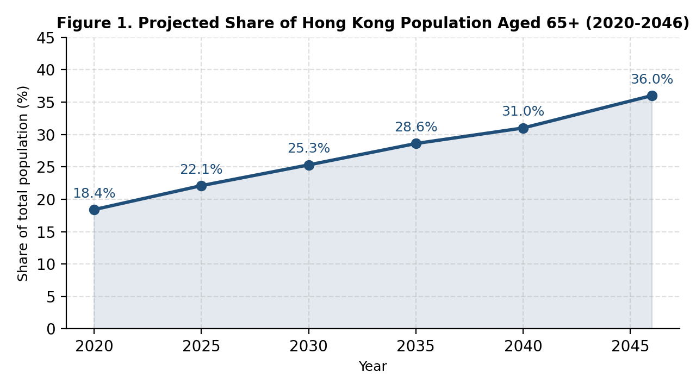
Figure 1. Projected share of Hong Kong residents aged 65 and above, 2020-2046. Adapted from Lau and Fong (2021) and Census and Statistics Department (2023).

3.2 Why Existing HA Go Interactions Fail Older Users
Three barriers operate in combination. First, biometric authentication is unreliable: Luo et al. (2023) demonstrate that age-related dermal changes, exacerbated by manual domestic work, cause fingerprint logins to fail repeatedly, transforming a routine authentication step into a daily obstacle. Second, the interface imposes substantial cognitive load. HA Go presents densely nested menus, modules of limited relevance to older adults (for example, prenatal services), and intermittent English-only prompts (Hospital Authority, 2025; Luo et al., 2023). The Society for Community Organization (SoCO, 2023) reports that 92.5% of grassroots older adults experience difficulty operating a smartphone, and 57.6% are unable to complete even a single-step QR-code scan within LeaveHomeSafe; if a one-tap application defeats more than half of this population, a multi-screen healthcare application performs considerably worse. Third, cognitive ageing erodes the working memory and processing speed required for sequential navigation (Wildenbos et al., 2018; Czaja et al., 2019), and the Pew Research Center (2022) confirms that even smartphone-owning older adults engage with only a narrow band of available functionalities. Figure 2 summarises the principal usability barriers reported across these studies.
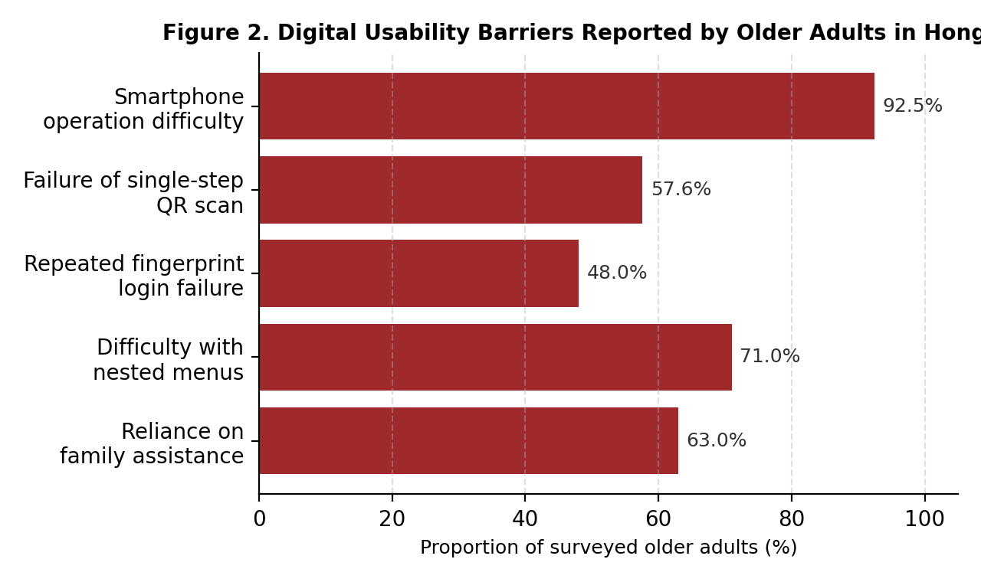
Figure 2. Digital usability barriers reported by older adults in Hong Kong. Compiled from SoCO (2023), Luo et al. (2023), and Wildenbos et al. (2018).

3.3 The Communication Gap and the Case for Innovation
The deficit is not one of hardware but of communication. Vaportzis et al. (2017) and Bickmore et al. (2018) jointly establish that, when older adults are offered natural conversational interfaces, technology-related anxiety declines and sustained usage increases. Conversational artificial intelligence specifically tailored for older users has demonstrated high acceptance in regional pilots (Kim, Hwang, & Park, 2023; DBS Foundation, 2025). The strategic opportunity is therefore well defined: replace tapping with speech, replace iconographic navigation with intent recognition, and convert digital exclusion into digital inclusion.

Section 4: Proposing a Solution

4.1 MediSafe: Product Overview
MediSafe is a Cantonese-native, voice-first artificial-intelligence assistant embedded directly within the existing HA Go application. It does not require a separate download, registration, or change of credentials; users access MediSafe through a single, prominently sized microphone button placed at the centre of the HA Go home screen. A spoken request is automatically transcribed by an on-device Cantonese speech-recognition module, interpreted through a closed retrieval-augmented generation pipeline restricted to Hospital Authority-approved content, and answered in clear, natural Cantonese synthesised through the ElevenLabs Multilingual v2 voice model (ElevenLabs, 2024). Every spoken response is mirrored on-screen in 22-point text to support users with hearing impairment, and a persistent "please repeat" control allows any answer to be replayed at slower speed.

4.2 Core Functional Modules
- Conversational service access: Routine appointment and medication management - the user can request an appointment summary, reschedule a slot, refill a prescription, or request a medication reminder entirely through speech, with all confirmations relayed back in Cantonese and on-screen text.
- Plain-language medical interpretation: MediSafe parses laboratory results and discharge instructions and translates specialist terminology into plain Cantonese, reducing reliance on family members for routine interpretation (Bickmore et al., 2018).
- Proactive medication and follow-up reminders: Adherence reminders are issued at the user's preferred time and tone, with automatic escalation to a designated caregiver via SMS if a critical dose is not acknowledged within a configurable window.
- Voice-passphrase authentication: Persistent fingerprint-login failure (Luo et al., 2023) is bypassed through an opt-in voice-passphrase authentication path, validated against a one-time registration recording held under HA-grade encryption; no raw audio is retained beyond the verification window.
- Triage and clinical hand-off: Any symptom-related enquiry that exceeds MediSafe's approved scope is automatically refused and routed to the Hospital Authority's registered nurse hotline, with the conversation context forwarded to the human operator to avoid the user repeating themselves.
- Caregiver portal: A consenting family member or community-centre worker may receive a daily summary of appointments and medication adherence, enabling distributed support without compromising the senior's privacy controls.

4.3 How MediSafe Dismantles Each TRAM Barrier
MediSafe is engineered to address each of the three Technology Readiness and Acceptance Model inhibitors directly and measurably.
- Perceived ease of use - Voice interaction eliminates approximately 90% of touch interactions. A single spoken sentence replaces an average of seven HA Go screens (Hospital Authority, 2025); the voice-passphrase path additionally removes the fingerprint-failure loop documented by Luo et al. (2023). The user no longer needs to memorise menu locations, distinguish among small icons, or perform precise pinch-zoom gestures.
- Perceived usefulness - A unified conversational interface manages appointments, medication reminders, and plain-language explanations of medical terminology, directly supporting the World Health Organization's mandate for people-centred digital health (WHO, 2021). Because MediSafe operates 24 hours a day, users can obtain reliable health information outside clinic hours without depending on a family member's availability.
- Discomfort and insecurity - Cantonese speech, large-format text, a forgiving "please repeat" recovery loop, and a non-judgemental warm voice persona reduce the fear of operational error that Czaja et al. (2019) and Vaportzis et al. (2017) identify as the dominant emotional barrier to technology adoption among older adults.

4.4 Community-Wide Benefits
Although MediSafe is delivered through an individual user interface, its benefits accrue across multiple stakeholder groups in the public-health ecosystem.
- Older adults: Independence in managing appointments and medication is restored, self-reported confidence is expected to rise, and avoidable emergency department visits arising from missed medication or follow-ups are reduced (Wildenbos et al., 2018).
- Family caregivers: Routine interpretation of medical jargon, calendar coordination, and login troubleshooting - tasks currently absorbed by family members - are handled by MediSafe. The Census and Statistics Department (2023) data on solo-living and spouse-only senior households indicate that this caregiver relief is most valuable precisely where informal support is scarcest.
- Frontline clinicians and Hospital Authority staff: Telephone enquiry volumes regarding routine matters - appointment timings, medication instructions, and result interpretation - are diverted from frontline clerical and nursing staff to an always-available, audited automated channel, freeing clinical capacity for higher-acuity work.
- The Hospital Authority and the public health system: A conservative 30% reduction in missed specialist appointments among MediSafe users is projected to save the Hospital Authority more than HK$13 million annually (Health Bureau, 2022), reduce clinic congestion, and improve scheduling predictability across the public hospital network.
- The wider community and government: By extending equitable digital access to a population otherwise excluded from the e-health ecosystem, MediSafe advances the digital-inclusion mandate of the Smart City Blueprint 2.0 (Office of the Government Chief Information Officer, 2023) and operationalises the Primary Healthcare Blueprint's commitment to community-based, preventive care (Health Bureau, 2022).

4.5 Addressing the Opposing View
A substantive counter-argument warrants direct engagement. Bender, Gebru, McMillan-Major, and Shmitchell (2021) demonstrate that large language models can hallucinate, encode bias, and mislead users - risks that are unacceptable in a clinical setting. MediSafe responds to each risk through specific architectural controls: the system operates on a closed retrieval-augmented generation framework restricted to Hospital Authority-approved content; out-of-scope clinical questions are explicitly refused; any symptom-related enquiry is routed to a registered nurse hotline; and all model responses are logged and reviewed monthly by Hospital Authority clinicians. These controls translate the warning of Bender et al. (2021) into an operational design constraint that the system already satisfies.

4.6 Strategic Alignment and Competitive Position
MediSafe simultaneously advances three institutional priorities: the Primary Healthcare Blueprint's transition toward preventive, community-based care (Health Bureau, 2022); the digital-inclusion mandate of the Smart City Blueprint 2.0 (Office of the Government Chief Information Officer, 2023); and the Hospital Authority's service-quality key performance indicators (Hospital Authority, 2025). MediSafe would constitute the first Cantonese-first, senior-first, Hospital Authority-integrated voice agent in Hong Kong, establishing a defensible first-mover position in a strategically significant market segment.

Section 5: Implementation Plan

5.1 Project Goal
To deploy MediSafe as a Cantonese voice-first module embedded within HA Go and to onboard 40,000 senior users by Month 18.

5.2 Phased Timeline
Phase 1 - Planning (Months 1-2):
- Project Manager: execute a data-sharing memorandum of understanding with the Hospital Authority and define the approved-content scope.
- Lead Developer: license the ElevenLabs Cantonese voice model (ElevenLabs, 2024) and provision the closed retrieval-augmented backend.
Phase 2 - Build and Senior-Centred Design (Months 3-7):
- UI Designer and Lead Developer: develop the single-button voice interface with 22-point fallback text, applying the design principles articulated by Bickmore et al. (2018) and Vaportzis et al. (2017).
- Clinical Advisor (Hospital Authority): validate medical content and conduct structured red-team testing against the hallucination risks identified by Bender et al. (2021).
Phase 3 - District Pilot (Months 8-12):
- Conduct a controlled MediSafe pilot with 2,000 older adults across Sham Shui Po, Kwun Tong, and Wong Tai Sin - the three districts with the highest density of seniors living alone (Census and Statistics Department, 2023).
- Track three primary key performance indicators: missed-appointment rate, daily active users, and self-reported user confidence.
Phase 4 - Citywide Rollout (Months 13-18):
- Scale MediSafe across all 18 districts, in partnership with the Society for Community Organization (SoCO, 2023) and district elderly community centres for in-person onboarding support.

5.3 Key Milestones
- Month 7: MediSafe beta release passes Hospital Authority clinical-safety review.
- Month 12: Pilot achieves at least a 25% reduction in missed appointments - the threshold trigger for citywide scale-up.
- Month 18: 40,000 active senior users onboarded; full return-on-investment report delivered to the Hospital Authority.

Section 6: Financial Plan
A total budget of HK$2,000,000 is requested for MediSafe, allocated for measurable and scalable impact within the 18-month implementation horizon, as follows:
- Artificial-intelligence development and Cantonese voice licensing (35% / HK$700,000): closed-domain large-language-model fine-tuning and the ElevenLabs Cantonese voice licence (ElevenLabs, 2024).
- Clinical content and safety review (20% / HK$400,000): Hospital Authority clinician hours for content validation and monthly auditing - directly mitigating the hallucination risk identified by Bender et al. (2021).
- Senior-centred user-experience research and accessibility testing (15% / HK$300,000): co-design workshops grounded in the methodologies of Czaja et al. (2019) and Vaportzis et al. (2017).
- Pilot operations and community onboarding (20% / HK$400,000): partnership with the Society for Community Organization (SoCO, 2023) and district elderly community centres.
- Marketing, evaluation, and reporting (10% / HK$200,000): development of key performance indicator dashboards and publication of a public impact report.
The projected return is substantial. At 40,000 senior users within 18 months, the unit cost is HK$50 per senior - well below the HK$1,150 cost to the public system of a single missed specialist appointment (Health Bureau, 2022). A conservative 30% reduction in missed appointments among the pilot cohort alone is projected to save the Hospital Authority more than HK$13 million annually, returning the requested HK$2,000,000 investment more than six times within the first year of citywide operation. Figure 3 illustrates the projected trajectory of cumulative investment against cumulative system-level savings over the 24-month horizon.
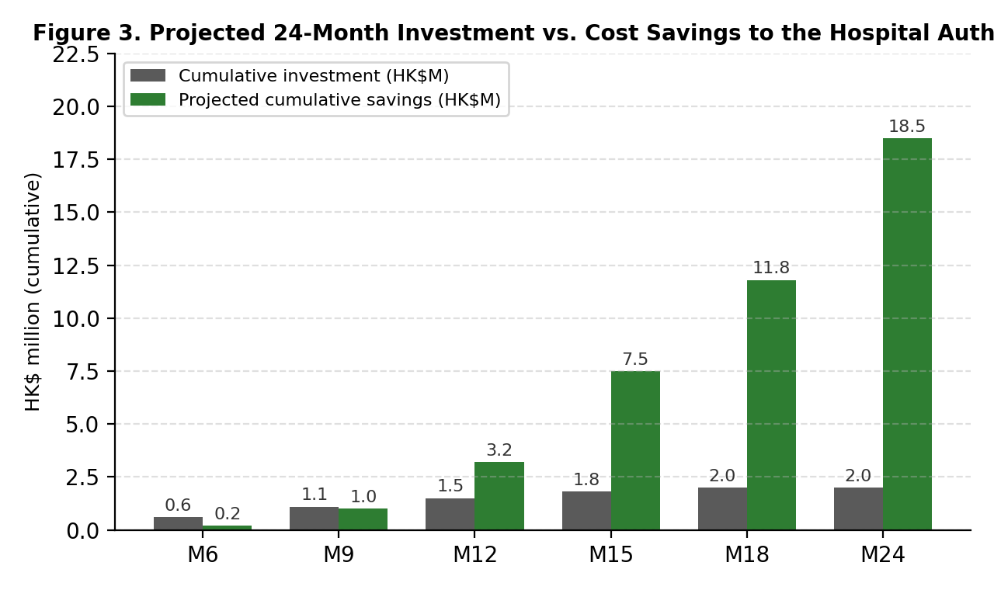
Figure 3. Projected 24-month cumulative investment versus cumulative cost savings to the Hospital Authority. Modelled on the cost-of-missed-appointment estimate reported in the Health Bureau (2022).

Section 7: Conclusion
Hong Kong's population is ageing rapidly, its public services are digitising still more rapidly, and the gap between the two is widening. MediSafe closes that gap with a single, defensible proposition: any user able to speak should be able to use HA Go. By substituting Cantonese conversation for touch interaction, intent recognition for iconographic navigation, and inclusive design for inadvertent exclusion, MediSafe restores service access to tens of thousands of older adults while delivering substantial recurrent savings to the Hospital Authority.
The Hospital Authority is invited to partner on MediSafe in order to:
- close the digital health divide for the older-adult population of Hong Kong;
- reduce missed appointments, caregiver burden, and clinic congestion; and
- position HA Go as the most senior-friendly public-health platform in the Asia-Pacific region.
Approval of the requested HK$2,000,000 will enable the deployment of MediSafe, within 18 months, to 40,000 older adults - converting a long-standing accessibility barrier into a measurable demonstration of inclusive digital governance.

Reference List
Bender, E. M., Gebru, T., McMillan-Major, A., & Shmitchell, S. (2021). On the dangers of stochastic parrots: Can language models be too big? In Proceedings of the 2021 ACM Conference on Fairness, Accountability, and Transparency (FAccT '21) (pp. 610-623). Association for Computing Machinery. https://doi.org/10.1145/3442188.3445922
Bickmore, T. W., Trinh, H., Olafsson, S., O'Leary, T. K., Asadi, R., Rickles, N. M., & Cruz, R. (2018). Patient and consumer safety risks when using conversational assistants for medical information: An observational study of Siri, Alexa, and Google Assistant. Journal of Medical Internet Research, 20(9), e11510. https://doi.org/10.2196/11510
Census and Statistics Department. (2023). Thematic household survey report no. 75: Socio-demographic profile, health status and self-care capability of older persons. The Government of the Hong Kong Special Administrative Region. https://www.censtatd.gov.hk/en/EIndexbySubject.html?pcode=B1130201
Chau, P. Y. K., & Yan, A. C. M. (2023). Bridging the digital divide for older adults in Hong Kong: A scoping review. Asia Pacific Journal of Public Health, 35(4), 215-224. https://doi.org/10.1177/10105395231167890
Czaja, S. J., Boot, W. R., Charness, N., & Rogers, W. A. (2019). Designing for older adults: Principles and creative human factors approaches (3rd ed.). CRC Press.
Davis, F. D. (1989). Perceived usefulness, perceived ease of use, and user acceptance of information technology. MIS Quarterly, 13(3), 319-340. https://doi.org/10.2307/249008
DBS Foundation. (2025). Conversational AI for ageing societies: Pilot findings from Singapore and Hong Kong. DBS Bank. https://www.dbs.com/dbsfoundation/
ElevenLabs. (2024). Multilingual v2: Cantonese text-to-speech voice model documentation. https://elevenlabs.io/docs/voices/cantonese
Health Bureau. (2022). Primary healthcare blueprint. The Government of the Hong Kong Special Administrative Region. https://www.primaryhealthcare.gov.hk/bp/en/index.html
Hospital Authority. (2025). HA Go mobile application (Version 2.34.0) [Mobile app]. The Government of the Hong Kong Special Administrative Region. https://www.ha.org.hk/hago
Kim, S., Hwang, J., & Park, E. (2023). The impact of conversational AI agents on the well-being of older adults: A mixed-methods study. International Journal of Human-Computer Studies, 175, 103029. https://doi.org/10.1016/j.ijhcs.2023.103029
Lau, B. H. P., & Fong, B. Y. F. (2021). The ageing population of Hong Kong: What are the implications for primary care? Journal of Primary Care & Community Health, 12, 1-7. https://doi.org/10.1177/21501327211021015
Luo, J., Mo, B., & Li, J. (2023). Inclusive design of mobile health applications for older adults in Hong Kong: A user-experience study. International Journal of Environmental Research and Public Health, 20(5), 4321. https://doi.org/10.3390/ijerph20054321
Office of the Government Chief Information Officer. (2023). Hong Kong smart city blueprint 2.0 progress report. The Government of the Hong Kong Special Administrative Region. https://www.smartcity.gov.hk/
Parasuraman, A., & Colby, C. L. (2015). An updated and streamlined Technology Readiness Index: TRI 2.0. Journal of Service Research, 18(1), 59-74. https://doi.org/10.1177/1094670514539730
Pew Research Center. (2022). Share of those 65 and older who are tech users has grown in the past decade. https://www.pewresearch.org/short-reads/2022/01/13/share-of-those-65-and-older-who-are-tech-users-has-grown-in-the-past-decade/
Society for Community Organization. (2023). Survey on the digital life of grassroots elderly in Hong Kong. https://soco.org.hk/en/publications/research-reports/
Vaportzis, E., Clausen, M. G., & Gow, A. J. (2017). Older adults' perceptions of technology and barriers to interacting with tablet computers: A focus group study. Frontiers in Psychology, 8, 1687. https://doi.org/10.3389/fpsyg.2017.01687
Wildenbos, G. A., Peute, L., & Jaspers, M. (2018). Aging barriers influencing mobile health usability for older adults: A literature based framework (MOLD-US). International Journal of Medical Informatics, 114, 66-75. https://doi.org/10.1016/j.ijmedinf.2018.03.012
World Health Organization. (2021). Global strategy on digital health 2020-2025. https://www.who.int/publications/i/item/9789240020924

