ANALYSIS DOCUMENT

KYC-API
Automated Biometric Identity Verification Platform for Microfinance Institutions

1. Introduction
This Analysis Document formalizes the behavioral specification of the KYC-API system. It builds directly on the Technical Requirements Document and translates the defined requirements into use cases, actor descriptions, class diagrams, and system sequence diagrams.
The document covers the system's use case model — including all actors and their roles — detailed textual descriptions of the most critical use cases, an analysis class diagram showing the entities and their relationships (including the subscription plan model), and system-level sequence diagrams for the main scenarios.
KYC-API is a subscription-based, automated biometric identity verification platform built for Microfinance Institutions (MFIs) in Cameroon. It processes photos of a client's National Identity Card (NIC) and a live selfie through a multi-stage machine learning pipeline, returning a structured KYC verification result compliant with COBAC regulatory requirements.

2. Project Presentation

2.1 General Project Presentation
KYC-API is a subscription platform that automates the Know Your Customer (KYC) identity verification process for MFIs in Cameroon. The system receives photos of a client's NIC card and a selfie, runs them through a 10-stage processing pipeline, and returns one of three statuses: VERIFIED, PENDING (flagged for human review), or REJECTED.
Every MFI that subscribes to the platform selects a subscription plan that determines its monthly verification quota, the number of branches and agents it can register, and the features available to it. Each subscribing MFI receives a complete dashboard for managing verifications, reviewing flagged cases, viewing statistics, and generating compliance reports — regardless of whether its agents submit verifications directly through the dashboard or whether the MFI's own internal software calls the KYC-API programmatically.

2.2 Project Context
In Cameroon's microfinance sector, client onboarding remains largely manual. COBAC — the Central African Banking Commission — requires every MFI to perform and document KYC verification for each client, but most small MFIs have no digital tool to do so. This creates compliance gaps, enables identity fraud including ghost clients and duplicate registrations, and produces no reusable digital identity record.
KYC-API was conceived as an internship project under Openxtech, a Cameroonian fintech company, to fill this gap with an affordable, subscription-based, COBAC-aligned solution purpose-built for the operating realities of Cameroonian MFIs.

3. System Use Cases

3.1 Requirements

3.1.1 Functional Requirements
ID | Functional Requirement
FR01 | Extract identity fields (name, ID number, DOB, expiry, sex) from Cameroonian NIC images using OCR.
FR02 | Compare client selfie to NIC photo and produce a face match confidence score.
FR03 | Detect whether the submitted selfie is a live face or a printed/screen photo attack.
FR04 | Detect if a person has already been registered under a different identity using face embedding similarity search.
FR05 | Assign a final KYC status (VERIFIED, PENDING, or REJECTED) based on pipeline results.
FR06 | Expose verification functionality as authenticated REST API endpoints for MFIs that wish to integrate KYC-API into their own software.
FR07 | Provide a web dashboard for MFI agents (submission) and MFI managers (review, statistics, reports), included with every subscription regardless of integration mode.
FR08 | Log every verification request and manual decision with timestamp and actor for COBAC compliance.
FR09 | Support multiple MFI accounts with isolated data, separate API keys, and independent dashboard views.
FR10 | Allow MFI managers to generate and download compliance reports for selected date ranges.
FR11 | Assign each MFI account a subscription plan (Starter, Growth, Pro, or Enterprise) that determines its monthly verification quota, branch/agent limits, and available features.
FR12 | Track verification usage against the subscribed plan's monthly quota and notify the MFI Manager when usage approaches or exceeds the limit.
FR13 | Allow the Openxtech Admin to assign, upgrade, downgrade, or suspend an MFI's subscription plan.

3.1.2 Non-Functional Requirements
ID | Non-Functional Requirement
NFR01 | Performance: Full verification pipeline completes in under 10 seconds per request.
NFR02 | Accuracy: FAR below 1%, FRR below 5% for face matching.
NFR03 | Security: HTTPS, hashed API keys, encrypted biometric data at rest.
NFR04 | Data Privacy: Biometric data treated as sensitive personal data with access control and retention policies.
NFR05 | Availability: 99% uptime target during business hours (7am-7pm WAT).
NFR06 | Scalability: Dockerized for horizontal scaling as the subscriber base grows.
NFR07 | Maintainability: PEP 8 code standards, independently testable modules, auto-generated Swagger documentation.
NFR08 | Regulatory Compliance: System satisfies COBAC KYC requirements for MFIs in the CEMAC zone.

3.2 Actors and Their Roles

3.2.1 Internal Actors
Internal actors belong to Openxtech, the organization that owns and operates the KYC-API platform.

Actor | Description and Role
Openxtech Admin | The platform administrator from Openxtech. Manages all MFI accounts subscribed to the platform, assigns and adjusts subscription plans, monitors system health and uptime, tracks revenue and usage per account, and can suspend accounts or revoke compromised API keys. Has access to the full platform view across all subscribed MFIs.

3.2.2 External Actors
External actors are the MFI personnel who interact with the system from outside Openxtech's organization.

Actor | Description and Role
MFI Agent | A field agent employed by a subscribing MFI. Is physically present with the client and submits the verification request — either by capturing the client's NIC photos and selfie directly through the KYC-API dashboard form, or through the MFI's own internal software if the MFI has chosen to integrate the API. Can view the result of verifications they submitted.
MFI Manager | A manager or supervisor at a subscribing MFI. Monitors all verification requests submitted by their MFI regardless of submission channel, reviews cases flagged as PENDING (duplicates or low-confidence matches), approves or rejects flagged cases, views aggregate statistics, downloads compliance reports for COBAC audits, manages their MFI's agent accounts and API keys, and monitors usage against their subscription plan's monthly quota.

Note on integration: an MFI may choose to have its own developers call the KYC-API verification endpoint from the MFI's existing internal software, instead of having agents fill in the dashboard form directly. This is a submission channel, not a separate actor — the same MFI Agent and MFI Manager roles apply, and both continue to use the KYC-API dashboard for review, statistics, and compliance reporting regardless of which channel was used to submit the original request.

3.3 Use Case Diagram
The following PlantUML script generates the system use case diagram. Paste into plantuml.com to render.

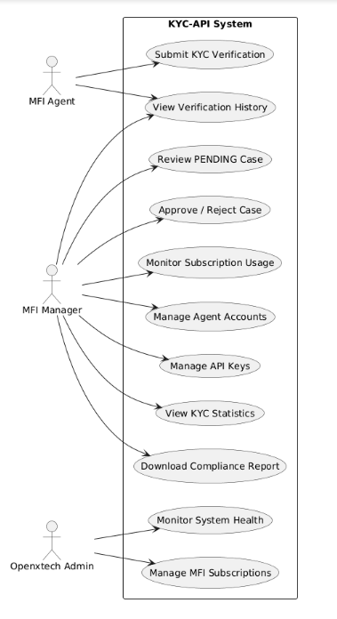

3.4 Textual Description of Use Cases

UC1 — Submit KYC Verification
Title | Submit KYC Verification
Objective | Submit a client's identity documents for automated biometric verification
Actors | MFI Agent
Preconditions | The agent is authenticated on the dashboard (or the MFI's internal software holds a valid API key). The client is physically present with their NIC card. The MFI's monthly quota has not been exceeded.
Postconditions | A verification record is created with status VERIFIED, PENDING, or REJECTED. An audit log entry is recorded. Usage counter for the MFI's subscription plan is incremented.
Main Scenario | 1. Agent opens the verification form on the dashboard (or the MFI's internal software sends the request via API). 2. ID card front, ID card back, and selfie are submitted using live camera capture. 3. System validates the request (fields present, images valid, quota not exceeded). 4. System runs the full processing pipeline: preprocessing, OCR, liveness detection, face matching, duplicate detection. 5. System assigns final KYC status. 6. Result is returned to the agent on the dashboard or to the MFI's software as a JSON response.
Alternative Scenario A | Request validation fails (missing field, invalid image format): system returns error code 400 with descriptive message. No pipeline is run.
Alternative Scenario B | Pipeline detects duplicate: status is set to PENDING, case is added to review queue, MFI Manager is notified.
Alternative Scenario C | ID card is expired: system immediately assigns REJECTED status without running remaining pipeline steps.
Alternative Scenario D | Monthly subscription quota exceeded: system rejects the request with an error indicating the quota has been reached and prompts the MFI to upgrade its plan.

UC2 — Review PENDING Case
Title | Review PENDING Case
Objective | Allow the MFI Manager to examine a verification flagged as PENDING and make a human decision
Actors | MFI Manager
Preconditions | The MFI Manager is authenticated on the dashboard. At least one PENDING case exists in the review queue.
Postconditions | The case status is updated to APPROVED or REJECTED. An audit log entry is created with the manager's identity and timestamp.
Main Scenario | 1. MFI Manager navigates to the review queue in the dashboard. 2. Manager selects a PENDING case. 3. Dashboard displays: selfie vs ID card photo side by side, extracted identity fields, match confidence score, anti-spoof score, and duplicate match details. 4. Manager reviews the information and clicks Approve or Reject. 5. System updates the verification status and logs the decision.
Alternative Scenario | Manager requests additional information before deciding: status remains PENDING, note is added to the case log.

UC3 — Download Compliance Report
Title | Download Compliance Report
Objective | Generate a downloadable compliance report for a selected period for COBAC audit purposes
Actors | MFI Manager
Preconditions | MFI Manager is authenticated. The MFI account has at least one completed verification in the selected period.
Postconditions | A PDF compliance report is generated and downloaded, containing all verification records for the selected period.
Main Scenario | 1. MFI Manager navigates to Reports section in the dashboard. 2. Manager selects date range, branch, and status filters. 3. Manager clicks Generate Report. 4. System queries all verification records for the MFI account within the selected period. 5. System generates a formatted PDF report containing: total verifications, breakdown by status, individual records with timestamp and client ID. 6. Report is made available for download.
Alternative Scenario | No records exist in the selected period: system displays informational message, no report generated.

UC4 — Monitor Subscription Usage
Title | Monitor Subscription Usage
Objective | Allow the MFI Manager to track verification usage against their subscribed plan's monthly quota
Actors | MFI Manager
Preconditions | MFI Manager is authenticated. The MFI account has an active subscription plan.
Postconditions | Manager has visibility into current usage, remaining quota, and renewal date. May trigger a plan upgrade request.
Main Scenario | 1. MFI Manager opens the Subscription section of the dashboard. 2. System displays current plan name, monthly quota, verifications used this cycle, and renewal date. 3. If usage exceeds 80% of quota, system displays a warning banner. 4. Manager may click Upgrade Plan to request a higher tier.
Alternative Scenario | Usage has reached 100% of quota: new verification submissions are blocked until the next billing cycle or until the plan is upgraded by Openxtech Admin.

4. Class Diagrams

4.1 Entity Identification
Entity | Attributes | Role in System
MfiAccount | id, name, email, apiKey, status, createdAt | Represents each MFI subscribed to the platform
SubscriptionPlan | id, name, monthlyPrice, verificationQuota, maxBranches, maxAgents, supportLevel | Defines the tier (Starter, Growth, Pro, Enterprise) an MFI is subscribed to and the limits and features that apply
Agent | id, mfiAccountId, fullName, branch, status, createdAt | Represents an MFI field agent account registered under an MFI
Verification | id, clientId, agentId, mfiAccountId, submissionMethod, status, confidenceScore, createdAt, processedAt | Central record of each KYC verification request and its result
ExtractedData | id, verificationId, fullName, idNumber, dateOfBirth, placeOfBirth, expiryDate, sex, fieldConfidences | Stores OCR output extracted from the NIC card
FaceEmbedding | id, verificationId, clientId, vector, modelUsed, createdAt | Stores the numerical face fingerprint for duplicate detection
LivenessResult | id, verificationId, passed, method, antiSpoofScore, landmarksDetected, createdAt | Records the result of the liveness / anti-spoofing check
FaceMatchResult | id, verificationId, matchScore, verified, threshold, modelUsed | Records the face matching score between selfie and ID card photo
DuplicateFlag | id, verificationId, matchedClientId, similarityScore, reviewedBy, resolution, createdAt | Records duplicate detection results and human review decisions
AuditLog | id, verificationId, mfiAccountId, action, actorType, actorId, timestamp, details | Immutable log of every action for COBAC compliance
ComplianceReport | id, mfiAccountId, generatedAt, periodStart, periodEnd, totalVerifications, format | Represents a generated compliance report for a given MFI and period
ApiKey | id, mfiAccountId, keyValue, isActive, createdAt, lastUsedAt, rateLimit | Manages API key lifecycle for MFIs that integrate KYC-API into their own software

4.2 Analysis Class Diagram
The following PlantUML script generates the analysis class diagram (attributes only, no method signatures, no types, as required for the analysis phase). The SubscriptionPlan entity is central here since it governs each MFI account's quota and feature access.

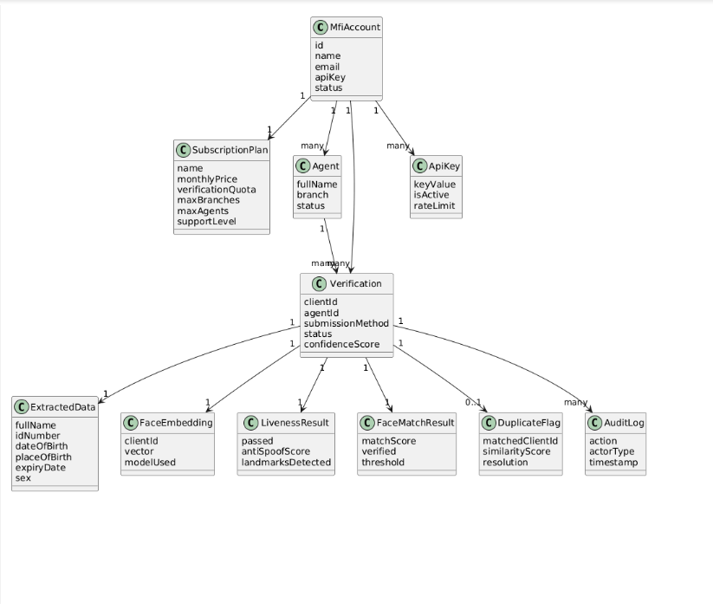

4.3 Object Diagram
The following object diagram captures the system state at the moment a verification is completed and flagged as PENDING due to a duplicate detection, for an MFI subscribed to the Growth plan.

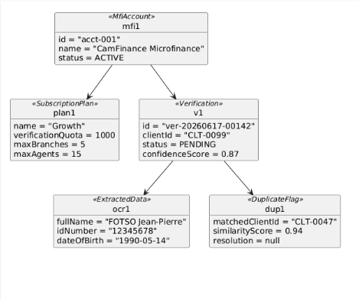

5. System Sequence Diagrams
System sequence diagrams use two lifelines only: the actor and the system, as required at the analysis level.

5.1 Submit KYC Verification
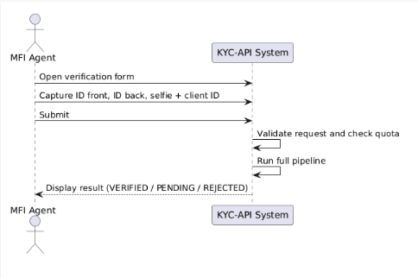

5.2 Review PENDING Case
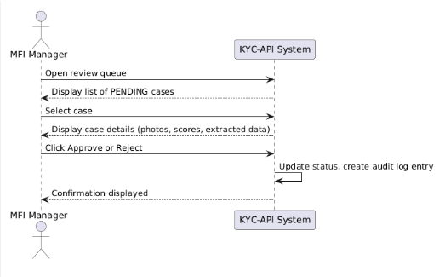

5.3 Download Compliance Report
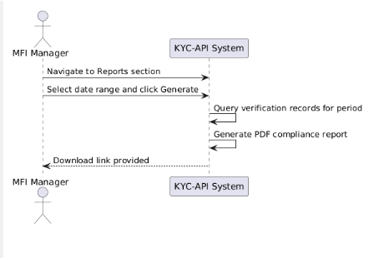

5.4 Monitor Subscription Usage
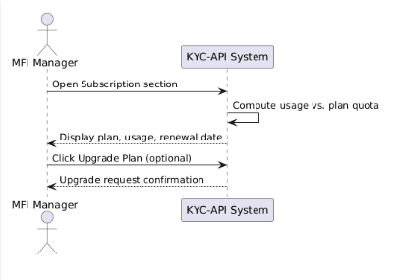

6. Conclusion
This Analysis Document has formalized the behavioral specification of the KYC-API system. It has defined two external actors, MFI Agent and MFI Manager, and one internal actor, Openxtech Admin, along with thirteen functional requirements and eight non-functional requirements that the system must satisfy.
The use case model identifies eleven system use cases and provides detailed textual descriptions for the four most critical scenarios, including the subscription usage monitoring flow introduced to support the platform's subscription-based business model. The analysis class diagram identifies twelve core entities, including the SubscriptionPlan and Agent entities, and their relationships, while the object diagram captures a concrete system state during a PENDING duplicate detection scenario for a Growth-plan subscriber. Four system sequence diagrams formalize the main interaction flows at the system boundary level.
The next deliverable, the Design Document (Cahier de Conception), will build on this analysis to define the detailed software architecture, the complete class diagram with types and method signatures, the data model, the API contract, algorithm descriptions, the subscription plan specifications, and the system mockups.

