OPENXTECH
Yaoundé, Cameroon

DESIGN DOCUMENT

KYC-API
Automated Biometric Identity Verification Platform for Microfinance Institutions

1. Introduction
This Design Document defines the complete technical architecture and implementation design of the KYC-API system. It builds directly on the Technical Requirements Document and the Analysis Document to translate the behavioral specification into a concrete software design ready for implementation.
The document covers the system objectives, external interfaces, design constraints, reference documents, modeling standards and tools, the general architecture with module descriptions and structural diagrams, and the detailed design including the full class diagram, key algorithms, subscription plan specifications, application theme, and interface mockups.

2. Project Presentation

2.1 System Objectives
KYC-API has three primary objectives:
- Automate COBAC-compliant KYC identity verification for Cameroonian MFIs, eliminating manual paper-based processes.
- Deliver KYC-API as a subscription platform with tiered plans that match the size and growth stage of each subscribing MFI, with every plan including a full management dashboard.
- Deliver an original academic contribution in the form of a trained anti-spoofing classifier and a measurable evaluation of the full pipeline on real-world Cameroonian NIC data.

2.2 System Interfaces
KYC-API interacts with the following external interfaces:

Interface | Protocol | Description
MFI Internal Software | HTTPS / REST | POST /kyc/verify and GET endpoints for MFIs that integrate KYC-API into their own systems. JSON body with base64 images. API key authentication.
KYC-API Dashboard | HTTP / REST | Dashboard makes HTTP calls to the FastAPI backend on behalf of agents and managers.
Tesseract OCR Engine | System call / Python binding | pytesseract library calls Tesseract binary installed on server.
DeepFace / ArcFace | Python library | In-process library call. Models downloaded automatically on first run.
FAISS Index | In-process library | In-memory index loaded from disk at startup. Queried via Python API.
PostgreSQL Database | TCP / SQLAlchemy ORM | All persistent data storage, including subscription plan and usage data.
Payment Notification (manual) | Administrative | Subscription billing is managed by Openxtech administratively; the Admin updates plan status in the system upon confirmed payment. No live payment gateway integration in this phase.

2.3 General Design Constraints
- COBAC Regulatory Compliance: The system must maintain an immutable audit trail of every verification, log actor identities and timestamps, and be able to generate compliance reports on demand. This constrains the data model and retention policy.
- Biometric Data Protection: Face images and embeddings are classified as sensitive personal data under Cameroonian law. They must be stored encrypted at rest and access must be role-restricted. This constrains the database configuration and storage architecture.
- Zero-Cost Constraint: The system must be buildable using only free and open-source tools. This constrains the choice of ML models (DeepFace/ArcFace over AWS Rekognition), OCR (Tesseract over Google Vision), and infrastructure (Railway/Render free tier over AWS).
- Field-Condition Robustness: NIC photos will be taken on low-end Android phones in poor lighting. The preprocessing pipeline must handle blur, tilt, shadow, and low resolution. This constrains the image processing design.
- Multi-tenancy: Each MFI must see only its own data. This constrains every database query and dashboard view to be filtered by mfi_account_id.
- Subscription Enforcement: Every verification request must be checked against the subscribing MFI's plan quota before the pipeline runs. This constrains the API gateway to perform a quota check as an early validation step.
- Camera-Only Capture: The dashboard must restrict document and selfie capture to live camera input only, with no file upload option, to reduce the risk of pre-recorded image submission at the interface level.

3. Reference Documents
Document | Version | Status
KYC-API Technical Requirements Document | 1.0 | Approved
KYC-API Analysis Document | 1.0 | Approved
COBAC KYC Regulatory Framework (CEMAC zone) | Current | Reference
ArcFace: Additive Angular Margin Loss for Deep Face Recognition (Deng et al., 2019) | - | Academic Reference
NUAA Photograph Imposter Database (Tan et al., 2010) | - | Dataset Reference
FastAPI Documentation | Latest | Technical Reference

4. Standards, Norms and Tools

4.1 Design Methodology
The project uses a Unified Process (UP) approach with UML as the modeling language.
The UP approach was selected because it is use-case driven (aligned with the API-centric nature of this system), supports iterative delivery (the pipeline is built and tested module by module), and produces the formal deliverables required by the academic institution: requirements, analysis, and design documents.
UML was selected as the modeling language because it is the standard for the ISI program, it covers all required diagram types, and Visual Paradigm — available in the development environment — provides full UML support including Use Case, Class, Component, Deployment, Activity, Sequence, State Machine, ERD, and DFD diagrams.

4.2 Development Environment and Tools

4.2.1 Hardware and Tools
Tool / Technology | Version | Cost | Role
Python | 3.11 | Free | Primary programming language
FastAPI | Latest | Free | REST API framework
DeepFace (ArcFace backend) | Latest | Free | Face matching and embedding generation
Tesseract OCR + pytesseract | 5.x | Free | NIC text extraction
OpenCV | Latest | Free | Image preprocessing pipeline
MediaPipe | Latest | Free | Face landmark detection for liveness
FAISS | Latest | Free | Face embedding similarity search
scikit-learn | Latest | Free | SVM anti-spoofing classifier training
PostgreSQL + pgvector | 16+ | Free | Database and vector storage
SQLAlchemy | Latest | Free | ORM for database interactions
Streamlit | Latest | Free | Admin dashboard
Docker + Docker Compose | Latest | Free | Containerization and deployment
MLflow | Latest | Free | ML experiment tracking
Evidently AI | Latest | Free | Model drift detection
pytest + Locust | Latest | Free | Unit testing and load testing
Visual Paradigm | Latest | Free (Community) | UML diagrams
GitHub | - | Free | Version control

4.2.2 Programming Standards
- Python code follows PEP 8 style guide: 4-space indentation, snake_case for variables and functions, PascalCase for classes, maximum 79 characters per line.
- All functions must have docstrings following the Google docstring format.
- Type hints are mandatory on all function signatures.
- Each module must have a corresponding unit test file under tests/.
- Git commit messages follow the Conventional Commits format: feat:, fix:, docs:, test:, refactor:.
- All sensitive configuration (API keys, database credentials) must use environment variables, never hardcoded.

4.3 Quality Plan
Quality assurance in this project is structured around the following standards and practices:
- Software Quality Assurance (SQA) based on IEEE 730: A test plan is defined before implementation of each module. All public functions have unit tests before being integrated into the pipeline.
- Verification and Validation (V&V) based on IEEE 1059: Face matching accuracy is measured on a test set of real photo pairs. OCR accuracy is measured field by field on annotated NIC images. API performance is measured under load using Locust.
- Configuration Management: All source code is versioned on GitHub. Model files (.pkl) are versioned using MLflow. Database schema changes are managed with Alembic migrations.
- Risk Management based on ISO 27005: Key risks identified include poor image quality from field conditions (mitigated by robust preprocessing), dataset bias in anti-spoofing classifier (mitigated by demographic diversity audit), and biometric data breach (mitigated by encryption at rest and access controls).

5. General Design

5.1 Module Identification and Description
Module | Description | Key Technologies
API Gateway Module | Handles all incoming HTTP requests. Performs API key authentication, subscription quota validation, request validation, rate limiting, and response formatting. Routes requests to the pipeline. | FastAPI, Pydantic, JWT
Image Preprocessor | Decodes base64 images, resizes, normalizes lighting, deskews, and crops the NIC into photo zone and text zone. Prepares clean images for downstream modules. | OpenCV, Pillow
OCR Engine | Extracts identity fields from the NIC text zone. Applies regex-based field parsing and format validation specific to Cameroonian NIC structure. Produces structured JSON with field confidence scores. | Tesseract, pytesseract, regex
Liveness Detector | Two-layer liveness check: MediaPipe detects 3D face landmarks to verify a real face geometry is present, then the trained LBP-SVM anti-spoofing classifier scores the selfie texture. | MediaPipe, scikit-learn, OpenCV
Face Matcher | Extracts face regions using MediaPipe, then calls DeepFace with the ArcFace backend to compare the selfie face to the NIC card face. Returns a distance score and a boolean verified result based on a tunable threshold. | DeepFace, ArcFace, MediaPipe
Duplicate Detector | Generates a 512-dimension face embedding from the selfie using ArcFace. Queries the FAISS index for the nearest stored embedding. If cosine similarity exceeds the threshold, flags as potential duplicate. | FAISS, DeepFace, NumPy
Decision Engine | Aggregates results from all pipeline modules and applies decision logic to assign final KYC status: VERIFIED, PENDING, or REJECTED. | Python (pure logic)
Subscription Manager | Tracks each MFI account's subscription plan, current usage against the monthly quota, and enforces blocking or warning behavior as thresholds are reached. Handles plan upgrades and downgrades initiated by Openxtech Admin. | Python, SQLAlchemy
Data Layer | PostgreSQL database accessed via SQLAlchemy ORM. Stores all verification records, extracted data, embeddings, audit logs, MFI accounts, subscription plans, and API keys. pgvector extension stores face embeddings as vector columns. | PostgreSQL, pgvector, SQLAlchemy, Alembic
Admin Dashboard | Streamlit web application providing a verification submission form for MFI agents, a PENDING case review queue for MFI managers, statistics views, subscription usage view, and compliance report generation. | Streamlit, Plotly, ReportLab
Monitoring Module | Tracks model performance over time using Evidently AI. Detects face matching accuracy drift as the client population changes. Alerts when drift threshold is exceeded. | Evidently AI, MLflow

5.2 Component Diagram
Paste the following PlantUML script into plantuml.com to render the component diagram:

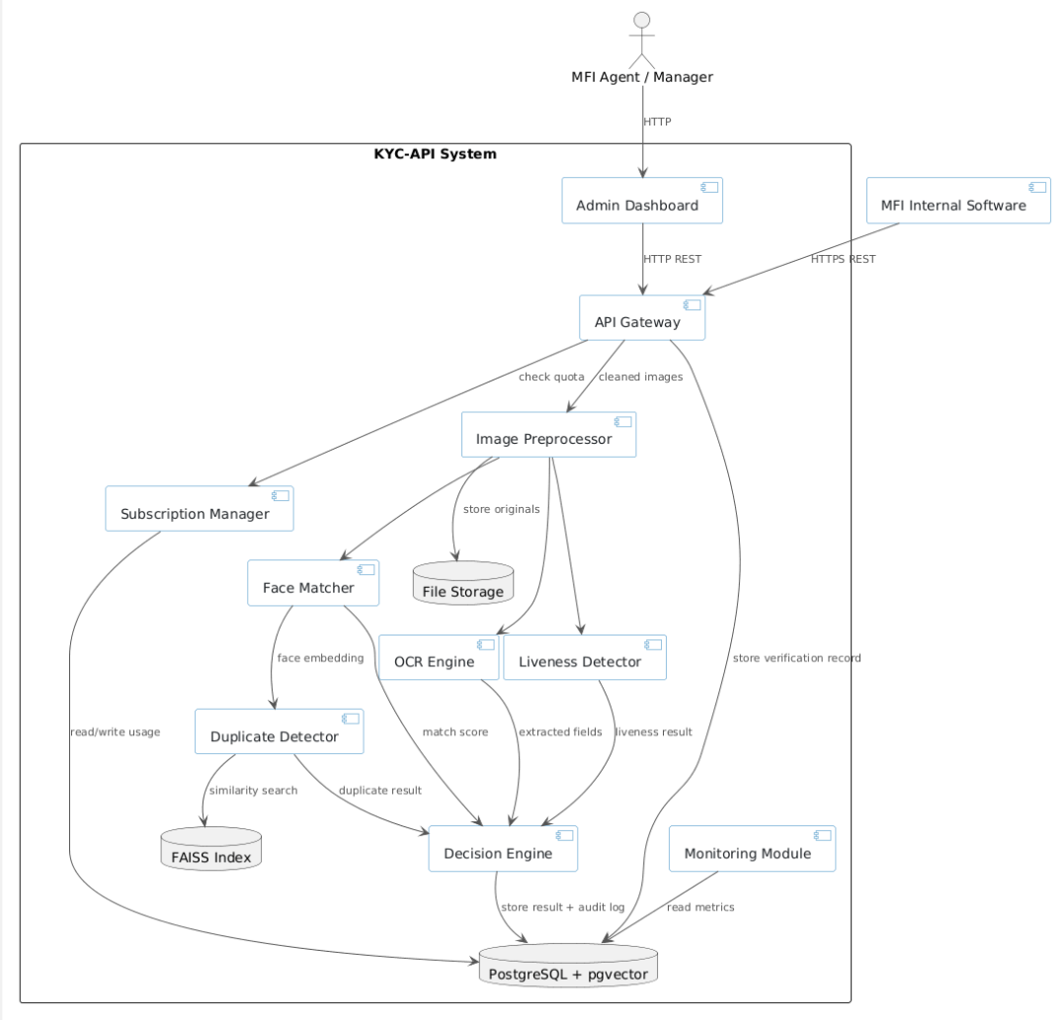

5.3 Deployment Diagram
Paste the following PlantUML script to render the deployment diagram:

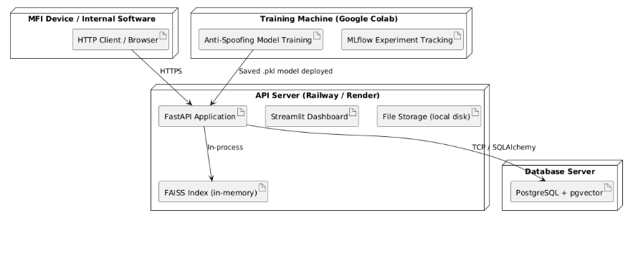

6. Detailed Design

6.1 Design Class Diagram
The full design class diagram with types, method signatures, and all relationships is provided as PlantUML code below. Paste into plantuml.com to render. The SubscriptionPlan class is now a first-class entity governing each MfiAccount.

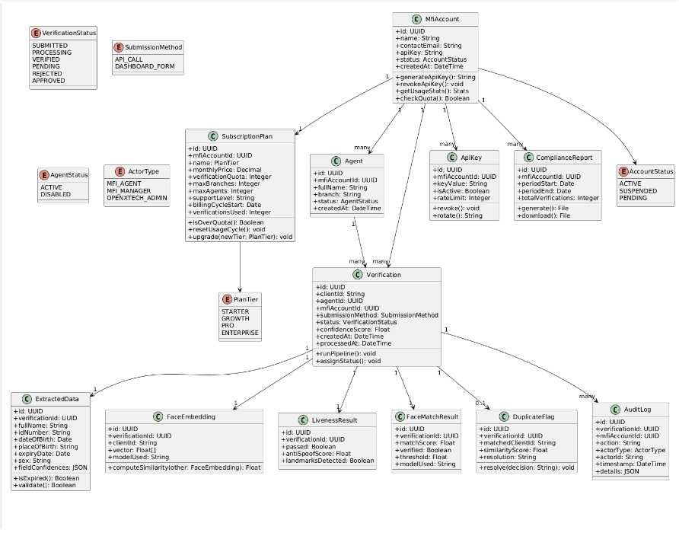

6.2 Subscription Plans
KYC-API is offered to MFIs under four subscription tiers, differentiated primarily by monthly verification volume, with proportionally expanded operational limits and support levels at higher tiers.

Feature | Starter | Growth | Pro | Enterprise
Monthly price | 25,000 FCFA | 65,000 FCFA | 150,000 FCFA | Custom
Verification quota / month | 200 | 1,000 | 5,000 | 10,000+
Branches | 1 | Up to 5 | Unlimited | Unlimited
Agent accounts | Up to 3 | Up to 15 | Unlimited | Unlimited
API integration access | No | Yes | Yes, higher throughput | Yes, dedicated infra option
Compliance reports | Monthly only | On-demand | On-demand | On-demand
Support level | Email | Priority email | Phone + email, 24h | Dedicated account manager
Other | &mdash; | &mdash; | Custom rate limits, quarterly model review | SLA uptime guarantee, custom OCR tuning

Quota enforcement logic: each verification request decrements the MFI account's remaining monthly quota. When usage reaches 80% of the quota, the dashboard displays a warning banner to the MFI Manager. When usage reaches 100%, new verification submissions are blocked until either the next billing cycle begins or the Openxtech Admin approves a plan upgrade. The quota resets automatically at the start of each billing cycle.

6.3 Key Algorithms

6.3.1 Full Verification Pipeline Algorithm
The pipeline begins with a quota check, then executes sequentially. Any REJECTED condition causes immediate exit without running subsequent steps.

FUNCTION run_pipeline(mfi_account_id, client_id, id_front_b64, id_back_b64, selfie_b64):
// Step 0 — Quota check
IF subscription_manager.is_over_quota(mfi_account_id):
RETURN ERROR("QUOTA_EXCEEDED")

// Step 1 — Preprocess
id_front = decode_and_preprocess(id_front_b64)
id_back = decode_and_preprocess(id_back_b64)
selfie = decode_and_preprocess(selfie_b64)
text_zone, photo_zone = crop_nic_zones(id_front)

// Step 2 — OCR
extracted = ocr_extract(text_zone)
IF extracted.expiry_date < TODAY: RETURN REJECTED

// Step 3 — Liveness
landmarks_ok = mediapipe_check(selfie)
spoof_score = antispoof_classifier.predict(selfie)
IF NOT landmarks_ok OR spoof_score < LIVENESS_THRESHOLD: RETURN REJECTED

// Step 4 — Face Matching
match = deepface_verify(selfie, photo_zone, model='ArcFace')
IF match.distance > FACE_MATCH_THRESHOLD: RETURN REJECTED

// Step 5 — Duplicate Detection
embedding = deepface_represent(selfie, model='ArcFace')
nearest, score = faiss_index.search(embedding, k=1)
IF score > DUPLICATE_THRESHOLD: RETURN PENDING (flag duplicate)

// Step 6 — Store, increment usage, and return
store_embedding(client_id, embedding)
store_verification_record(client_id, extracted, match, liveness)
subscription_manager.increment_usage(mfi_account_id)
RETURN VERIFIED

6.3.2 LBP Anti-Spoofing Feature Extraction Algorithm
FUNCTION extract_lbp_features(face_image):
gray = convert_to_grayscale(face_image)
cells = divide_into_cells(gray, cell_size=16)
histogram = []
FOR each cell IN cells:
FOR each pixel IN cell:
center = pixel.value
neighbors = get_8_neighbors(pixel)
binary_code = ''
FOR each n IN neighbors:
binary_code += '1' IF n >= center ELSE '0'
lbp_value = binary_to_decimal(binary_code)
cell_histogram = compute_histogram(cell_lbp_values, bins=256)
histogram.append(cell_histogram)
feature_vector = normalize(concatenate(histogram))
RETURN feature_vector

6.3.3 Decision Engine Logic
FUNCTION assign_kyc_status(ocr_result, liveness_result, face_match, duplicate):
IF ocr_result.expired: RETURN REJECTED, reason='ID_EXPIRED'
IF NOT liveness_result.passed: RETURN REJECTED, reason='LIVENESS_FAILED'
IF NOT face_match.verified: RETURN REJECTED, reason='FACE_MISMATCH'
IF duplicate.found: RETURN PENDING, reason='DUPLICATE_DETECTED'
RETURN VERIFIED

6.4 Application Theme
The dashboard follows the Openxtech brand identity.

Element | Value | Usage
Primary Color | #CE2835 | Primary buttons, active states, REJECTED status badges
Dark Accent | #412A6C | Featured plan accents, highlighted sections
Dark Navy | #212529 | Sidebar background, primary text
Light Background | #F3F5F8 | Page background
White surfaces | #FFFFFF / #FAFBFC | Cards, tables, form panels — multiple shades of white used to create depth without color
Success Green | #1D9E75 | VERIFIED status badges, approval buttons
Warning Orange | #E67E22 | PENDING status badges
Primary Font | Inter / Arial | All body text and labels
Buttons | 8px border radius, filled primary or outline style | All interactive actions
Cards | White background, 1px light-gray border, 12-14px border radius | All dashboard panels and content blocks

6.5 Interface Mockups
The following mockups present the main screens of the KYC-API dashboard, designed in the Openxtech brand palette with a predominantly white, layered surface aesthetic.

Screen 1 — MFI Agent: Verification Submission Form
The agent submission screen restricts document capture to live camera input only, with no upload option, reinforcing the platform's interface-level liveness safeguard. The result panel appears immediately after pipeline processing.
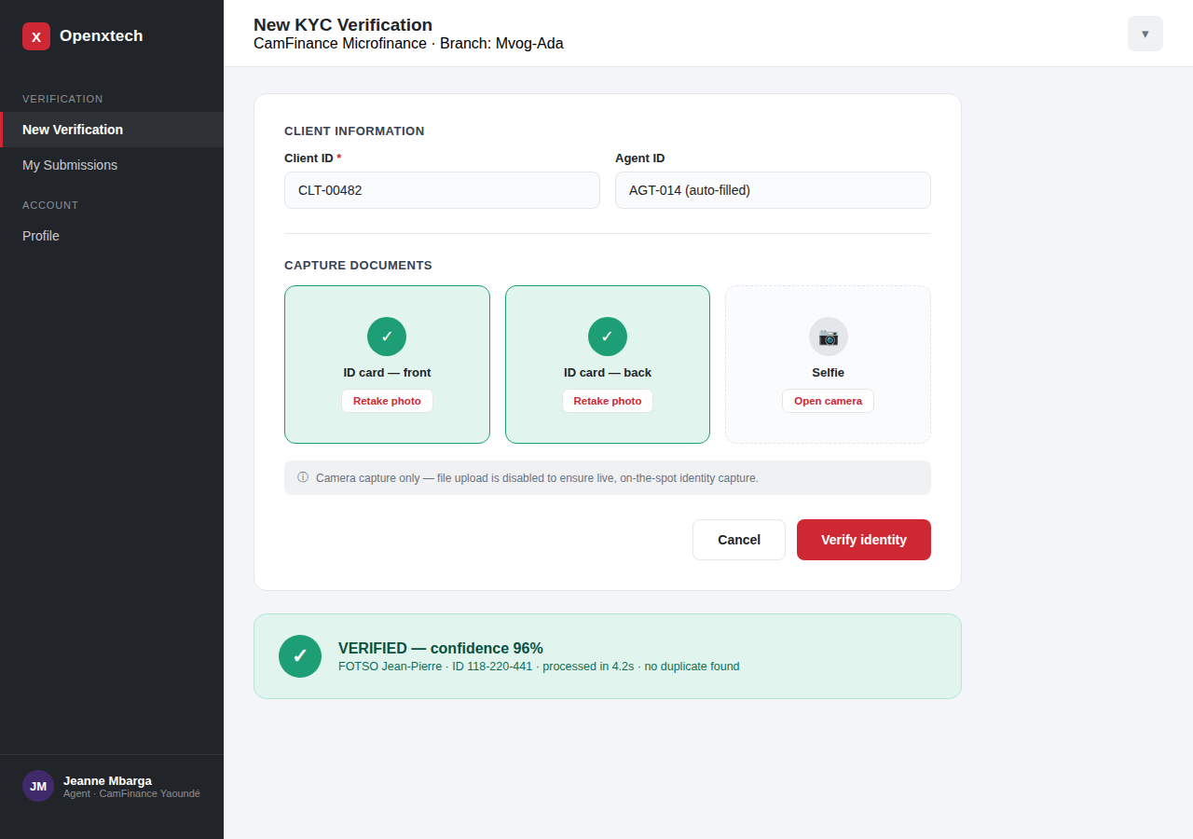
Figure 1 — Agent verification submission form

Screen 2 — MFI Manager: Review Queue
Managers see a filterable queue of PENDING cases on the left and a full case detail panel on the right, including side-by-side identity evidence, confidence scores, and the approve/reject decision.
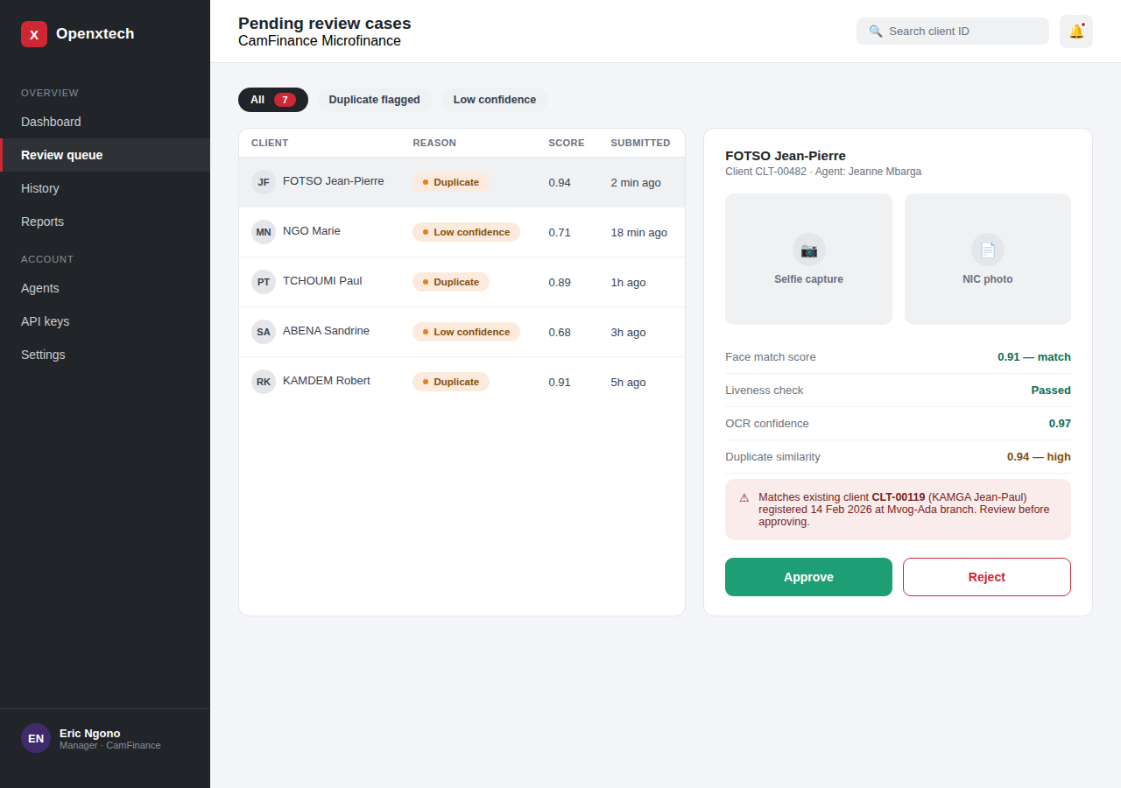
Figure 2 — Manager review queue and case detail

Screen 3 — MFI Manager: Statistics Dashboard
The statistics view gives MFI managers visibility into verification volume trends, status breakdown, and branch-level performance, supporting both operational oversight and subscription usage planning.
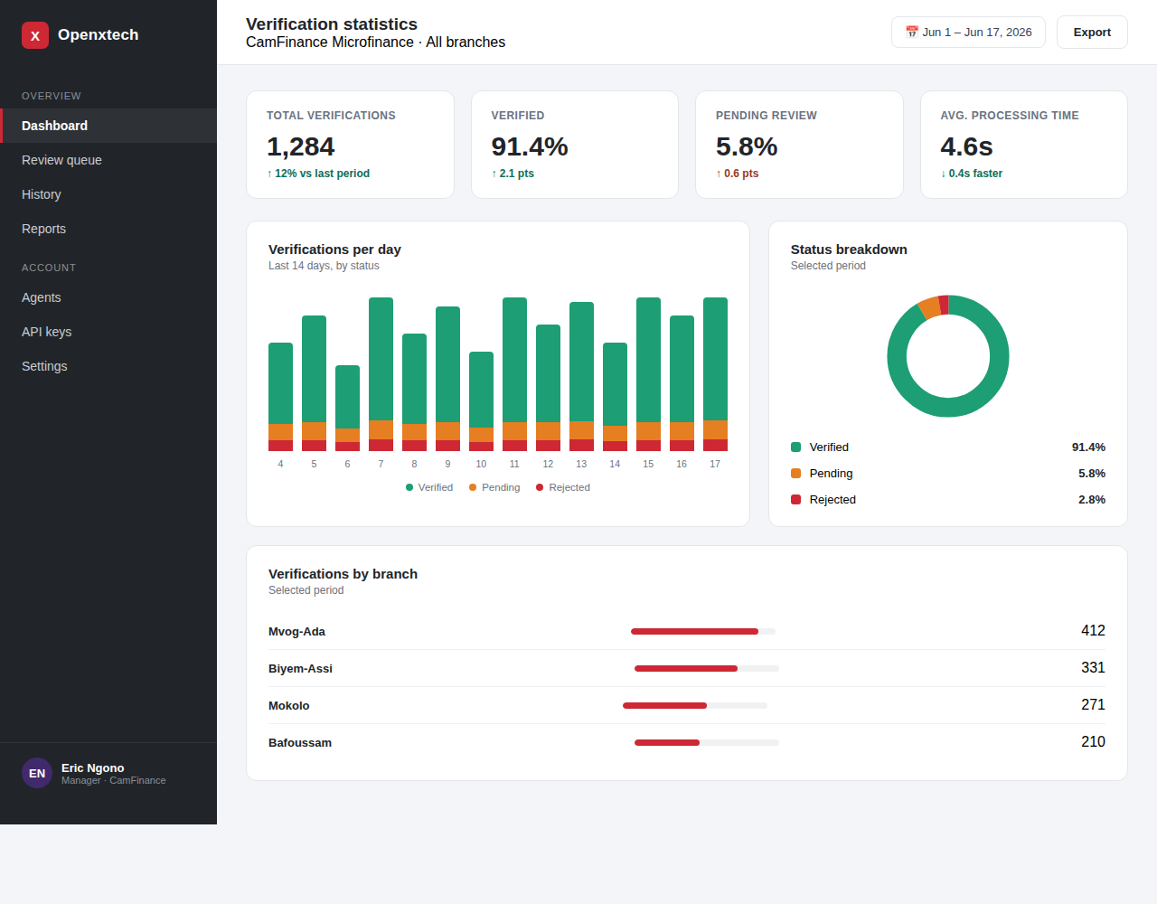
Figure 3 — Verification statistics dashboard

Screen 4 — Compliance Report Generation
Managers select a date range and filters, generate a COBAC-ready compliance report, and preview it before download, satisfying the audit trail requirement defined in the Technical Requirements Document.
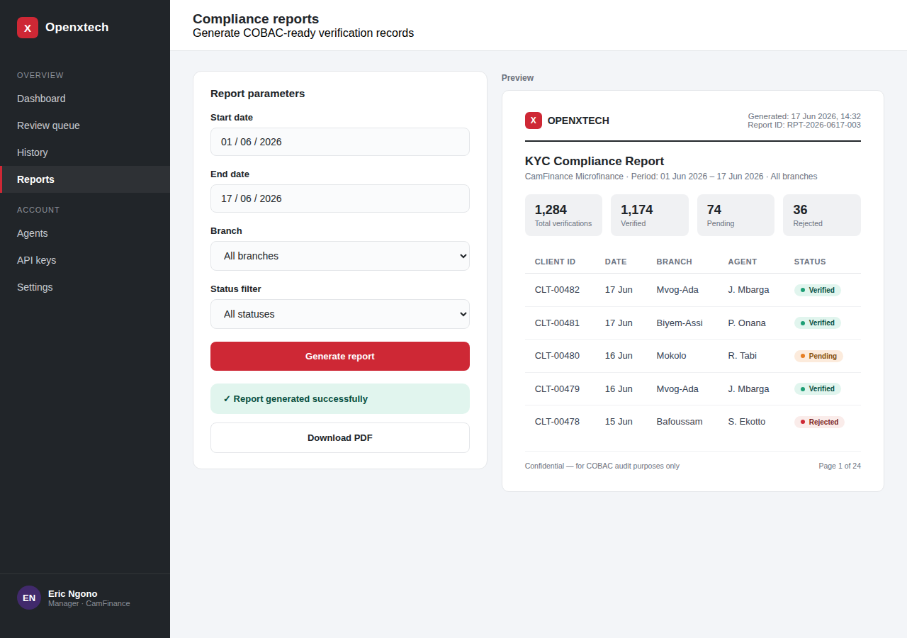
Figure 4 — Compliance report generation and preview

Screen 5 — Subscription Plans (Marketing / Sign-up Page)
The subscription plans page is presented to prospective MFIs during account registration, with the Pro plan highlighted as the recommended tier for established MFI networks.
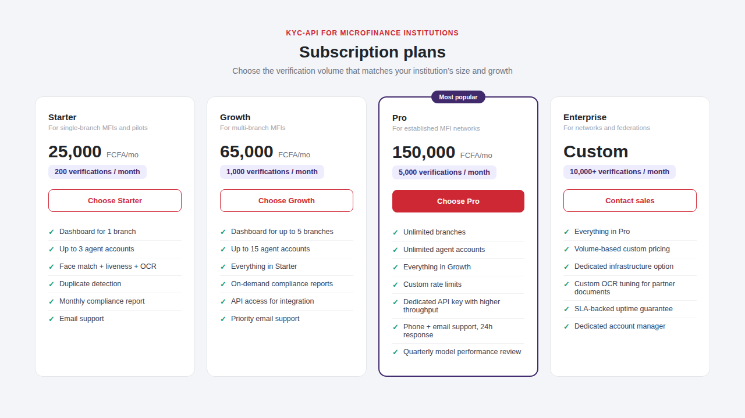
Figure 5 — Subscription plans page

7. Conclusion
This Design Document has defined the complete technical architecture of the KYC-API system as a subscription-based platform for Cameroonian MFIs. It has specified the ten software modules and their responsibilities including the new Subscription Manager module, provided the component and deployment diagrams, detailed the full design class diagram with the SubscriptionPlan entity and all method signatures, described the three core algorithms with quota enforcement built into the pipeline entry point, defined the four-tier subscription plan structure with associated feature limits, presented the Openxtech brand-aligned application theme, and showcased five rendered interface mockups covering the agent submission flow, manager review queue, statistics dashboard, compliance reporting, and the subscription plans page.
The design confirms that the full system is buildable using exclusively free and open-source tools at zero licensing cost, while meeting all functional requirements, COBAC compliance constraints, and the subscription business model identified in the previous documents.
The next phase is implementation, beginning with Phase 1 (Research and Setup) as defined in the Technical Requirements Document: COBAC requirements study, NIC card layout analysis, sample data collection, repository initialization, and API contract finalization.

