Structural Vision AR: Intelligent Structural Health
Assessment and Virtual Building Preview Platform
Prof. Deepika G  Assistant Professor  Department of Computer Science and Engineering  Sai Vidya Institute of  Technology  Bengaluru, India  deepika.g@saividya.ac.in | Dr. Manjunath T N  Principal  Sai Vidya Institute of  Technology  Bengaluru, India  principal@saividya.ac.in | Kishore P  1VA23CS082  Department of Computer Science and Engineering  Sai Vidya Institute of  Technology  Bengaluru, India  kishorep.23cs@saividya.ac.in
Sanjana Aithal  1VA23CS143  Department of Computer Science and Engineering  Sai Vidya Institute of  Technology  Bengaluru, India  sanjanaaithal.23cs@saividya.ac.in | Kiran R  1VA23CS081  Department of Computer Science and Engineering  Sai Vidya Institute of  Technology  Bengaluru, India  kiranr.23cs@saividya.ac.in | Sujan B R  1VA23CS161  Department of Computer Science and Engineering  Sai Vidya Institute of  Technology  Bengaluru, India  sujanbr.23cs@saividya.ac.in

Abstract: In today’s time the building’s inspection is still done Manually and that is a Tedious thing do to and it also varies from each expert person’s judgment .This paper presents Structural Vision AR, a mobile platform that combines a two-stage deep learning pipeline with marker-less augmented reality to deliver on site structural assessment from a single photograph. A YOLOv8 based instance segmentation model detects and delineates surface cracks at pixel level, while a MobileNetV3-Small classifier fine-tuned by transfer learning identifies the affected structural component (beam, ceiling, column, slab, or wall). A rule-based risk engine fuses crack area ratio with detection confidence to grade severity as Low, Medium, or High and to map each grade to a recommended maintenance window. The results are anchored back onto the physical structure through an ARCore-based viewer that projects the segmented crack pattern and risk colored markers onto detected surfaces. The complete system is served by a FastAPI backend with Supabase managed authentication, storage, and per-building scan history. Experimental evaluation shows a mask mAP@50 of 0.741 with precision of 0.851 for crack segmentation and 97% validation accuracy for component classification, with end-to-end scan latency under 3 seconds on CPU-only hardware. This platform performs a very practical and low cost way for digitalizing initial Structural inspections.
Keywords: Structural health monitoring, crack detection, instance segmentation, YOLOv8, MobileNetV3, transfer learning, augmented reality, ARCore, FastAPI, ONNX.
I. INTRODUCTION
Civil infrastructure’s such as residential building, bridges, industrial facilities, over a certain period of time the also start to deteriorates because of many reasons such as structural loads, weather conditions and material aging. The surface cracks often appear early on the building, this can be detected early on so that the maintenance can be reduced as the crack is resolved early. Yet the engineers still use the periodic manual inspection in this they visually examine the structures, estimate the crack severity based on their experience and record the results manually. This takes longer time and costs more money especially when inspectors must asses large numbers of civil structures. It is subjective as different inspectors have different reports on the same structure.
Deep Learning has made automated crack detection more practical. Convolutional neural networks (CNNs) perform better than traditional image processing methods when identifying cracks in concrete while modern single stage detectors can analyse crack geometry in near real time. At the same time AR(Augmented Reality) frameworks on the standard smartphones now support easier plane detection and world anchored rendering of the images in the AR. This allows the engineers to view detected results directly on the physical structure instead of relying on the inspection reports.
Most existing solutions/systems address only one part of this opportunity. Some focus on the crack detections side, while others use AR mainly for design visualization. Few have integrated pixel level crack segmentation, structural component recognition, severity assessment, maintenance forecasting and AR visualization into a single mobile application.
This paper presents Structural Vision AR, an end-to-end platform designed to address this gap. The main contributions are as follows:
- A Two-staged inference pipeline that combines a YOLOv8 instance segmentation model for crack detection which is paired with MobileNetV3 using Transfer-learning classifier for structural component’s identification. Both models can run on CPU based hardware
- Using a Rule-based risk engine that converts segmentation results into low, medium, high severity levels and predicts an actionable maintenance window.
- With the help of ARCore a visualisation module that projects the detected crack pattern onto a real surface using a transparent texture overlay rendered on the sever side, together with risk coloured 3D markers.
- The complete system architecture consists of a Flutter mobile client, FastAPI inference backend, Supabase persistence layer. We evaluate the system on real devices and report is accuracy, latency and key failure modes.
The rest of the paper is organised as follows. Section II reviews the related work. Section III describes the system architecture and methodology. Section IV presents the experimental results and Section V concludes with directions of future research.
II. RELATED WORK
Researchers have extensively studied about automated visual inspections of civil structures across computer vision, structural engineering and more recently mobile computing. Early methods relied on handcrafted image processing techniques such as edge detection, thresholding and morphological operations. These methods usually perform poorly when lighting conditions are not met. Deep Learning has emerged as the dominant approach for automated crack detections [1,2].
A. Deep Learning for Crack Detection
Cha et al. [1] showed that a CNN based sliding window classifier can detect concrete cracks with over 97% accuracy, even when lighting and shadows change. They later expanded this work using faster R-CNN to detect multiple types of damage[2]. Zhang et al. [5] developed early deep-learning model for detecting road cracks using smartphone images and found that learned features performed better than handcrafted features. Public datasets have helped researchers push the field forward. SDNET2018 [3] contains more than 56,000 annotated concrete images, while Yang et al.’s CRACK500 [4] provides pixel level crack masks and support’s feature pyramid methods for segmenting thin cracks. Mask R-CNN [8] made accurate pixel level damage detection practical. The recent YOLO models [6] achieves similar mask quality with much lower inference costs, making them a star option to build CPU based systems like ours.
B. Component Recognition and Transfer Learning
Assessing severity means more than detecting cracks. The cracks location also matters : a crack in a load-bearing column can pose greater risk than a crack in a partition wall. Lightweight CNNs, such as MobileNet family [7], provide strong classification performance while using only a few million parameters, making them a good fit for mbile and edge devices. Transfer learning from large scale pretrained models [10] also helps adapt these networks to specialized tasks. In out case, we have tuned the model to classify the five structural component types using a relatively small labelled dataset. However, deployed classifiers can become overly confident w3hen they encounter inputs outside their training distribution [9]. We address this limitation directly in Section IV.
C. Augmented Reality in Construction and Inspection
AR adoption in the construction sector has grown around design overlay and progress monitoring, with industrial systems pairing BIM models with head mounted displays, and a research agenda for AR/VR in architecture, engineering, and construction has been articulated by Davila Delgado et al. [11]. Smartphone AR frameworks such as ARCore provide marker-less plane detection, hit-testing, and world anchoring without dedicated hardware. However, published systems rarely feed machine-learning inspection output into the AR view. Structural Vision AR differs by rendering the segmentation result itself the detected crack polygons as a world anchored overlay, closing the loop between automated analysis and on site visualization.
III. METHODOLOGY
The proposed system follows a client server architecture in which a Flutter mobile application captures imagery, a FastAPI backend performs all machine-learning inference, and Supabase provides authentication, relational storage, and image hosting. Figure 1 shows the system architecture and Figure 2 the end-to-end processing workflow.
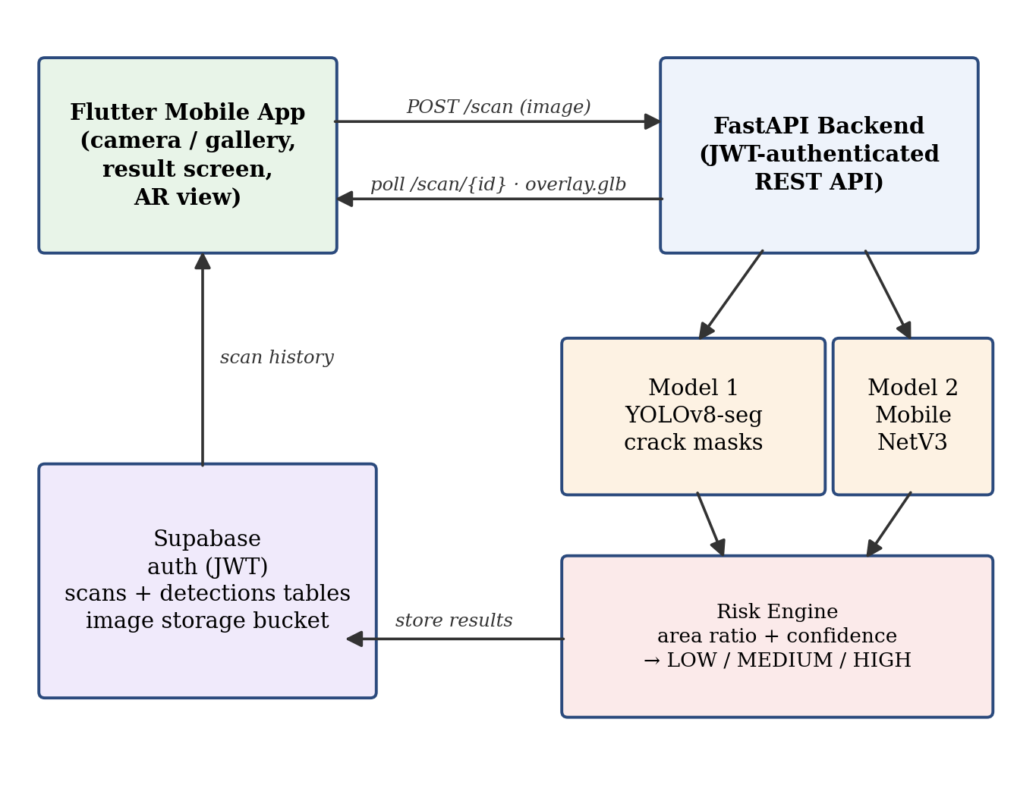
Figure 1: System Architecture of Proposed Model
3.1 System Architecture and Scan Lifecycle
A scan begins when the user captures or uploads a photograph of a structural element. The image is transmitted as a JWT authenticated multipart request to the backend, which processes the scan asynchronously: the client polls the scan endpoint every two seconds until inference completes. Both models are loaded by file path at startup, so a retrained model can be swapped in by overwriting a single file with no code change an operationally important property during iterative retraining. Results, including crack polygons, component label, confidence scores, and the computed risk grade, are persisted to Supabase per user and per building, enabling longitudinal tracking of crack progression across repeated scans.
3.2 Dataset Preparation and Pre-processing
The crack segmentation model is trained on a merged corpus built from the CRACK500 pavement crack dataset [4] and a public Roboflow concrete crack segmentation dataset, unified into YOLO polygon-annotation format. Merging heterogeneous sources broadens the distribution of surfaces, lighting conditions, and crack widths seen in training. Images are letterboxed to the training resolution, and standard augmentations (scale jitter, horizontal flip, HSV perturbation, mosaic) are applied by the training framework. For the component classifier, a five-class image dataset (beam, ceiling, column, slab, wall) was assembled and split into training and validation sets; classifier inputs are resized to 256 pixels, centre cropped to 224×224, and normalized with ImageNet statistics to match the pretraining domain [10].
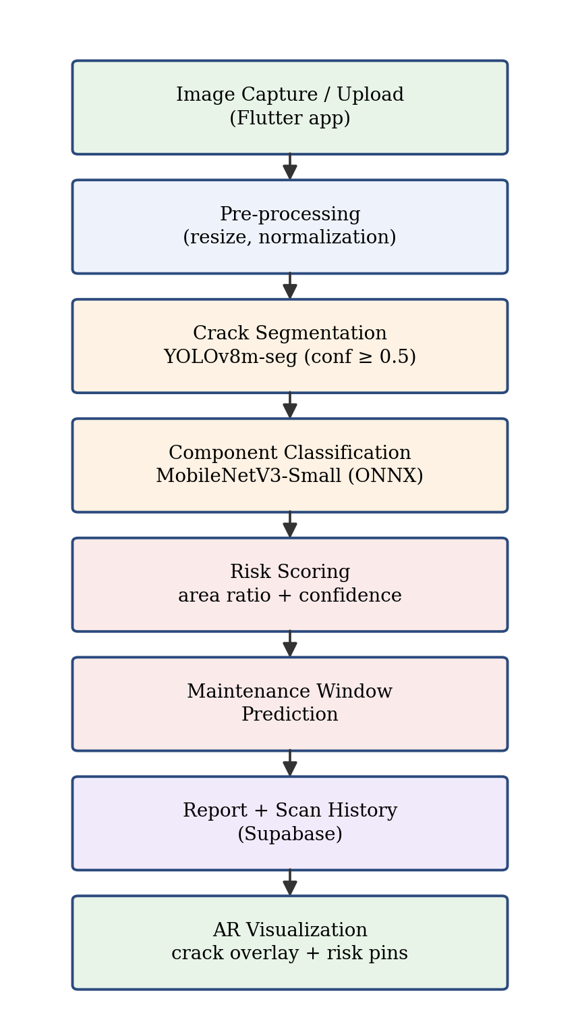
Figure 2: Workflow of Proposed Methodology
3.3 Model 1 : Crack Instance Segmentation
Crack detection is performed by a YOLOv8 segmentation network [6], which predicts bounding boxes, per-instance polygon masks, and confidence scores in a single forward pass. Two versions were developed iteratively. Version 1 used the small YOLOv8s-seg variant trained at 640 px on a single public dataset and reached a mask mAP@50 of 0.691. Error analysis showed the model was data-bound rather than architecture-bound, with failures concentrated on thin hairline and low contrast cracks under-represented in training data. Version 2 therefore attacked the data axis first and capacity second: the merged dataset of Section 3.2, a higher 1024 px training resolution so hairline cracks survive downscaling, and a one-step capacity increase to YOLOv8m-seg large enough to absorb the additional data, yet small enough to preserve the sub-3-second CPU response budget. At inference the confidence threshold is set to 0.5, as the default 0.25 produced false positives on crack-like textures such as seams and shadow edges.
3.4 Model 2 — Structural Component Classification
The component classifier is a MobileNetV3-Small network [7] initialized with ImageNet weights and fine-tuned on the five class component dataset, then exported to ONNX for fast CPU inference through ONNX Runtime. The network learns a feature hierarchy in which early layers respond to material textures, intermediate layers to shape and orientation cues that separate the classes a column as a vertical elongated region against background, a beam as its horizontal counterpart, a ceiling by upward perspective and a final softmax produces the class distribution. The maximum class probability is surfaced in the application as an interpretable confidence value.
3.5 Risk Scoring and Maintenance Window Prediction
Severity grading fuses two signals from the segmentation output: the crack area ratio (total detected crack polygon area divided by image area), which drives severity, and detection confidence, which escalates the grade only when the affected area is already substantial high confidence on a tiny crack means “definitely a crack,” not “dangerous.” Table 2 lists the decision rules, tuned by validating the resulting grade distribution over a held-out set of crack images. Each grade maps to a maintenance window prediction Immediate (0–6 months), Short term (6–24 months), or Long-term (2–5 years) translating raw detection output into an actionable inspection recommendation.
Risk Level | Condition and Maintenance Window
HIGH | Area ratio > 0.05, or > 0.03 with confidence > 0.85 = Immediate (0–6 months)
MEDIUM | Area ratio > 0.01, or > 0.005 with confidence > 0.80 = Short-term (6–24 months)
LOW | Otherwise = Long-term (2–5 years)
Table 2: Risk grading rules and maintenance windows
3.6 AR Visualization Module
The AR viewer is built on ARCore through a Flutter AR plugin. On entering AR mode the application performs marker-less plane detection, displaying tracked feature points immediately with guidance prompts to improve first-use success. Two visualization elements are anchored to detected surfaces. First, risk-colored 3D pin markers, generated server-side as GLB assets so marker styling can change without an application update, are placed by tap on any tracked plane. Second and the module's distinguishing feature the backend renders each scan's detected crack polygons onto a transparent texture, constructs a flat quad mesh on demand, and serves it as a GLB; the client projects this overlay onto the tapped surface so the user sees the actual segmented crack pattern registered on the physical wall, rather than a generic annotation. The platform additionally supports placement of a preset building model on an empty site for virtual building preview.
IV. RESULTS
The system was evaluated at deployment settings (640 px inference) on a fixed 200 image validation set for segmentation, on the held-out classification split for the component model, and end-to-end on a physical Android device (Vivo Y200) with the backend running on CPU-only hardware (Intel 13th-gen i7, no discrete GPU).
4.1 Crack Segmentation Performance
Table 1 compares the two model versions on the common validation set. The retrained YOLOv8m-seg model improves mask mAP@50 from 0.691 to 0.741, driven almost entirely by an 11 point precision gain to 0.851 the deployed model now rarely hallucinates cracks. Recall held at 0.700, indicating that residual errors are false negatives concentrated in hairline and low-contrast cracks still under-represented in training data; this diagnosis directs the improvement roadmap discussed in Section V. Inference cost roughly doubled to ~390 ms per image on CPU, comfortably within the < 3 s end-to-end scan budget, and the previous model is retained as an instant rollback.
Metric | v1 (YOLOv8s-seg) | v2 (YOLOv8m-seg) | Change
Mask mAP@50 | 0.691 | 0.741 | +0.050
Mask precision | 0.741 | 0.851 | +0.110
Mask recall | 0.700 | 0.700 | ±0.000
CPU inference (ms) | ~190 | ~390 | +200
Table 1: Crack segmentation results across model versions
4.2 Component Classification and Failure Analysis
The MobileNetV3-Small classifier achieved 97% validation accuracy across the five component classes. Occlusion-based attention analysis confirms the model attends to semantically meaningful regions: for a correctly classified column (confidence 0.97), the attention mass falls on the vertical member itself, as shown in Figure 3.
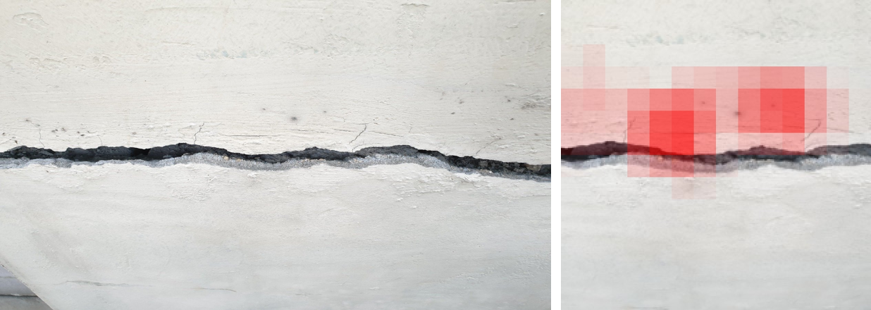
Figure 3: Correct column classification (left) and occlusion attention map (right)
A documented failure case illustrates the classifier's principal limitation. A cluttered bedroom wall photographed with furniture and partial occlusion was classified as ceiling with 0.98 confidence (Figure 4): the occlusion heatmap shows the model relied on a plain, uniformly lit upper surface region resembling a ceiling, while contextual objects contributed nothing toward the correct class. Such overconfidence on out-of-distribution input is a well-documented property of deep classifiers [9] rather than a defect specific to this model. Mitigations adopted are in-app framing guidance — photograph the element so it fills the frame, as an inspector naturally would — and, longer term, augmenting training data with cluttered real-world scenes.
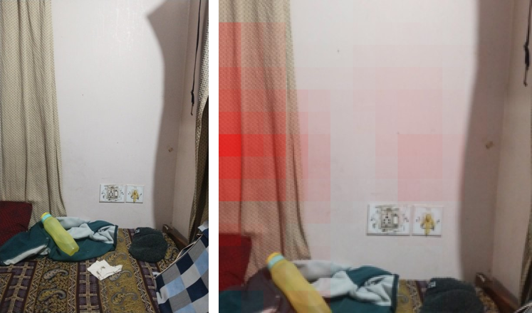
Figure 4: Out-of-distribution failure cluttered wall classified as ceiling (0.98), with attention concentrated on the ceiling-like plain region
4.3 Risk Grading Output
Figure 5 shows representative pipeline outputs across the three risk levels drawn from the curated evaluation set: a heavily cracked surface with area ratio 0.112 graded HIGH, a single moderate crack at 0.025 graded MEDIUM, and a hairline crack at 0.008 graded LOW. Verified against the live pipeline, the grades matched the expected label for all six curated images (two per level). The higher small-crack sensitivity of the v2 model shifts area ratios upward, skewing the wider validation distribution toward MEDIUM an interaction between detector recall and fixed thresholds that motivates threshold re-tuning after each retrain.
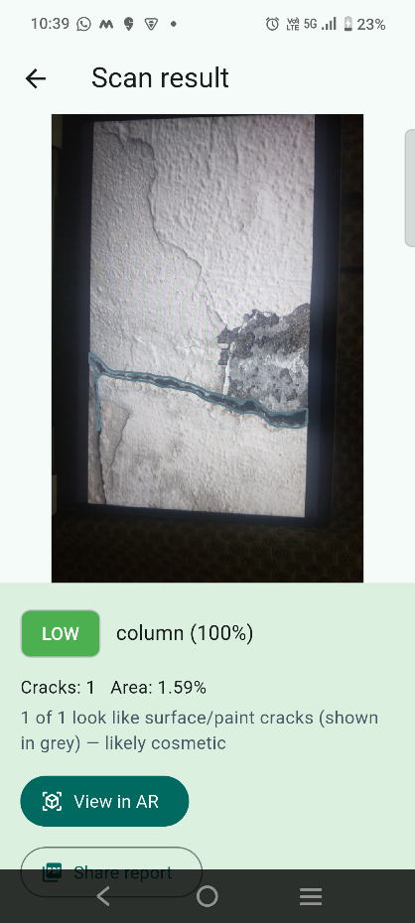
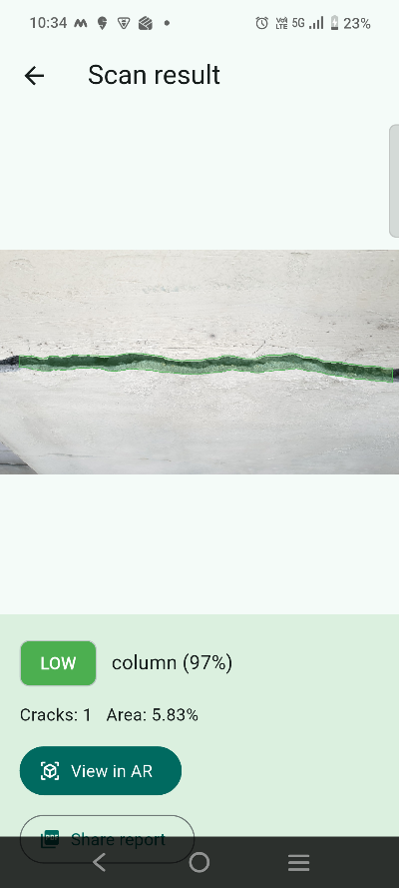
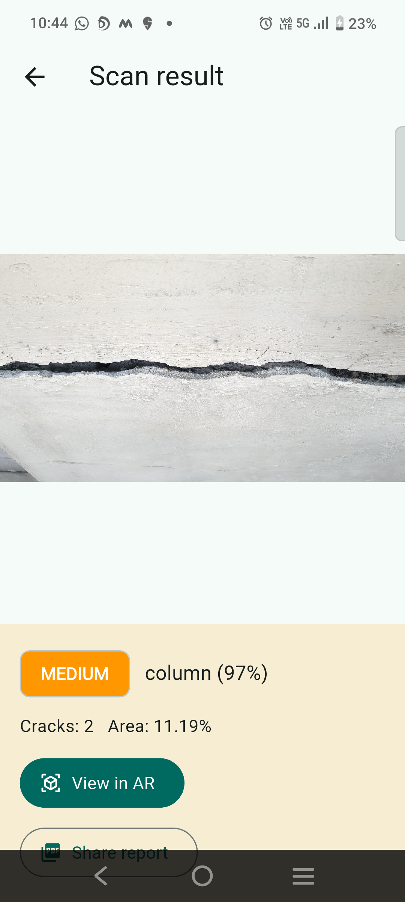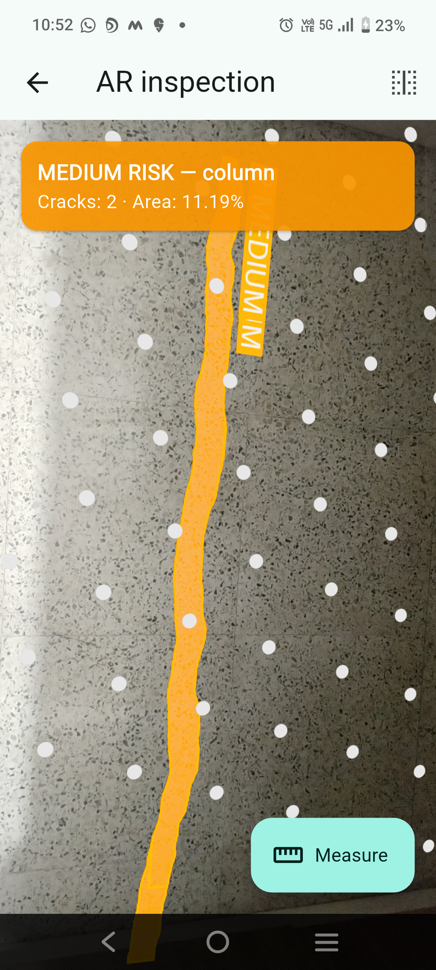
Figure 6: Application screenshots — (a) High severity detection result, (b) crack detection overlay, (c) Medium severity scan result, (d) AR view with crack projection anchored to physical surface
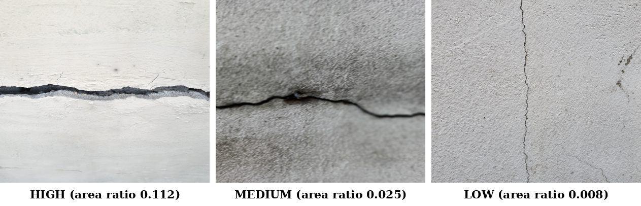
Figure 5: Representative scans across the three risk levels
4.4 On-Device AR and System Performance
On the test device, the release build detects the first plane in approximately one minute of scanning under normal indoor lighting (an order of magnitude faster than debug builds), after which pin placement and crack-overlay projection are interactive. The complete scan round-trip upload, dual-model inference, risk grading, and result retrieval completes in under 3 seconds. Device testing also drove robustness fixes, including camera handover between the scanning and AR subsystems and a point-hit fallback when a tap misses tracked plane geometry. Current limitations are that plane detection is restricted to horizontal surfaces on the test device pending an ARCore update, and the crack overlay is placed at the user's tap point at a fixed physical size rather than being automatically registered to the true crack position.
V. CONCLUSION AND FUTURE WORK
This paper presented Structural Vision AR, a mobile platform that unifies pixel-level crack segmentation, structural component classification, rule-based risk grading, maintenance window prediction, and in-situ augmented reality visualization in a single deployable system. The two-stage pipeline achieves a mask mAP@50 of 0.741 with 0.851 precision for crack segmentation and 97% accuracy for component classification, with end-to-end latency under 3 seconds on CPU-only hardware demonstrating that meaningful structural inspection support does not require specialized equipment. The documented model evolution shows that the current accuracy ceiling is set by training data rather than architecture, and the transparent failure-mode analysis of out-of-distribution inputs reflects a deliberately honest deployment posture.
Future work proceeds along four axes. First, closing the recall gap toward a 90% mAP target through targeted data collection on observed failure patterns, auditing noisy public-dataset labels, deploying at the native 1024 px training resolution, and tuning the detection operating point. Second, enriching the AR module with per-crack markers and severity labels, vertical plane support, true spatial registration of overlays to physical cracks, and physical crack-width measurement from AR plane geometry. Third, distinguishing cosmetic surface crazing from structurally significant cracking using geometric features of the segmented masks width, straightness, and branching augmented by AR-measured physical width. Fourth, a video scan mode that samples frames from a short sweep and merges detections, extending single-image assessment to whole-room coverage. Together these directions advance the platform from a per-photograph assessment tool toward a comprehensive digital inspection assistant.
REFERENCES
[1]. Y.-J. Cha, W. Choi, and O. Büyüköztürk, "Deep Learning-Based Crack Damage Detection Using Convolutional Neural Networks," Computer-Aided Civil and Infrastructure Engineering, vol. 32, no. 5, pp. 361–378, 2017, doi: 10.1111/mice.12263.
[2]. Y.-J. Cha, W. Choi, G. Suh, S. Mahmoudkhani, and O. Büyüköztürk, "Autonomous Structural Visual Inspection Using Region-Based Deep Learning for Detecting Multiple Damage Types," Computer-Aided Civil and Infrastructure Engineering, vol. 33, no. 9, pp. 731–747, 2018, doi: 10.1111/mice.12334.
[3]. S. Dorafshan, R. J. Thomas, and M. Maguire, "SDNET2018: An annotated image dataset for non-contact concrete crack detection using deep convolutional neural networks," Data in Brief, vol. 21, pp. 1664–1668, 2018, doi: 10.1016/j.dib.2018.06.015.
[4]. F. Yang, L. Zhang, S. Yu, D. Prokhorov, X. Mei, and H. Ling, "Feature Pyramid and Hierarchical Boosting Network for Pavement Crack Detection," IEEE Transactions on Intelligent Transportation Systems, vol. 21, no. 4, pp. 1525–1535, 2020, doi: 10.1109/TITS.2019.2910595.
[5]. L. Zhang, F. Yang, Y. D. Zhang, and Y. J. Zhu, "Road crack detection using deep convolutional neural network," 2016 IEEE International Conference on Image Processing (ICIP), Phoenix, AZ, USA, 2016, pp. 3708–3712, doi: 10.1109/ICIP.2016.7533052.
[6]. G. Jocher, A. Chaurasia, and J. Qiu, "Ultralytics YOLOv8," Ultralytics, 2023. [Online]. Available: https://github.com/ultralytics/ultralytics.
[7]. A. Howard et al., "Searching for MobileNetV3," 2019 IEEE/CVF International Conference on Computer Vision (ICCV), Seoul, Korea, 2019, pp. 1314–1324, doi: 10.1109/ICCV.2019.00140.
[8]. K. He, G. Gkioxari, P. Dollár, and R. Girshick, "Mask R-CNN," 2017 IEEE International Conference on Computer Vision (ICCV), Venice, Italy, 2017, pp. 2980–2988, doi: 10.1109/ICCV.2017.322.
[9]. A. Nguyen, J. Yosinski, and J. Clune, "Deep neural networks are easily fooled: High confidence predictions for unrecognizable images," 2015 IEEE Conference on Computer Vision and Pattern Recognition (CVPR), Boston, MA, USA, 2015, pp. 427–436, doi: 10.1109/CVPR.2015.7298640.
[10]. J. Deng, W. Dong, R. Socher, L.-J. Li, K. Li, and L. Fei-Fei, "ImageNet: A large-scale hierarchical image database," 2009 IEEE Conference on Computer Vision and Pattern Recognition (CVPR), Miami, FL, USA, 2009, pp. 248–255, doi: 10.1109/CVPR.2009.5206848.
[11]. J. M. Davila Delgado, L. Oyedele, P. Demian, and T. Beach, "A research agenda for augmented and virtual reality in architecture, engineering and construction," Advanced Engineering Informatics, vol. 45, 2020, 101122, doi: 10.1016/j.aei.2020.101122.

