Title of the Study
Extended Abstract
Closely follow the four main sections of the template for extended abstracts: Context, Gap, Proposed Study, Method, and References. Only make changes to these section titles if your paper does not conform to traditional empirical or methodological papers. We will give extra scrutiny during screening if your extended abstract has a different arrangement. Please see the Submission Details section at the end of this template for information about formatting, page lengths, and more. Do not include any introduction or author names. Start with the Context section.

Context
The Context section describes the domain of the problem that practitioners would recognize. Examples of empirical domains include: social media, platform commerce, healthcare, future of work, etc. Examples of methodological domains include: recommendation systems, structural equation modeling, time-series forecasting, etc. Your goal is to convince the reader of the phenomenon’s importance: Why should we care about this right now? After establishing the domain, describe the current State-of-the-Art: How are academics or industry practitioners currently trying to solve this problem? This sets the baseline for your study.

Gap
The Gap section describes the limitations of current literature or practice that you seek to address. Use this section to setup a tension in your research that readers can palpably relate to and are eager to see resolved. Briefly describe key papers that are foundational to your study, without requiring readers to have extensive knowledge of the literature. Help readers understand why the state-of-the-art solutions are unable to resolve the problem.

Proposed [Study | Model | Framework | Approach] (select one)
The Proposed Study section describes how your study (proposed or ongoing) will resolve the gaps you highlighted earlier. You may describe a proposed study, model, framework, or approach (whichever word is most appropriate) that you will construct in response to the gaps identified earlier. Emphasize the novelty of your study and how it deviates from traditional theory or methods. And tell us how your study, if successful, will contribute to the literature.

Method
The method section outlines the methodological study you will undertake. This could entail an empirical study (data collection and analysis), a methodological design (algorithm and assessment), or conceptual approach. Inform readers why your proposed methods are appropriate and effective to conduct the proposed study described earlier.

References [1 page max.]
The Reference section should comprise only published materials accessible to the public. Proprietary information may not be cited. References should be ordered in alphabetic order. The reference section should be one page at maximum.
References should be listed alphabetically by author name at the end of the extended abstract in conformance with APA 7th edition (minus DOI URLs). In-text citations should be indicated by the author’s last name and year of publication, e.g., (DeGross, 1977) or DeGross (1977). References must be complete, i.e., include, as appropriate, volume, number, month, publisher, city and state, editors, last name & initials of all authors, page numbers, etc. If you use EndNote, be aware that different versions of the software change the styles, creating some inconsistencies.
<<<Please ensure that all references are present, complete, and accurate as per the examples below.>>>
Ackoff, R. L. (1967). Management misinformation systems. Management Science, 14(4), 147-156.
Benbasat, I., & Zmud, R. W. (2003). The identity crisis within the IS discipline: Defining and communicating the discipline's core properties. MIS Quarterly, 27(2), 183-194.
Bonini, C. P. (1963). Simulation of information and decision systems in the firm. Prentice-Hall.
Broadbent, M., Weill, P., O’Brien, T., & Neo, B. S. (1996). Firm context and patterns of IT infrastructure capability. Proceedings of the 14th International Conference on Information Systems, 13, 174-194. https://aisel.aisnet.org/icis1996/13
Carroll, J. (2005). The Blacksburgh Electronic Village: A study in community computing. In P. van den Besselaar & S. Kiozumi (Eds.), Digital Cities III: Information Technologies for Social Capital (pp. 43-65). Springer-Verlag.

_____________All sections below are for reference — remove from submission______________

Submission Details

Page Length
Extended Abstracts are limited to two pages for the main content (Context, Gap, Proposed Study, Method), including all figures and tables. You may use at most one page for References. Submissions that do not conform to these limits will be screened out without review.

Formatting and Style
Format your extended abstract exactly like this document. The easiest way to use this template is to replace the placeholder content with your own material. The template file contains specially formatted styles (e.g., Normal, Heading, Bullet, References, Title, Author, Affiliation) that are designed to reduce the work in formatting your final submission.
Please adhere to the A4 page size only (in MS Word, you can check the page format in the menu: File --> Page Setup). Maintain the margins found on this template: 1” (2.5 cm) around. If you have any difficulties with the template, please contact the organizers for assistance.
Please ensure your manuscript complies with the following instructions:
- Line spacing should be single (exactly 1.0);
- Margins should be 1 inch (2.54 cm);
- Do not change character or word spacing;
- Please do not use double spaces between sentences – this is a tradition no longer necessary on modern word processors;
- Please do not edit the styles in this template;
- Please ensure all text is justified, not “ragged” ( = left-aligned).
Non-compliance of these instructions may lead to screening out of your submission without review.

Title
Your paper’s title should be using the “Title” style in this template (which is configured as Georgia 20-point bold). Ensure proper capitalization within your title (i.e. “The Next Frontier of Information Systems” versus “the next frontier of Information systems.”
All proper nouns should be capitalized. Articles (the, a), coordinating conjunctions (and, but, or, for, nor, etc.) should not be capitalized, unless, of course, they are used as the first word in the title. Likewise for prepositions (on, at, to, from, by, etc.).

Normal or Body Text
Please use the “Normal” style for normal text – this style is configured as a 10-point Georgia font (similar to Times New Roman, but more easily read online) or, if it is unavailable, another proportional font with serifs, as close as possible in appearance to Times New Roman 10-point. Please use sans-serif or non-proportional fonts (such as Arial or Courier) only for special purposes, such as source code text (SpecialStyle). [References to Georgia font from this point forward should be interpreted as “Georgia or equivalent.”]

Sections
The heading of a section should be using the “Heading 1” style, each word should be capitalized – configured as Georgia 13-point bold, left justified. Sections should not be numbered.

Subsections
Headings of subsections should be using the style “Heading 2” – configured as Georgia 11-point bold italics with initial letters capitalized. (Note: for sub-sections and sub-subsections, words like ‘the’, ‘of’, ‘a’, ‘an’ are not capitalized unless it is the first word of the heading.)

Sub-subsections
Headings for sub-subsections should be using “Heading 3” – configured as Georgia 10-point bold with initial letters capitalized. Please do not go any further into another layer/level.

Figures, Tables & Captions
Place figures and tables close to the relevant text (or where they are referenced in the text).
Captions should be using the “Caption” style – configured as Georgia 10-point bold. They should be numbered (e.g., “Table 1” or “Figure 2”), centered and placed beneath the figure or table. Please note that the words “Figure” and “Table” should be spelled out (e.g., “Figure” rather than “Fig.”) wherever they occur. The proceedings will be made available online, thus color figures are possible.

Inserting Images
Occasionally MS Word generates larger-than-necessary PDF files when images inserted into the document are manipulated in MS Word. To minimize this problem, use an image editing tool to resize the image at the appropriate printing resolution (usually 300 dpi), and then insert the image into Word using Insert | Picture | From File...
As indicated in Figure 1, using tables to hold places can work very well in Word. If you want to copy a figure from another application (such as PowerPoint) and then paste to the place where you want your figure to be, make sure that (1) the figure stays in the position, and (2) it does not take up too much space. You can ensure the former by double clicking the figure, then go to “Layout” tab, and select “In line with text.” To ensure the latter, use “Paste Special,” then select “Picture.” You can resize the figure to your desired size once it is pasted.

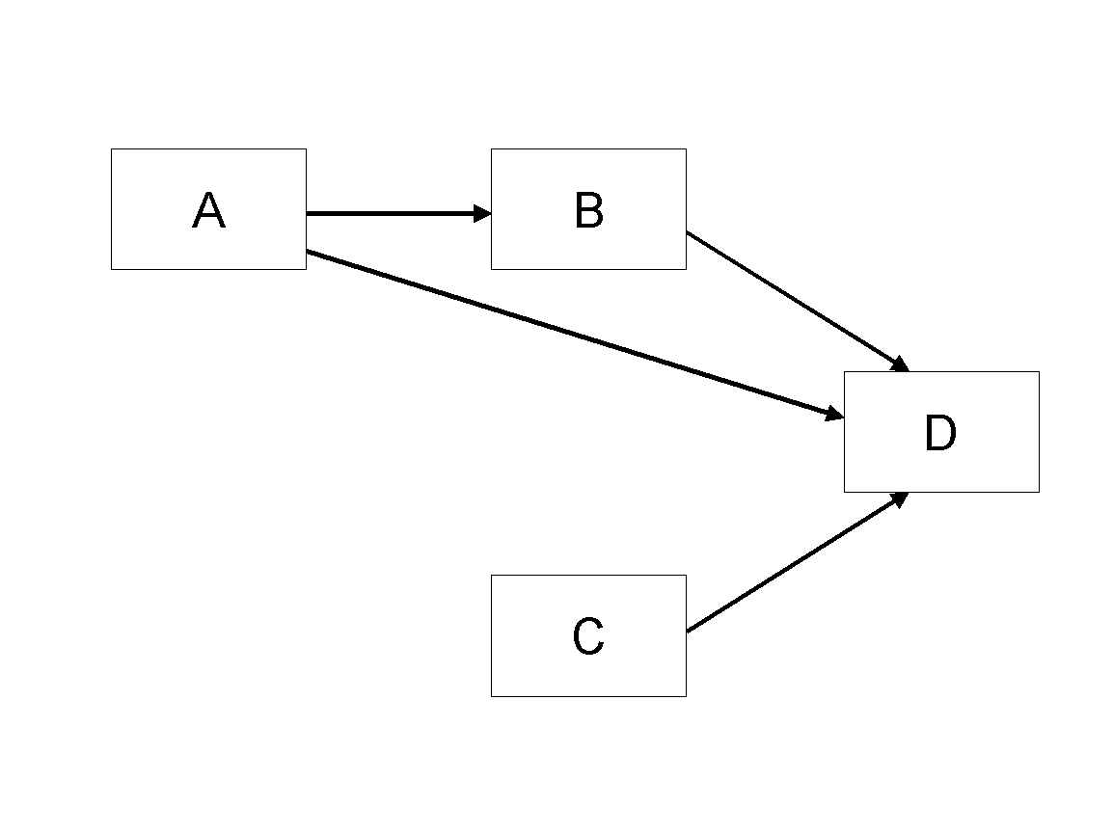
Figure 1. Modified Research Model

Table Style
Inserting a table in the text can work well. You may want to adjust the vertical spacing of the text in the tables. (In Word, use Format | Paragraph… and then the Line and Page Breaks tab. Generally, text in each field of a table will look better if it has equal amounts of spacing above and below it, as in Table 1.)
 | Treatment 1 | Treatment 2
Setting A | 125 | 95
Setting B | 85 | 102
Setting C | 98 | 85
Table 1. A Very Nice Table

Language, Style, and Content
With regard to spelling and punctuation, you may use any dialect of English (e.g., British, Canadian, US, etc.) provided this is done consistently. Hyphenation is optional. To ensure suitability for an international audience, please pay attention to the following:
- Write in a straightforward style.
- Try to avoid long or complex sentence structures.
- Briefly define or explain all technical terms that may be unfamiliar to readers.
- Explain all acronyms the first time they are used in your text – e.g., “primary care provider (PCP)”.
- Explain local references (e.g., not everyone knows all city names in a particular country).
- Be careful with the use of gender-specific pronouns (he, she) and other gendered words (chairman, manpower, man-months). Use inclusive language that is gender-neutral (e.g., they, s/he, chair, staff, staff-hours, person-years).

Acknowledgements & AI Use
Please do not add acknowledgements to your original submission because it will help identify authors.
Generative AI can support research in various ways, and AIS encourages members to explore its opportunities and risks. Authors may use generative AI (e.g., ChatGPT) for tasks like literature mapping, text mining, and editing, but submissions must reflect their intellectual contributions. Authors must disclose and justify any use of generative AI in their submissions. By submitting, authors accept full responsibility for their paper’s content, including AI-generated results and potential plagiarism. Under no circumstances can an AI tool be credited as an author. AIS recognizes the need for science-wide norms on AI use and has developed these guidelines based on practices from other scientific disciplines.

