Title of the Paper
Full Paper | Short Paper (select one)

Abstract
The paper should include an abstract. The abstract should be understandable by the general reader outside the context of the study. The abstract should be formatted like this paragraph, and may be up to 200 words in length.
Keywords: One, Two, Three, Four.

Introduction
We ask that authors follow these basic guidelines when submitting to TSWIM. In essence, you should format your paper exactly like this document. The easiest way to use this template is to replace the placeholder content with your own material. The template file contains specially formatted styles (e.g., Normal, Heading, Bullet, References, Title, Author, Affiliation) that are designed to reduce the work in formatting your final submission.
Beyond the required Abstract section, Full Papers and Short Papers may use any further sections that they wish. However, we strongly suggest following the traditional structure of papers found in IS journals and conferences. For example, an empirical paper might include: Abstract, Introduction, Literature Review, Proposed Model, Methodology, Discussion, and Conclusion.

Page Format and Length

Page Size and Spacing
Please adhere to the A4 page size only (in MS Word, you can check the page format in the menu: File --> Page Setup). Maintain the margins found on this template: 1” (2.5 cm) around. If you have any difficulties with the template, please contact the organizers for assistance.
Please ensure your manuscript complies with the following instructions:
- Line spacing should be single (exactly 1.0);
- Margins should be 1 inch (2.54 cm);
- Do not change character or word spacing;
- Please do not use double spaces between sentences – this is a tradition no longer necessary on modern word processors;
- Please do not edit the styles in this template;
- Please ensure all text is justified, not “ragged” ( = left-aligned).
Non-compliance of these instructions may lead to desk rejection of your paper.

Length
This template is only for Full Papers and Short Papers. Please find the template for other submission formats on the TSWIM website. Full Papers must not exceed fifteen (15) pages, all inclusive. Short Papers must not exceed eight (8) pages, all inclusive. Any submission that exceeds page length limits will screened out without review.

Text Format and Style

Title
Your paper’s title should be using the “Title” style in this template (which is configured as Georgia 20-point bold). Ensure proper capitalization within your title (i.e. “The Next Frontier of Information Systems” versus “the next frontier of Information systems.”
All proper nouns should be capitalized. Articles (the, a), coordinating conjunctions (and, but, or, for, nor, etc.) should not be capitalized, unless, of course, they are used as the first word in the title. Likewise for prepositions (on, at, to, from, by, etc.).

Normal or Body Text
Please use the “Normal” style for normal text – this style is configured as a 10-point Georgia font (similar to Times New Roman, but more easily read online) or, if it is unavailable, another proportional font with serifs, as close as possible in appearance to Times New Roman 10-point. Please use sans-serif or non-proportional fonts (such as Arial or Courier) only for special purposes, such as source code text (SpecialStyle). [References to Georgia font from this point forward should be interpreted as “Georgia or equivalent.”]

Sections
The heading of a section should be using the “Heading 1” style, each word should be capitalized – configured as Georgia 13-point bold, left justified. Sections should not be numbered.

Subsections
Headings of subsections should be using the style “Heading 2” – configured as Georgia 11-point bold italics with initial letters capitalized. (Note: for sub-sections and sub-subsections, words like ‘the’, ‘of’, ‘a’, ‘an’ are not capitalized unless it is the first word of the heading.)

Sub-subsections
Headings for sub-subsections should be using “Heading 3” – configured as Georgia 10-point bold with initial letters capitalized. Please do not go any further into another layer/level.

Figures, Tables & Captions
Place figures and tables close to the relevant text (or where they are referenced in the text).
Captions should be using the “Caption” style – configured as Georgia 10-point bold. They should be numbered (e.g., “Table 1” or “Figure 2”), centered and placed beneath the figure or table. Please note that the words “Figure” and “Table” should be spelled out (e.g., “Figure” rather than “Fig.”) wherever they occur.

Figures and Images
Occasionally MS Word generates larger-than-necessary PDF files when images inserted into the document are manipulated in MS Word. To minimize this problem, use an image editing tool to resize the image at the appropriate printing resolution (usually 300 dpi), and then insert the image into Word using Insert | Picture | From File...
As indicated in Figure 1, using tables to hold places can work very well in Word. If you want to copy a figure from another application (such as PowerPoint) and then paste to the place where you want your figure to be, make sure that (1) the figure stays in the position, and (2) it does not take up too much space. You can ensure the former by double clicking the figure, then go to “Layout” tab, and select “In line with text.” To ensure the latter, use “Paste Special,” then select “Picture.” You can resize the figure to your desired size once it is pasted.

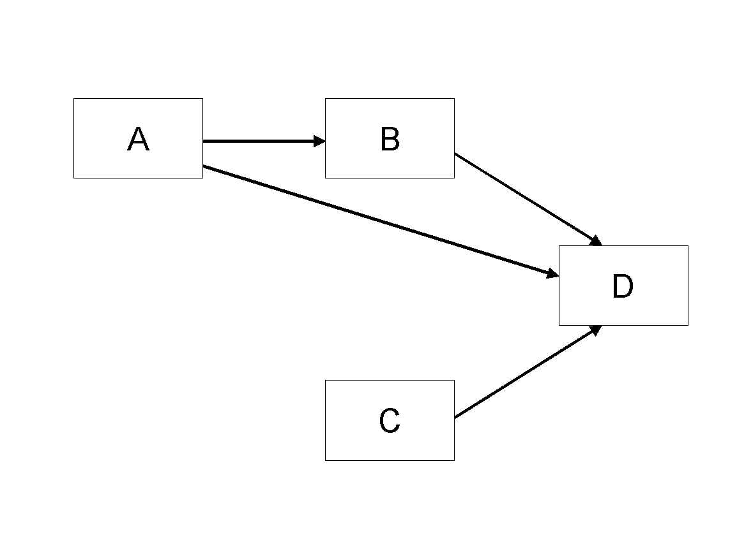
Figure 1. Modified Research Model

Table Style
Inserting a table in the text can work well. You may want to adjust the vertical spacing of the text in the tables. (In Word, use Format | Paragraph… and then the Line and Page Breaks tab. Generally, text in each field of a table will look better if it has equal amounts of spacing above and below it, as in Table 1.)
 | Treatment 1 | Treatment 2
Setting A | 125 | 95
Setting B | 85 | 102
Setting C | 98 | 85
Table 1. A Very Nice Table

Language, Writing Style, and Content
With regard to spelling and punctuation, you may use any dialect of English (e.g., British, Canadian, US, etc.) provided this is done consistently. Hyphenation is optional. To ensure suitability for an international audience, please pay attention to the following:
- Write in a straightforward style.
- Try to avoid long or complex sentence structures.
- Briefly define or explain all technical terms that may be unfamiliar to readers.
- Explain all acronyms the first time they are used in your text – e.g., “primary care provider (PCP)”.
- Explain local references (e.g., not everyone knows all city names in a particular country).
- Be careful with the use of gender-specific pronouns (he, she) and other gendered words (chairman, manpower, man-months). Use inclusive language that is gender-neutral (e.g., they, s/he, chair, staff, staff-hours, person-years).

Acknowledgements & AI Use
Please do not add acknowledgements to your original submission because it will help identify authors.
Generative AI can support research in various ways, and AIS encourages members to explore its opportunities and risks. Authors may use generative AI (e.g., ChatGPT) for tasks like literature mapping, text mining, and editing, but submissions must reflect their intellectual contributions. Authors must disclose and justify any use of generative AI in their submissions. By submitting, authors accept full responsibility for their paper’s content, including AI-generated results and potential plagiarism. Under no circumstances can an AI tool be credited as an author. AIS recognizes the need for science-wide norms on AI use and has developed these guidelines based on practices from other scientific disciplines.

Conclusion
It is important that you write for a general audience. It is also important that your work is presented in a professional fashion. This guideline is intended to help you achieve that goal. By adhering to the guideline, you also help the conference organizers tremendously in reducing our workload and ensuring impressive presentation of your conference paper.

References
References should be listed alphabetically by author name at the end of the paper in conformance with APA 7th edition. In-text citations should be indicated by the author’s last name and year of publication, e.g., (DeGross, 1977) or DeGross (1977). References must be complete, i.e., include, as appropriate, volume, number, month, publisher, city and state, editors, last name & initials of all authors, page numbers, etc. If you use EndNote, be aware that different versions of the software change the styles, creating some inconsistencies.
Your references should comprise only published materials accessible to the public. Proprietary information may not be cited.
References should be ordered in alphabetic order.
<<<Please ensure that all references are present, complete, and accurate as per the examples below.>>>
Ackoff, R. L. (1967). Management misinformation systems. Management Science, 14(4), 147-156.
Benbasat, I., & Zmud, R. W. (2003). The identity crisis within the IS discipline: Defining and communicating the discipline's core properties. MIS Quarterly, 27(2), 183-194.
Bonini, C. P. (1963). Simulation of information and decision systems in the firm. Prentice-Hall.
Broadbent, M., Weill, P., O’Brien, T., & Neo, B. S. (1996). Firm context and patterns of IT infrastructure capability. Proceedings of the 14th International Conference on Information Systems, 13, 174-194. https://aisel.aisnet.org/icis1996/13
Carroll, J. (2005). The Blacksburgh Electronic Village: A study in community computing. In P. van den Besselaar & S. Kiozumi (Eds.), Digital Cities III: Information Technologies for Social Capital (pp. 43-65). Springer-Verlag.

