**Group B: Assignment No 3**

**MongoDB - Map reduces operations:**

Implement Map reduces operation with suitable example using MongoDB.

**Aim:** To study and implement MapReduce operation in MongoDB

**Title:** Write and execute simple queries to demonstrate MapReduce operation.

**Theory:**

1. **Create collection bank**

2. **Insert following documents into it.**

>db.bank.insert ({'custid':'c001','custname':'amit','bank':'SBI','blance':3000,'loction':'Pune'})

> db.bank.insert ({'custid':'c002','custname':'amol','bank':'AXIS','blance':4000,'loction':'Pune'})

> db.bank.insert ({'custid':'c002','custname':'amit','bank':'AXIS','blance':5000,'loction':'Mumbai'})

> db.bank.insert ({'custid':'c003','custname':'amit','bank':'AXIS','blance':5000,'loction':'Nagpur'})

> db.bank.insert ({'custid':'c004','custname':'amay','bank':'AXIS','blance':6000,'loction':'Nashik'})

> db.bank.insert ({'custid':'c005','custname':'amar','bank':'HDFC','blance':7000,'loction':'pune'})

> db.bank.insert ({'custid':'c006','custname':'vijay','bank':'HDFC','blance':8000,'loction':’Mumbai'})

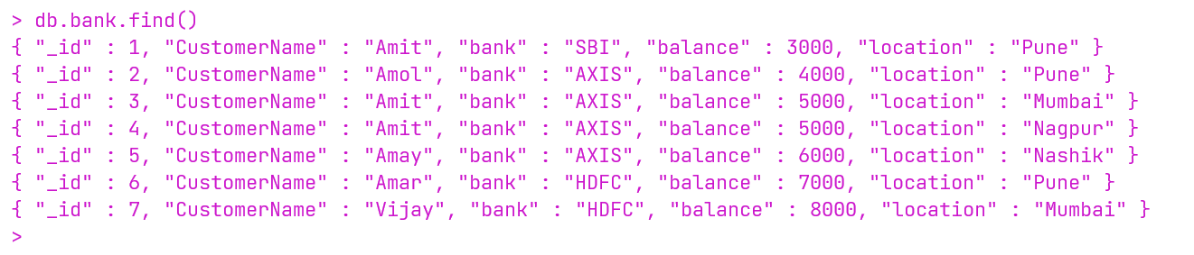

3**. Perform aggregation using Map-Reduce to display bank wise balance**

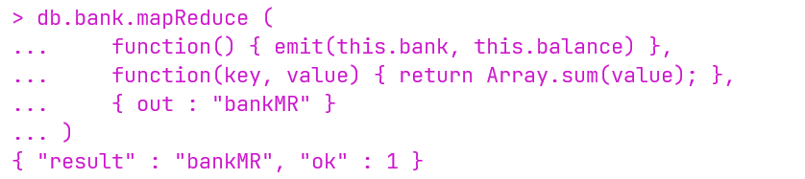

4. **Display the result of new collection bankMR**

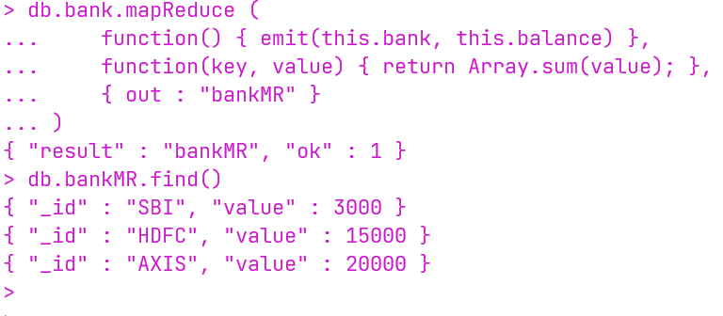

5. **Display the balance of HDFC bank only from bankMR collection**

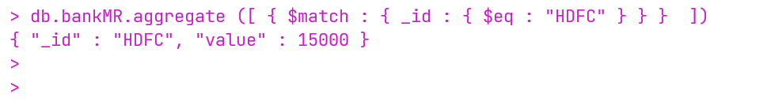

6. **Display the balance of SBI bank only from bankMR collection**



7. **Display the balance of AXIS bank only from bankMR collection**

