**Title**: Design at least 10 SQL queries for suitable database application using SQL DML statements: all types of Joins, Sub-Query and View.

**Tables:**

Pack_grades(grade_id,grade_name,min_price,max_price)

Packages(pack_id,speed,strt_date,monthly_payment,sector_id)

Customers(cust_id,firstname,lastname,birthdate,joindate,city,state,street,main_phone_num,secondary_phn_no,fax,monthly_discount,pack_id)

Sectors(sector_id,sector_name)

**Foreign Key Syntax:**

## CREATE TABLE TABLENAME (

COLUMN_LIST, PRIMARY KEY (COL NAME),  
 FOREIGN KEY (COL NAME FROM SAME TABLE) REFERENCES REF_TABLE NAME (COL NAME FROM REF_TABLE));

**Inner JOIN**

1. Customers and internet packages (*Customers* & *Packages* tables) –
   1. Write a query to display first name, last name, package number and internet speed for all customers.

SELECT First_Name, Last_Name, Customers.Pack_Id, Internet_Speed

FROM Customers

INNER JOIN Packages ON Customers.Pack_Id = Packages.Pack_Id;

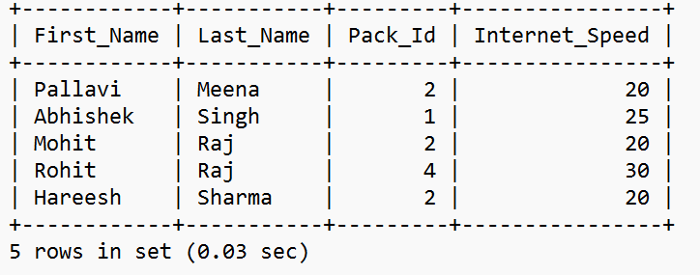

* 1. Write a query to display first name, last name, package number and internet speed for all customers whose package number equals 2 or 4. Order the query in ascending order by last name.

SELECT First_Name, Last_Name, Customers.Pack_Id, Internet_Speed AS

Internet_Speed_In_MBPS

FROM Customers

JOIN Packages ON Customers.Pack_Id = Packages.Pack_Id

WHERE Customers.Pack_Id BETWEEN 2 AND 4 ORDER BY Last_Name;

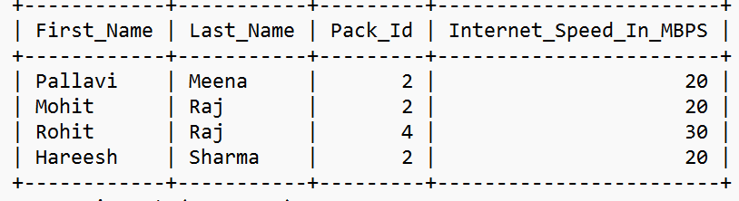

1. Internet packages and sectors –
   1. Display the package number, internet speed, monthly payment and sector name for all packages (*Packages* and *Sectors* tables).

SELECT Packages.Pack_Id, Internet_Speed

AS Internet_Speed_In_Mbps, Monthly_Payment, Sector_Name

FROM Packages

JOIN Sector ON Packages.Sector_Id = Sector.Sector_Id ORDER BY Pack_Id;

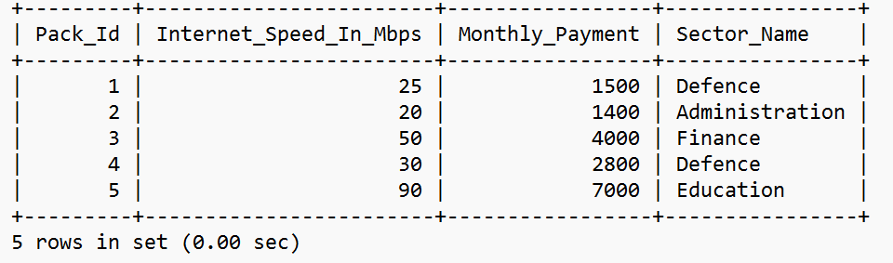

* 1. Display the customer name, package number, internet speed, monthly payment and sector name for all customers (*Customers*, *Packages* and *Sectors* tables).

SELECT First_Name, Customers.Pack_Id, Internet_Speed, Monthly_Payment, Sector_Name

FROM Customers

JOIN Packages ON Customers.Pack_Id = Packages.Pack_Id

JOIN Sector ON Packages.Sector_Id = Sector.Sector_Id;

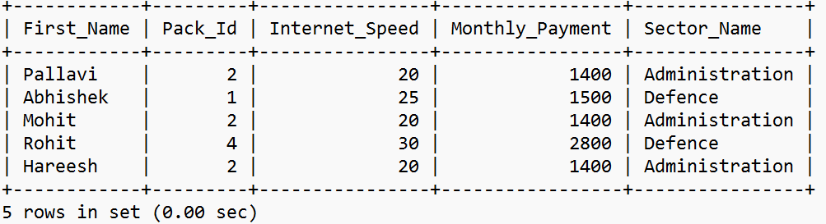

* 1. Display the customer name, package number, internet speed, monthly payment and sector name for all customers in the Administration sector (*Customers*, *Packages* and *Sectors* tables).

SELECT First_Name, Customers.Pack_Id, Internet_Speed, Monthly_Payment, Sector_Name

FROM Customers

JOIN Packages ON Customers.Pack_Id = Packages.Pack_Id

JOIN Sector ON Packages.Sector_Id = Sector.Sector_Id

WHERE Sector_Name = 'Administration';

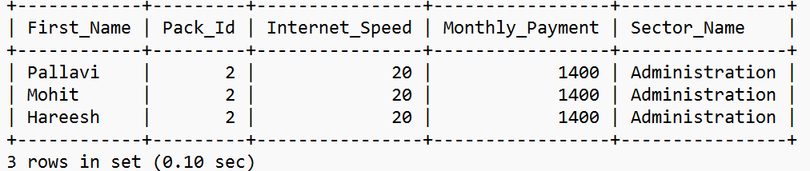

1. Display the last name, first name, join date, package number, internet speed and sector name for all customers in the private sector who joined the company in the year 2006.

SELECT First_Name, Customers.Pack_Id, Internet_Speed, Monthly_Payment, Sector_Name

FROM Customers

JOIN Packages ON Customers.Pack_Id = Packages.Pack_Id

JOIN Sector ON Packages.Sector_Id = Sector.Sector_Id

WHERE Joining_Date BETWEEN '2021-01-01' AND '2022-12-31';

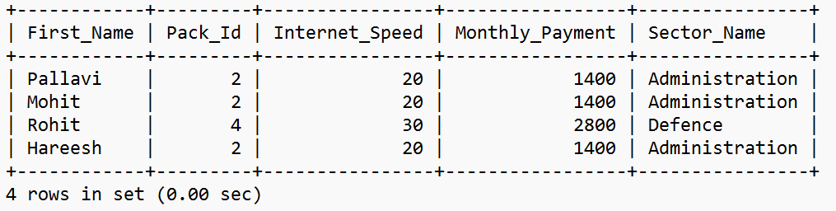

**Non Equi Join**

1. Display the package number, internet speed, monthly payment and package grade for all packages whose monthly payment is between min_price and max_price(*Packages* and *Pack_Grades* tables).

SELECT * FROM Packages

LEFT OUTER JOIN Pack_Grades ON Pack_Id = Grade_Id

WHERE Monthly_Payment BETWEEN Min_Price AND Max_Price;

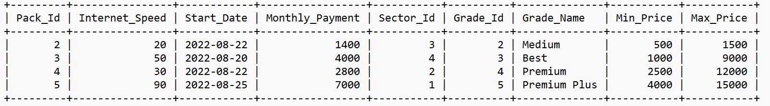

**Outer Join**

* 1. Customers and internet packages (*Customers* and *Packages* tables)
     1. Display the first name, last name, internet speed and monthly payment for all customers. Use INNER JOIN to solve this exercise.

SELECT First_Name, Last_Name, Monthly_Payment,

Internet_Speed

FROM Customers

INNER JOIN Packages ON Customers.Pack_Id = Packages.Pack_Id;

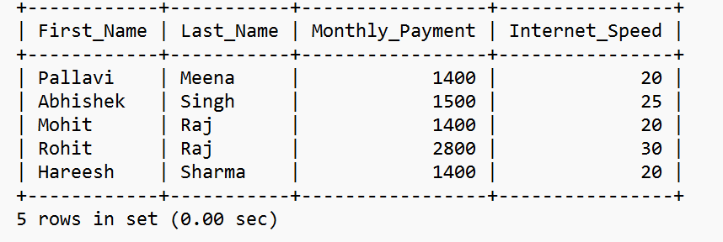

* + 1. Modify last query to display all customers, including those without any internet package.
    2. Modify last query to display all packages, including those without any customers.
    3. Modify last query to display all packages and all customers.

SELECT * FROM Customers

LEFT OUTER JOIN Packages ON Customers.Pack_Id = Packages.Pack_Id;

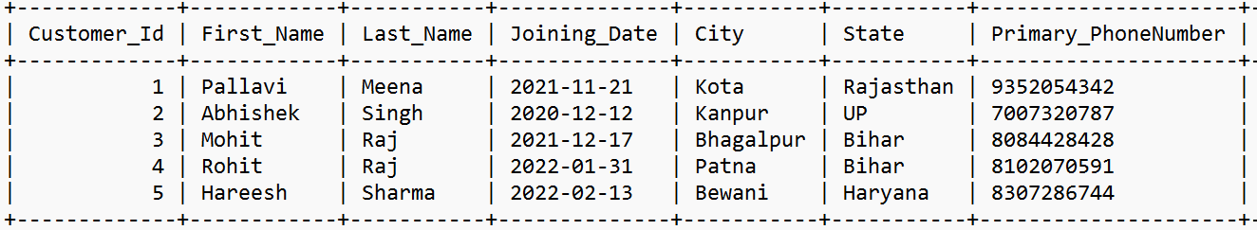

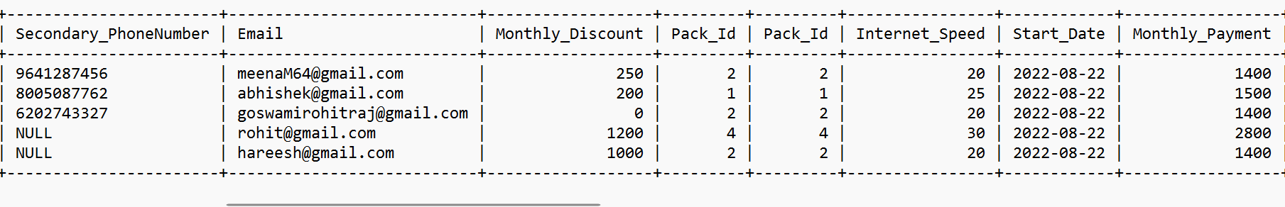

**Self Join**

* + 1. Display the last name, first name and package number for all customers who have the same package number as customer named ‘A Taylor’ (*Customers* table).

SELECT Table1_Customers.First_Name AS First_Name,

Table2_Customers.Pack_Id AS Pack_Id

FROM Customers AS Table1_Customers

JOIN Customers AS Table2_Customers

ON Table1_Customers.Customer_Id =

Table2_Customers.Customer_Id

GROUP BY Table1_Customers.Customer_Id;

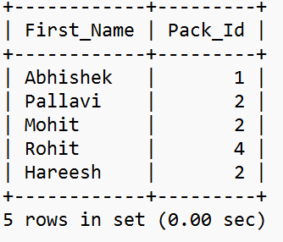

* + 1. Display the first name and monthly discount for all customers whose monthly discount is lower than the monthly discount of employee with Customers Id 3(*Customers* table).

mysql> SELECT Table1_Customers.First_Name AS First_Name,

Table2_Customers.Monthly_Discount AS Monthly_Discount

FROM Customers AS Table1_Customers JOIN Customers AS Table2_Customers

ON Table1_Customers.Customer_Id = Table2_Customers.Customer_Id

WHERE Table2_Customers.Monthly_Discount < 1000;

