**DBMS Lab**

**Assignment No. 5 (Stored Procedures and Functions)**

**Title**:- Write a Stored Procedure for the categorization of student.

If marks scored by students in examination is <=1500 and marks>=990 then student will be placed in distinction category

If marks scored are between 989 and 900 category is first class

If marks 899 and 825 category is Higher Second Class

Write a PL/SQL block to use procedure created with above requirement.

Stud_Marks(name, total_marks)

Result(Roll,Name, Class)

**Commands and Screenshots**:-

Table: Student_Marks

mysql> CREATE TABLE Student_Marks (

-> Roll_No int NOT NULL PRIMARY KEY,

-> Name varchar(25),

-> Total_Marks int );

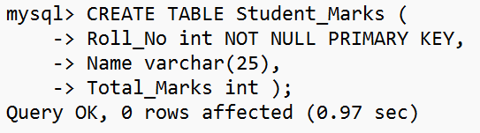

Table: Result

mysql> CREATE TABLE Result (

-> Roll_No int NOT NULL PRIMARY KEY,

-> Name varchar(25),

-> Class varchar(25) );

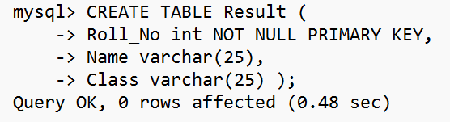

Procedure: Grade_Allotment

mysql> DELIMITER :

mysql> CREATE PROCEDURE Grade_Allotment (IN Roll int, Name varchar(25), Marks int)

-> BEGIN

-> IF marks BETWEEN 990 AND 1500 THEN

-> INSERT INTO result VALUES (name, 'Distinction');

-> ELSEIF marks BETWEEN 900 AND 989 THEN

-> INSERT INTO result VALUES (name, 'First Class');

-> ELSEIF marks BETWEEN 825 AND 899 THEN

-> INSERT INTO Result VALUES ( name, 'Second Higher Class');

-> ELSE

-> SELECT 'marks are in between 825 and 1500' AS Suggestion;

-> END IF;

-> END:

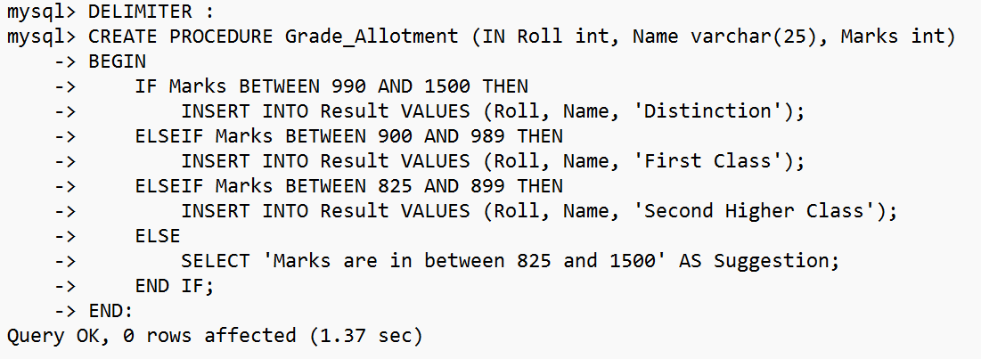

Procedure: Insert_Records

mysql> CREATE PROCEDURE Insert_Records (IN Roll int, Name varchar(25), Marks int)

-> BEGIN

-> IF Marks BETWEEN 825 AND 1500 THEN

-> INSERT INTO Student_Marks VALUES(Roll, Name, Marks);

-> CALL Grade_Allotment (Roll, Name, Marks);

-> ELSE

-> SELECT 'Marks are in between 825 and 1500' AS Suggestion;

-> END IF;

-> END:

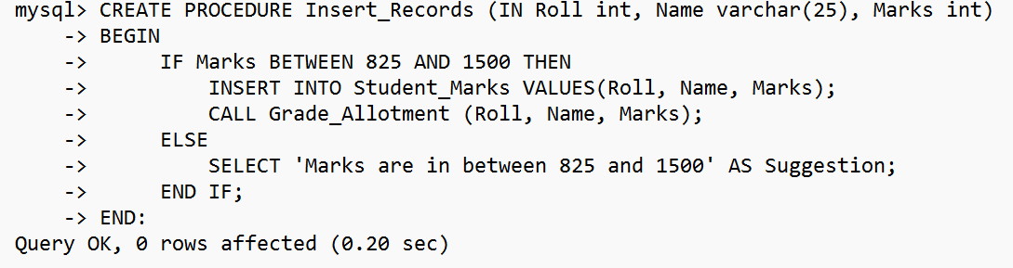

Inserting Records

mysql> DELIMITER ;

mysql> CALL Insert_Records (7337, 'Mohit Raj', 1200);

mysql> CALL Insert_Records (5147, 'Himanshu Singh', 925);

mysql> CALL Insert_Records (7345, 'Priyanshu Priyam', 1400);

mysql> CALL Insert_Records (150, 'Pallavi', 850);

Displaying Records

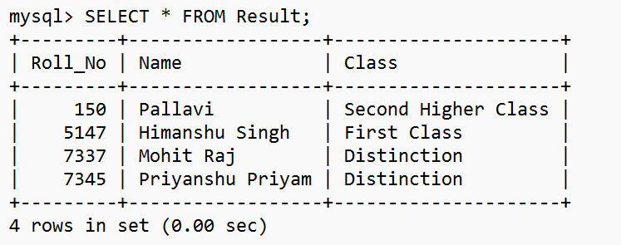

mysql> CALL Insert_Records (7329, 'Alex', 810);

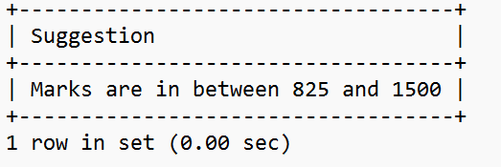

DELIMITER //

DROP PROCEDURE IF EXISTS proc_Grade //

CREATE PROCEDURE proc_Grade (IN r_num INTEGER, IN nme VARCHAR(30))

BEGIN

DECLARE mks INTEGER;

DECLARE cls VARCHAR(30);

SELECT Total_Marks INTO mks FROM Stud_Marks WHERE Roll = r_num AND Name = nme;

CASE

WHEN mks >= 990 AND mks <= 1500 THEN SET cls = "Distinction";

WHEN mks >= 900 AND mks <= 989 THEN SET cls = "First Class";

WHEN mks >= 825 AND mks <= 899 THEN SET cls = "HS Class";

WHEN mks < 825 THEN SET cls = "PASS";

END CASE;

INSERT INTO Result VALUES(r_num, nme, cls);

SELECT r_num AS ROLL, nme AS NAME, cls AS CLASS;

END //