**DBMS Lab**

**Assignment No. 6 (Cursors in MySQL)**

**Title**:- Write a PL/SQL block of code using parameterized Cursor that will merge the data available in the newly created table N_RollCall with the data available in the table O_RollCall. If the data in the first table already exist in the second table then that data should be skipped.

**Screenshots:-**

Creating Tables

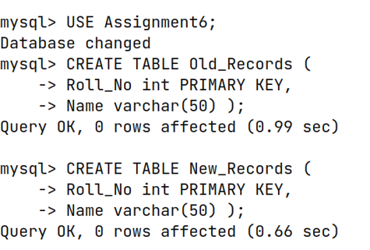

Inserting Data into Tables

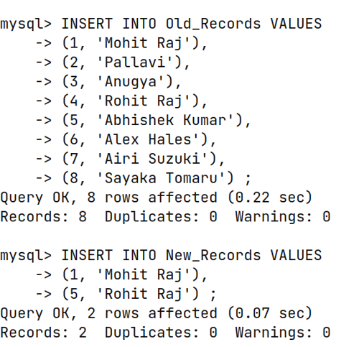

Procedure Join_Tables

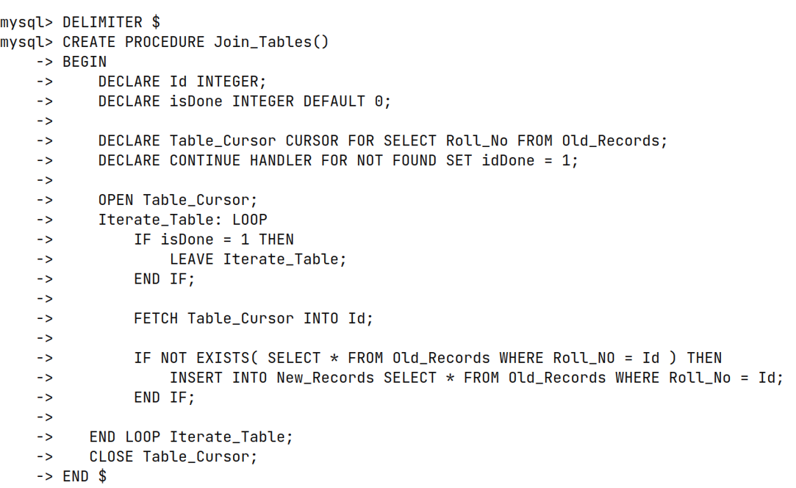

Invoking Procedure

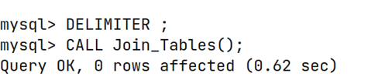

Merging Tables Result

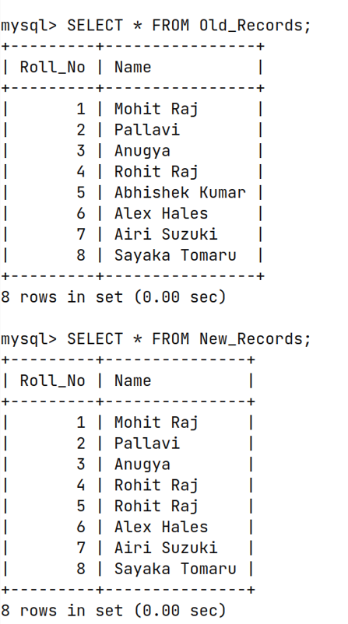

CREATE PROCEDURE UPDATE_TABLE()

BEGIN

DECLARE ORNO INTEGER;

DECLARE NRNO INTEGER;

DECLARE ONAME VARCHAR(30);

DECLARE NNAME VARCHAR(30);

DECLARE DONE INTEGER DEFAULT FALSE;

DECLARE CO CURSOR FOR SELECT * FROM O_RollCall;

DECLARE CN CURSOR FOR SELECT * FROM N_RollCall;

DECLARE CONTINUE HANDLER FOR NOT FOUND SET DONE = TRUE;

OPEN CO;

LOOPCO: LOOP

FETCH CO INTO ORNO, ONAME;

IF DONE THEN LEAVE LOOPCO;

END IF;

OPEN CN;

LOOPCN: LOOP

FETCH CN INTO NRNO, NNAME;

IF ORNO = NRNO AND ONAME = NNAME THEN

CLOSE CN;

LEAVE LOOPCN;

END IF;

IF DONE THEN INSERT INTO N_RollCall VALUES(ORNO, ONAME);

SET DONE = FALSE;

CLOSE CN;

LEAVE LOOPCN;

END IF;

END LOOP;

END LOOP;

CLOSE CO;

SELECT * FROM O_RollCall;

SELECT * FROM N_RollCall;

END //