**Assignment 7**

**Database Trigger**

Write a database trigger on Library table. The System should keep track of the records that are being updated or deleted. The old value

of updated or deleted records should be added in Library_Audit table.

**Screenshots**

Creating Database and Library Table

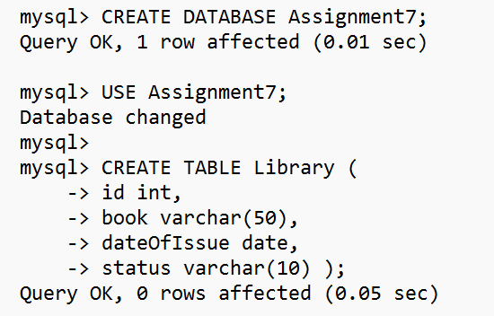

Audit_Table

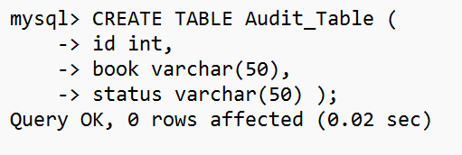

Inserting Into Table Library

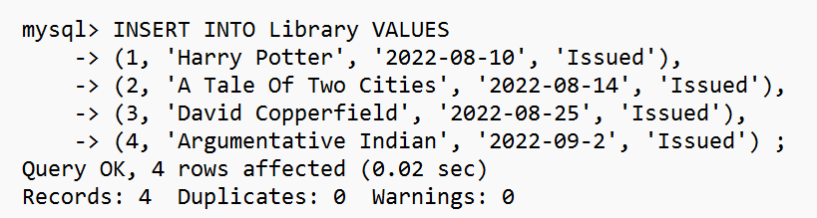

Creating Trigger

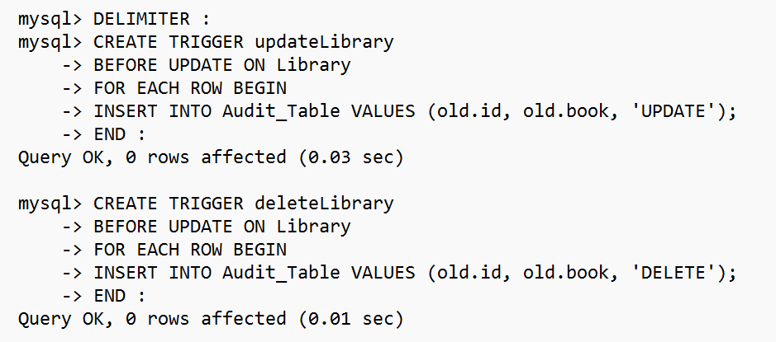

Making Changes in Library Table to trigger Database Trigger

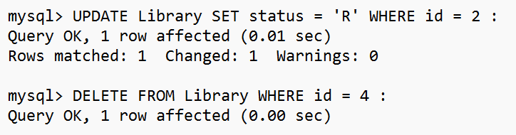

Changes reflected in Audit_Table

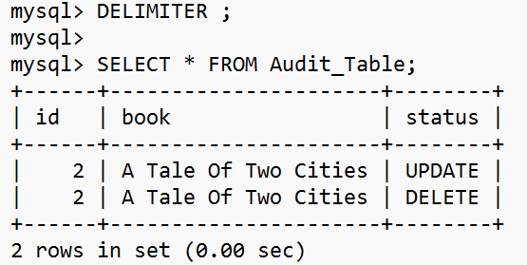

**DBMS Lab**

**Assignment No. 7 (Trigger)**

**Name: RAJVARDHAN SINGH INDA**

**Roll No: 7348**

Database Trigger (All Types: Row level and Statement level triggers, Before and After Triggers).

Write a database trigger on Library table. The System should keep track of the records that are being updated or deleted. The old value of updated or deleted records should be added in Library_Audit table.

**Tables**

**LIBRARY**

mysql> CREATE TABLE LIBRARY (Book_ID INTEGER PRIMARY KEY, Title VARCHAR(100), Author VARCHAR(60), P_Year INTEGER);

Query OK, 0 rows affected (0.21 sec)

mysql> DESC LIBRARY;

+---------+--------------+------+-----+---------+-------+

| Field | Type | Null | Key | Default | Extra |

+---------+--------------+------+-----+---------+-------+

| Book_ID | int(11) | NO | PRI | NULL | |

| Title | varchar(100) | YES | | NULL | |

| Author | varchar(60) | YES | | NULL | |

| P_Year | int(11) | YES | | NULL | |

+---------+--------------+------+-----+---------+-------+

4 rows in set (0.00 sec)

**LIBRARY_AUDIT**

mysql> CREATE TABLE LIBRARY_AUDIT (Book_ID INTEGER, Title VARCHAR(100), Author VARCHAR(60), P_Year INTEGER, Event VARCHAR(30));

Query OK, 0 rows affected (0.21 sec)

mysql> DESC LIBRARY_AUDIT;

+---------+--------------+------+-----+---------+-------+

| Field | Type | Null | Key | Default | Extra |

+---------+--------------+------+-----+---------+-------+

| Book_ID | int(11) | YES | | NULL | |

| Title | varchar(100) | YES | | NULL | |

| Author | varchar(60) | YES | | NULL | |

| P_Year | int(11) | YES | | NULL | |

| Event | varchar(30) | YES | | NULL | |

+---------+--------------+------+-----+---------+-------+

5 rows in set (0.00 sec)

**INSERT**

mysql> DELIMITER //

mysql> DROP TRIGGER IF EXISTS INSERT_LIB //

Query OK, 0 rows affected, 1 warning (0.00 sec)

mysql> CREATE TRIGGER INSERT_LIB

-> AFTER INSERT ON LIBRARY

-> FOR EACH ROW

-> BEGIN

-> INSERT INTO LIBRARY_AUDIT VALUES(NEW.Book_ID, NEW.Title, NEW.Author, NEW.P_Year, "INSERT");

-> END

-> //

Query OK, 0 rows affected (0.07 sec)

mysql> INSERT INTO LIBRARY VALUES(1, "Origin", "Dan Brown", 200

Query OK, 1 row affected (0.05 sec)

mysql> SELECT * FROM LIBRARY //

+---------+--------+-----------+--------+

| Book_ID | Title | Author | P_Year |

+---------+--------+-----------+--------+

| 1 | Origin | Dan Brown | 2000 |

+---------+--------+-----------+--------+

1 row in set (0.00 sec)

mysql> SELECT * FROM LIBRARY_AUDIT //

+---------+--------+-----------+--------+--------+

| Book_ID | Title | Author | P_Year | Event |

+---------+--------+-----------+--------+--------+

| 1 | Origin | Dan Brown | 2000 | INSERT |

+---------+--------+-----------+--------+--------+

1 row in set (0.00 sec)

**UPDATE**

mysql> DELIMITER //

mysql> DROP TRIGGER IF EXISTS UPDATE_LIB //

Query OK, 0 rows affected, 1 warning (0.00 sec)

mysql> CREATE TRIGGER UPDATE_LIB

-> BEFORE UPDATE ON LIBRARY

-> FOR EACH ROW

-> BEGIN

-> INSERT INTO LIBRARY_AUDIT VALUES(OLD.Book_ID, OLD.Title, OLD.Author, OLD.P_Year, "UPDATE");

-> END

-> //

Query OK, 0 rows affected (0.06 sec)

mysql> UPDATE LIBRARY SET P_YEAR = 2002 WHERE Book_ID = 1 //

Query OK, 1 row affected (0.05 sec)

Rows matched: 1 Changed: 1 Warnings: 0

mysql> SELECT * FROM LIBRARY //

+---------+--------+-----------+--------+

| Book_ID | Title | Author | P_Year |

+---------+--------+-----------+--------+

| 1 | Origin | Dan Brown | 2002 |

+---------+--------+-----------+--------+

1 row in set (0.00 sec)

mysql> SELECT * FROM LIBRARY_AUDIT //

+---------+--------+-----------+--------+--------+

| Book_ID | Title | Author | P_Year | Event |

+---------+--------+-----------+--------+--------+

| 1 | Origin | Dan Brown | 2000 | INSERT |

| 1 | Origin | Dan Brown | 2000 | UPDATE |

+---------+--------+-----------+--------+--------+

2 rows in set (0.00 sec)

mysql>

**DELETE**

mysql> DELIMITER //

mysql> DROP TRIGGER IF EXISTS DELETE_LIB //

Query OK, 0 rows affected, 1 warning (0.00 sec)

mysql> CREATE TRIGGER DELETE_LIB

-> BEFORE DELETE ON LIBRARY

-> FOR EACH ROW

-> BEGIN

-> INSERT INTO LIBRARY_AUDIT VALUES(OLD.Book_ID, OLD.Title, OLD.Author, OLD.P_Year, "DELETE");

-> END

-> //

Query OK, 0 rows affected (0.06 sec)

mysql> DELETE FROM LIBRARY WHERE Book_ID = 1;

-> //

Query OK, 1 row affected (0.04 sec)

mysql> SELECT * FROM LIBRARY //

Empty set (0.00 sec)

mysql> SELECT * FROM LIBRARY_AUDIT //

+---------+--------+-----------+--------+--------+

| Book_ID | Title | Author | P_Year | Event |

+---------+--------+-----------+--------+--------+

| 1 | Origin | Dan Brown | 2000 | INSERT |

| 1 | Origin | Dan Brown | 2000 | UPDATE |

| 1 | Origin | Dan Brown | 2002 | DELETE |

+---------+--------+-----------+--------+--------+

3 rows in set (0.00 sec)