Module 6.2 Assignment – Movies Table Queries
Course: CSD-310 Database Development and Use
Student: Luis Cortez
Date: July 2, 2026

Assignment Objective
The purpose of this assignment is to demonstrate how Python connects to a MySQL database using the mysql.connector library. The program executes SQL queries against the Movies database, retrieves records from multiple tables, displays the results, and properly closes the database connection.

Query 1 – Display All Studios

SELECT *
FROM studio;

Description
This query retrieves every record from the studio table and displays the Studio ID and Studio Name.
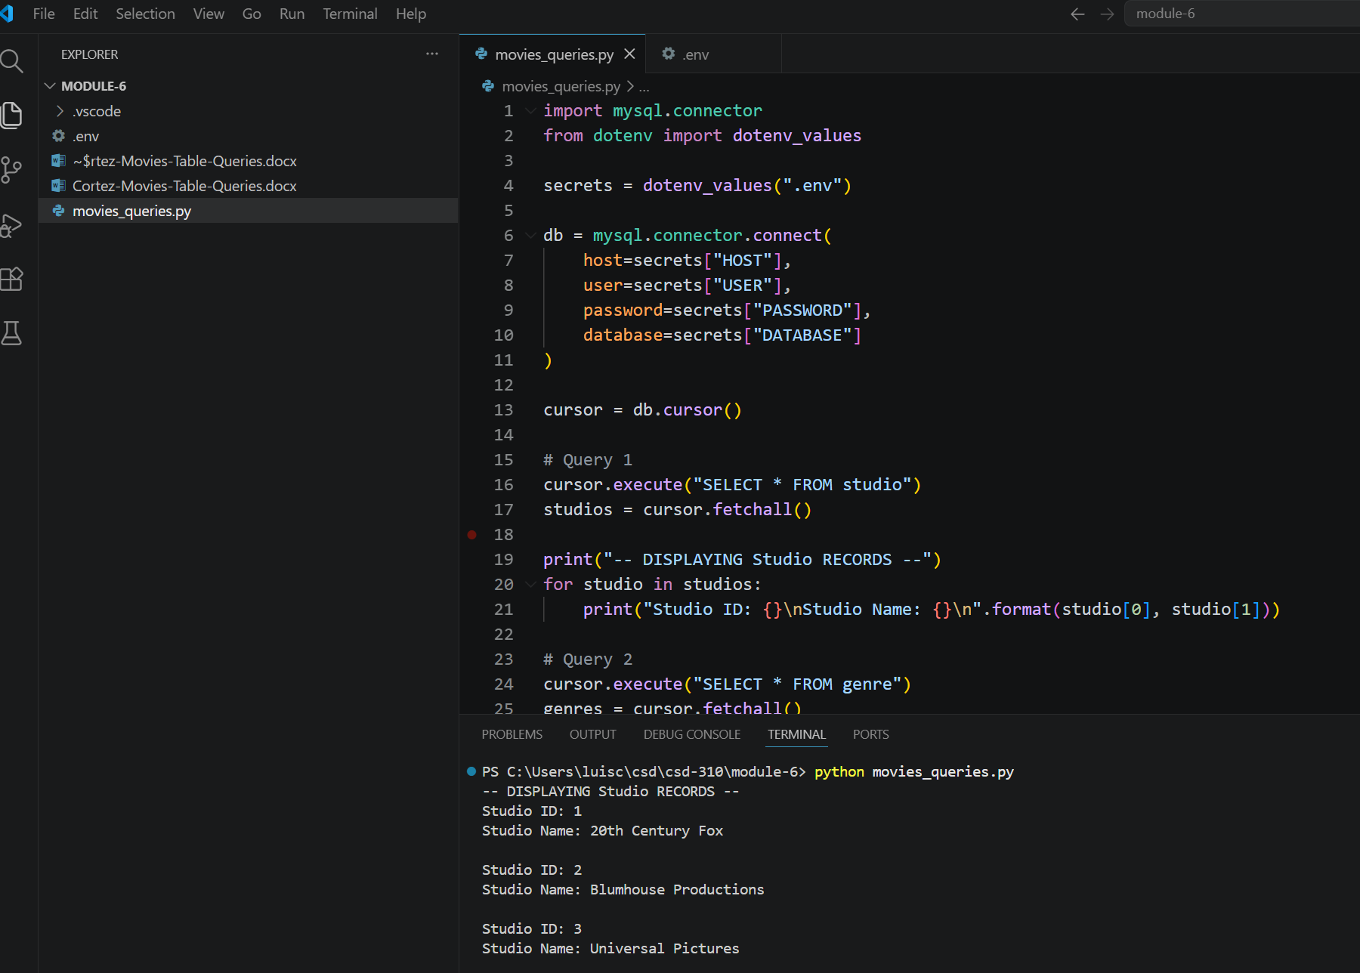

Query 2 – Display All Genres

SELECT *
FROM genre;

Description
This query retrieves every record from the genre table and displays the Genre ID and Genre Name.
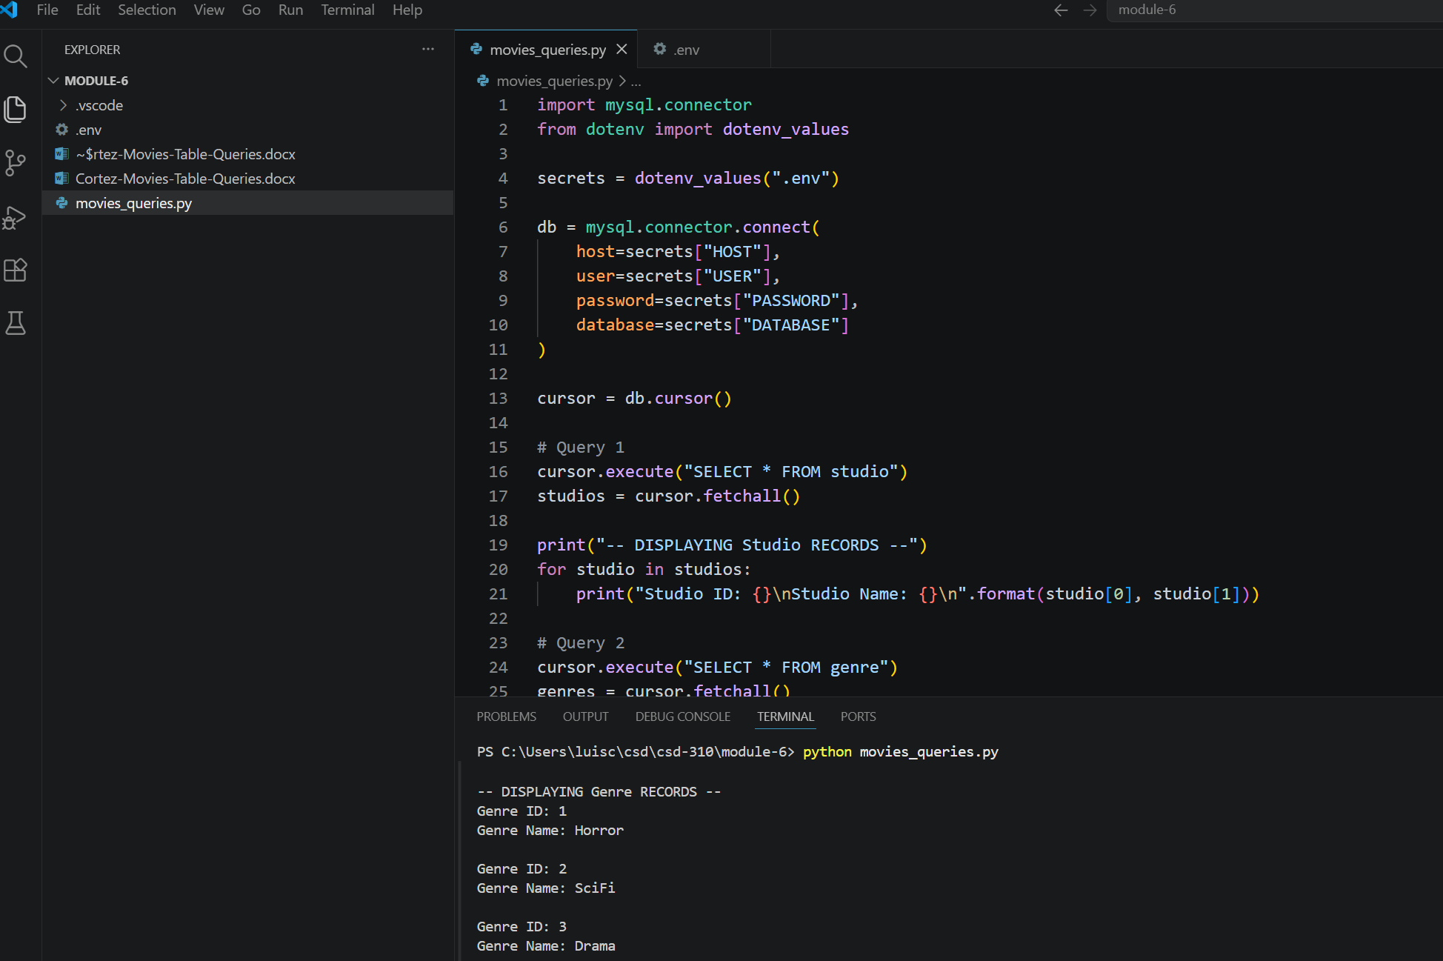

Query 3 – Display Films Shorter Than 120 Minutes

SELECT film_name, film_runtime
FROM film
WHERE film_runtime < 120;

Description
This query displays all movies whose runtime is less than 120 minutes.

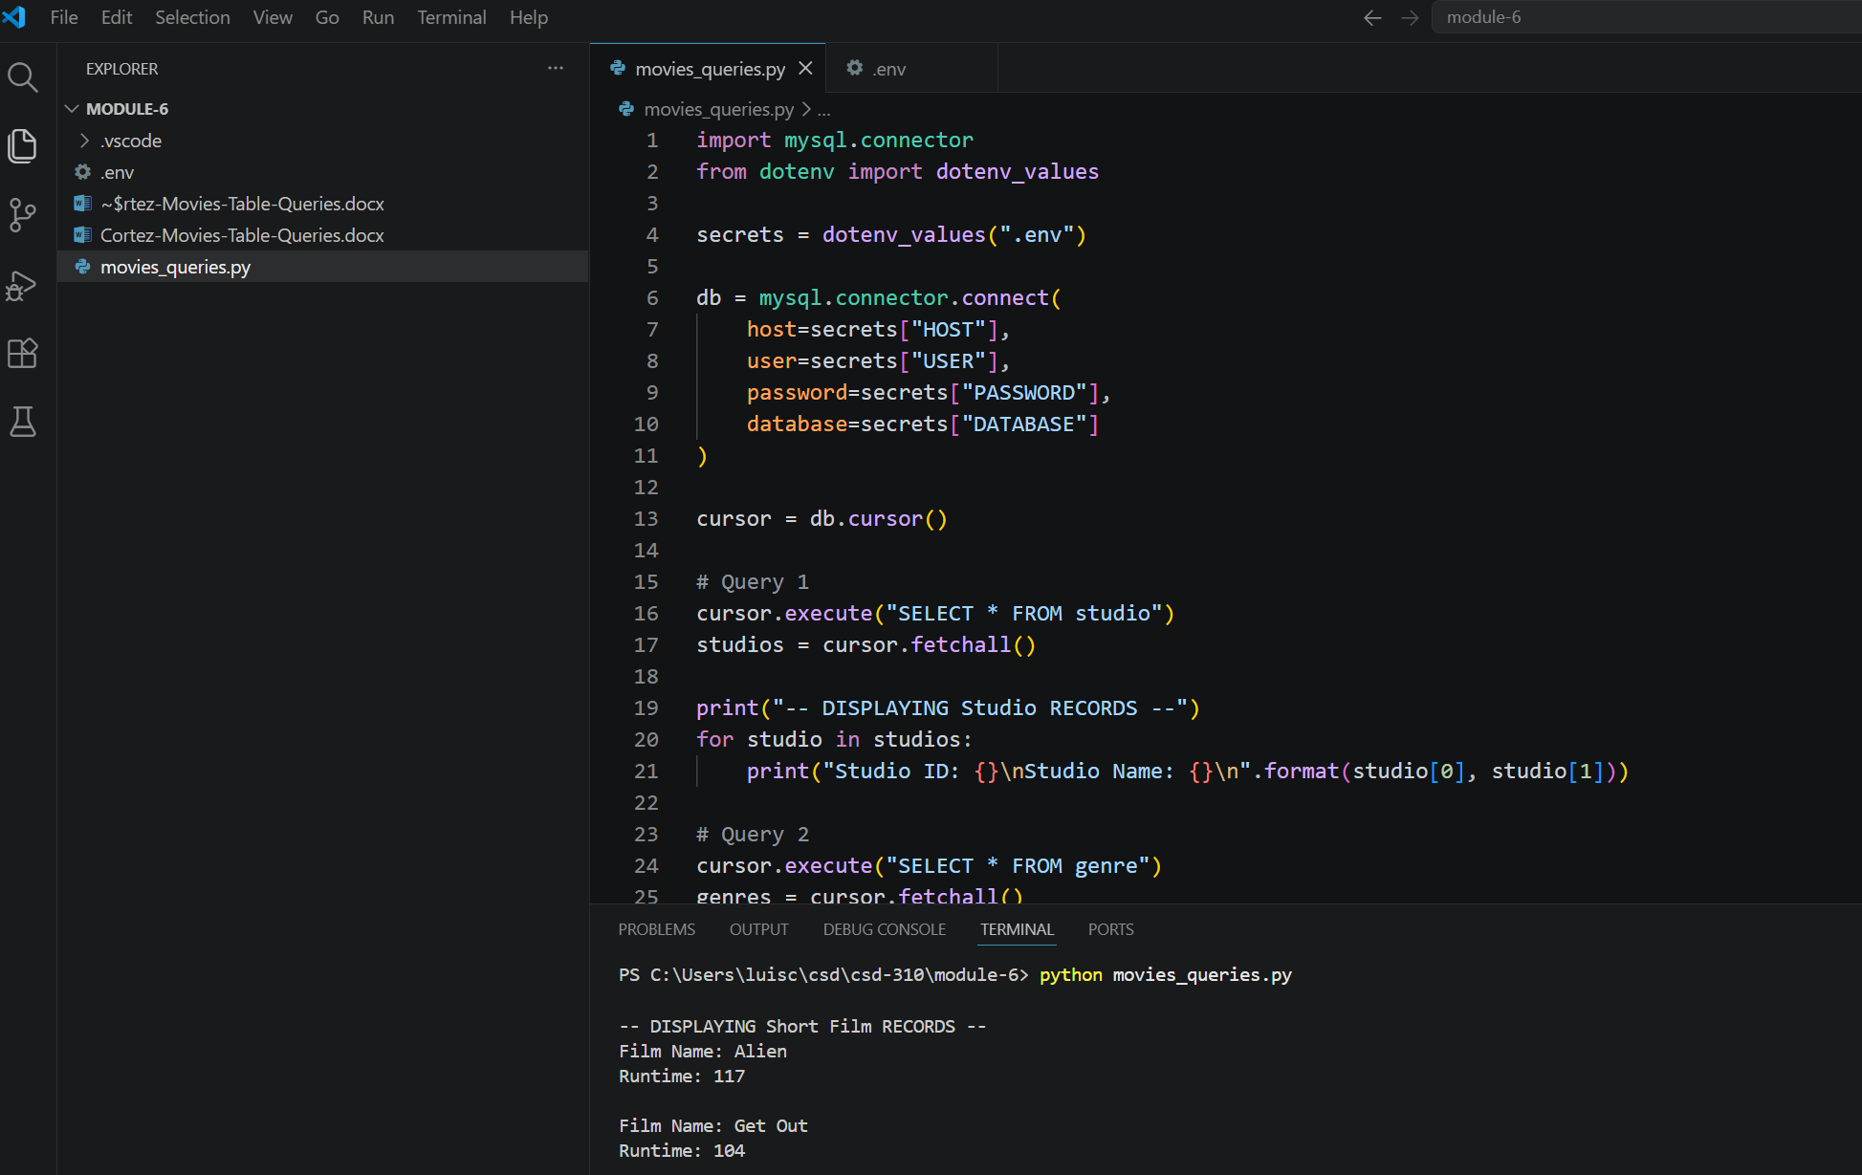

Query 4 – Display Films Ordered by Director

SELECT film_name, film_director
FROM film
ORDER BY film_director;

Description
This query retrieves movie titles together with their directors and sorts the results alphabetically by director.

