CSD310-300H Database Development and Use
Module 4.2 Assignment – MySQL Install
Student: Luis Cortez
Assignment: Module 4.2 – MySQL Install
Date: June 26, 2026


Figure 1. Initial MySQL Workbench connection after successfully logging into the local MySQL server.

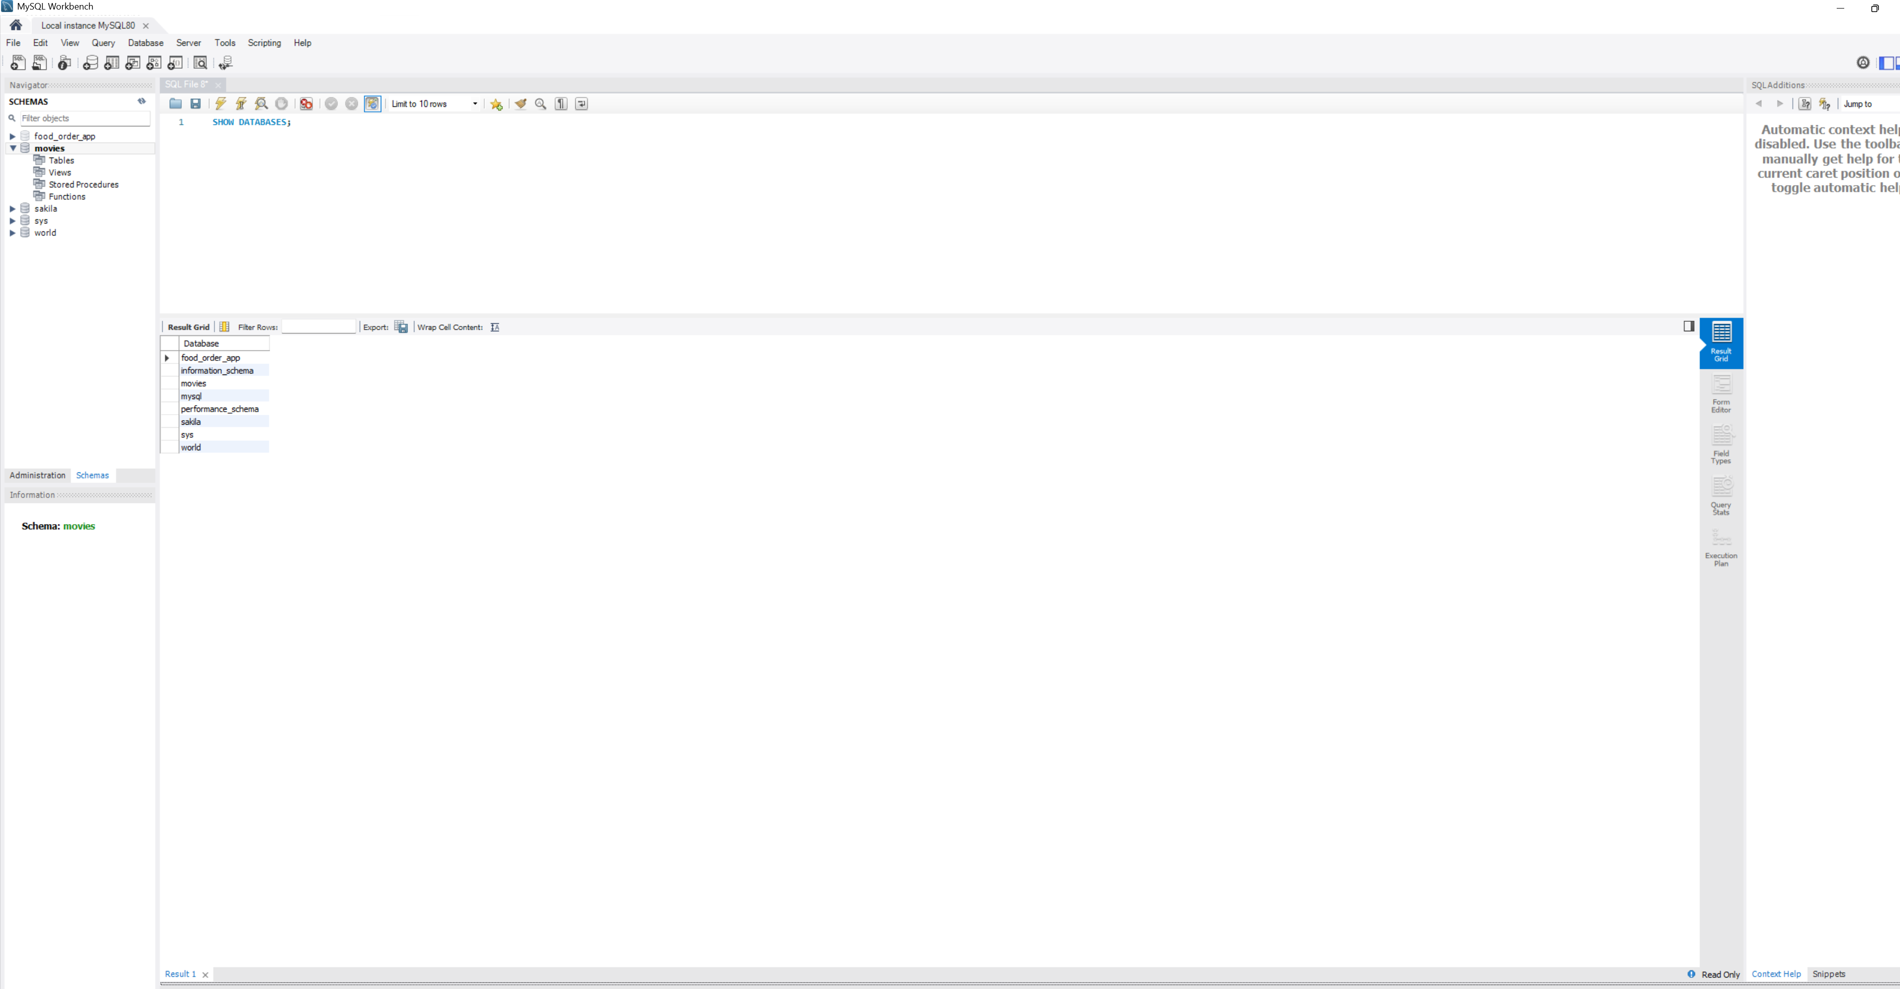
Figure 2. Output of the SHOW DATABASES; command displaying all available databases, including the newly created movies database.

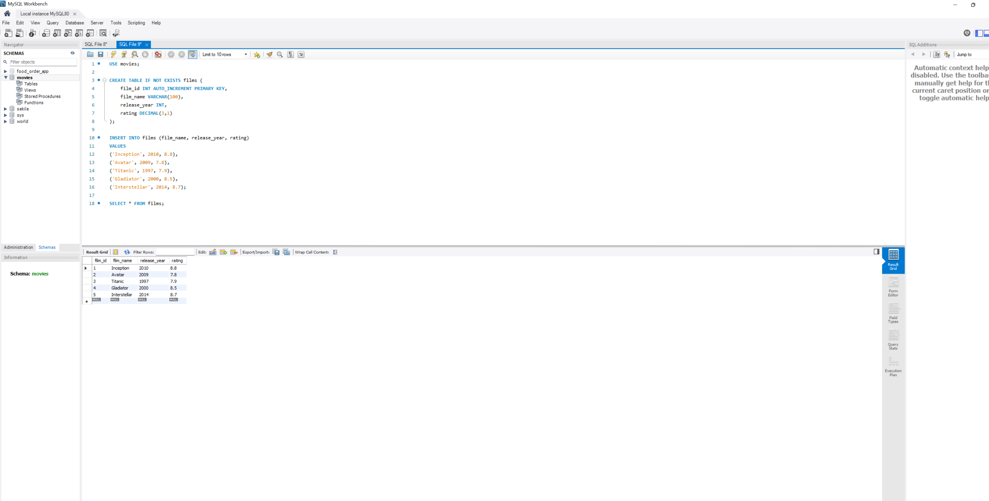
Figure 3. Films table created in the movies database with sample records.

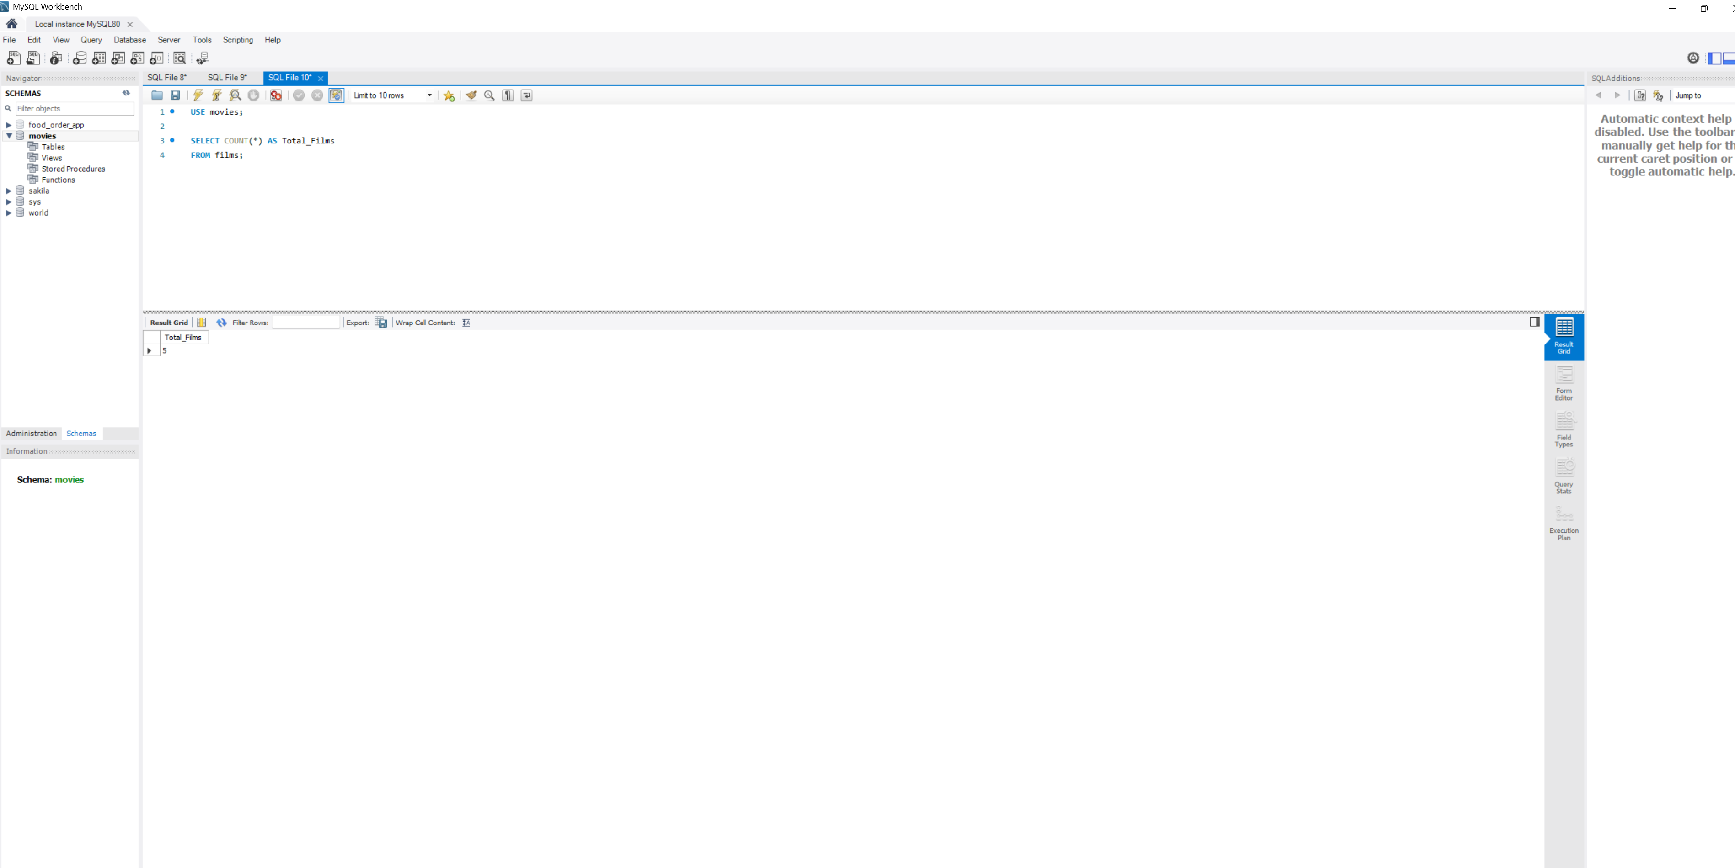
Function 1 — COUNT()
SQL Statement: SELECT COUNT(*) AS Total_Films FROM films;
Alias: Total_Films
Explanation: The COUNT() function counts the total number of records in a table. It is useful for determining how many rows exist or how many rows satisfy a condition.

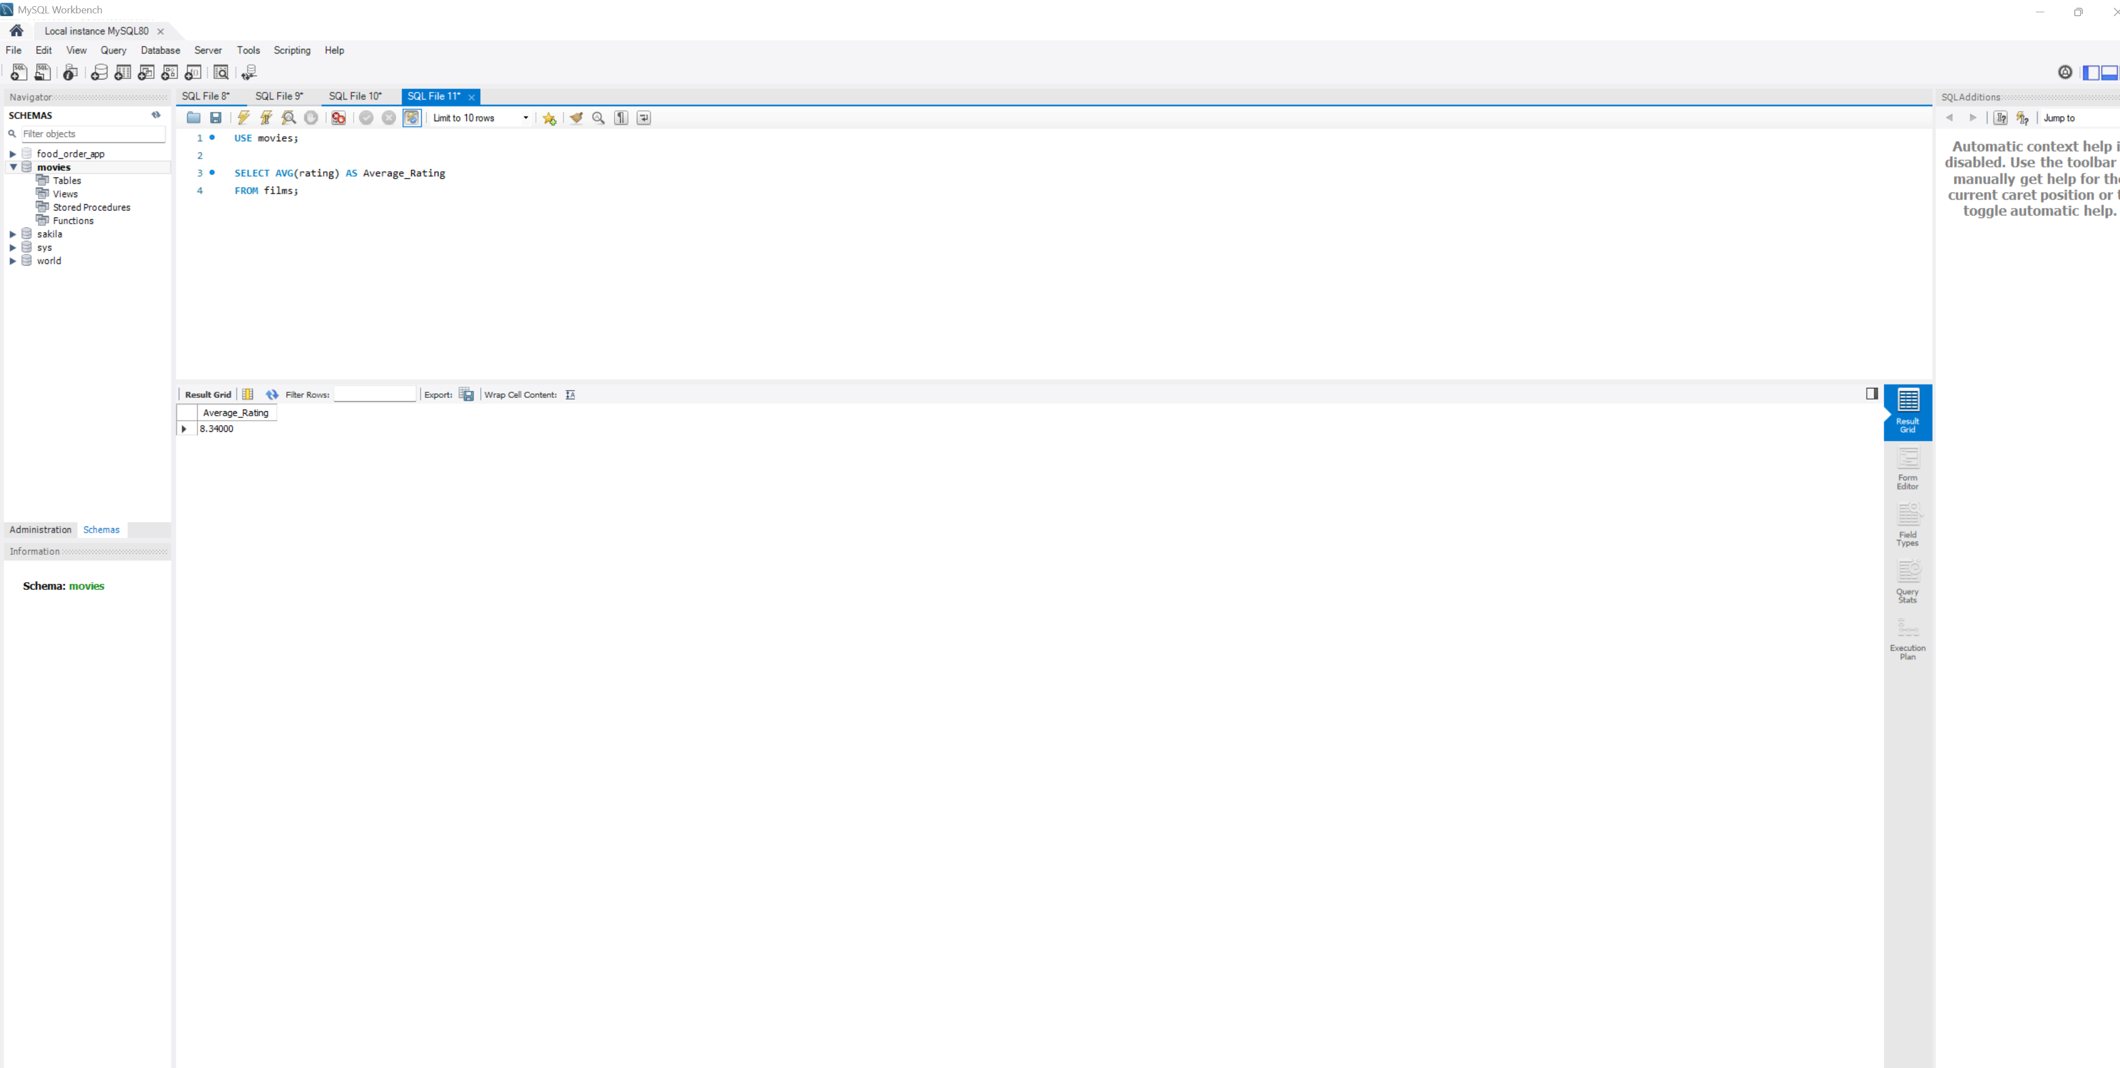
Function 2 — AVG()
SQL Statement: SELECT AVG(rating) AS Average_Rating FROM films;
Alias: Average_Rating
Explanation: The AVG() function calculates the average value of a numeric column. It is commonly used to summarize data, such as finding the average rating of movies.

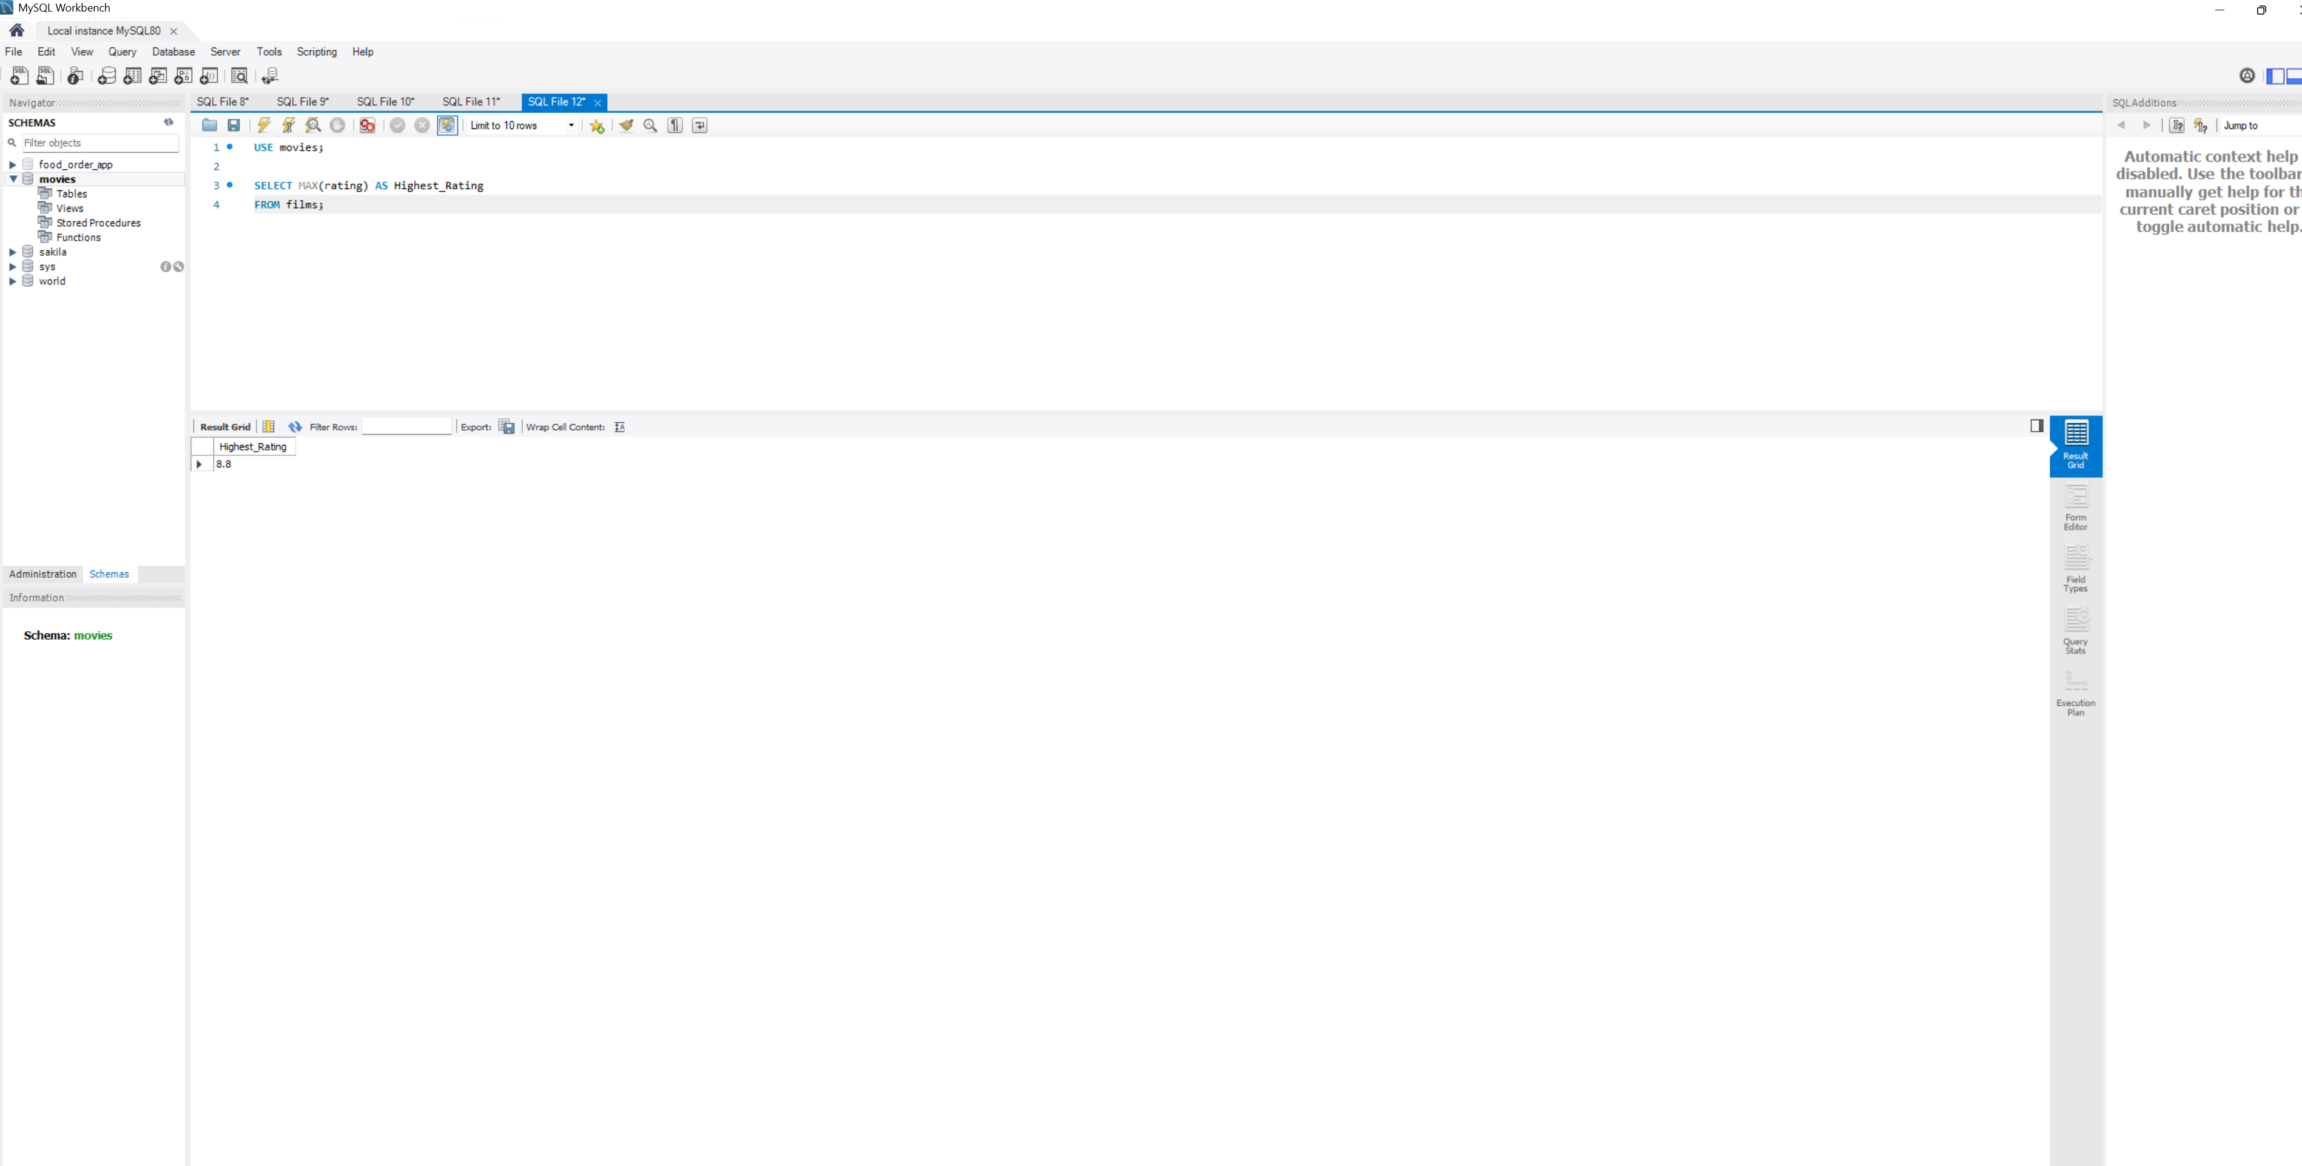
Function 3 — MAX()
SQL Statement: SELECT MAX(rating) AS Highest_Rating FROM films;
Alias: Highest_Rating
Explanation: The MAX() function returns the highest value in a column. It is useful for identifying the maximum value in a dataset, such as the highest movie rating.

