Student Name: Luis Cortez
Course: CSD310-300H Database Development and Use (2265-DD)
Assignment: Module 5.2 Assignment – Movies Setup
Date: June 27, 2026

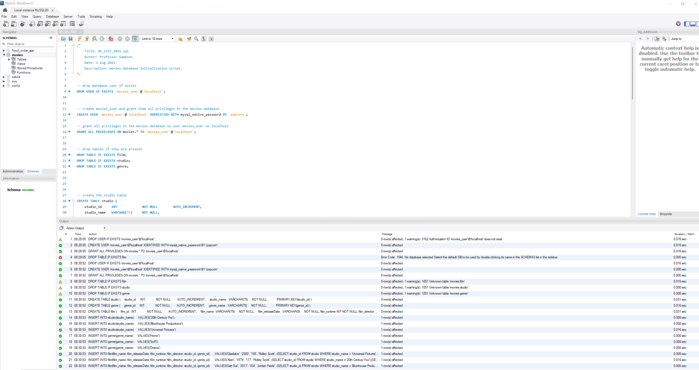
Figure 1. Output after running the db_init_2022.sql script to create and populate the movies database tables.

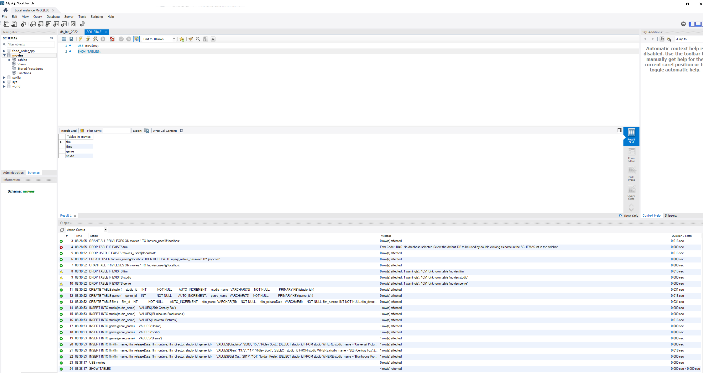

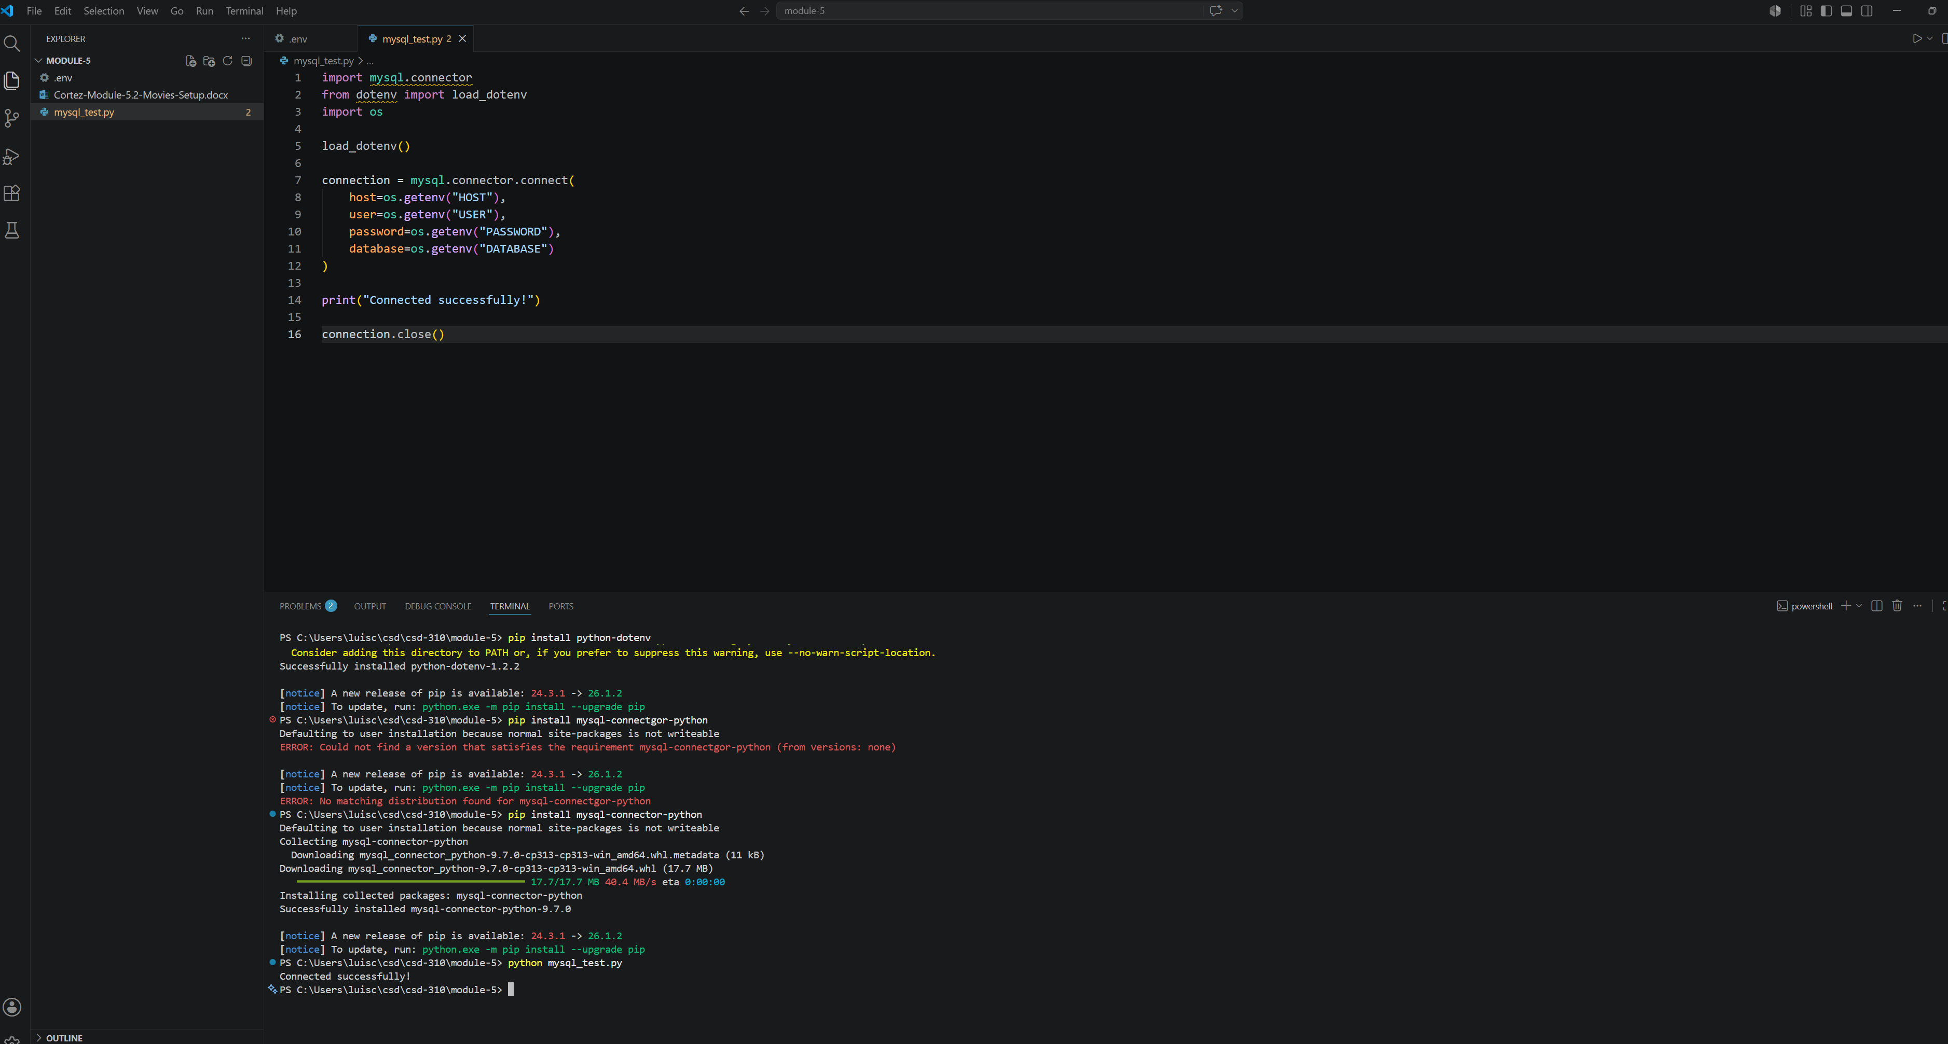
Figure 3. Successfully installed the MySQL Connector and Python dotenv packages, then verified the Python application connected to the MySQL movies database using the credentials stored in the .env file.

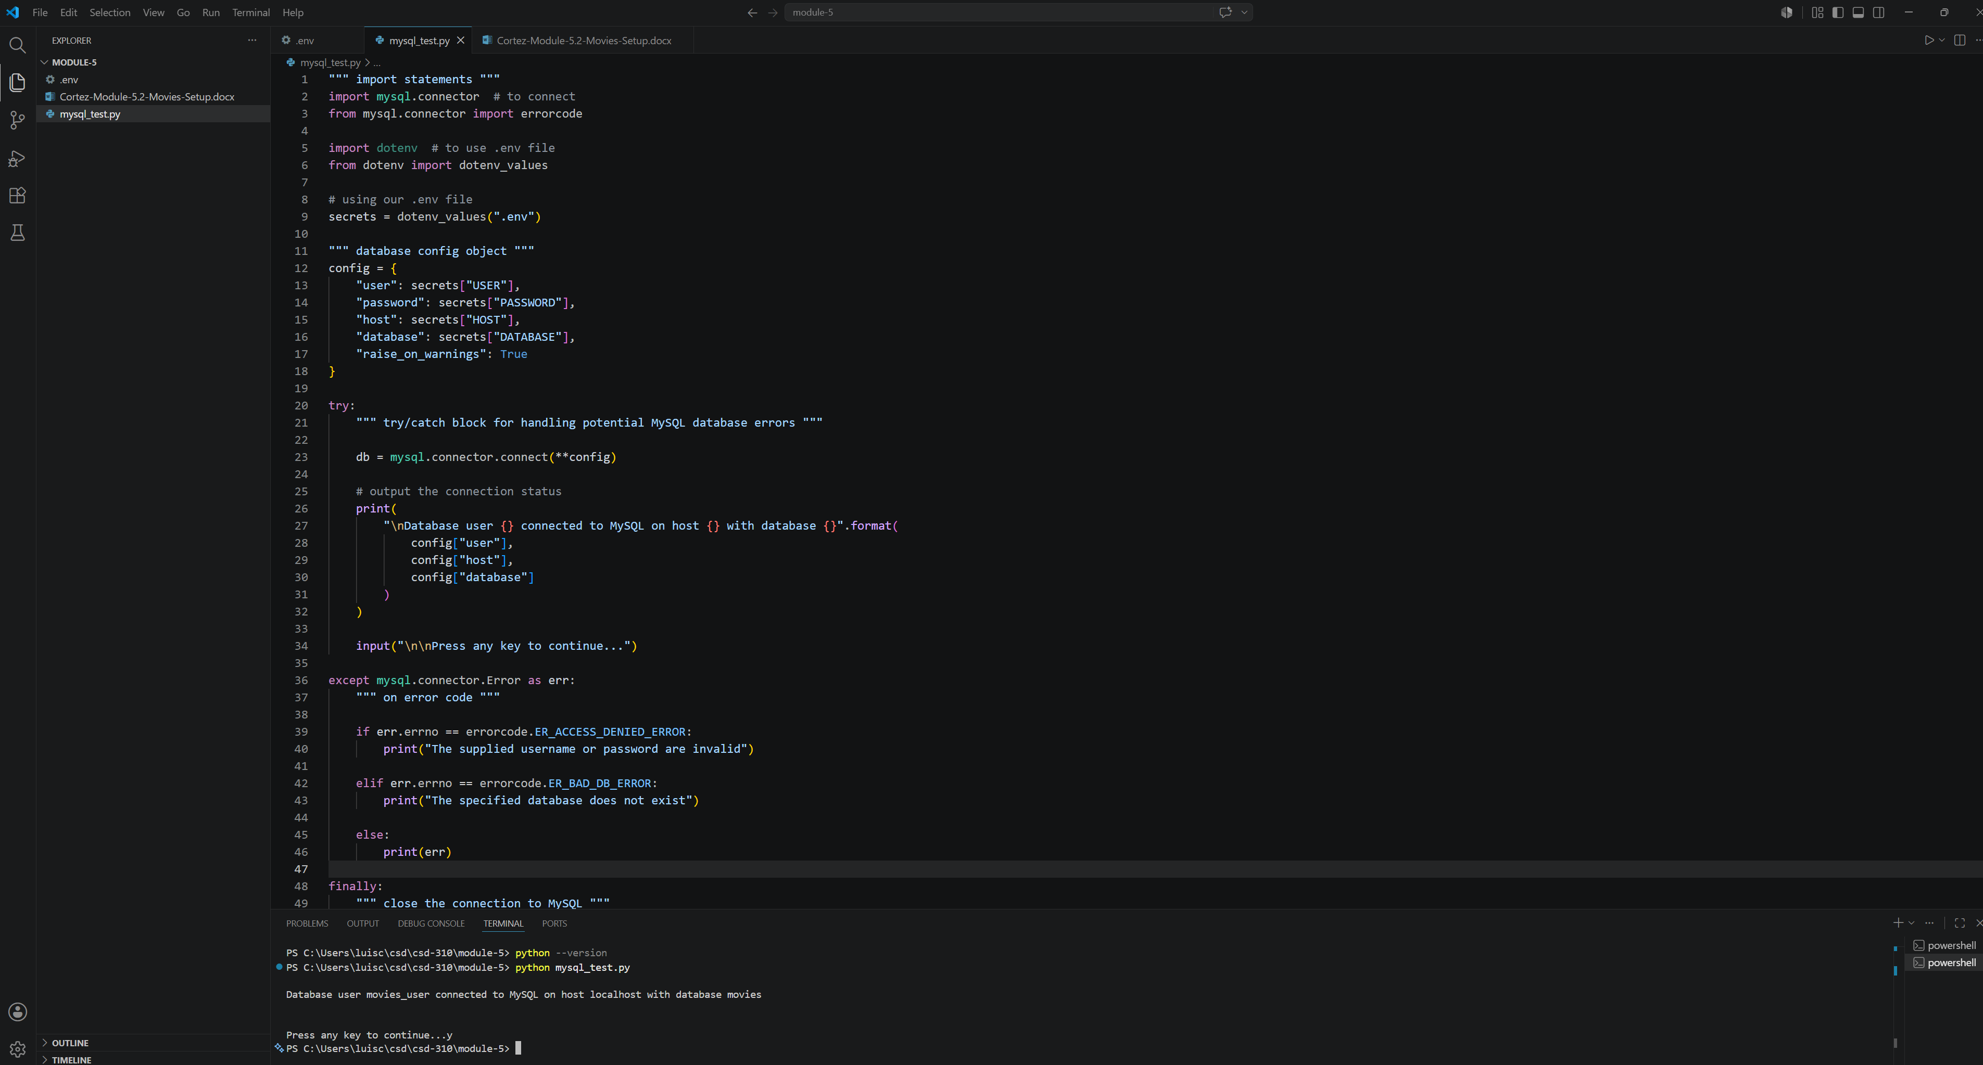
Figure 3. Python script successfully connected to the MySQL movies database using credentials stored in the .env file.

