Name: Luis Cortez
Assignment: Module 3.2 – Normalized Tables
Course: CSD-310
Date: June 2026

Normalized Tables

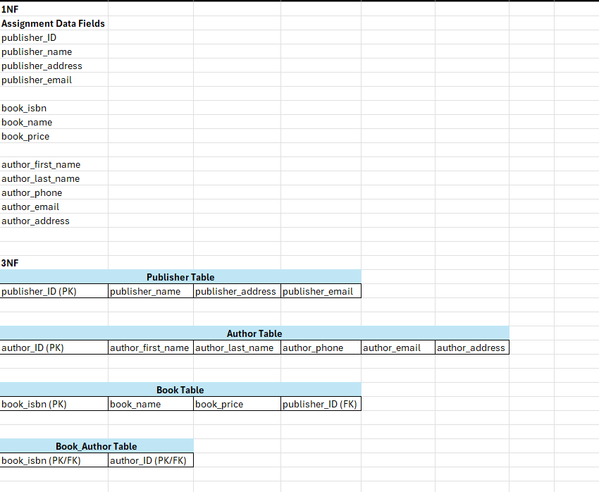

Assumptions Made:

- publisher_ID was provided and is used as the primary key for the Publisher Table.
- book_isbn was provided and is used as the primary key for the Book Table because each book should have a unique ISBN.
- author_ID was added because no unique author identifier was provided. Author names alone may not be unique.
- A book can have one or more authors, and an author can write one or more books. For this reason, a Book_Author Table was created to connect books and authors.
- Each book is assumed to have one publisher, so publisher_ID is stored as a foreign key in the Book Table.
- The tables are in 3NF because publisher information, author information, book information, and book-author relationships are separated into independent tables.

