Luis Cortez
Module 2.3 Assignment – Data Models
Date: June 13, 2026

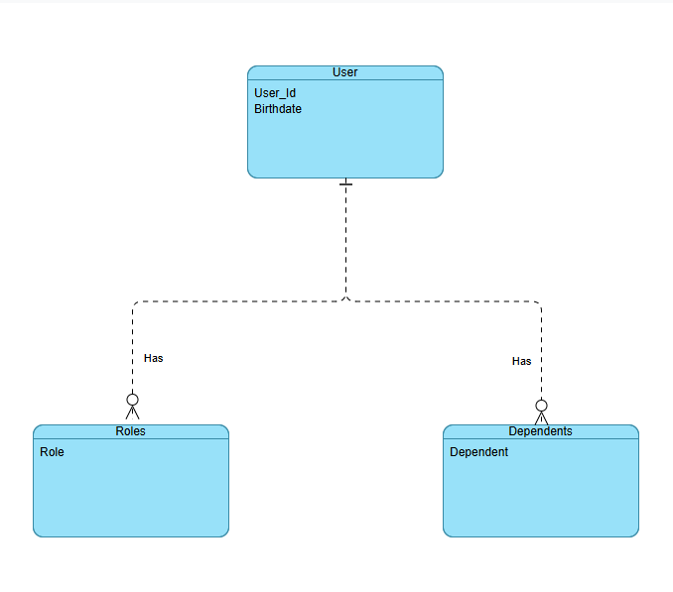

NoSQL Data Structure
